**User Guide: Import Tab**

Use the import tab to import the .tf files.

* Enter the folder location of the files.
* If no files have been previously imported, the import input field will be blank.
* Only use the absolute or full path.

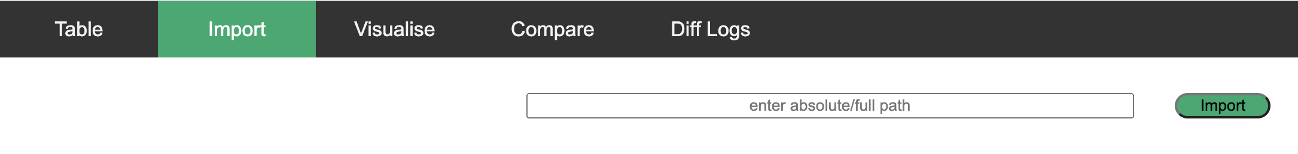

The example folder is found at /path/to/aciTerraformServer/example.

*Note: change /path/to so it matches your environment.*

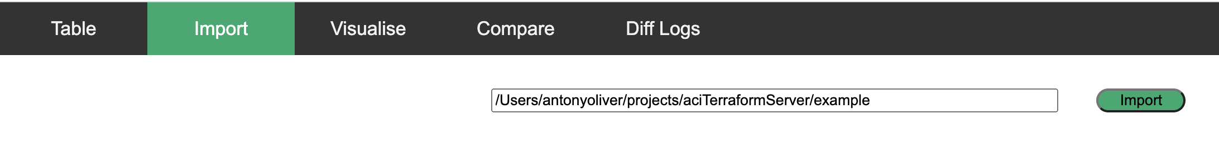

Otherwise:

Alternatively, use bash to import the TF files.

poetry run python3 source/import_aci_tf.py – f /path/to/aciTerraformServer/example