User Manual For Hydropick

Hydrographic Sonar Depth Editing Software

# Table of Contents

1. Admin
   1. Open source project location
   2. Requirements
2. Importing a survey
3. The window
   1. The map pane
   2. The survey pane
   3. The edit pane
   4. The depth line pane
4. Miscellaneous
   1. The location information dialog
5. Tricks and Quirks

# 1. Admin

a. Open Source Project

Hydropick is an opens source project. Repository can be found at

<https://github.com/twdb/hydropick>

b. Hydropick was designed to run with a Canopy distribution, but all the required packages can

be installed separately. sdi is a required package created by TWDB at

<https://github.com/twdb/sdi>

c) There is a log file generated called hydropick.log. It is usually under some hidden folder.

In windows probably:

C:\Users\NAME\AppData\Roaming\twdb\hydropick\

On Macs:

Users/NAME/.twdb/hydropick/hydropick.log

# 2. Importing a Survey

When the application is started you will see a new window similar to the one shown in the Window section. To ‘import’ a survey, either select import from the file menu or hit the import icon on the tool bar. This will bring up a directory dialog window where you can select the folder where your survey project is located. If this is the first time this survey is opened in hydropick and all the data is still stored in a SurveyData directory structure, then the import will take a long time because the application will save all the data in a set of HDF5 files. All future imports will take the data directly from these files which will be faster.

If you wish to import the survey with all the pick files from previous line edits from the SDI editor,

then there is another option for that in the file menu. This can be done at anytime.

Upon importing a survey you will see the map display of the lake with all of the survey lines and

core samples.

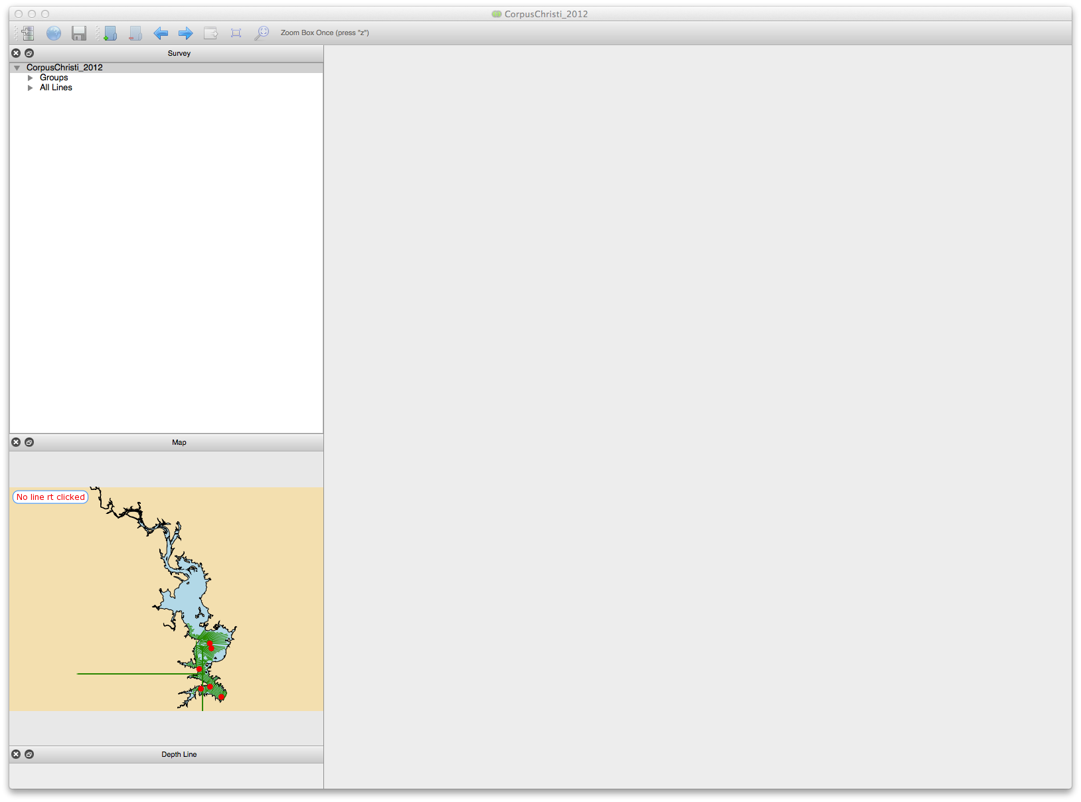

# 3. The Window:

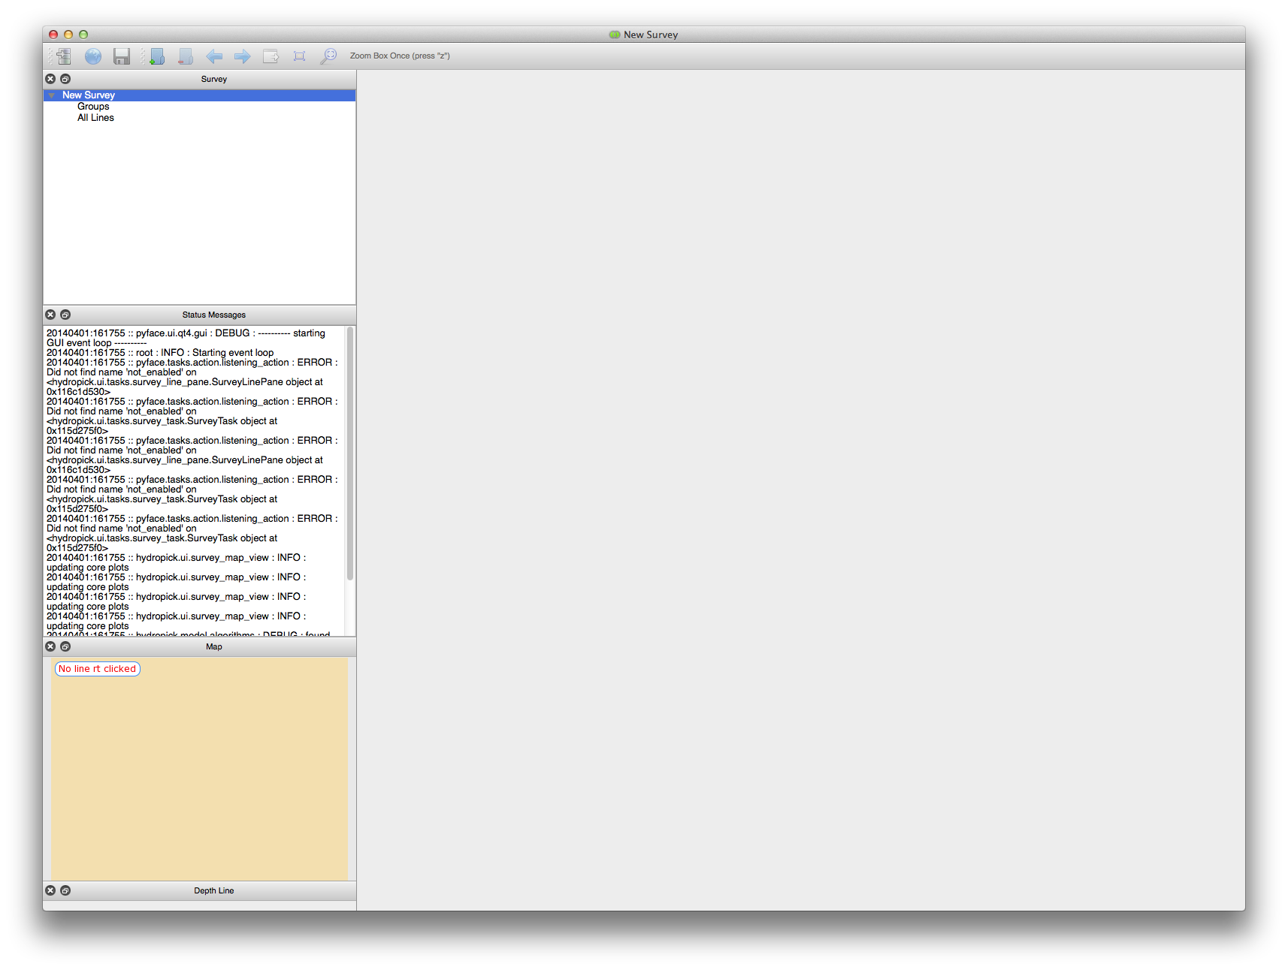

The screenshot shows the 5 major panes available when you open the application:

The Central Pane (Editing pane)

The Survey Pane

The Map Pane

The Depth Line Pane

The Messages Pane

The last 4 can be selected on or off from the view menu. The Central pane is always there. These panes operate independently. They can be moved around or pulled out of the window and placed on a separate screen or overlapped to some degree to be accessed by tabs.

## a. The Map Pane

The map pane allows you to see the whole lake, where all the survey lines and core samples are, and to select, deselect, or select for editing any of the lines.

There are several types of survey lines.

* pending : solid blue
  + initial state of all lines waiting to be looked at and approved
* approved : dashed black
  + lines chosen by some user to be finished
  + what that means is up to the users
* bad : dotted grey
  + lines designated by some user to be bad or unsuable
* current line to edit: bold solid red
  + line opened in the editing pane
* selected group : solid green
  + lines currently ‘selected’ by the user for various purposes. These may consist of multiple ‘survey groups’ or individual lines.
    - create or replace lines in a survey group
    - to apply an algorithm to selected group
    - to cycle through selected with the arrows
* core samples : red circles

Actions:

* add or remove line to selected group
  + right click on it
* see id of line in text box
  + left click on it
* select for editing
  + double click on it
* zoom in and out
  + use the mouse wheel
  + use the ‘+’ or ’-’ keys
* pan
  + hold down the left mouse button and drag the map

## b. The Survey Pane

This allows you to browse all of the groups and survey lines in the Survey. You can select groups, individual lines, make new groups, and replace or delete them.

* selected a survey line for editing
  + double click on any line name to open it in the editing window
* add a group of lines to selected lines
  + left click a group to select only that set
  + command + left click to ADD that group to selected lines
* make a new group
  + select ‘New Group’ from Edit menu
  + left click on the name and select rename to rename it.
* delete a group
  + left click and delete to delete it or select it and delete from Edit menu
* replace or add lines in group
  + select group (selected lines show in green in map)
  + select more lines either from map or with command + left click in survey pane
  + now select ‘Replace Group with Selected’ from Edit menu
* select all lines
  + click on ‘All Lines’ or ‘Groups’ heading
* deselect (almost) all
  + left click on one line and all the others will be deselected.

## c) The Editing Pane

This pane allows you to see any or all of the sonar images for the chosen survey line, along with core sample positions, pre-impoundment and post (current) surfaces, and intensity cross sections for any part of any sonar image. One can also edit the surface lines and set various survey line parameters

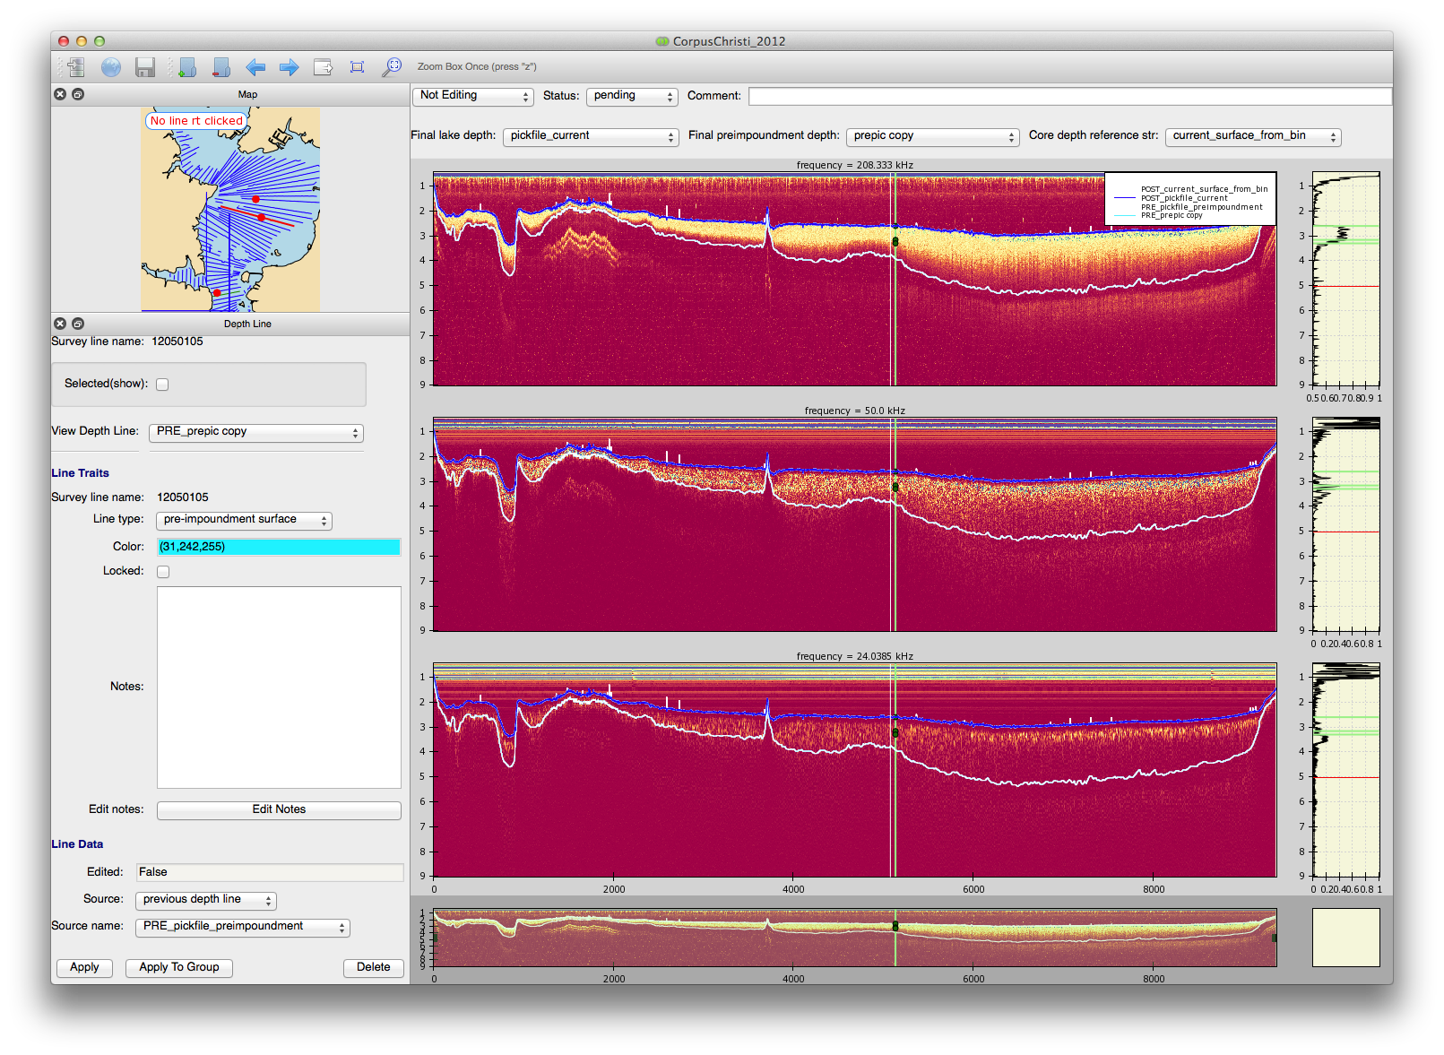

c.1 Layout

The default layout shows sonar images for all 3 frequencies stacked and labeled, with a mini view on the bottom for seeing where you are when you zoom in, and intensity cross sections on the right side of each sonar plots. From the View: Plot View Selection menu you can select which frequencies to look at and whether to show the cross sections.

The color map for the images can be chosen from the tools menu : Change Colormap. The display for each frequency can be further adjusted with the tools menu: Image Adjustment.

c.1.1 Zoom

There are several methods for zooming.

* use the mouse wheel
* use the ‘+/-’ keys
* zoom in with a box:
  + zoom once:
    - click on any image and press ‘z’ to zoom once. The mouse will become a ‘+’ and you can draw a box with the left mouse button held.
  + zoom multiple times:
    - click on the zoom box icon in the toolbar and make several zooms selections in a row
    - click again to remove this zoom state
* zoom out options
  + press escape when in any sonar image
  + press the zoom extents icon in the tool bar
* zoom from mini plot: (no effect on vertical zoom)
  + adjust the horizontal extent of the zoom box using the mini plot
    - hold right mouse button to select horizontal range
  + zoom area selected in this manner can be easily dragged back and forth in the mini plot
    - drag this with left mouse held down.
  + remove zoom with left click in a non selected area of mini plot.

c.1.2 Pan

Pan in any sonar image by dragging with right mouse held down.

c.1.3 Elements of main plot

* White line - horizontal position cursor
  + follows mouse and determines which crossection of the intensity plot is shown on the right.
  + can be frozen in place by clicking on any image, positioning the cursor and typing ‘alt+c’
* green vertical line and circles
  + represents core sample postions - all cores within a present distance of a survey line are displayed
  + nearest horizontal position of the core sample to the survey line is shown by green line
  + boundary depths are shown by green circles
* Legend
  + clicking on a legend line will highlight/make bold that line in the top plot
  + moving the legend
    - the legend dragging can be enabled by turning off the pan with the ‘disable pan’ icon in the tool bar. Then the legend can be dragged around with the right mouse held down.

c.1.4 Elements Intensity cross section

* black line
  + displays intensity cross section of sonar image at position of white cursor
* green horizontal lines
  + show depths of core sample boundaries when cursor ‘near’ a core
* red horizontal line
  + depth of mouse pointer in sonar plot.

c.2 Control panel

The set of controls above the sonar images allow you to set survey line parameters and choose surfaces to edit.

c.2.1 Editing

The editing control has 3 choices

* Not Editing
  + The normal state
* Editing
  + This brings up a ‘selected target’ control which give you a choice of which surface to edit.
  + selecting a target turns that surface line black
  + hold the left mouse button down to ‘draw’ changes to the surface line.
  + deselecting Editing will save the changes
* Mark Bad Data
  + brings up a toggle button to mark or unmark sections of the survey line that the user wants to be designated as bad. A mask will be saved in the survey line file that can be used later to filter that data.
  + select or deselect bad data with the left mouse button held down in any sonar image
  + bad data will show up with a dark shadow over it.

c.2.2 Survey line settings

Several attributes can be saved for a survey line to be used for further analysis and can be displayed here and on the map.

* Final Lake Depth:
  + designates one of the ‘current surface’/’post-impoundment’ surface lines as the final and true representation for the current lake bottom surface
* Final preimpoundment depth:
  + designates one of the ‘pre-impoundment’ surface lines as the final and true representation for the preimpoundment surface of the lake before it was dammed up and sediment accrued.
* Status
  + pending, approved, bad
    - status saved to line to be used as desired in further analysis
    - status coded into map view
    - exact meaning of status to be determined by user consensus
* Comment
  + Any comment the user want to make on the survey line or its status (like who approved it or when, etc)

c.2.3 Core depth reference line

Core boundaries are given relative to the current surface where they were taken. To plot them properly a good current surface line has to be chosen for them to be plotted relative to (ie the first boundary at ‘0’ will be on the chosen surface line. The user can choose between any existing current surface as a fixed line or choose Final Lake Depth to have it always chosen to whatever is selected in final lake depth.

(Note : if the chosen line is deleted or has some problem the application will try to plot it relative to the next best choice it can find. This may mean that the line shown in the control will temporarily be out of sync. check log or messages to see what is used.)

## d. The Depth Line Pane

The depth line pane (shown in the previous screenshot) allows the user to create, view, edit, and delete surface lines for the lake bottom. Depth line here is a general term for the surface lines drawn in the sonar plots representing the pre and post impoundment surfaces.

d.1 Information Box

This is the section at the top of the depth pane. It shows:

* survey line name
  + the current Survey line being edited in the edit pane
* selected check box
  + if checked displays the names of all the survey lines currently in the group of ‘selected’ lines (green in the map)
* view depth line
  + a selector control to choose an existing depth line to display below it.
  + choosing ‘New Line’ in this control will bring up a template that the user can edit to create a new line by filling in the parameters below and hitting apply.

d.2 The Depth line editor parameters section

This has 3 parts.

* Line traits
* Line data
* Control buttons

d.2.1 Line traits

These allow you to choose/change non data parameters for this line. These items are changed immediately upon activating the control when applied to an existing line. If ‘New Line’ is chosen, these are just settings that will be used to creat a new line when Apply is pressed.

* surveyline name
  + shows the the survey line to which this depth line is associated.
* Line type
  + is one of the two surfaces available
* color
* locked
  + will prevent most parameters from being changed or the data from being edited
  + in the case of the ‘current surface line from bin’ which is the orginal surface provide by the sdi instruments, only the plot color can be changed.
* notes
  + are for arbitrary information the user wants to save about this depth line

d.2.2 Line data

This shows informations and settings for the actual depth line surface data which is plotted in the sonar plots.

* Edited
  + tells whether the data was manually edited in the edit pane
* Source
  + shows or selected what source was used to generate the original data for this line. It can be ‘sdi_file’, or ‘previous depth line’, or ‘algorithm’.
  + Algorithm
    - when algorithm is selected another button will appear ‘Configure algorithm’. This button must be pressed after an algorithm is chosen. It will bring up a custom dialog box for that algorithm allowing the user to set the parameters available for the algorithm.
* Source name
  + Which specific source of the source type chosen in source was used.
    - for sdi_file this is the name of the bin file it came from. Normally matches survey line name.
    - for previous depth line this is the name of another existing depth line whose data will be copied to this line.
    - for algorithm the user can choose from a list of existing algorithms
      * algorithms will generally be added by a programmer. The application was designed so that external algorithms can be called but a class must be added to the algorithms module for each selection in the pull down control choices. It should be pretty easy for someone with minimal python skills to copy the format shown in the algorithms module to add more new algorithms, assuming they have an algorithm to implement.
      * opening this dialog should provide default parameters so that hitting ok will give some reasonable line
      * opening the dialog will cause ‘Done’ do display in the button, letting the user know it has been configured

d.2.3 Control buttons

There are 3 control buttons.

* Apply
* Apply to group
* Delete

Each Button requires either an existing depth line selected or a new line configured. In the case of an algorithm source if the configure button does not say ‘Done’ the user must press it again to configure the algorithm.

* Apply
  + applies the current settings to the parameters AND the data
  + in the case of a new line it will use the chosen source to generate data for this depth line and create a new line with the parameters shown.
  + in the case of a previous line it will apply the source chosen to change the data for the existing line accordingly. All other parameter will have already been updated.
* Apply to Group
  + Only makes sense for algorithm since data for one survey line surface will not fit on another survey line.
  + This applies a configured algorithm to all the survey lines selected. (shown by ‘selected’ check box above. The data will be generated by the algorithm using each survey line in turn, and the depth line parameters above will be set for each line.
  + Upon pressing the button the user is given a dialog allowing a selection of
    - overwrite name
      * which overwrites any line with the same name in any of the chosen survey lines unless they are locked (see next choice)
    - overwrite locked
      * which will overwrite lines with the same name even if they are locked
    - overwrite approved
      * this will overwrite lines on approved survey lines as well if chosen
    - new name
      * user can choose new name for the depth lines created on this group of survey lines.
  + Note that this may take a while
* Delete
  + delete chosen depth line from survey line.

# 4. The Locations dialog:

From the view menu you can open a locations dialog box which show cursor locations in lat/long, northing/easting, and depth, as well as core information when cursor is near a core (whenever it shows up in the cross section plot)

# 5. Tricks and Quirks:

This manual is written just before the release of the first version of the software. There are a number of things that could and should be improved in future version that now may appear as quirks or require some trick to work them.

a) Groups vs Selected Lines

there is a concept of groups in the application, but really groups just tag a bunch of survey lines, and provide a convenient way of selecting that set. What really counts for most applications, like applying an algorithm to many lines, is the Selected lines list. These show up in green.

Apply to Group really means apply to all the selected lines. You can select them individually or add to the selection a group at a time using groups. You can see the selected lines both in the map view and in the Depth Line view if you check selected lines box.

* quirk:
  + the coding of lines in the map view may not be the best. For instance if the line in the editing window is alway red - is it in selected lines? What about approved or bad lines showing up as black or grey? Some user should think of how they would like that to work in detail and pass that to a programmer to implement.

b) Message pane

It doesn’t update live when groups of activities are logged. For instance loading a new survey does not show the progress in the message pane until it is done. This can be seen in the log file but you may not be able to view that whlle the application is running in windows.

c) Cursor disabled

It may be when changing the layout (which frequencies show) that the cursor will freeze if the dialog box is in the Application window. For the cursor to unfreeze move the mouse out of the Application window - even up to the title bar is fine.

d) Dialog boxes don’t close.

Dialog boxes made from menus don’t close when you close the application. Be sure to close all these when you are done (or best, as you use them).

e) Core data updating in Location Information box

If the core file is changed and you have the Location Information dialog box open, you will need to close and reopen that to see the newly loaded core data.

f) There are many configuration variables that can be easily changed.

These could be put into a configuration text file that can be changed by users before opening if the application was set up to load from a configuration file when available (just import all the constants from that module if it is a hydro_config.py file for instance.)