RAMP 1.4 Boards

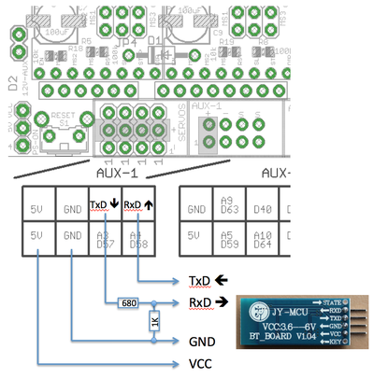

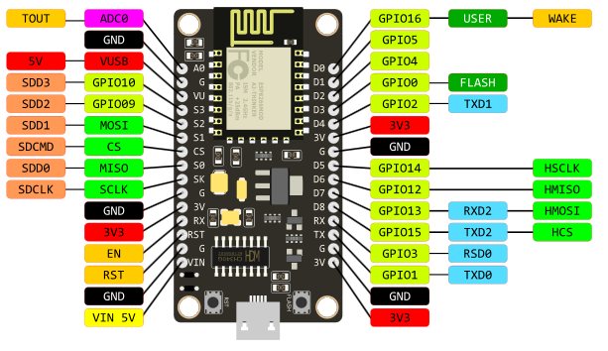

Load following program onto NodeMCU 🡪

#include<SoftwareSerial.h> //Included SoftwareSerial Library

//Started SoftwareSerial at RX and TX pin of ESP8266/NodeMCU

SoftwareSerial s(3,1);

void setup() {

//Serial S Begin at 9600 Baud

s.begin(9600);

}

void loop() {

//Write '123' to Serial

s.println("M17");

s.println("G1 X0 Y120 Z120");

s.println("G1 X10 Y100 Z0");

s.println("G1 X142 Y108 Z80");

s.println("G1 X62 Y-14 Z0");

s.println("G1 X10 Y100 Z0");

s.println("G1 X0 Y120 Z120");

s.println("G1 X10 Y100 Z0");

s.println("G1 X142 Y108 Z80");

s.println("G1 X62 Y-14 Z0");

s.println("G1 X10 Y100 Z0");

s.println("G1 X-180 Y100 Z100");

delay(10000);

}