Statistically examining the similarities and differences in the characteristics of the Women’s Super League and the Premier League

**Introduction**

Since football’s inception, spectators and fans have tracked football statistics in an attempt to gauge the performances of a team or player. For decades fans have relied heavily on surface level statistics to assess the performances of football teams. While basic statistics such as goals and assists can paint somewhat of a picture, the intricacies and subtle insights within football are often hidden behind a myriad of sophisticated performance metrics.

The last decade has seen substantial growth in the popularity of women’s football with viewership figures following an upward trajectory. Most notably, the 2019 women’s world cup amassed 1.12 billion viewers Perelman, R. (2019). The rise in popularity has also led to a rise in comparisons between men and women’s football. However, the comparisons made are often rudimentary and fail to explore the rich data available.

In light of such comparisons, this study aims to statistically examine the similarities and differences between the Women’s Super League (WSL) and the Premier League. This study explores the potential underlying reasons for any statistical differences whilst also discussing the implications of any differences within the leagues.

This study takes advantage of the datafication within football by utilising the rich data available to accurately compare the characteristics of WSL teams and Premier League teams. The data in this study was collected from www.fbref.com, with focus on the performance metrics from the 21/22 season. All metrics used in this study are Per 90 metrics meaning that they are averaged out to reflect the frequency of events occurring within the period of 90 minutes. (E.g the number of tackles reflects the number of tackles in 90 minutes)

**Goalkeeping statistics**

We begin our analysis by examining goalkeepers. Goalkeepers are a key component to any team as they play an important role in preventing opposition teams from scoring. In recent years, the Premier League has seen a tactical shift as an increasing number of teams have adopted a more possession-based style of play with Pep Guardiola being a key catalyst to this approach. In order to employ this style of play, teams require their goalkeepers to be ball playing goalkeepers that are able to build play out the back. Consequently, rather than launching or booting the ball, more goalkeepers are being instructed to pass the ball short for goal kicks as this tactic is essential to fostering a possession-based style of play.

While this tactical evolution has been evident in the Premier League, it would be intriguing to see if it has been replicated in the WSL. In an attempt to investigate this, a radar plot has been created to analyse goalkeeping distribution statistics.

The radar plot reveals that keepers in the WSL launch less off their goal kicks when compared to Premier League keepers. Additionally, they attempt more passes at a shorter average distance. Naturally, it would be easy to presume that keepers in the WSL launch less of their goal kicks because it is a less effective tactic in the WLS. However, the completion rate of launched goal kicks is almost identical in the Premier League and WSL. Therefore, it seems that keepers are passing the ball from goal kick due to tactical instructions rather than a lack of effective alternatives. Thus, the statistics point towards the trend of ball playing goalkeepers being even more prominent in the WSL than the Premier League.

Following on from the distribution of goalkeepers, attention is paid to the shot stopping ability of goalkeepers in both leagues. The average height of keepers in the WSL is 5ft8, a stark difference to the average of 6ft3 in the Premier League Malone, R. (2021). Considering that the goals in both leagues are the same size, logic would dictate that WSL keepers should perform worse than their counterparts as WSL keepers have considerably less reach and wingspan to prevent goals. As the clean sheet percentage rate is typically used when assessing keepers, we employ this metric to make a preliminary assessment of the shot stopping abilities of keepers in both leagues.

The boxplot displayed above indicates that the WSL has a wider range of clean sheet rates which implies that a teams ability to prevent goals varies drastically from team to team. More noticeably, the statistics reveal that WSL keepers on average have a significantly higher clean sheet percentage rate. The WSL average is 35.7% compared to a Premier League average of 28.8%. This would suggest that WSL keepers are more proficient at preventing goals than their counterparts. Thus, the statistics challenge the notion that WSL keepers are less adept at shot stopping due to their size and reach disadvantage. However, while it may be the case that WSL keepers are in fact more proficient at shot stopping, more evidence is needed to come to a concrete conclusion.

Delving deeper into the stats, we analyse more sophisticated metrics that allow for a more accurate assessment of the performances of keepers in both leagues. This study utilises a more modern statistic known as post shot expected goals minus goals (PSxG-G). To understand this metric, we begin first by explaining the post shot expected goals (PSxG) metric.

Post shot expected goals measure a goalkeeper’s proficiency at shot stopping. The metric assesses the probability of a shot being saved based on the location of where a shot is taken, the velocity of the shot and the shot placement. Thus, subtracting the number of goals conceded from the PSxG generates the post shot expected goals minus goals (PSxG-G) metric. This metric measures a goalkeeper’s performance in relation to the shots they have encountered. A positive value indicates that a goalkeeper has prevented more goals than expected while a negative statistic indicates that a goalkeeper has conceded more goals than expected.

This study also uses shots on target to evaluate how busy keepers are within a match. It is often hypothesised that keepers that face few attempts at their goal have a natural tendency to drop their concentration levels which may result in them underperforming more frequently. This study utilised a scatter plot to determine whether this hypothesis has any credence in either leagues.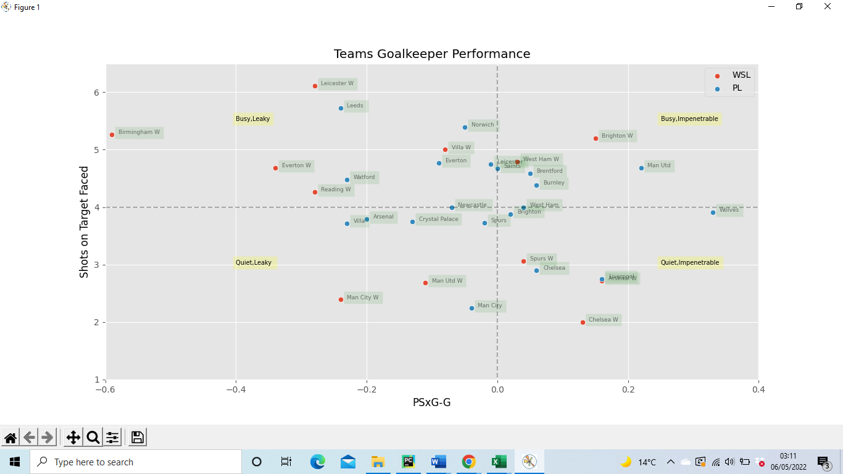 In addition, the scatter plot produced will also allow us to ascertain whether keepers in the WSL outperform Premier League keepers despite their size difference.

The scatter plot provides a wide range of values as both leagues have teams with keepers that underperform and over perform according to their PSxG-G statistics. However, it is noticeable that the four teams that produce the smallest PSxG-G values are all WSL teams. Thus, WSL keepers overrepresent the population of keepers that are significantly underperforming. In contrast, Premier League teams make up three of the four teams with the highest PSxG-G values. It appears that the bottom third of WSL keepers are massive underperformers while the remaining two thirds perform somewhat averagely in comparison to Premier League keepers The scatter plot provides a completely different picture to the one provided by the clean sheet percentages as WSL keepers no longer look like the superior shot stoppers. This highlights the importance of using more advanced metrics in order to gain deeper insights and more accurate conclusions.

Additionally, from the scatter plot we can also deduce that there is no correlation between the performance of a keeper and the number of shots on target a keeper faces.

**Passing statistics**

Passing is a fundamental component within football. Passing allows teams to progress play and create chances while possession of the ball also prevents the opposition from scoring. With this being the case, this study examines the passing statistics of teams in the Premier League and WSL

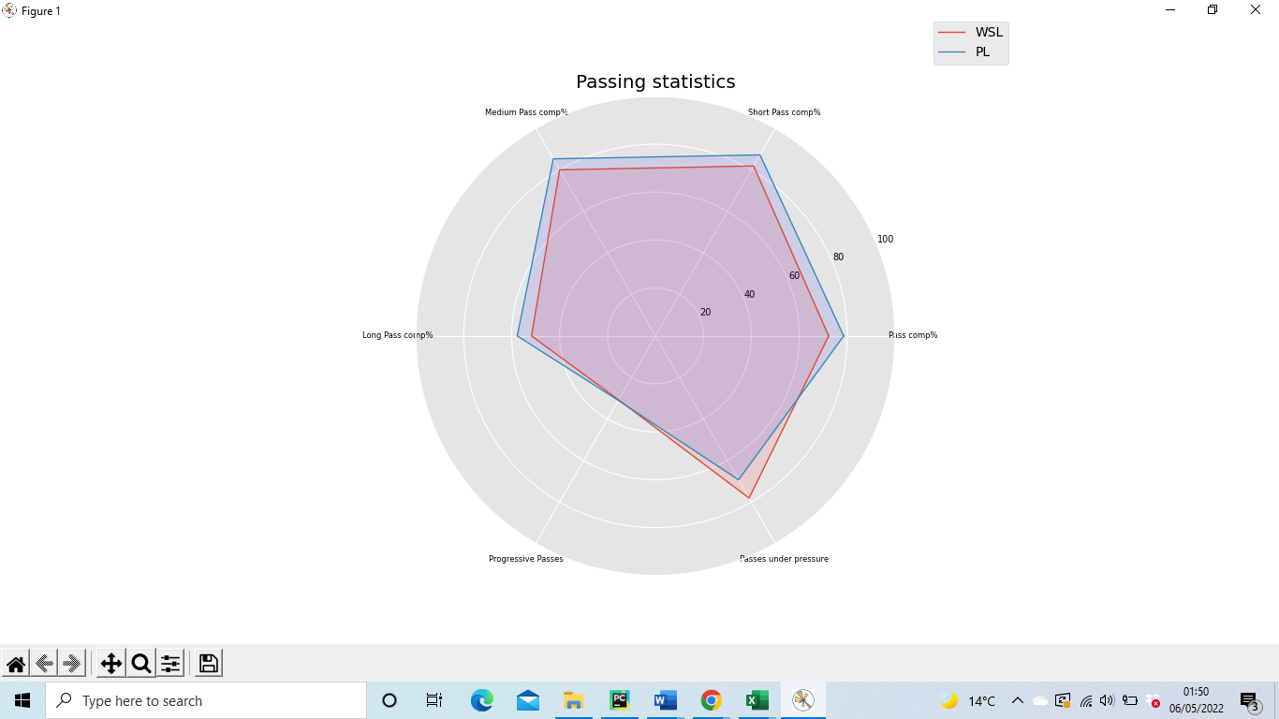.

The radar plot reveals that passing accuracy percentages (or pass completion’s percentages) are lower in the WSL relative to the Premier League. The gap in passing accuracy remains fairly consistent among the different passing ranges which suggests that the disparity is not due to random chance. The statistics may be explained by the fact that WSL players have lower technical passing ability. This gap in technical skills is likely to be linked to the amount training players in both leagues have done. The WSL became a professional league in the 2018/2019 season. Prior to that, most teams were semi-professional and were not training full time. With passing being the most fundamental aspect of football, it is coached and drilled upon in almost all training sessions. Thus, the gap in technical passing ability is likely to be a consequence of the disparity in the accumulated hours that players have spent training.

The gulf in passing accuracy may also be explained by the contrasting number of passes that are played under pressure in both leagues. The radar chart reveals that WSL players play significantly more passes under pressure. This is relevant as being pressured by an opposition player usually leads to the player on the ball rushing their pass which can often go astray. Considering the negative relationship between pass accuracy and pressure from the opposition, it is no surprise that WSL teams have lower pass accuracy.

The radar plots also reveal that Premier League players and WSL players play the same number of progressive passes. This suggests that players in both leagues share the same vision and confidence to spot and play progressive passes.

To provide more context within the realm of passing, a bar chart is created reflecting different types of passes that have been played or completed.

The bar chart reveals that WSL players play considerably less left footed passes when compared to their counterparts. Thus, we can infer that the proportion of players that are left footed is smaller within the WSL than within the Premier League. A scarcity of proficient left footed passers presents managers with a number of tactical dilemmas, as such players are a key to maintaining natural width within a team.

The absence of left footed players or competent left footed passers can cause issues. For instance, being forced to play a predominantly right footed player on the left-wing position can potentially disrupt and stifle the flow of a team. The winger will be reluctant to travel down the line, play passes down the line or attempt early crosses. Instead the player will often look to cut inside and play passes infield on their dominant foot. This can become predictable and opposition teams will find it easier to negate the attacking threat of the player.

Complications can also arise from not having a competent left footed passer playing left centre back. Where possible, teams will typically prefer to employ centre back partnerships that consist of left footed left centre backs and right footed right centre backs as it provides the most natural balance. Playing a predominantly right footed player left centre back can bring about difficulties. Issues can occur when the player is passing to the left back as the ball often ends up behind the left back due to the angle for a right footed forward pass being more unfavourable. This can hinder a team’s ability to move the ball efficiently and progress play quickly. This tactical dilemma is amplified in today’s game as many teams now require centre backs to be efficient and skilled at passing the ball forward.

Consequently, due to their greater scarcity, left footed players in the WSL are comparatively more valuable than their Premier League equivalents. With this being the case, managers in the league should look to keep a hold of such players as they are difficult to replace.

The bar chart also indicates that WSL teams attempt more high passes than Premier League teams. This statistic may partially be explained by the fact that WSL teams have a higher propensity to pressure their opponents. When a team pressures an opposition player the team looks to block all passing lanes before either tackling or intercepting the ball. However, physically players can only block or intercept passes that are head height or below. Thus, while low passes are easier to intercept, high passes are an effective tool that can be used to evade pressure from the opposition. Consequently, due to the high frequency of pressures in the WSL, players may be influenced to play more high passes as they are less likely to be intercepted by opposition players.

**Dribbling statistics**

Dribbling is an effective tool that can be used to destabilise a team’s defensive structure. In light of this, a bar chart is created which displays dribbling statistics within both leagues. The bar chart indicates that dribbling success rates are almost identical in the Premier League and the WSL. However, WSL players attempt and complete more dribbles in a match. This an interesting observation and while there is no obvious explanation a potential contributing factor may be due to the passing accuracy of WSL players. The radar plot displayed earlier indicates that WSL players are less proficient in passing and as a result WSL coaches may tactically instruct players to dribble when they have the opportunity as they see it as a more efficient route to the opposition goal.

**Defensive statistics**

This study looks at the defensive statistics in both leagues. A radar plot is used to display the clearances, blocks, interceptions, tackles and tackle success rates in both leagues.

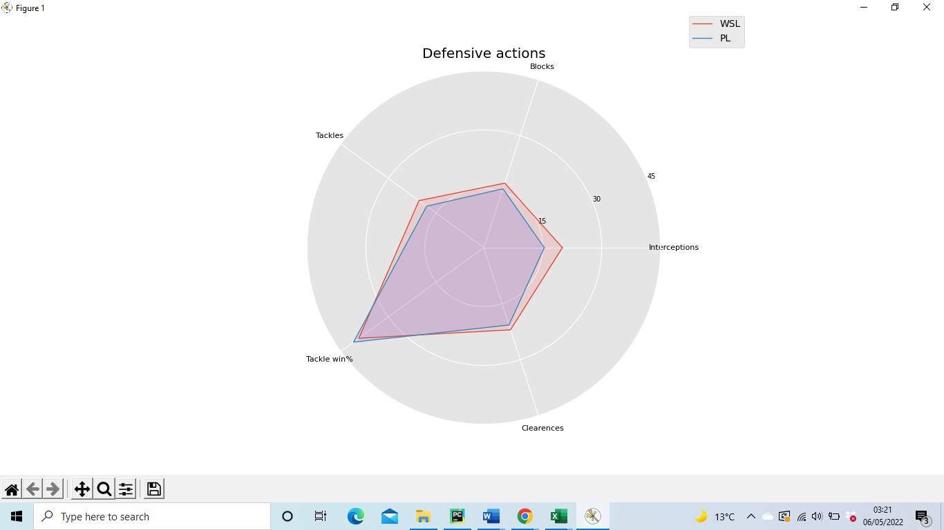

The radar plot displays that the WSL produces more clearances, blocks, interceptions and tackles than the Premier League. This indicates that the dynamics of the WSL differ to that of the Premier League. Matches in the WSL generate more turnovers with games tending to be of a back-and-forth nature characterised by frequent defensive actions. Taking this into account, we look to add more context to the statistics and explore some of the potential underlying causes for the disparity within the two leagues.

The WSL produces more blocks than the Premier League. This could be due to tactical instructions as players may be instructed to dive aggressively in the way of opposition shots. The number of blocks could also be a result of excellent positioning from defenders as keeping tight to an opposition player reduces that player’s options while increasing the chances of producing a blocked shot or pass. Having said that, pinpointing the exact reasons for the greater number of blocks may be difficult and thus these explanations remain speculative.

We turn our attention to the number of interceptions and tackles produced as these statistics are more significant in the context of football. Interceptions are a vital aspect of football. They occur when a player seizes a pass that was intended for an opposition player. Therefore, the more passes that are played the more opportunities there are to intercept the ball. With this being considered, the interception statistics are particularly interesting. The WSL produces a higher number of interceptions relative to the Premier League, despite less passes being played in the WSL. The number of interceptions may be greater for several reasons. Earlier statistics indicate that women have lower passing proficiency. As a result, the passes within the WSL may be easier to intercept which may partly explain the discrepancy in the number of interceptions.

As with interceptions and blocks, the tackling numbers are also higher in the WSL relative to the Premier League. This could be linked to the fact that WSL are more inclined to attempt dribbles in a match. Dribbling consists of players trying to manoeuvre and carry the ball past opposition players. Consequently, dribbling requires the ball carrier and the opposition player to be in close proximity which in turn allows the opposition a better opportunity to tackle the ball carrier. Thus, higher tackling numbers in the WSL may partially be explained by the fact that WSL players attempt relatively more dribbles in a match which provides opposition players with more frequent opportunities to tackle the ball.

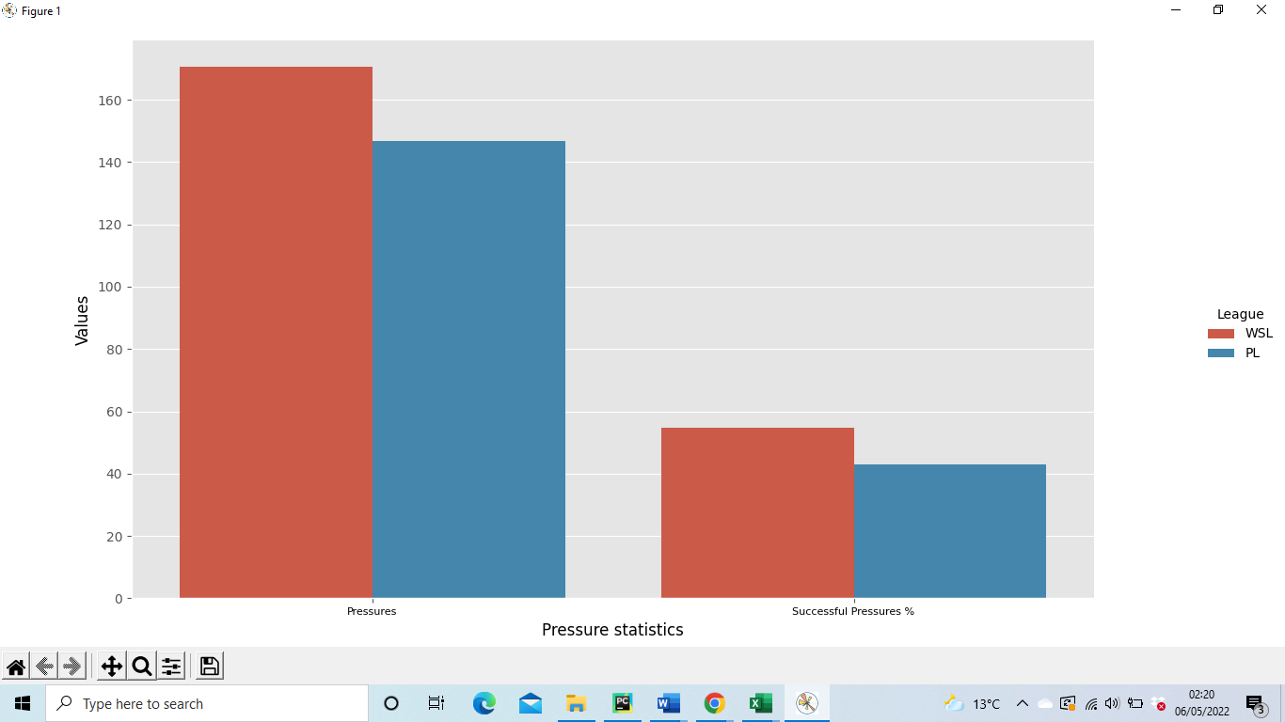One factor which may influence defensive statistics is the number of pressures a team executes. A pressure occurs when a player runs with intensity to close down an opposition player. When a player is being pressed or pressured they often have less time and options on the ball. This can lead to rushed decisions and the player may have an increased propensity to lose the ball. Thus, there may be a positive correlation between the amount of pressure and the number of tackles and interceptions a team produces. Considering this, we use a bar chart to see if there is a difference in the number of pressures and the success rates in each league.

From the bar chart it is evident that teams in WSL apply more pressures in a game and have a higher success rate when pressuring the opposition. Logic dictates that the higher success rate is a key factor in explaining why the tactic is more prominent in the WSL league. Additionally, from inspecting the bar chart and the prior radar plot we can deduce that the number of pressures positively impacts the number of tackles and interceptions a team makes.

In order to provide context and a more thorough analysis, we examine the location of the tackles and pressures performed by teams. A football pitch is often divided into three sections. The defensive third, the middle third and the attacking third. Tackling a player in the attacking third has completely different implications to tackling a player in the defensive third, highlighting the need for such context.

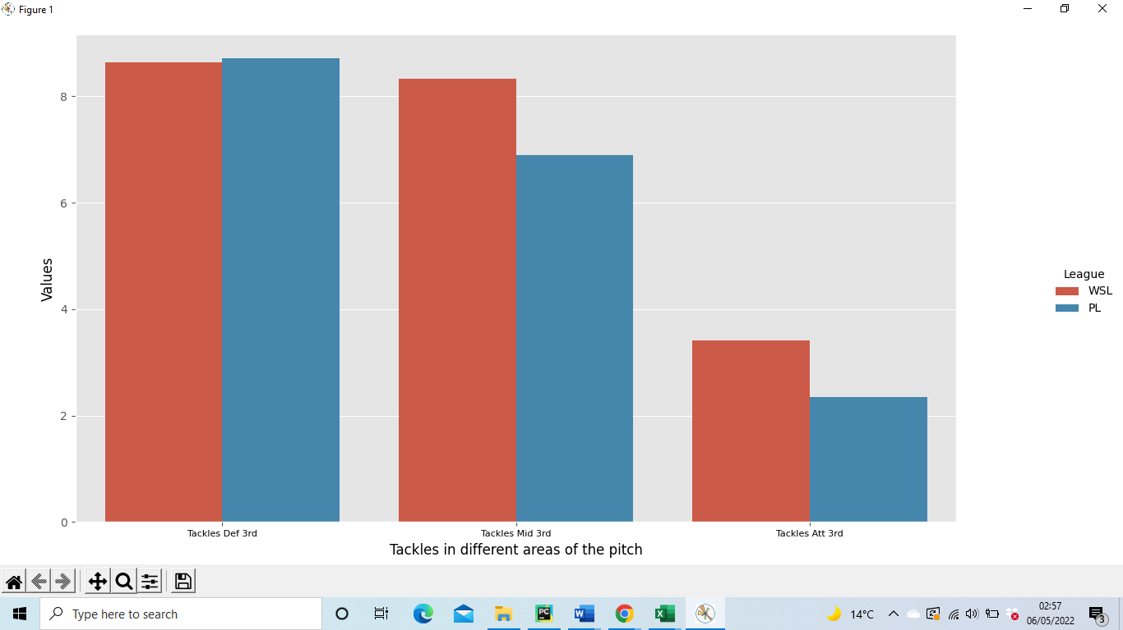

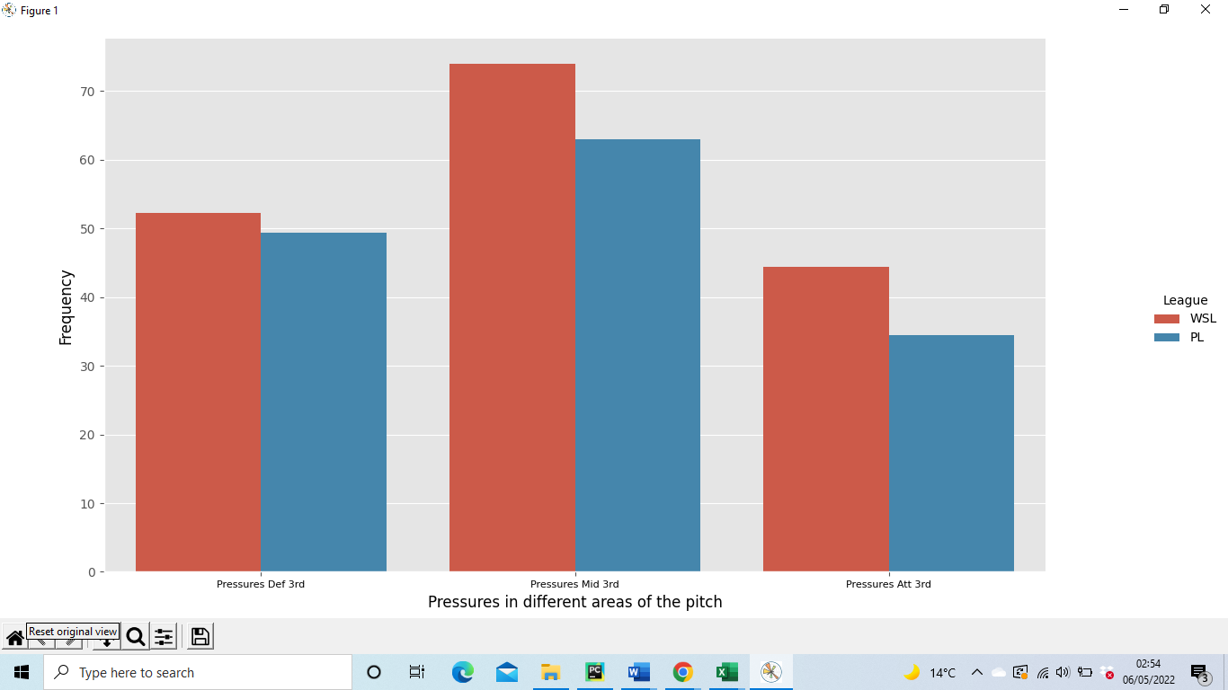The bar chart reveals interesting information. In comparison to Premier League teams, WSL teams are more inclined to pressure and win the ball back in the middle third and final third of the pitch. From the statistics earlier on in this study, we deduced that goalkeepers in the WSL were more likely to make short passes during goal kicks in order to promote a possession-oriented build-up of play. In an attempt to disrupt this build-up of play, opposing managers may instruct their team to pressure and attempt tackles in the attacking third of the pitch as part of a high pressing strategy. Thus, these tactical instructions are likely to play a part in explaining why WSL teams are more likely to pressure and tackle in the attacking third.

The tendency to win the ball in these areas brings tactical implications. Winning the ball back high up on the pitch often leads to good counter attacking opportunities as the ball winning team is closer to goal while the opposition defence is usually vulnerable and out of shape.

From a strategic perspective, WSL managers may tactically adjust to the fact that other teams tend to generate counterattacks from tackling and winning the ball in the attacking third. Managers may place tactical emphasis on their team’s defensive shape while in possession, instructing defenders to make sure that opposition forwards are tightly marked to mitigate the threat of counterattacks.

**Set Pieces statistics**

Another key aspect of football is set pieces. Set pieces such as free kicks, corners and throw-ins occur frequently in matches. As a result, teams spend considerable time training set pieces, often creating set piece routines to maximise their chances of scoring. Utilising a bar chart we analyse the frequency of each type of set piece in both leagues.

The bar indicates that freekicks and corner kicks occur slightly more often in the Premier League, however, there is a substantial disparity in the number of throw-ins as throw-ins occur significantly more frequently in the WSL. While it is difficult to say for certain why the WSL produces more throw-ins, tentative explanations can be provided. Perhaps, the frequent pressing and the lower passing accuracy in the WSL may explain why throw-ins occur so frequently. The frequent pressures may force players into rushed and misplaced passes that go out of play. Additionally, the lower passing accuracy indicates that misplaced passes are more prevalent and thus a significant portion of these misplaced passes may be going out of play.

The regularity of throw-ins in the WSL would suggest that tactical emphasis on such set pieces would be highly beneficial. Premier League teams such as Brentford and Liverpool have directly benefited from the utilisation of a throw-in coach. For instance, Thomas Gronnemark has been influential in transforming Liverpool’s throw-ins making them more efficient and dangerous Worville, T (2020). With the benefits being apparent, throw-in coaches should be utilised in the WSL as the benefits will only be amplified.

Another thing to consider is that players that are long throw specialists are considerably more valuable in the WSL. Players with long throws are able to cover more distance and evade more opposition players with their throws. The nature of the WSL allows such players to demonstrate their skills and aid their team more frequently.

**Shooting statistics**

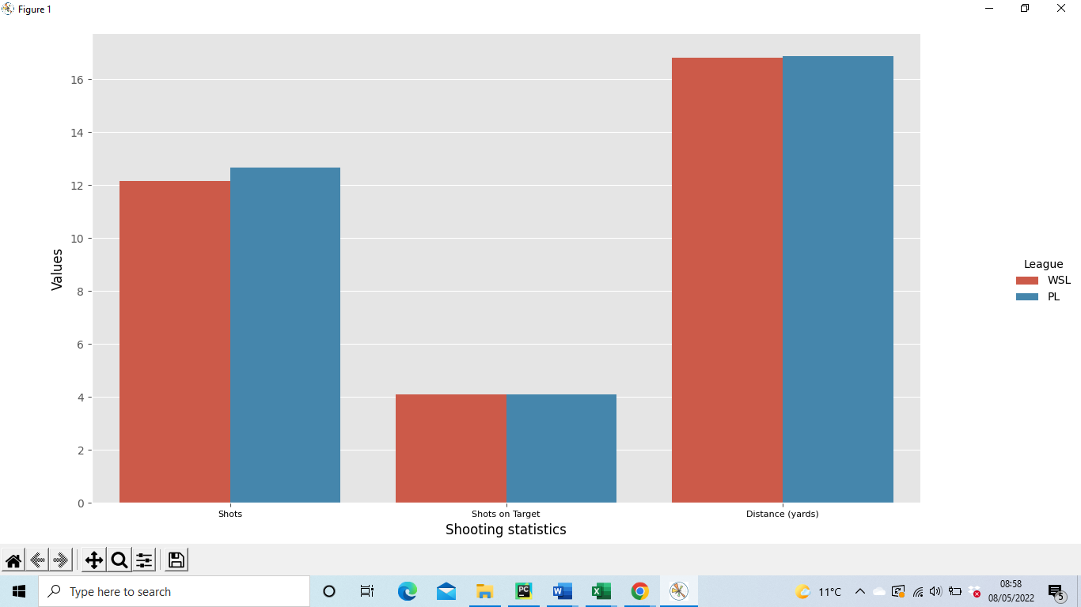The bar chart displays the number of shots, number of shots on target and the distance of shots in both leagues. From the bar chart it is evident that the shooting statistics in the WSL mirror that of the Premier League. The average distance of shots taken is identical which suggests that teams in both leagues consider 16.8 yards to be the most optimal shooting distance. The number of shots on target is also the same in both leagues. This is partly due to teams shooting from the same distances on average whilst also taking a similar number of shots in a game.

The bar chart below reveals that more shots stem from errors in the WSL. This could be due to the high pressing nature of the WSL as teams win the ball more frequently in the final third. Thus, players are often in shooting range when they do win the ball explaining why more shots stem from errors.

Earlier statistics revealed that WSL players complete more dribbles. Despite this, Premier League players complete more dribbles that lead to shots. This may be explained by the role of wingers. Within a team, wingers tend to dribble the most and would therefore contribute the most to these statistics. With this in mind, the statistics may be influenced by the influx of goal scoring wingers in the Premier League. Traditionally wingers would focus on crossing the ball to their strikers and would use dribbling and trickery to do so. However, in recent years inverted goal scoring wingers have become popular in the Premier League. Such wingers utilise their dribbling prowess to fashion shots on goal, Salah and Mane being prime examples of this trend. Thus, their prominence is likely to play a role in the disparity in the number of dribbles that led to shots.

**Goal statistics**

Goals are the most important commodity in football as they are the margins that decide football games. Needless to say, every team aims to score as many goals as possible. A radar plot is produced displaying goal related statistics. The plot displays goals, expected goals (xG), non-penalty expected goals (npxG), goals per shot (G/Sh), goals per shot on target (G/SoT).

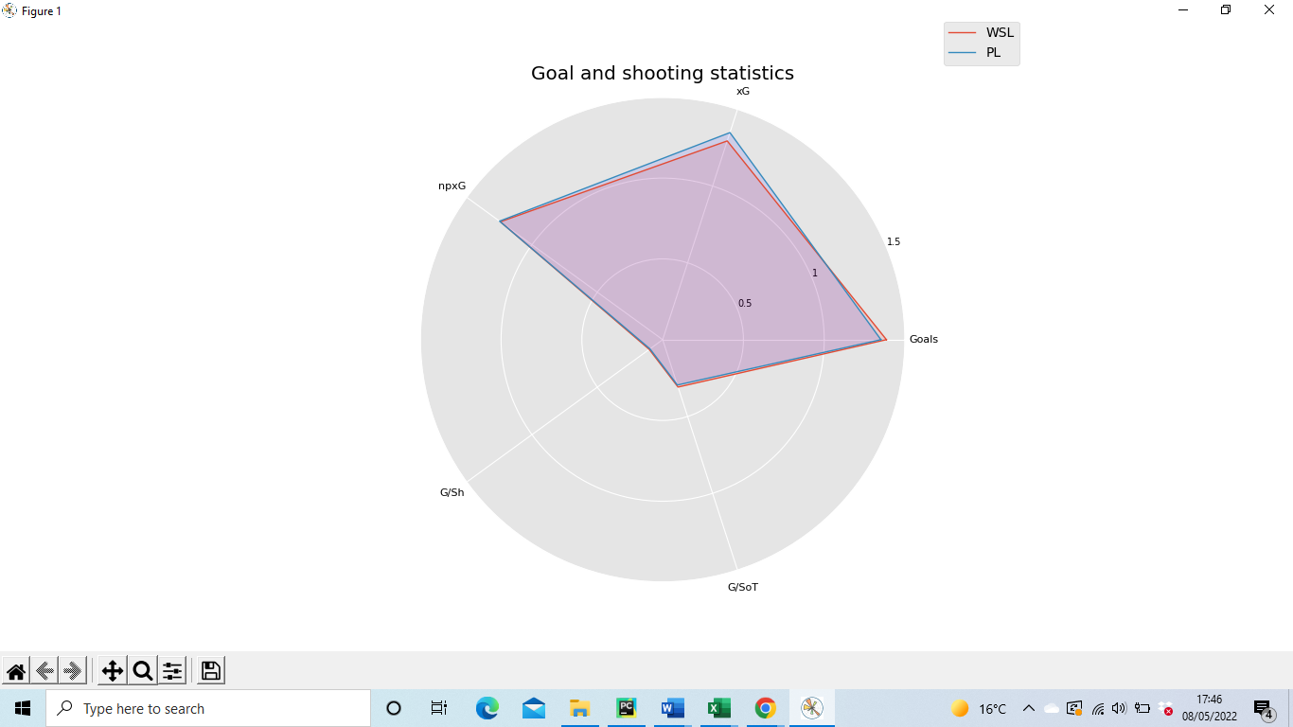

Although the WSL and the Premier League differ in various aspects, the two leagues share remarkably similar characteristics when it comes to goal scoring statistics. From the radar plot it can be determined that both leagues share almost goals per shot, goals per shot on target and non-penalty expected goals. The WSL average slightly more goals per game than the Premier League despite the Premier league having a higher expected goals value. Thus, WSL teams outperformed their expected goals by a greater margin than their Premier League counterparts.

The bar chart displayed earlier on revealed differences in the frequency of different shot creating actions. For instance dribbling creates relatively more shots in the Premier League while relatively more shots stem from errors in the WSL. Considering this, it is interesting that the number of goals per shot is almost the same in both leagues. Thus, despite the differences in the shot creating actions, both leagues share the roughly same shooting efficiency.

The WSL and the Premier League share almost the same non-penalty expected goals statistic while the Premier League has a slightly higher expected goals statistic. Thus, we can deduce that the expected goals statistic is only higher due to penalties being awarded more frequently in the Premier League.

**Conclusions**

In conclusion, this study has comprehensively examined the similarities and differences between the WSL and Premier League. From the results it is evident that the WSL and Premier League share some commonalities such as their goal scoring statistics.

However, ultimately there are a number of fundamental differences between the two leagues which changes the dynamics of their games. Some of the most notable differences are described below. The statistics reveal that the WSL produces significantly more tackles, interceptions, clearances and blocks relative to the Premier League. In addition, there is a significant disparity in the passing accuracies within the two leagues as WSL teams produce lower passing accuracies. Lastly, the statistics indicate that WLS teams engage in more pressures and are more successful when doing so.

As there are a number of fundamental differences between the two leagues, it can be deduced that although the players in the WSL and Premier League play the same sport, the nature of their matches are different. Thus, the statistics reveal that WSL matches are of a more back-and-forth nature filled with frequent defensive actions. Additionally, the statistics indicate that WSL matches are more disjointed and played at a higher intensity. In light of this, managers and players in the WSL should adapt to these characteristics if they haven’t already.

Interestingly, it has been evident throughout this study that differences between the two leagues in one aspect of football may generate differences in other individual aspects of football. For instance, we deduce that the relatively low passing accuracy in the WSL plays a part in explaining why the WSL has comparatively high interception and throw-in statistics in the WSL. This indicates that there is an interdependency that is prevalent within different individual elements of football.

While this study has been thorough and comprehensive in its analysis, we acknowledge that it has several limitations. Firstly, the analysis was based only on the data from the 21/22 season. Thus, the use of more historical data is encouraged in future studies in order to increase the accuracy of results. In addition, the data in this study is limited to the performance metrics found on www.fbref.com. Consequently, we encourage future studies to expand on the performance metrics used in this study, allowing for fresh alternative perspectives.

Lastly, women’s football is an under-researched area within the literature of football. Thus, we hope this study provokes more research to be undertaken on one of the fastest growing sports in the UK.

**References**

Perelman, R. (2019) *FOOTBALL Panorama: 2019 Women’s World Cup set records at 1.12 billion viewers*, *The Sports Examiner*. Available at: https://www.thesportsexaminer.com/football-panorama-2019-womens-world-cup-set-records-at-1-12-billion-viewers/ (Accessed: May 6, 2022).

Malone, R. (2021) *Should the goal size be smaller in women’s football?*, *Sports Gazette*. Available at: https://sportsgazette.co.uk/should-the-goal-size-be-smaller-in-womens-football/ (Accessed: May 6, 2022).

Worville, T. (2020) *What difference has throw-in coach Thomas Gronnemark really made to Liverpool?*, *The Athletic*. Available at: https://theathletic.com/2244722/2020/12/07/throw-in-coach-thomas-gronnemark-liverpool/ (Accessed: May 6, 2022).