Tool Walkthrough: finding your way around the lab
This guide shows each tool you will open during the training, what it is for, and the few pages a security engineer comes back to most. Every picture is a real page from the lab. The lab prints the web address and the sign-in name for each tool when it starts; the sign-in values are saved as lab variables, so you never copy a password into a file.

How to read this guide
- Each tool has a short 'what it is for' line, then the pages to learn, in the order you will meet them.
- Under each picture, 'Look at' says what to read on the page, and 'Why it matters' says what a security engineer does with it.
- The modules that use the tool are listed so you know where to practise.

OpenShift web console
What it is for. The control panel for the cluster. You use it to see what is running, what failed, and what the platform is warning about.
Used in: Almost every module points at it

Overview
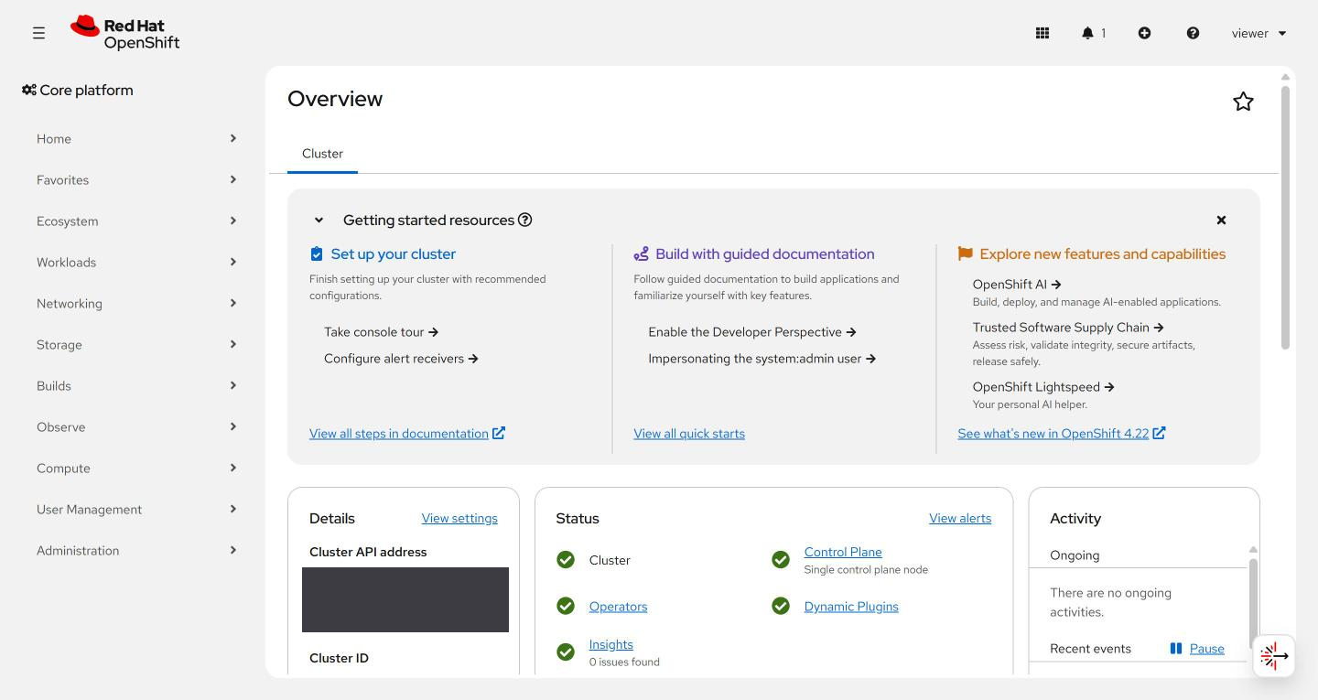
Look at:
- The Status box: Cluster, Control Plane, Operators. Green ticks mean healthy.
- The left menu: Workloads, Networking, Observe and Administration hold most of what you need.
Why it matters. Start here. A red item on the Overview tells you where to look before you run any command.

Nodes
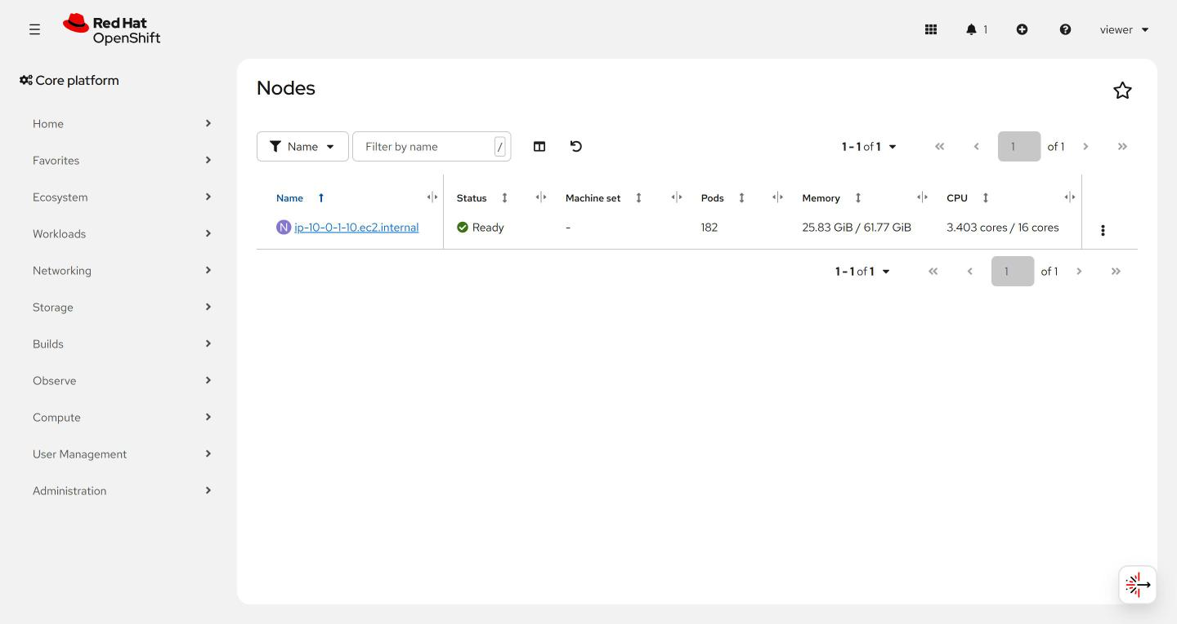
Look at:
- Status says Ready when the machine is healthy.
- Pods, Memory and CPU show how full the machine is.
Why it matters. A full node is the first thing to rule out when pods are slow or fail to start.

Pods in a project
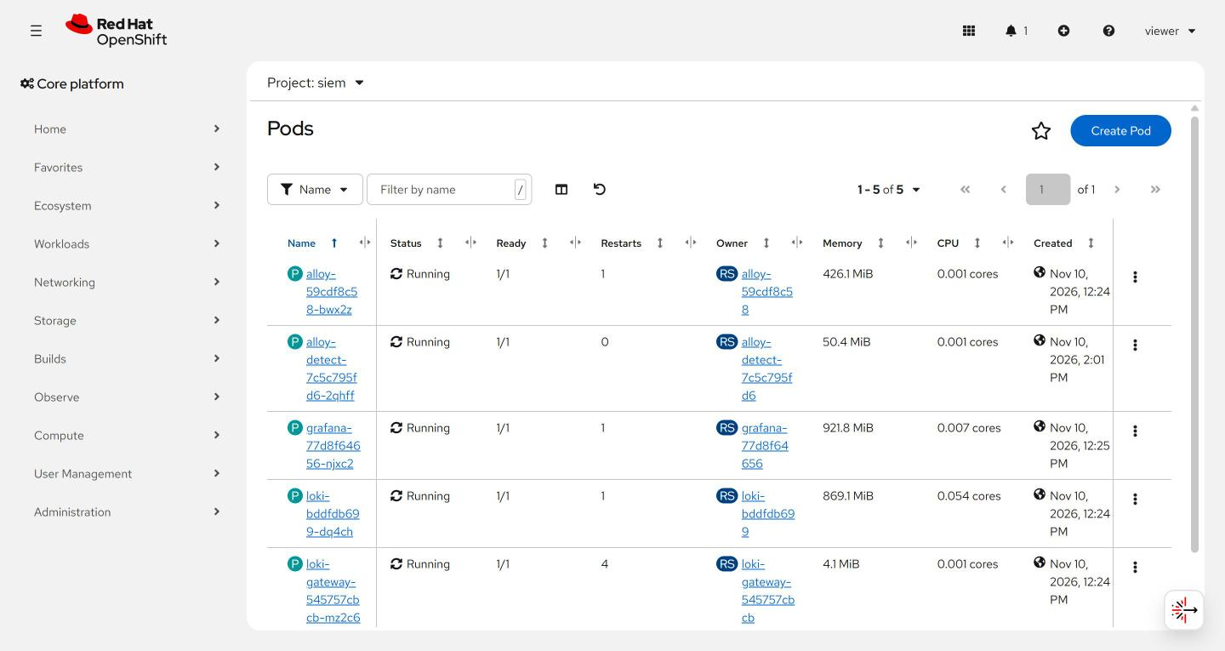
Look at:
- The project picker at the top (here: siem). Pods only show for the project you chose.
- Status and Restarts. Running with many restarts means something keeps crashing.
- Memory and CPU per pod.
Why it matters. Pods are where your workloads live. Restarts and status are the quickest health check, and they match what the oc get pods command prints.

Events
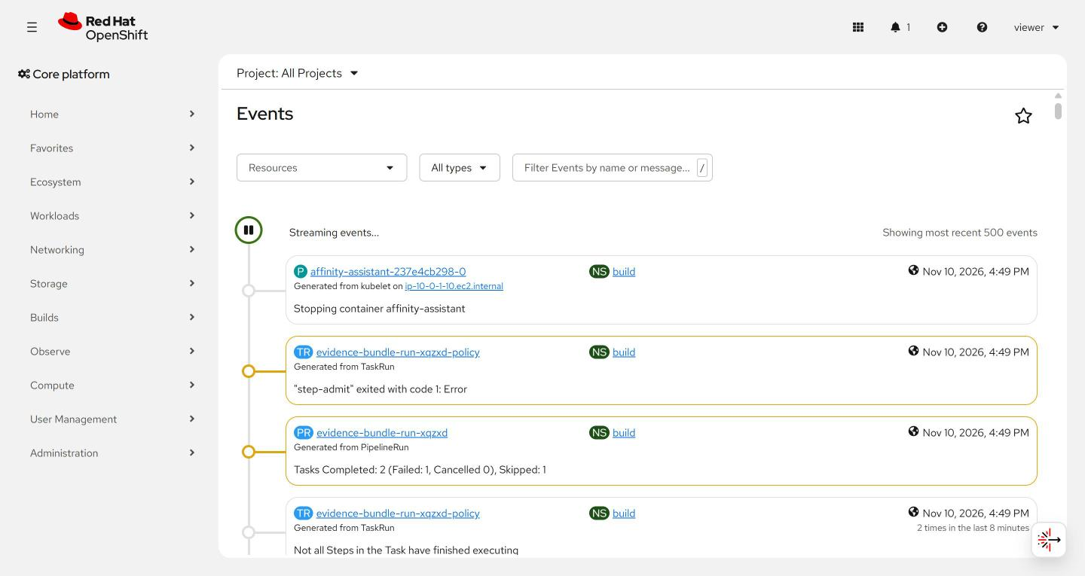
Look at:
- Newest first. Yellow rows are warnings.
- Each row names the object and the project it belongs to.
Why it matters. Events say why something failed, for example a task that exited with an error. They are the first thing to read when a pipeline run fails.

Pipelines and runs
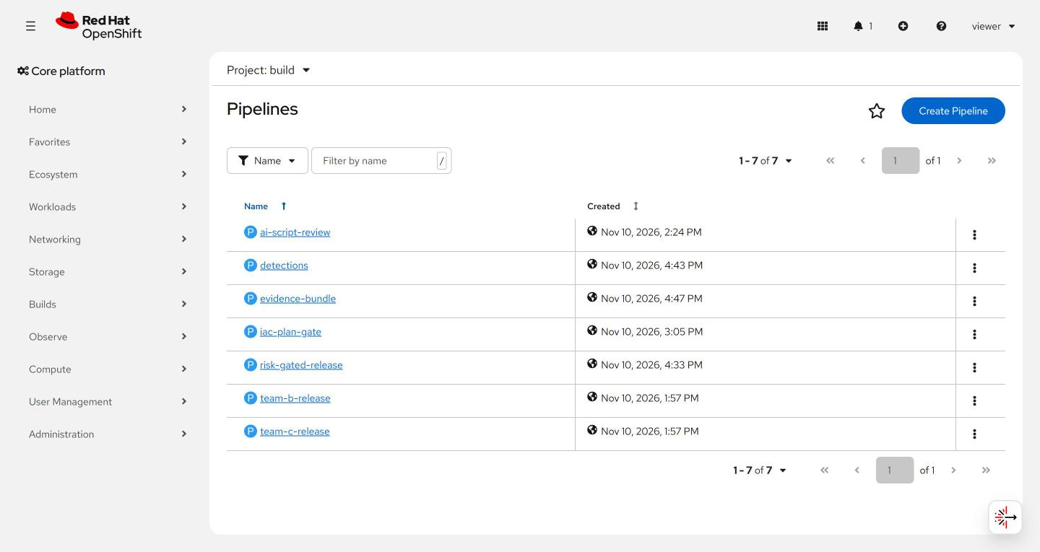
Look at:
- Pipelines are the definitions. Open Pipelines, then PipelineRuns to see each run.
Why it matters. This is where a build or a security gate runs. Modules on scanning, signing and evidence use it.

PipelineRuns
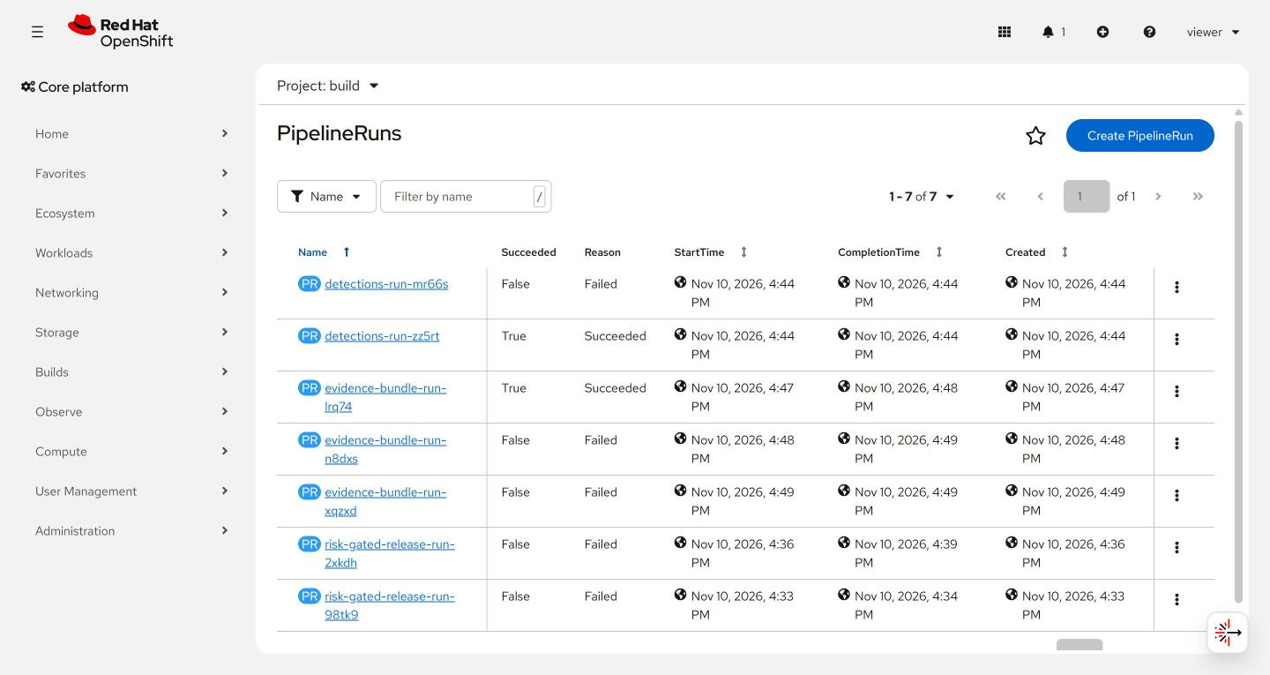
Look at:
- Succeeded True or False, and the Reason. Failed means a task stopped the run.
- Open one run to see its tasks and logs.
Why it matters. A failed gate is a result, not a mistake. Read which task failed and why before you rerun.

Kyverno policies
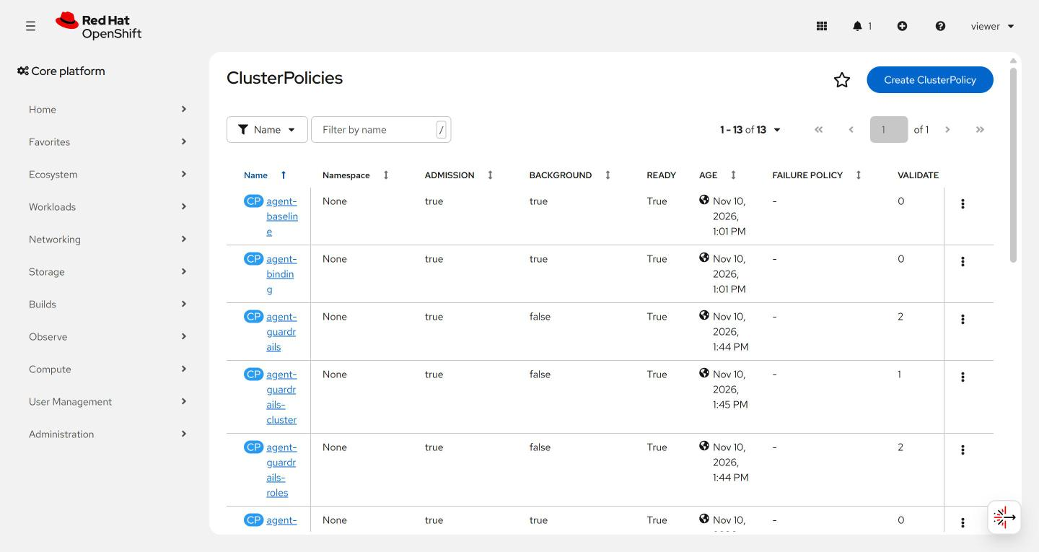
Look at:
- READY True means the policy is loaded.
- ADMISSION true means it can refuse a new object. BACKGROUND true means it also checks what already exists.
Why it matters. Policies are the guardrails. This page shows which rules are on, and whether they refuse or only record.

Alerting
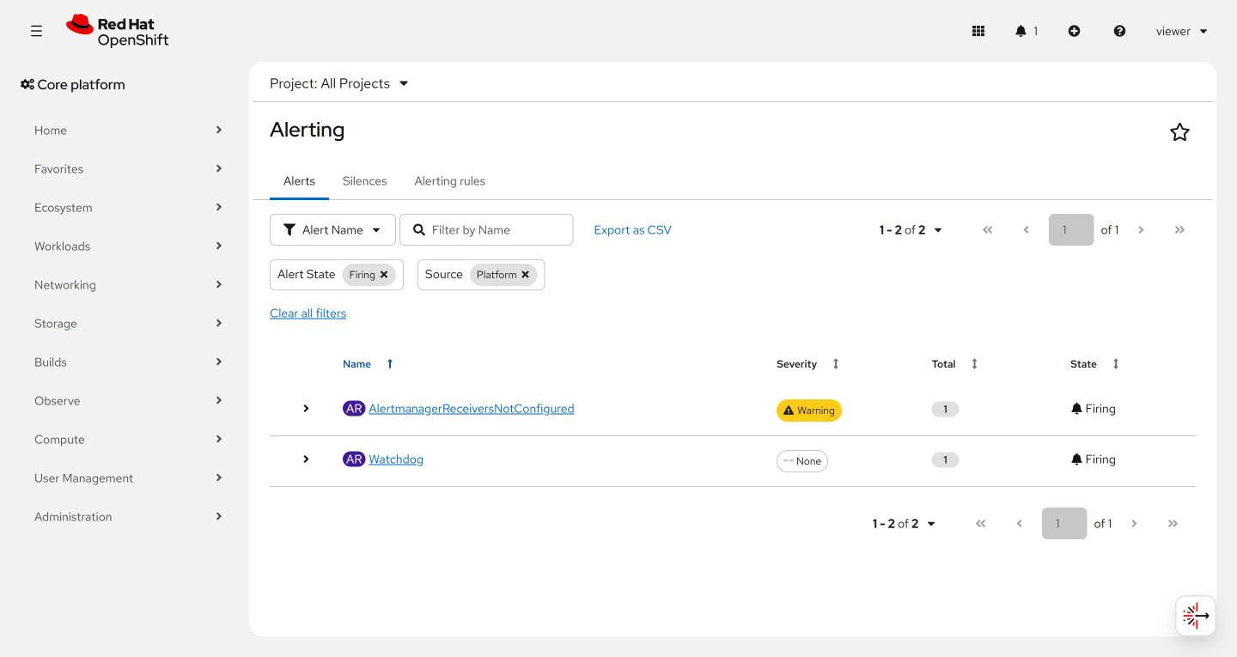
Look at:
- Filters at the top: state and source. Platform alerts come from the cluster itself.
- Firing means the condition is true right now.
Why it matters. Alerts tell you something needs attention. Watchdog firing is normal: it proves alerting works.

Grafana (with Loki)
What it is for. Search logs and set up alerts. Loki stores the logs; Grafana is how you search them and turn a search into an alert.
Used in: SDR-2 to SDR-5, AID-3 to AID-5, ENG-0

Explore
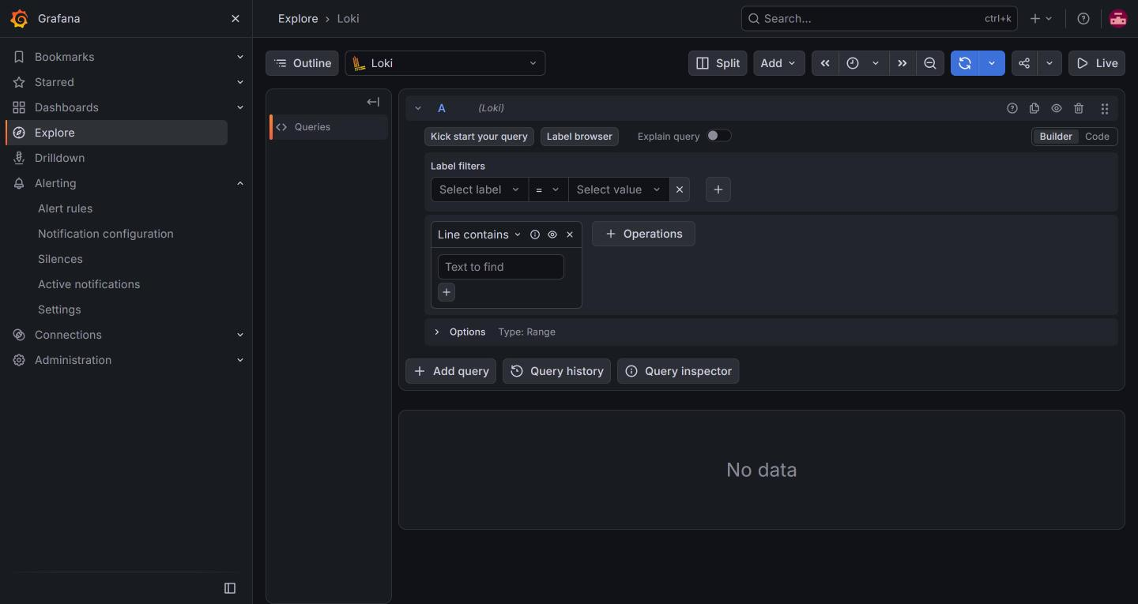
Look at:
- The data source at the top says Loki.
- Pick a label, then a value, to narrow the logs. Use Code to type a query yourself.
- Set the time range with the clock button.
Why it matters. This is the search box for every log. Investigations start here: who did what, and when.

Alert rules
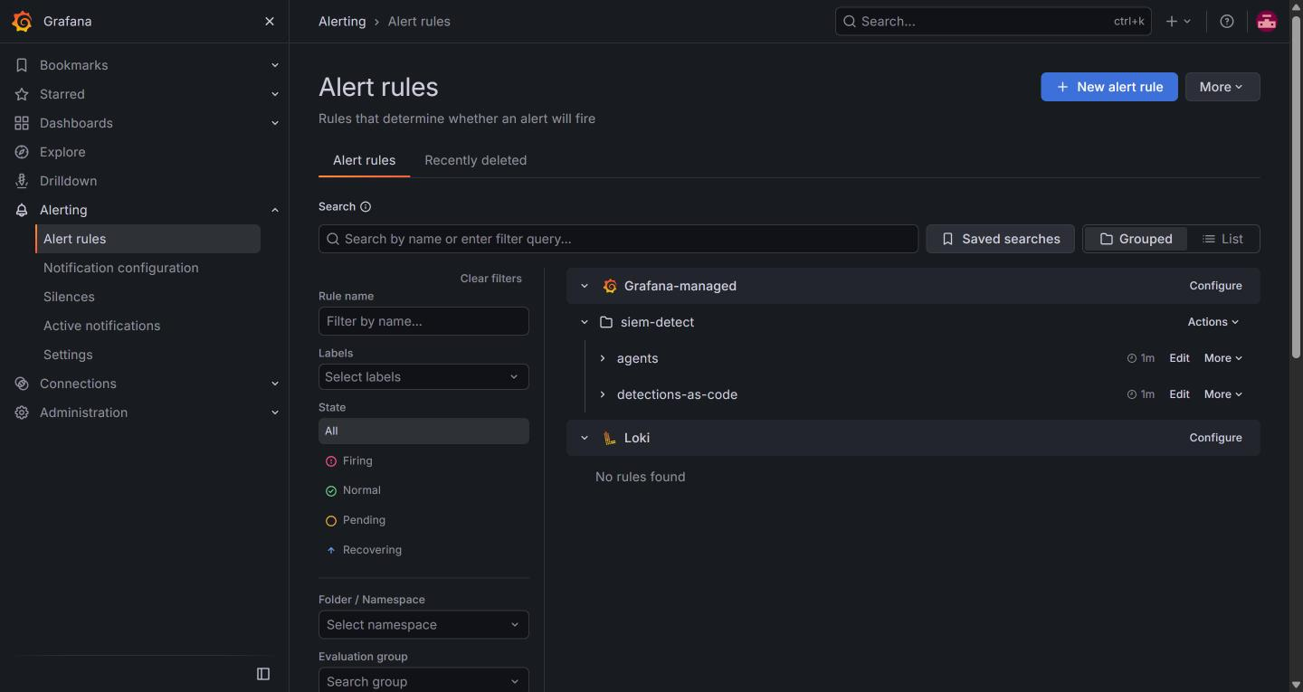
Look at:
- Rules are grouped in a folder (here siem-detect).
- State filters: Firing, Normal, Pending.
Why it matters. Each rule is a saved search with a threshold. This is where detections live and where you check that they are healthy.

Contact points
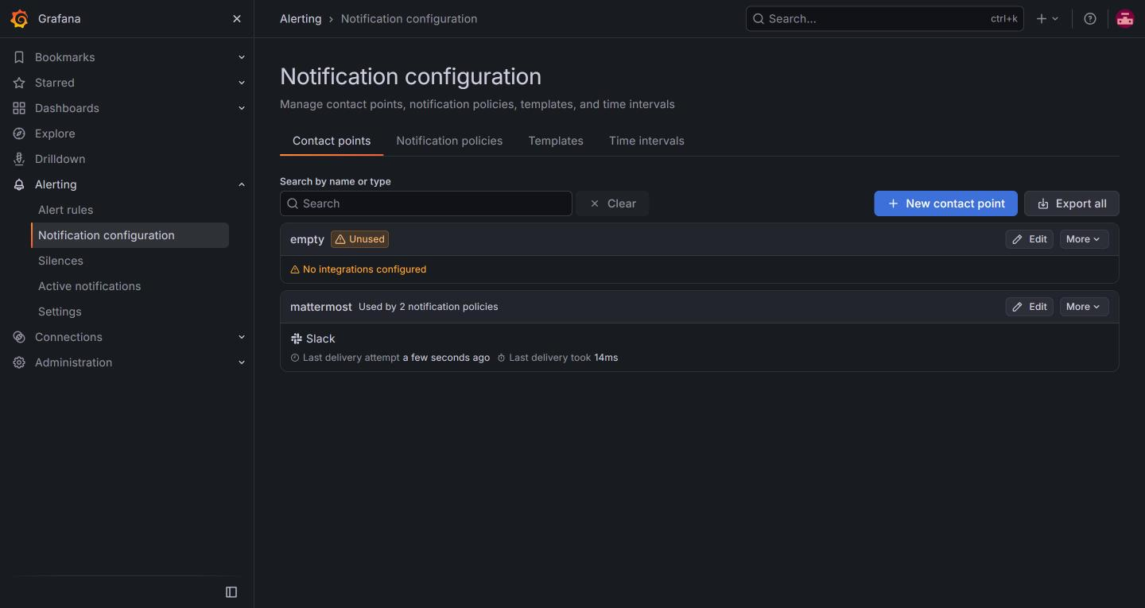
Look at:
- A contact point is where an alert goes. Here, mattermost.
- Last delivery attempt shows whether the message was sent.
Why it matters. An alert nobody receives is the same as no alert. Check delivery here first when a message does not arrive.

Mattermost
What it is for. Team chat. Alerts from Grafana arrive in a channel, the way a real security team receives them.
Used in: SDR-2, SDR-5, AID-2, ENG-0

The alert channel
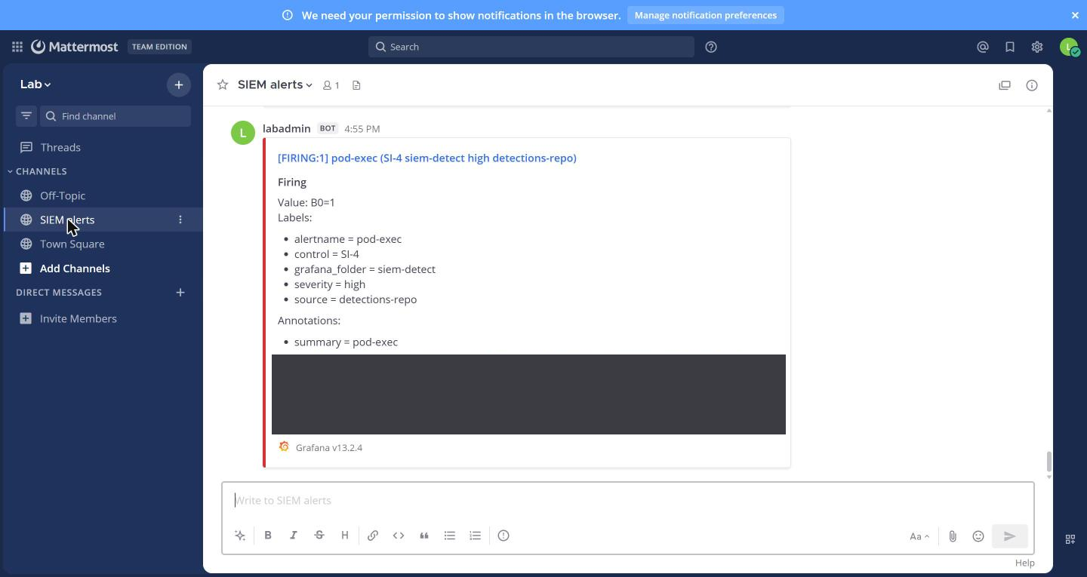
Look at:
- The title shows FIRING, the rule name and the severity.
- Labels name the control, the folder and where the rule came from.
- Source opens the rule. Silence mutes it for a while.
Why it matters. This is what you triage. Read the labels first: they tell you what fired and who owns the rule.

Gitea
What it is for. The lab's git server. Detections, pipelines and infrastructure files live here as code, and changes go through pull requests.
Used in: ENG-0, GRC-3, SDR-5, AID-3, IAC-2, VM-2 to VM-5

Dashboard
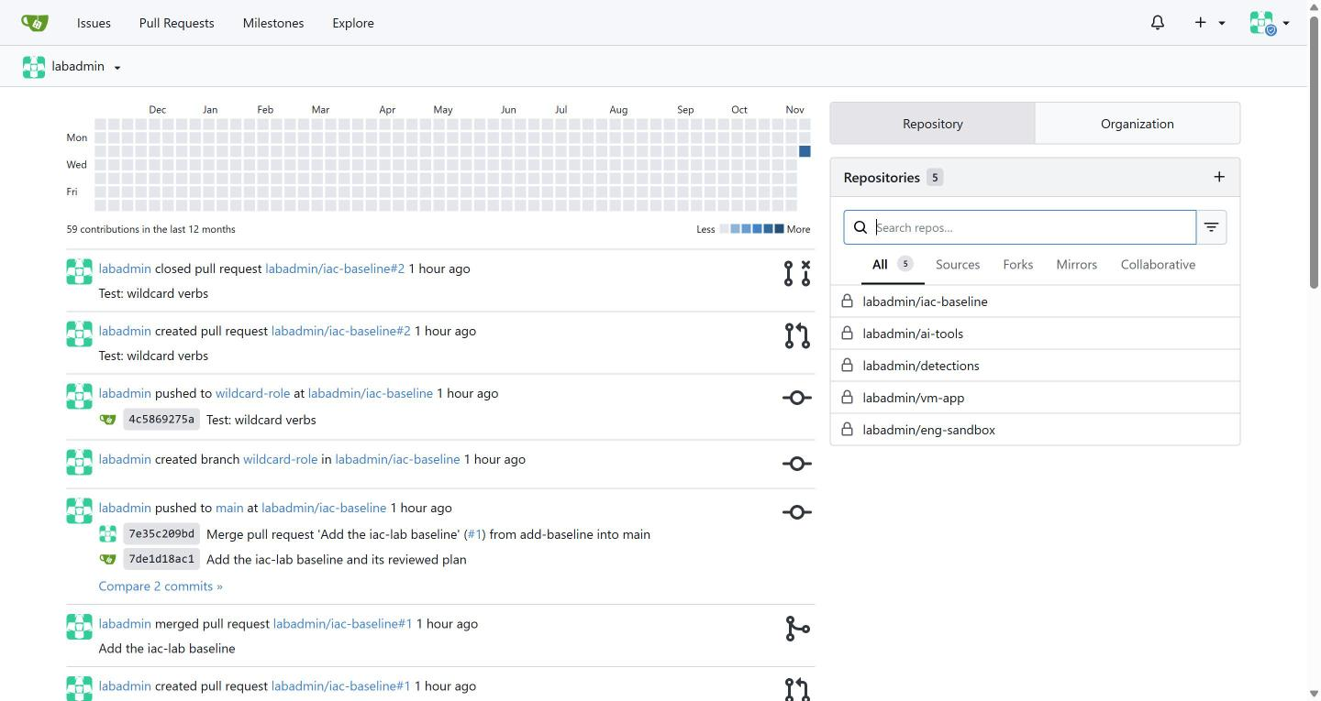
Look at:
- Repositories on the right. The feed on the left shows recent pushes and pull requests.
Why it matters. The feed is an audit trail of who changed what, and when.

Pull requests
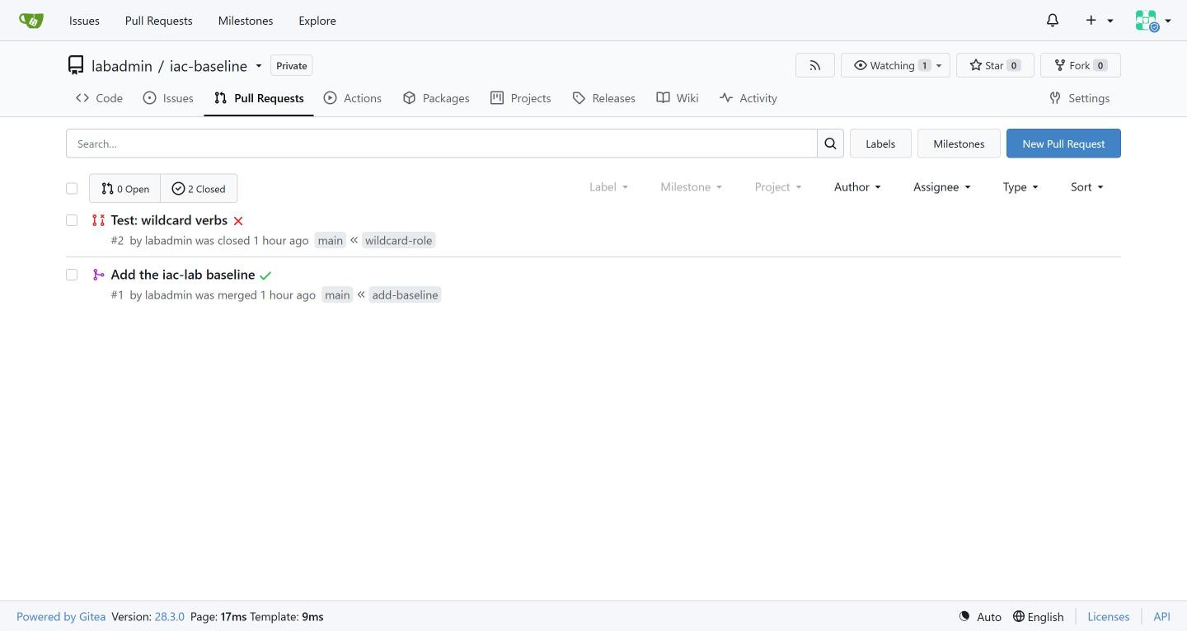
Look at:
- Open and Closed counts. A green tick means checks passed; a red cross means they failed.
- main on the left, the branch on the right.
Why it matters. A pull request is where a change is reviewed and gated before it reaches main. A closed, failed one is a gate doing its job.

Keycloak
What it is for. Sign-in and identity. It decides who users are and which applications they may use.
Used in: SDR-2 to SDR-4

Home and sign-in
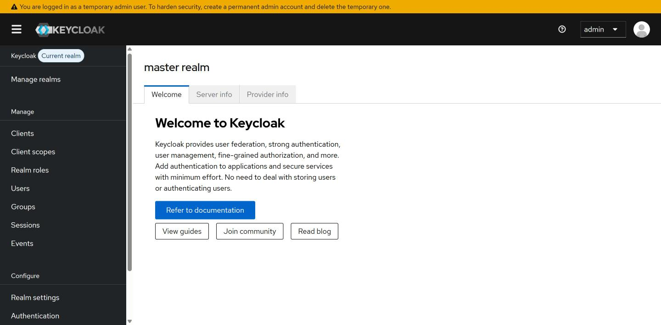
Look at:
- The realm name at the top left. A realm is one separate set of users and clients.
- The menu: Clients, Users, Sessions, Events.
Why it matters. Check which realm you are in before you read or change anything.

Clients
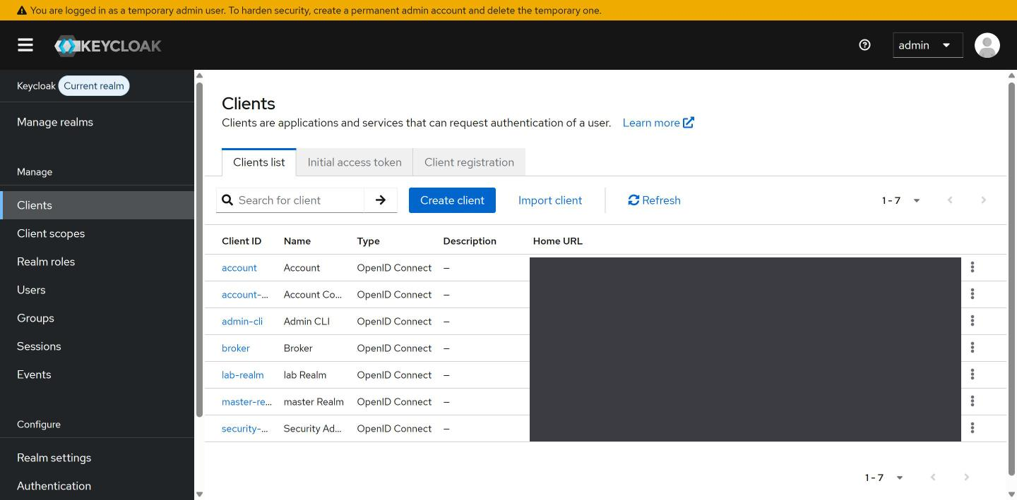
Look at:
- A client is an application that asks Keycloak to sign users in.
Why it matters. Every client is a door into the system. Know which ones exist and which you did not expect.

Users
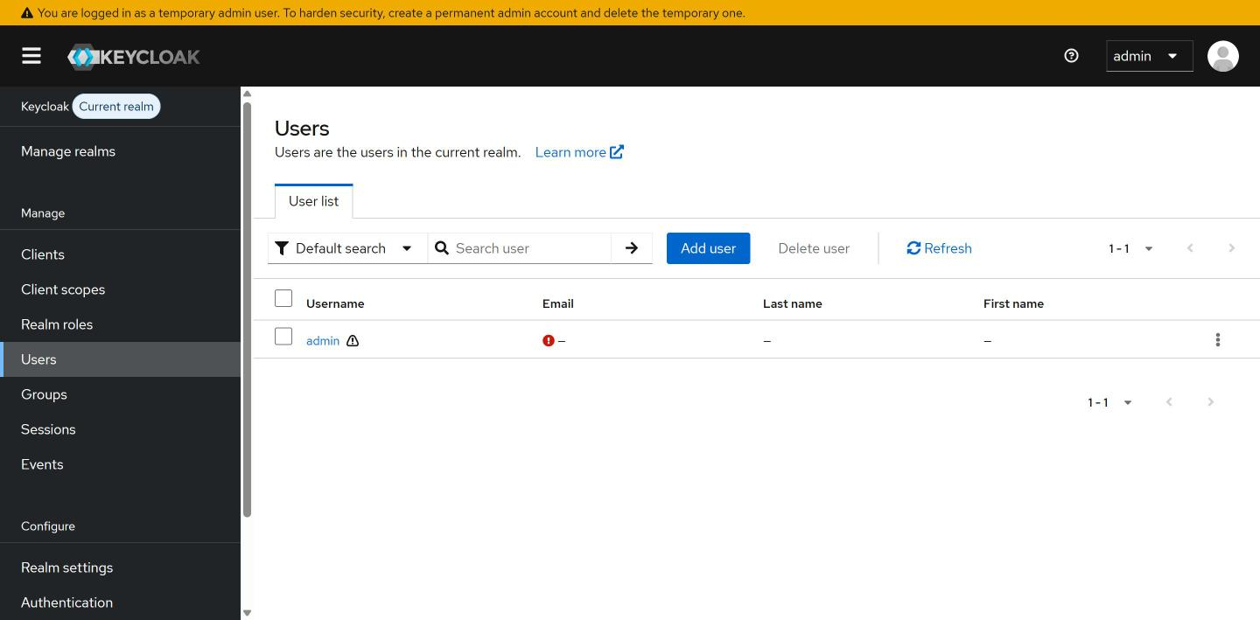
Look at:
- The user list and the Add user button.
Why it matters. Accounts are what an attacker wants. Review who exists, and look for accounts nobody can explain.

Events
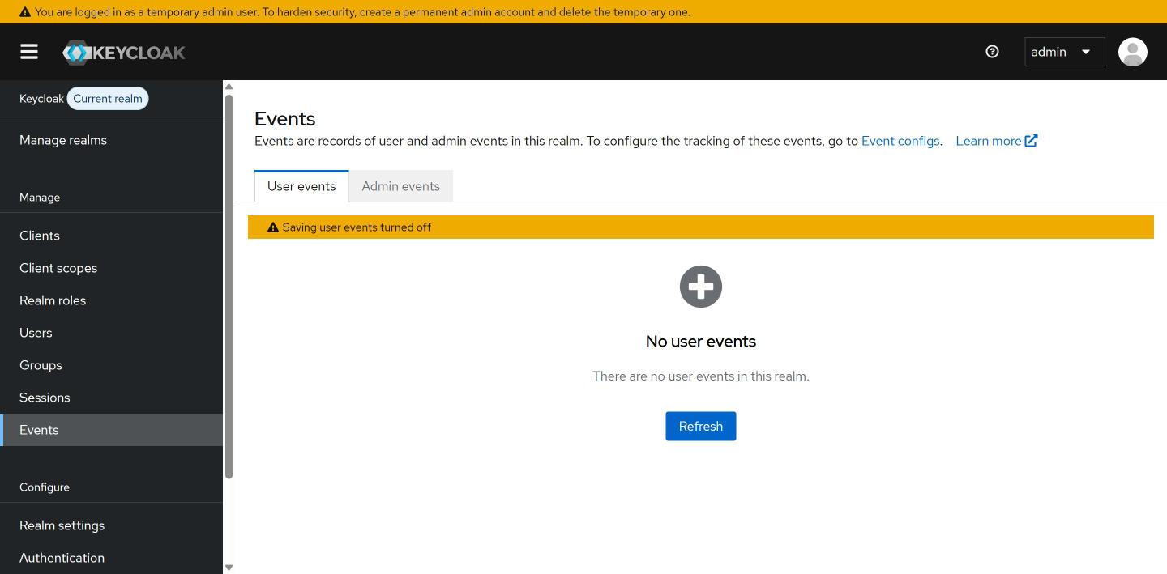
Look at:
- The banner says saving user events is turned off. No events are kept until you turn it on.
Why it matters. Sign-in events are the raw material for detections. Turn them on, or you cannot investigate a bad sign-in.

Argo CD
What it is for. Keeps the cluster matching what is in git. If someone changes the cluster by hand, Argo CD shows the difference.
Used in: GRC-5

Applications
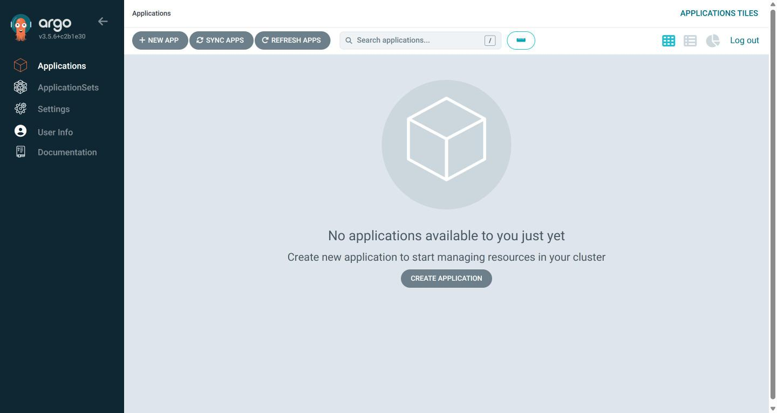
Look at:
- The page is empty until an application is added in GRC-5. Once there are applications, each tile shows its sync state and health.
- Sync apps and Refresh apps compare git with the cluster.
Why it matters. Out of sync means the cluster no longer matches git. That is drift, and it is evidence a change happened.

AWS console
What it is for. The cloud account the lab runs in. You mostly use the command line, but the console is the quickest way to see what exists.
Used in: ENG-0 setup, CPS-4

EC2 instances
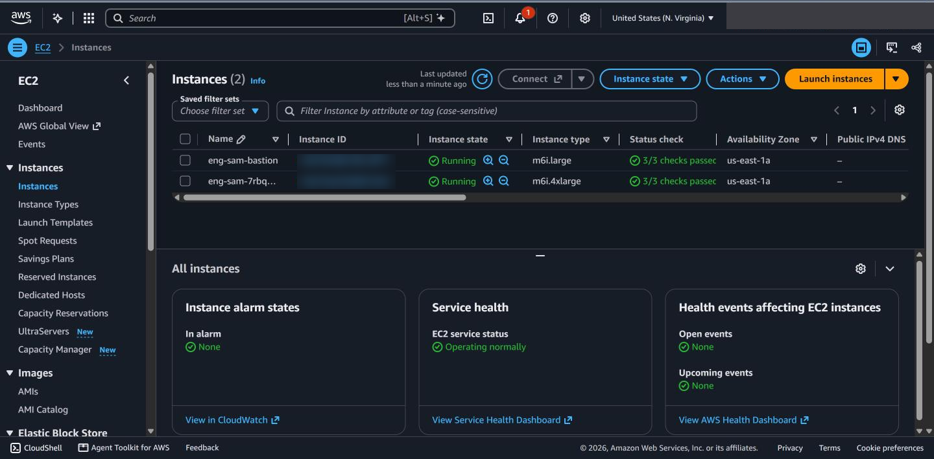
Look at:
- Instance state: Running costs money. The cluster machine and the bastion are listed.
- Instance type shows the size.
Why it matters. Anything running is billed. Check here that nothing is left on after the lab is shut down.

S3 buckets
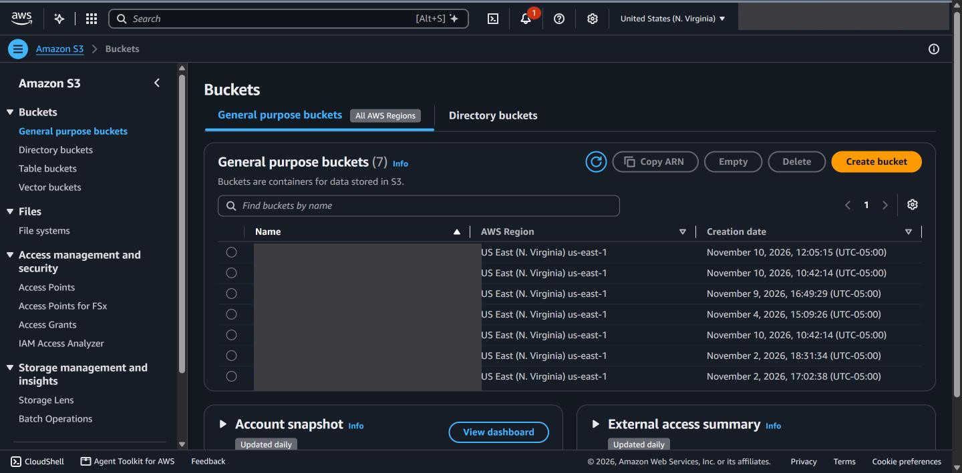
Look at:
- Names starting eng-sam are the lab's logs, artifacts and state.
Why it matters. Buckets hold logs and evidence. Know which hold what, and who can read them.

KMS keys
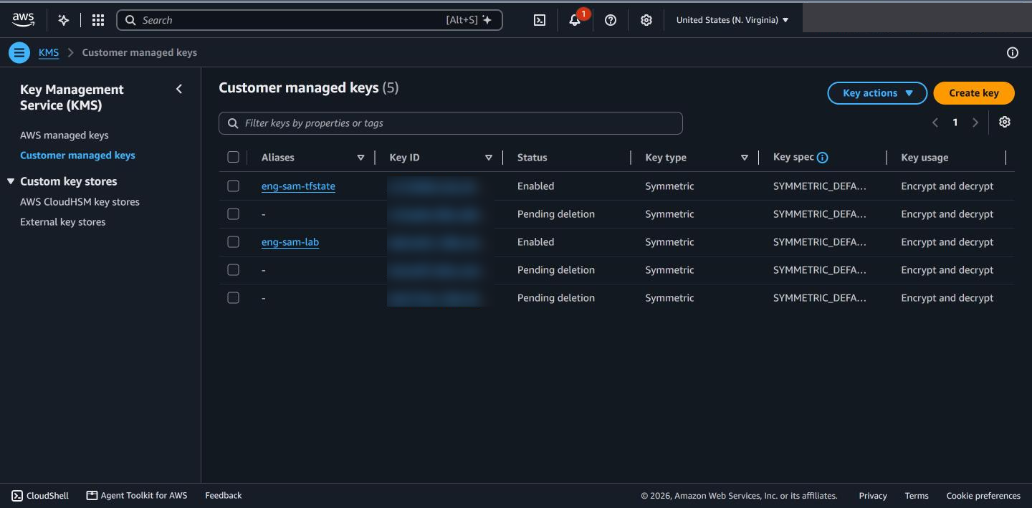
Look at:
- Status Enabled or Pending deletion.
- Key usage says what a key is for.
Why it matters. Encryption keys protect the data. A key pending deletion is a key you can no longer use.

Trivy (command line)
What it is for. Scans a container image for known vulnerabilities. It has no web page: you run it in the lab shell, and the Trivy operator also scans what runs in the cluster and saves the results as reports.
Used in: ENG-0, GRC-4, VM-2 to VM-5

Scan an image
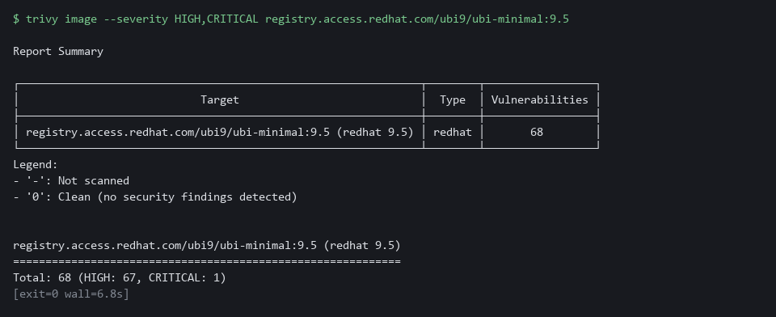
Look at:
- Total at the bottom: how many findings, split by severity.
- --severity HIGH,CRITICAL hides the low and medium noise.
Why it matters. A scan gives a count to act on. A gate in a pipeline blocks a release when the count is not zero.

Count by severity, and fixable only
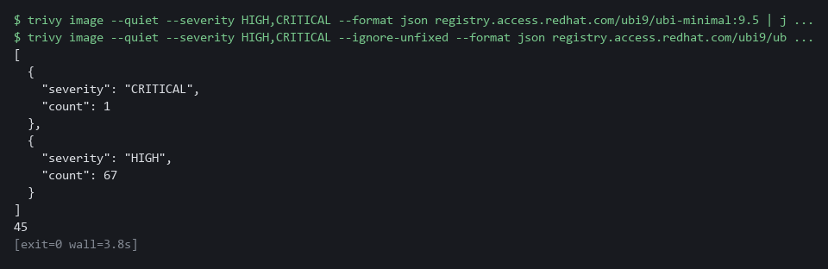
Look at:
- The first block groups findings by severity.
- The last number counts only findings that have a fix, using --ignore-unfixed.
Why it matters. Fixable findings are the ones you can act on today. Unfixable ones need a decision, not a patch.

What the operator found in the cluster
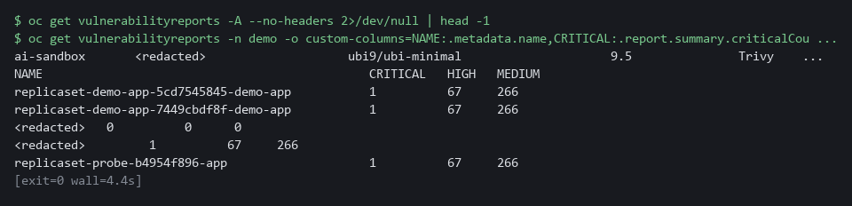
Look at:
- One report per running workload, with Critical, High and Medium counts.
- A row of 0 0 0 is a clean image.
Why it matters. Reports show what is vulnerable right now in the cluster, without scanning anything by hand.

Habits that carry across every tool
- Start from the question, not the tool. 'Did anything change?' goes to Gitea and Argo CD. 'Who did this?' goes to Grafana Explore. 'Is it healthy?' goes to the console.
- Pick the project or realm first. Most empty pages are the wrong project, not missing data.
- Read Events and logs before you retry a failed run.
- Use the web page to look, and the command line to prove it. Both should show the same thing.
- Never paste a password into a note or a message. Read it from the lab variable and type it where it is asked.

