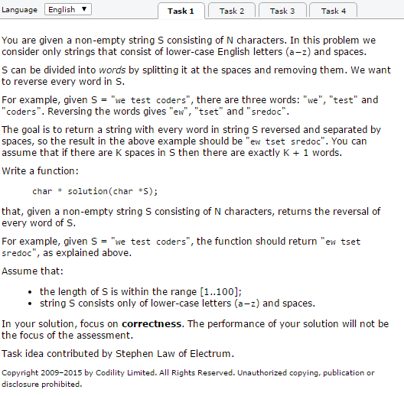

// you can write to stdout for debugging purposes, e.g.

// printf("this is a debug message\n");

char \* solution(char \*S) {

// write your code in C99

}

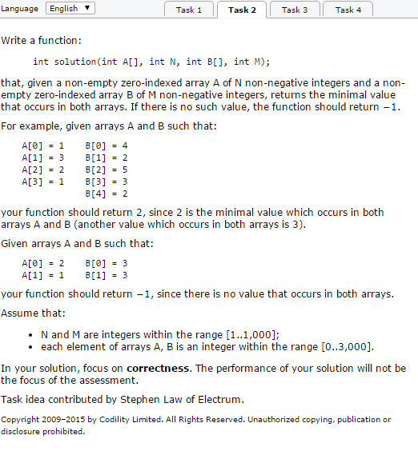

// you can write to stdout for debugging purposes, e.g.

// printf("this is a debug message\n");

int solution(int A[], int N, int B[], int M) {

// write your code in C99

}

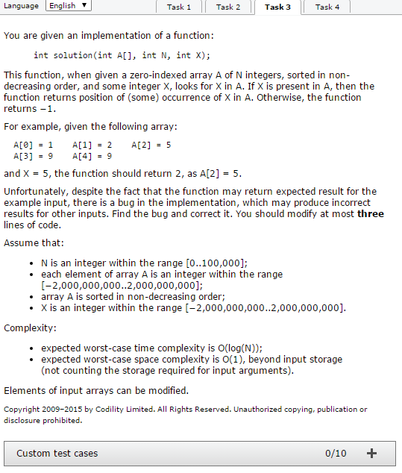

int solution(int \*A, int N, int X) {

int r, m, l;

if (N == 0) {

return -1;

}

l = 0;

r = N - 1;

while (l < r) {

m = (l + r) / 2;

if (A[m] > X) {

r = m - 1;

} else {

l = m;

}

}

if (A[l] == X) {

return l;

}

return -1;

}

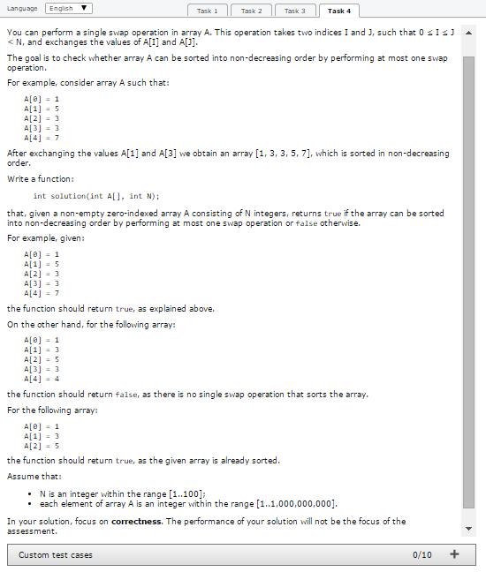

// you can write to stdout for debugging purposes, e.g.

// printf("this is a debug message\n");

int solution(int A[], int N) {

// write your code in C99

}