Appendix 1. Ecosystem and Socioeconomic Profile of the Sablefish stock in the Alaska - Report Card

Kalei Shotwell, Abby Tyrell

Draft 2021



*With Contributions from:*

Kalei Shotwell, Abby Tyrell

# Current Year Update

The ecosystem and socioeconomic profile or ESP is a standardized framework for compiling and evaluating relevant stock-specific ecosystem and socioeconomic indicators and communicating linkages and potential drivers of the stock within the stock assessment process (Shotwell et al., In Review). The ESP process creates a traceable pathway from the initial development of indicators to management advice and serves as an on-ramp for developing ecosystem-linked stock assessments. Please refer to the last full ESP and partial ESP documents for further information regarding the ecosystem and socioeconomic linkages for this stock (*list references*).

## Management Considerations

Summary conclusions from ESP for ABC (risk table)

## Modeling Considerations

Summary of indicators with high importance in the Bayesian adaptive sampling routine and discussion of which indicators have had consistent high importance. List of research ecosystem model runs that are currently ongoing and potential for operational use in the future.

# Assessment

## Ecosystem and Socioeconomic Processes

One paragraph description of ecosystem and socioeconomic (if available) conceptual model(s)

## Indicator Suite

One paragraph description of LME level indicators relevant to stock (ESR summary)

### Ecosystem Indicators:

1.) Physical Indicators

a.) Annual marine heatwave cumulative index over the central GOA: Annual marine heatwave cumulative index over the central GOA (contact: Steve Barbeaux)

Status and trends: NA

Influential factors: NA

b.) Late spring (May-June) daily sea surface temperatures (SST) for the eastern GOA from the NOAA Coral Reef Watch Program: Late spring (May-June) daily sea surface temperatures (SST) for the eastern GOA from the NOAA Coral Reef Watch Program (contact: Jordan Watson)

Status and trends: Despite marked inter-annual variability, there appears to only be a slight upward trend in the overall time series.

Influential factors: Oceanography.

c.) Late spring (May-June) daily sea surface temperatures (SST) for the southeastern Bering Sea from the NOAA Coral Reef Watch Program: Late spring (May-June) daily sea surface temperatures (SST) for the southeastern Bering Sea from the NOAA Coral Reef Watch Program (contact: Jordan Watson)

Status and trends: While inter-annual variability is evident, a generally increasing trend is apparent (from both linear and non-linear smoothers). However, a cold stanza is a dominant feature for a portion of the time series. Recent years appear remarkably warmer than the majority of the time series.

Influential factors: Um, global climate change?

d.) Summer temperature anomalies at 250 m isobath during the AFSC annual longline survey: Summer temperature anomalies at 250 m isobath during the AFSC annual longline survey (contact: Kevin Siwicke)

Status and trends: The 250-m slope temperature index is in prime sablefish habitat and has not deviated greatly from the long-term mean. However, this index has remained positive for the last five years, a deviation from the historical fluctuations around the mean, suggesting these deeper waters may remain somewhat warmer than average (~0.1°C) from 2017-2021.

Influential factors: Warming that has been evident in bottom temperatures throughout the shelf environment has not been particularly present over much of the slope environment, which may provide a buffer during spawning and egg deposition for sablefish.

2.) Lower Trophic Indicators

a.) Abundance of copepod community size from the continuous plankton recorder (CPR) for the offshore eastern GOA: Abundance of copepod community size from the continuous plankton recorder (CPR) for the offshore eastern GOA (contact: Clare Ostle)

Status and trends: On the western side of the oceanic Gulf of Alaska the diatom abundance anomaly was negative for the last two years. On the eastern side of the oceanic Gulf of Alaska the diatom anomaly was negative in 2020. The copepod community size anomaly was strongly negative in both the Alaskan Shelf and eastern Gulf of Alaska regions in the last 3-5 years, but it has oscillated in the western Gulf of Alaska from positive in 2019 to negative 2020. Zooplankton biomass anomalies were positive in both the Shelf and eastern Gulf of Alaska regions in 2020, while the anomaly was negative in the western side of the Gulf of Alaska.

Influential factors: The Pacific Decadal Oscillation (PDO) monthly values were often negative in 2017 causing a lower annual mean value compared to the years of 2014-2016 and 2018-2020, which had experienced a marine heat wave (DiLorenzo and Mantua, 2016). 2020 is another warm year, though not as warm as 2019. In warm conditions smaller species tend to be more abundant and the copepod community size index was mostly negative throughout the marine heat wave periods of 2014-2016, and 2018-2020. The decline in zooplankton biomass seen in 2018 is reversed in 2019, particularly in the shelf region, which had their most positive anomaly of the time series in 2019. The large diatom abundance was close to the average of the sampling period in the shelf region in 2020, with the western and eastern Gulf of Alaska regions showing a lower than average diatom abundance. This decrease in diatom abundance could potentially be linked to the increase in temperatures or the slight increase in meso-zooplankton abundance, increasing predation on diatoms in the area.

b.) Abundance of copepod community size from the continuous plankton recorder (CPR) for the offshore western GOA: Abundance of copepod community size from the continuous plankton recorder (CPR) for the offshore western GOA (contact: Clare Ostle)

Status and trends: . On the western side of the oceanic Gulf of Alaska the diatom abundance anomaly was negative for the last two years. On the eastern side of the oceanic Gulf of Alaska the diatom anomaly was negative in 2020. The copepod community size anomaly was strongly negative in both the Alaskan Shelf and eastern Gulf of Alaska regions in the last 3-5 years, but it has oscillated in the western Gulf of Alaska from positive in 2019 to negative 2020. Zooplankton biomass anomalies were positive in both the Shelf and eastern Gulf of Alaska regions in 2020, while the anomaly was negative in the western side of the Gulf of Alaska.

Influential factors: The Pacific Decadal Oscillation (PDO) monthly values were often negative in 2017 causing a lower annual mean value compared to the years of 2014-2016 and 2018-2020, which had experienced a marine heat wave (DiLorenzo and Mantua, 2016). 2020 is another warm year, though not as warm as 2019. In warm conditions smaller species tend to be more abundant and the copepod community size index was mostly negative throughout the marine heat wave periods of 2014-2016, and 2018-2020. The decline in zooplankton biomass seen in 2018 is reversed in 2019, particularly in the shelf region, which had their most positive anomaly of the time series in 2019. The large diatom abundance was close to the average of the sampling period in the shelf region in 2020, with the western and eastern Gulf of Alaska regions showing a lower than average diatom abundance. This decrease in diatom abundance could potentially be linked to the increase in temperatures or the slight increase in meso-zooplankton abundance, increasing predation on diatoms in the area.

c.) Age-0 sablefish growth rate from auklet diets in Middleton Island : Age-0 sablefish growth rate from auklet diets in Middleton Island (contact: Mayumi Arimitsu)

Status and trends: NA

Influential factors: NA

d.) Derived chlorophyll a concentration during spring seasonal peak (May) in the eastern GOA from the MODIS satellite: Derived chlorophyll a concentration during spring seasonal peak (May) in the eastern GOA from the MODIS satellite (contact: Jordan Watson)

Status and trends: Variable

Influential factors: Oceanography

e.) Derived chlorophyll a concentration during spring seasonal peak (May) in the southeastern Bering Sea from the MODIS satellite: Derived chlorophyll a concentration during spring seasonal peak (May) in the southeastern Bering Sea from the MODIS satellite (contact: Jens Nielsen)

Status and trends: NA

Influential factors: NA

f.) Peak timing of the spring bloom averaged across individual ADF&G statistical areas in the eastern GOA region from the MODIS satellite : Peak timing of the spring bloom averaged across individual ADF&G statistical areas in the eastern GOA region from the MODIS satellite (contact: Jordan Watson)

Status and trends: NA

Influential factors: NA

g.) Peak timing of the spring bloom averaged across individual ADF&G statistical areas in the southeastern Bering Sea from the MODIS satellite: Peak timing of the spring bloom averaged across individual ADF&G statistical areas in the southeastern Bering Sea from the MODIS satellite (contact: Jens Nielsen)

Status and trends: 2021 spring bloom timing was close to the long-term mean peak timing

Influential factors: NA

h.) Summer euphausiid abundance for the Kodiak core survey area from the AFSC acoustic survey : Summer euphausiid abundance for the Kodiak core survey area from the AFSC acoustic survey (contact: Patrick Ressler)

Status and trends: NA

Influential factors: NA

3.) Upper Trophic Indicators

a.) Arrowtooth flounder total biomass from the most recent stock assessment model in the GOA: Arrowtooth flounder total biomass from the most recent stock assessment model in the GOA (contact: Kalei Shotwell)

Status and trends: NA

Influential factors: NA

b.) Measure of evenness or concentration of age composition by cohort of female sablefish from the most recent sablefish stock assessment model : Measure of evenness or concentration of age composition by cohort of female sablefish from the most recent sablefish stock assessment model (contact: Dan Goethel)

Status and trends: NA

Influential factors: NA

c.) Incidental catch of sablefish in the GOA arrowtooth flounder fishery: Incidental catch of sablefish in the GOA arrowtooth flounder fishery (contact: Kalei Shotwell)

Status and trends: NA

Influential factors: NA

d.) Mean age of sablefish female spawning stock biomass from the most recent sablefish stock assessment model: Mean age of sablefish female spawning stock biomass from the most recent sablefish stock assessment model (contact: Dan Goethel)

Status and trends: NA

Influential factors: NA

e.) Catch-per-unit-of-effort (CPUE) of juvenile sablefish (<400 mm, likely age-1) collected on summer AFSC bottom-trawl surveys: Catch-per-unit-of-effort (CPUE) of juvenile sablefish (<400 mm, likely age-1) collected on summer AFSC bottom-trawl surveys (contact: Kalei Shotwell)

Status and trends: NA

Influential factors: NA

f.) Sablefish catch-per-unit-effort (CPUE) and lengths from the ADF&G large mesh bottom trawl survey of crab and groundfish: Sablefish catch-per-unit-effort (CPUE) and lengths from the ADF&G large mesh bottom trawl survey of crab and groundfish (contact: Kally Spalinger)

Status and trends: Sablefish CPUE on the ADF&G large-mesh bottom trawl survey remained at relatively low levels from 1989 until 2015, when it began increasing. Sablefish catches in kg have been above average for 6 of the last 7 years.

Influential factors: NA

g.) Summer sablefish condition for large adult (>=750 mm) female sablefish from the GOA AFSC longline survey: Summer sablefish condition for large adult (>=750 mm) female sablefish from the GOA AFSC longline survey (contact: Jane Sullivan)

Status and trends: The condition of large female sablefish in the longline survey was below average for the third consecutive year.

Influential factors: NA

h.) Summer sablefish condition for age-4, immature female sablefish from the GOA AFSC longline survey: Summer sablefish condition for age-4, immature female sablefish from the GOA AFSC longline survey (contact: Jane Sullivan)

Status and trends: The condition index for the 2020 age-4 immature females collected in the longline survey was below average for the third consecutive year.

Influential factors: NA

### Socioeconomic Indicators:

1.) Fishery Performance Indicators

a.) Sablefish condition for large (>= 750 mm) female sablefish from data collected randomly by observers in the BSAI fisheries: Sablefish condition for large (>= 750 mm) female sablefish from data collected randomly by observers in the BSAI fisheries (contact: Jane Sullivan)

Status and trends: There has been no update to this indicator since 2016 due to lack of data.

Influential factors: NA

b.) Sablefish condition for large (>= 750 mm) female sablefish from data collected randomly by observers in the GOA fisheries: Sablefish condition for large (>= 750 mm) female sablefish from data collected randomly by observers in the GOA fisheries (contact: Jane Sullivan)

Status and trends: The 2021 condition index for large female sablefish in the fishery is the lowest for the time series.

Influential factors: These findings are based on 24 samples collected in the fishery; however, the data are consistent with decreasing trends in body condition in the longline survey. The decrease in available data is attributed to shifts towards electronic monitoring and reduced fishing effort due to low prices, small fish, and Covid-19.

c.) Incidental catch estimates of sablefish in the Bering Sea fisheries excluding the sablefish fishery: Incidental catch estimates of sablefish in the Bering Sea fisheries excluding the sablefish fishery (contact: Kalei Shotwell)

Status and trends: NA

Influential factors: NA

d.) Incidental catch estimates of sablefish in the GOA fisheries excluding the sablefish fishery : Incidental catch estimates of sablefish in the GOA fisheries excluding the sablefish fishery (contact: Kalei Shotwell)

Status and trends: NA

Influential factors: NA

e.) Catch-per-unit-of-effort of sablefish from the longline fisheries in the GOA: Catch-per-unit-of-effort of sablefish from the longline fisheries in the GOA (contact: Kalei Shotwell)

Status and trends: NA

Influential factors: NA

f.) Catch per unit of effort of sablefish estimated from the pot fisheries in the eastern Bering Sea: Catch per unit of effort of sablefish estimated from the pot fisheries in the eastern Bering Sea (contact: Cara Rodgveller)

Status and trends: NA

Influential factors: NA

2.) Economic Indicators

a.) Average real ex-vessel price per pound of sablefish from fish ticket information: Average real ex-vessel price per pound of sablefish from fish ticket information (contact: Ben Fissel)

Status and trends: NA

Influential factors: NA

b.) Annual estimated real ex-vessel value of sablefish: Annual estimated real ex-vessel value of sablefish (contact: Ben Fissel)

Status and trends: NA

Influential factors: NA

3.) Community Indicators

## Indicator Monitoring Analysis

References for statistical tests for monitoring indicator suite by stage where relevant

### Beginning Stage: Traffic Light Test

One paragraph summary of indicator status and trends over time and last five years trend Report scores by category (if applicable) and overall ecosystem and socioeconomic indicators.

### Intermediate Stage: Importance Test

One paragraph summary of importance results with analysis of highly explanatory variables for stock assessment input of interest (e.g., recruitment estimates)

### Advanced Stage: Research Model Test

Update on ecosystem linked model in development and link to relevant literature or report on model

# Data Gaps and Future Research Priorities

Copy from full ESP

# Tables

Table 1: First stage ecosystem indicator analysis for Sablefish, including indicator title and the indicator status of the last five years. The indicator status is designated with text, (greater than = "high", less than = "low", or within 1 standard deviation = "neutral" of long-term mean). Fill color of the cell is based on the sign of the anticipated relationship between the indicator and sablefish (blue = good conditions for sablefish, red = poor conditions, white = average conditions). A gray fill and text = "missing" will appear if there were no data for that year.

| **Indicator category** | **Indicator** | **2017 Status** | **2018 Status** | **2019 Status** | **2020 Status** | **2021 Status** |
| --- | --- | --- | --- | --- | --- | --- |
| Physical | Annual Heatwave GOA Model | neutral | neutral | *high* | neutral | neutral |
| Spring Temperature Surface EGOA Satellite | neutral | neutral | *high* | neutral | neutral |
| Spring Temperature Surface SEBS Satellite | neutral | *high* | *high* | *high* | neutral |
| Summer Temperature 250m GOA Survey | neutral | neutral | neutral | neutral | neutral |
| Lower Trophic | Spring Chlorophylla Biomass EGOA Satellite | neutral | neutral | neutral | **low** | neutral |
| Spring Chlorophylla Biomass SEBS Satellite | **low** | neutral | **low** | neutral | neutral |
| Spring Chlorophylla Peak EGOA Satellite | neutral | *low* | neutral | *low* | neutral |
| Spring Chlorophylla Peak SEBS Satellite | *low* | **high** | neutral | neutral | neutral |
| Annual Copepod Community Size EGOA Survey | neutral | **low** | **low** | neutral | NA |
| Annual Copepod Community Size WGOA Survey | neutral | **low** | *high* | neutral | NA |
| Summer Euphausiid Abundance Kodiak Survey | **low** | NA | neutral | NA | NA |
| Annual Sablefish Growth YOY Middleton Survey | neutral | neutral | *high* | neutral | neutral |
| Upper Trophic | Summer Sablefish CPUE Juvenile Nearshore GOAAI Survey | neutral | *high* | *high* | *high* | *high* |
| Summer Sablefish CPUE Juvenile GOA Survey | *high* | NA | neutral | NA | neutral |
| Annual Sablefish Mean Age Female Adult Model | neutral | neutral | **low** | **low** | NA |
| Annual Sablefish Age Evenness Female Adult Model | **low** | **low** | **low** | **low** | NA |
| Summer Sablefish Condition Female Age4 GOA Survey | **low** | neutral | **low** | neutral | NA |
| Annual Arrowtooth Biomass GOA Model | neutral | neutral | neutral | neutral | NA |
| Annual Sablefish Incidental Catch Arrowtooth Target GOA Fishery | **high** | **high** | **high** | neutral | neutral |
| Summer Sablefish Condition Female Adult GOA Survey | **low** | neutral | neutral | neutral | neutral |

Table 2: First stage socioeconomic indicator analysis for Sablefish, including indicator title and the indicator status of the last five years. The indicator status is designated with text, (greater than = "high", less than = "low", or within 1 standard deviation = "neutral" of long-term mean). Fill color of the cell is based on the sign of the anticipated relationship between the indicator and sablefish (blue = good conditions for sablefish, red = poor conditions, white = average conditions). A gray fill and text = "missing" will appear if there were no data for that year.

| **Indicator category** | **Indicator** | **2017 Status** | **2018 Status** | **2019 Status** | **2020 Status** | **2021 Status** |
| --- | --- | --- | --- | --- | --- | --- |
| Fishery Performance | Annual Sablefish Longline CPUE GOA Fishery | **low** | **low** | **low** | neutral | neutral |
| Annual Sablefish Pot CPUE EBS Fishery | neutral | neutral | *high* | *high* | *high* |
| Annual Sablefish Incidental Catch GOA Fishery | neutral | **high** | **high** | **high** | *low* |
| Annual Sablefish Incidental Catch BSAI Fishery | neutral | neutral | **high** | **high** | **high** |
| Annual Sablefish Condition Female Adult GOA Fishery | neutral | neutral | neutral | *high* | **low** |
| Annual Sablefish Condition Female Adult BSAI Fishery | NA | NA | NA | NA | NA |
| Economic | Annual Sablefish Real Exvessel Value Fishery | neutral | neutral | **low** | **low** | NA |
| Annual Sablefish Real Exvessel Price Fishery | *high* | neutral | **low** | **low** | NA |

# Figures



##### Figure 1. Life history conceptual model for Sablefish summarizing ecological information and key ecosystem processes affecting survival by life history stage. Red text means increases in process negatively affect survival, while blue text means increases in process positively affect survival.

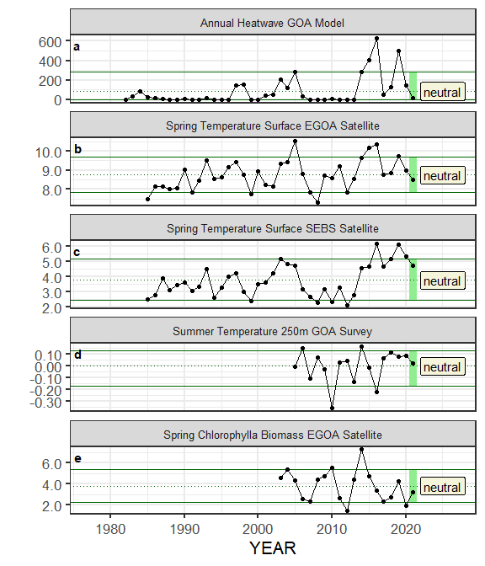

##### Figure ??. Selected ecosystem indicators for Sablefish with time series ranging from 1977 – present. Upper and lower solid green horizontal lines are 90th and 10th percentiles of time series. Dotted green horizontal line is the mean of the time series. Light green shaded areas represent the most recent year of the traffic light analysis results.

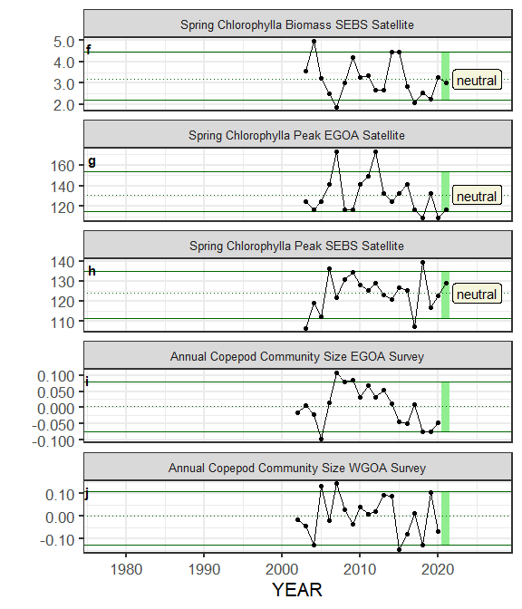

##### Figure ??. Selected ecosystem indicators for Sablefish with time series ranging from 1977 – present. Upper and lower solid green horizontal lines are 90th and 10th percentiles of time series. Dotted green horizontal line is the mean of the time series. Light green shaded areas represent the most recent year of the traffic light analysis results.

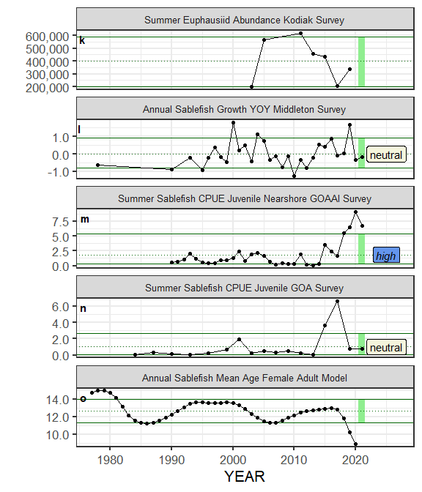

##### Figure ??. Selected ecosystem indicators for Sablefish with time series ranging from 1977 – present. Upper and lower solid green horizontal lines are 90th and 10th percentiles of time series. Dotted green horizontal line is the mean of the time series. Light green shaded areas represent the most recent year of the traffic light analysis results.

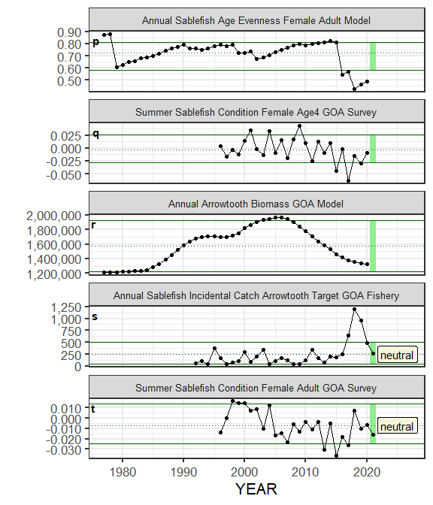

##### Figure ??. Selected ecosystem indicators for Sablefish with time series ranging from 1977 – present. Upper and lower solid green horizontal lines are 90th and 10th percentiles of time series. Dotted green horizontal line is the mean of the time series. Light green shaded areas represent the most recent year of the traffic light analysis results.

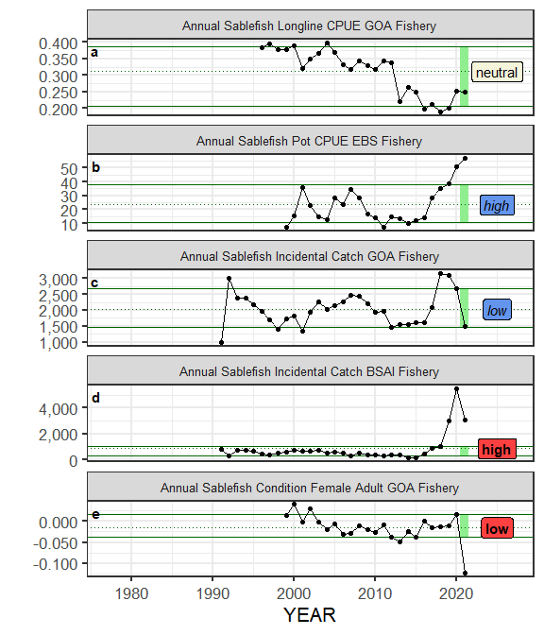

##### Figure ??. Selected socioeconomic indicators for Sablefish with time series ranging from 1977 – present. Upper and lower solid green horizontal lines are 90th and 10th percentiles of time series. Dotted green horizontal line is the mean of the time series. Light green shaded areas represent the most recent year of the traffic light analysis results.

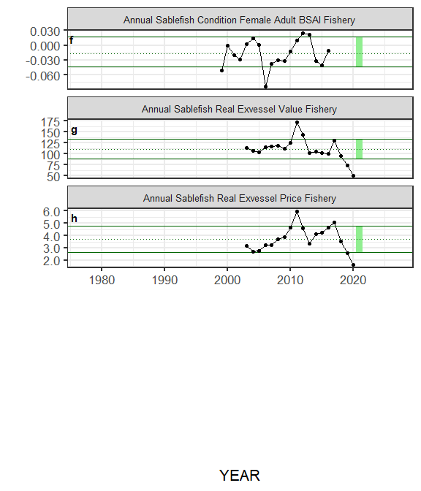

##### Figure ??. Selected socioeconomic indicators for Sablefish with time series ranging from 1977 – present. Upper and lower solid green horizontal lines are 90th and 10th percentiles of time series. Dotted green horizontal line is the mean of the time series. Light green shaded areas represent the most recent year of the traffic light analysis results.

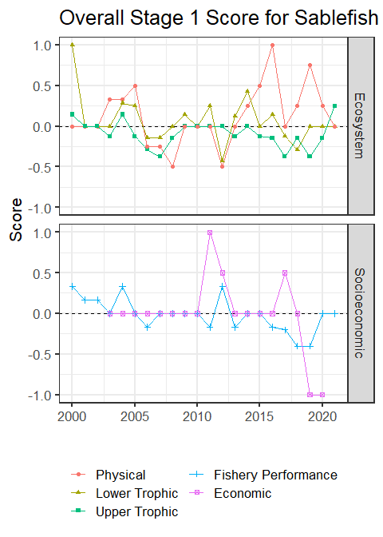

##### Figure 4. Simple traffic light score for overall ecosystem and socioeconomic categories from 1977 to present.



##### Figure 5. Bayesian adaptive sampling output showing (a) standardized covariates prior to subsetting and (b) the mean relationship and uncertainty (95% confidence intervals) with log Sablefish recruitment, in each estimated effect (left bottom graph), and marginal inclusion probabilities (right bottom graph) for each predictor variable of the subsetted covariate set