Alaska Sablefish  
*Anoplopoma fimbria*

2024 Ecosystem and Socioeconomic Profile Report Card



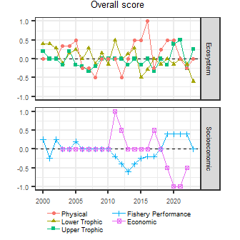

## Key indicator takeaways

### Model considerations (a few bullets)

* Stuff trending up/down

### Management considerations (a few bullets)

* Stuff trending up/down

### Recommendations for risk table?

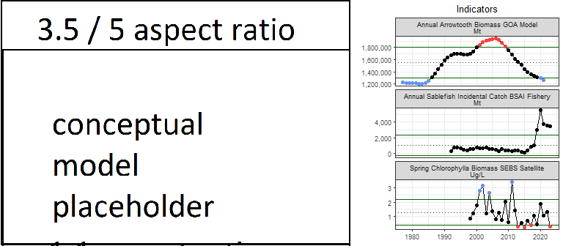

Links to AKFIN and other stuff, disclaimers, contact info