Appendix 1. Ecosystem and Socioeconomic Profile of the Sablefish stock in the Alaska Report Card

Erin Fedewa, Kalei Shotwell, Abby Tyrell

Draft 2023



*With Contributions from:*

Kalei Shotwell, Abby Tyrell

# Current Year Update

The ecosystem and socioeconomic profile or ESP is a standardized framework for compiling and evaluating relevant stock-specific ecosystem and socioeconomic indicators and communicating linkages and potential drivers of the stock within the stock assessment process (Shotwell et al., In Review). The ESP process creates a traceable pathway from the initial development of indicators to management advice and serves as an on-ramp for developing ecosystem-linked stock assessments. Please refer to the last full ESP and partial ESP documents for further information regarding the ecosystem and socioeconomic linkages for this stock (*list references*).

## Management Considerations

Summary conclusions from ESP for ABC (risk table)

## Modeling Considerations

Summary of indicators with high importance in the Bayesian adaptive sampling routine and discussion of which indicators have had consistent high importance. List of research ecosystem model runs that are currently ongoing and potential for operational use in the future.

# Assessment

## Ecosystem and Socioeconomic Processes

One paragraph description of ecosystem and socioeconomic (if available) conceptual model(s)

## Indicator Suite

One paragraph description of LME level indicators relevant to stock (ESR summary)

### Ecosystem Indicators:

#### 1. Physical Indicators

1. Annual_Heatwave_GOA_Model: Annual marine heatwave cumulative index over the central GOA
   * Contact: Steve Barbeaux
   * Status and trends: **Information not present in database**
   * Factors influencing trends: **Information not present in database**
   * Implications: **Information not present in database**
2. Spring_Temperature_Surface_GOA_Satellite: Late spring (May-June) daily sea surface temperatures (SST) for the GOA from the NOAA Coral Reef Watch Program
   * Contact: Matt Callahan
   * Status and trends: Slight trend in overall time series
   * Factors influencing trends: **Information not present in database**
   * Implications: **Information not present in database**
3. Spring_Temperature_Surface_EGOA_Satellite: Late spring (May-June) daily sea surface temperatures (SST) for the eastern GOA from the NOAA Coral Reef Watch Program
   * Contact: Matt Callahan
   * Status and trends: Despite marked inter-annual variability, there appears to only be a slight upward trend in the overall time series.
   * Factors influencing trends: Oceanography.
   * Implications: **Information not present in database**
4. Spring_Temperature_Surface_SEBS_Satellite: Late spring (May-June) daily sea surface temperatures (SST) for the southeastern Bering Sea from the NOAA Coral Reef Watch Program
   * Contact: Matt Callahan
   * Status and trends: While inter-annual variability is evident, a generally increasing trend is apparent (from both linear and non-linear smoothers). However, a cold stanza is a dominant feature for a portion of the time series. Recent years appear remarkably warmer than the majority of the time series.
   * Factors influencing trends: Um, global climate change?
   * Implications: **Information not present in database**
5. Summer_Temperature_250m_GOA_Survey: Summer temperature anomalies at 250 m isobath during the AFSC annual longline survey
   * Contact: Kevin Siwicke
   * Status and trends: The 250-m slope temperature index is in prime sablefish habitat and the magnitude of interannual differences is small compared to surface water temperature fluctuations. However, this index has remained positive for the last six years, a deviation from the historical fluctuations around the mean, suggesting these deeper waters continue to be warmer than average (~0.15°C) since 2017.
   * Factors influencing trends: Warming that has been evident in bottom temperatures throughout the shelf environment has not been particularly present over much of the slope environment, which may provide a buffer during spawning and egg deposition for sablefish.
   * Implications: **Information not present in database**

#### 2. Lower Trophic Indicators

1. Spring_Chlorophylla_Biomass_GOA_Satellite: Derived chlorophyll a concentration during spring seasonal peak (May) in the GOA from the MODIS satellite
   * Contact: Matt Callahan
   * Status and trends: **Information not present in database**
   * Factors influencing trends: **Information not present in database**
   * Implications: **Information not present in database**
2. Spring_Chlorophylla_Biomass_EGOA_Satellite: Derived chlorophyll a concentration during spring seasonal peak (May) in the eastern GOA from the MODIS satellite
   * Contact: Matt Callahan
   * Status and trends: Variable
   * Factors influencing trends: Oceanography
   * Implications: **Information not present in database**
3. Spring_Chlorophylla_Biomass_SEBS_Satellite: Derived chlorophyll a concentration during spring seasonal peak (May) in the southeastern Bering Sea from the MODIS satellite
   * Contact: Jens Nielsen
   * Status and trends: **Information not present in database**
   * Factors influencing trends: **Information not present in database**
   * Implications: **Information not present in database**
4. Spring_Chlorophylla_Peak_GOA_Satellite: Peak timing of the spring bloom averaged across individual ADF&G statistical areas in the GOA region from the MODIS satellite
   * Contact: Matt Callahan
   * Status and trends: **Information not present in database**
   * Factors influencing trends: **Information not present in database**
   * Implications: **Information not present in database**
5. Spring_Chlorophylla_Peak_EGOA_Satellite: Peak timing of the spring bloom averaged across individual ADF&G statistical areas in the eastern GOA region from the MODIS satellite
   * Contact: Matt Callahan
   * Status and trends: **Information not present in database**
   * Factors influencing trends: **Information not present in database**
   * Implications: **Information not present in database**
6. Spring_Chlorophylla_Peak_SEBS_Satellite: Peak timing of the spring bloom averaged across individual ADF&G statistical areas in the southeastern Bering Sea from the MODIS satellite
   * Contact: Jens Nielsen
   * Status and trends: 2021 spring bloom timing was close to the long-term mean peak timing
   * Factors influencing trends: **Information not present in database**
   * Implications: **Information not present in database**
7. Annual_Copepod_Community_Size_EGOA_Survey: Abundance of copepod community size from the continuous plankton recorder (CPR) for the offshore eastern GOA
   * Contact: Clare Ostle
   * Status and trends: On the western side of the oceanic Gulf of Alaska the diatom anomaly was also positive in 2021. On the eastern side of the oceanic Gulf of Alaska the diatom abundance anomaly was negative for the last two years, with the strongest negative anomaly of the time-series appearing in 2021. The copepod community size anomaly was mostly negative in all regions in the last 5-7 years, but it has oscillated in the Alaskan shelf to a positive anomaly in 2021. Zooplankton biomass anomalies were positive in both the Shelf and eastern Gulf of Alaska regions in 2020, but have switched to negative in 2021, while the anomaly has remained negative in the western side of the Gulf of Alaska. The zooplankton biomass anomaly in 2021 in the eastern Gulf of Alaska is the most negative it has been for the timeseries presented.
   * Factors influencing trends: The Pacific Decadal Oscillation (PDO) monthly values were often negative in 2017 causing a lower annual mean value compared to the years of 2014-2016 and 2018-2020, which had experienced a marine heat wave (DiLorenzo and Mantua, 2016). 2021 appears to be not as warm as the previous 7 years. In warm conditions smaller species tend to be more abundant and the copepod community size index reflects this and was mostly negative throughout the marine heat wave periods of 2014-2016, and 2018-2020. The large diatom abundance was positive in 2021 in the shelf and western regions, however in the eastern Gulf of Alaska regions there is a lower than average diatom anomaly. It is unclear what has led to the decrease in diatom abundance in this region, but it could be that the decreased meso-zooplankton biomass provided decreased grazing pressure and therefore an increase in the diatom abundance in the shelf and western Gulf of Alaska.
   * Implications: **Information not present in database**
8. Annual_Copepod_Community_Size_WGOA_Survey: Abundance of copepod community size from the continuous plankton recorder (CPR) for the offshore western GOA
   * Contact: Clare Ostle
   * Status and trends: On the western side of the oceanic Gulf of Alaska the diatom anomaly was also positive in 2021. On the eastern side of the oceanic Gulf of Alaska the diatom abundance anomaly was negative for the last two years, with the strongest negative anomaly of the time-series appearing in 2021. The copepod community size anomaly was mostly negative in all regions in the last 5-7 years, but it has oscillated in the Alaskan shelf to a positive anomaly in 2021. Zooplankton biomass anomalies were positive in both the Shelf and eastern Gulf of Alaska regions in 2020, but have switched to negative in 2021, while the anomaly has remained negative in the western side of the Gulf of Alaska. The zooplankton biomass anomaly in 2021 in the eastern Gulf of Alaska is the most negative it has been for the timeseries presented.
   * Factors influencing trends: The Pacific Decadal Oscillation (PDO) monthly values were often negative in 2017 causing a lower annual mean value compared to the years of 2014-2016 and 2018-2020, which had experienced a marine heat wave (DiLorenzo and Mantua, 2016). 2021 appears to be not as warm as the previous 7 years. In warm conditions smaller species tend to be more abundant and the copepod community size index reflects this and was mostly negative throughout the marine heat wave periods of 2014-2016, and 2018-2020. The large diatom abundance was positive in 2021 in the shelf and western regions, however in the eastern Gulf of Alaska regions there is a lower than average diatom anomaly. It is unclear what has led to the decrease in diatom abundance in this region, but it could be that the decreased meso-zooplankton biomass provided decreased grazing pressure and therefore an increase in the diatom abundance in the shelf and western Gulf of Alaska.
   * Implications: **Information not present in database**
9. Summer_Euphausiid_Abundance_Kodiak_Survey: Summer euphausiid abundance for the Kodiak core survey area from the AFSC acoustic survey
   * Contact: Patrick Ressler
   * Status and trends: **Information not present in database**
   * Factors influencing trends: **Information not present in database**
   * Implications: **Information not present in database**
10. Annual_Sablefish_Growth_YOY_Middleton_Survey: Age-0 sablefish growth rate from auklet diets in Middleton Island
    * Contact: Mayumi Arimitsu
    * Status and trends: **Information not present in database**
    * Factors influencing trends: **Information not present in database**
    * Implications: **Information not present in database**

#### 3. Upper Trophic Indicators

1. Summer_Sablefish_CPUE_Juvenile_Nearshore_GOAAI_Survey: Sablefish catch-per-unit-effort (CPUE) and lengths from the ADF&G large mesh bottom trawl survey of crab and groundfish
   * Contact: Kally Spalinger
   * Status and trends: Sablefish CPUE on the ADF&G large-mesh bottom trawl survey remained at relatively low levels from 1989 until 2015 when it began increasing, peaking in 2020. CPUE has declined the last 2 years, while catch in kg remains above average for 7 of the last 8 years.
   * Factors influencing trends: **Information not present in database**
   * Implications: **Information not present in database**
2. Summer_Sablefish_CPUE_Juvenile_GOA_Survey: Catch-per-unit-of-effort (CPUE) of juvenile sablefish (<400 mm, likely age-1) collected on summer AFSC bottom-trawl surveys
   * Contact: Kalei Shotwell
   * Status and trends: **Information not present in database**
   * Factors influencing trends: **Information not present in database**
   * Implications: **Information not present in database**
3. Annual_Sablefish_Mean_Age_Female_Adult_Model: Mean age of sablefish female spawning stock biomass from the most recent sablefish stock assessment model
   * Contact: Dan Goethel
   * Status and trends: **Information not present in database**
   * Factors influencing trends: **Information not present in database**
   * Implications: **Information not present in database**
4. Annual_Sablefish_Age_Evenness_Female_Adult_Model: Measure of evenness or concentration of age composition by cohort of female sablefish from the most recent sablefish stock assessment model
   * Contact: Dan Goethel
   * Status and trends: **Information not present in database**
   * Factors influencing trends: **Information not present in database**
   * Implications: **Information not present in database**
5. Summer_Sablefish_Condition_Female_Age4_GOA_Survey: Summer sablefish condition for age-4, immature female sablefish from the GOA AFSC longline survey
   * Contact: Jane Sullivan
   * Status and trends: The condition index for the 2021 age-4 immature females collected in the longline survey was above average for the first time since 2014.
   * Factors influencing trends: **Information not present in database**
   * Implications: **Information not present in database**
6. Annual_Arrowtooth_Biomass_GOA_Model: Arrowtooth flounder total biomass from the most recent stock assessment model in the GOA
   * Contact: Kalei Shotwell
   * Status and trends: **Information not present in database**
   * Factors influencing trends: **Information not present in database**
   * Implications: **Information not present in database**
7. Annual_Sablefish_Incidental_Catch_Arrowtooth_Target_GOA_Fishery: Incidental catch of sablefish in the GOA arrowtooth flounder fishery
   * Contact: Kalei Shotwell
   * Status and trends: **Information not present in database**
   * Factors influencing trends: **Information not present in database**
   * Implications: **Information not present in database**
8. Summer_Sablefish_Condition_Female_Adult_GOA_Survey: Summer sablefish condition for large adult (>=750 mm) female sablefish from the GOA AFSC longline survey
   * Contact: Jane Sullivan
   * Status and trends: The condition of large female sablefish in the longline survey was below average for the fourth consecutive year.
   * Factors influencing trends: **Information not present in database**
   * Implications: **Information not present in database**

### Socioeconomic Indicators:

#### 1. Fishery Performance Indicators

1. Annual_Sablefish_Combined_CPUE_Alaska_Fishery: Catch per unit of effort of sablefish estimated from the longline and pot fisheries combined in Alaska
   * Contact: Matt Cheng
   * Status and trends: Standardized relative indices of abundance for sablefish in 2021 increased by 36.8% compared to the previous year. Trends prior to 2017 primarily result from the hook-and-line fishery as they precede the 2017 regulatory shift that allowed for pot gear fishing in the Gulf of Alaska. In contrast, trends from 2017 - 2021 are indicative of both the hook-and-line and pot fishery. Starting in 2020, > 50% of fishery observations originated from pot gear. Considering that the index currently does not differentiate between rigid conical pots and “slinky-pots”, which likely exhibit differences in catchability, these trends should be interpreted with caution.
   * Factors influencing trends: Increases in relative indices of abundance for sablefish can be attributed to a variety of factors. Notably, there has been an influx of sablefish resulting from large recruitment events in recent years.
   * Implications: **Information not present in database**
2. Annual_Sablefish_Longline_CPUE_GOA_Fishery: Catch-per-unit-of-effort of sablefish from the longline fisheries in the GOA
   * Contact: Kalei Shotwell
   * Status and trends: **Information not present in database**
   * Factors influencing trends: **Information not present in database**
   * Implications: **Information not present in database**
3. Annual_Sablefish_Pot_CPUE_Alaska_Fishery: Catch per unit of effort of sablefish estimated from the pot fisheries in Alaska
   * Contact: Matt Cheng
   * Status and trends: Standardized relative indices of abundance from the pot fishery for sablefish in 2021 increased by 35.3% compared to the previous year. Trends prior to 2017 precede the regulatory shift for pot gear fishing in the Gulf of Alaska (GOA), and result from the Bering Sea Aleutian Islands (BSAI) pot fishery. Trends from 2017 - 2021 are representative of both the GOA and BSAI pot fisheries. Beginning in 2017, > 60% of fishery observations originate from the GOA pot fishery. This current index does not differentiate between rigid conical pots and “slinky-pots”, which may exhibit differences in catchability, and thus rends should be interpreted with caution. Note that the year 2015 is missing from this index due to low sample sizes, likely because of observer restructuring and low observer coverage in the BSAI region.
   * Factors influencing trends: Increases in standardized indices of abundance from the pot fishery are attributed to a variety of factors, which include high recruitment events in recent years, and the expansion of the pot fleet into the GOA.
   * Implications: **Information not present in database**
4. Annual_Sablefish_Pot_CPUE_EBS_Fishery: Catch per unit of effort of sablefish estimated from the pot fisheries in the eastern Bering Sea
   * Contact: Matt Cheng
   * Status and trends: **Information not present in database**
   * Factors influencing trends: **Information not present in database**
   * Implications: **Information not present in database**
5. Annual_Sablefish_Incidental_Catch_GOA_Fishery: Incidental catch estimates of sablefish in the GOA fisheries excluding the sablefish fishery
   * Contact: Kalei Shotwell
   * Status and trends: **Information not present in database**
   * Factors influencing trends: **Information not present in database**
   * Implications: **Information not present in database**
6. Annual_Sablefish_Incidental_Catch_BSAI_Fishery: Incidental catch estimates of sablefish in the Bering Sea fisheries excluding the sablefish fishery
   * Contact: Kalei Shotwell
   * Status and trends: **Information not present in database**
   * Factors influencing trends: **Information not present in database**
   * Implications: **Information not present in database**
7. Annual_Sablefish_Condition_Female_Adult_GOA_Fishery: Sablefish condition for large (>= 750 mm) female sablefish from data collected randomly by observers in the GOA fisheries
   * Contact: Jane Sullivan
   * Status and trends: The 2021 condition index for large female sablefish in the fishery is the lowest for the time series.
   * Factors influencing trends: These findings are based on 24 samples collected in the fishery; however, the data are consistent with decreasing trends in body condition in the longline survey. The decrease in available data is attributed to shifts towards electronic monitoring and reduced fishing effort due to low prices, small fish, and Covid-19.
   * Implications: **Information not present in database**
8. Annual_Sablefish_Condition_Female_Adult_BSAI_Fishery: Sablefish condition for large (>= 750 mm) female sablefish from data collected randomly by observers in the BSAI fisheries
   * Contact: Jane Sullivan
   * Status and trends: There has been no update to this indicator since 2016 due to lack of data.
   * Factors influencing trends: **Information not present in database**
   * Implications: **Information not present in database**

#### 2. Economic Indicators

1. Annual_Sablefish_Real_Exvessel_Value_Fishery: Annual estimated real ex-vessel value of sablefish
   * Contact: Ben Fissel
   * Status and trends: **Information not present in database**
   * Factors influencing trends: **Information not present in database**
   * Implications: **Information not present in database**
2. Annual_Sablefish_Real_Exvessel_Price_Fishery: Average real ex-vessel price per pound of sablefish from fish ticket information
   * Contact: Ben Fissel
   * Status and trends: **Information not present in database**
   * Factors influencing trends: **Information not present in database**
   * Implications: **Information not present in database**

#### 3. Community Indicators

## Indicator Monitoring Analysis

References for statistical tests for monitoring indicator suite by stage where relevant

### Beginning Stage: Traffic Light Test

One paragraph summary of indicator status and trends over time and last five years trend Report scores by category (if applicable) and overall ecosystem and socioeconomic indicators.

### Intermediate Stage: Importance Test

One paragraph summary of importance results with analysis of highly explanatory variables for stock assessment input of interest (e.g., recruitment estimates)

### Advanced Stage: Research Model Test

Update on ecosystem linked model in development and link to relevant literature or report on model

# Data Gaps and Future Research Priorities

Copy from full ESP

# Tables

Table 1: First stage ecosystem indicator analysis for Sablefish, including indicator title and the indicator status of the last five years. The indicator status is designated with text, (greater than = "high", less than = "low", or within 1 standard deviation = "neutral" of long-term mean). Fill color of the cell is based on the sign of the anticipated relationship between the indicator and sablefish (blue = good conditions for sablefish, red = poor conditions, white = average conditions). A gray fill and text = "missing" will appear if there were no data for that year.

| **Indicator category** | **Indicator** | **2019 Status** | **2020 Status** | **2021 Status** | **2022 Status** | **2023 Status** |
| --- | --- | --- | --- | --- | --- | --- |
| Physical | Annual Heatwave GOA Model | *high* | neutral | neutral | neutral | neutral |
| Spring Temperature Surface GOA Satellite | *high* | *high* | neutral | neutral | neutral |
| Spring Temperature Surface SEBS Satellite | *high* | *high* | neutral | neutral | neutral |
| Summer Temperature 250m GOA Survey | **high** | neutral | neutral | **high** | neutral |
| Lower Trophic | Spring Chlorophylla Biomass GOA Satellite | **low** | **low** | neutral | neutral | **low** |
| Spring Chlorophylla Biomass SEBS Satellite | neutral | neutral | neutral | neutral | **low** |
| Spring Chlorophylla Peak GOA Satellite | **high** | neutral | neutral | neutral | **high** |
| Spring Chlorophylla Peak SEBS Satellite | *low* | neutral | neutral | neutral | neutral |
| Annual Copepod Community Size EGOA Survey | **low** | neutral | neutral | neutral | NA |
| Annual Copepod Community Size WGOA Survey | *high* | neutral | neutral | **low** | NA |
| Summer Euphausiid Abundance Kodiak Survey | neutral | NA | NA | NA | NA |
| Annual Sablefish Growth YOY Middleton Survey | *high* | neutral | neutral | neutral | neutral |
| Upper Trophic | Summer Sablefish CPUE Juvenile Nearshore GOAAI Survey | *high* | *high* | *high* | *high* | neutral |
| Summer Sablefish CPUE Juvenile GOA Survey | neutral | NA | neutral | NA | neutral |
| Summer Sablefish Condition Female Age4 GOA Survey | **low** | neutral | *high* | **low** | NA |
| Annual Arrowtooth Biomass GOA Model | neutral | *low* | *low* | NA | NA |
| Annual Sablefish Incidental Catch Arrowtooth Target GOA Fishery | **high** | neutral | neutral | neutral | neutral |
| Summer Sablefish Condition Female Adult GOA Survey | neutral | neutral | neutral | **low** | *high* |

Table 2: First stage socioeconomic indicator analysis for Sablefish, including indicator title and the indicator status of the last five years. The indicator status is designated with text, (greater than = "high", less than = "low", or within 1 standard deviation = "neutral" of long-term mean). Fill color of the cell is based on the sign of the anticipated relationship between the indicator and sablefish (blue = good conditions for sablefish, red = poor conditions, white = average conditions). A gray fill and text = "missing" will appear if there were no data for that year.

| **Indicator category** | **Indicator** | **2019 Status** | **2020 Status** | **2021 Status** | **2022 Status** | **2023 Status** |
| --- | --- | --- | --- | --- | --- | --- |
| Fishery Performance | Annual Sablefish Combined CPUE Alaska Fishery | low | low | neutral | high | NA |
| Annual Sablefish Pot CPUE Alaska Fishery | high | neutral | high | high | NA |
| Annual Sablefish Incidental Catch GOA Fishery | high | high | neutral | neutral | low |
| Annual Sablefish Incidental Catch BSAI Fishery | high | high | high | high | high |
| Annual Sablefish Condition Female Adult GOA Fishery | neutral | high | neutral | low | neutral |
| Economic | Annual Sablefish Real Exvessel Value Fishery | low | low | low | neutral | NA |
| Annual Sablefish Real Exvessel Price Fishery | neutral | low | low | low | NA |

# Figures



##### Figure 1. Life history conceptual model for Sablefish summarizing ecological information and key ecosystem processes affecting survival by life history stage. Red text means increases in process negatively affect survival, while blue text means increases in process positively affect survival.

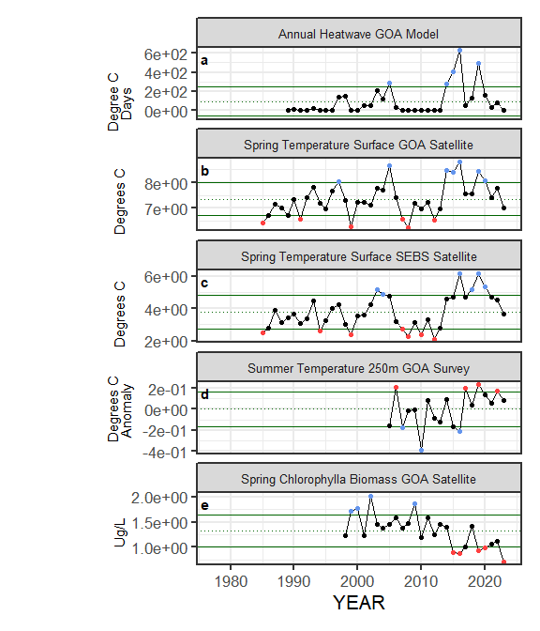

##### Figure ??. Selected ecosystem indicators for Sablefish with time series ranging from 1977 – present. Upper and lower solid green horizontal lines are plus and minus one standard deviation of the time series mean. Dotted green horizontal line is the mean of the time series.

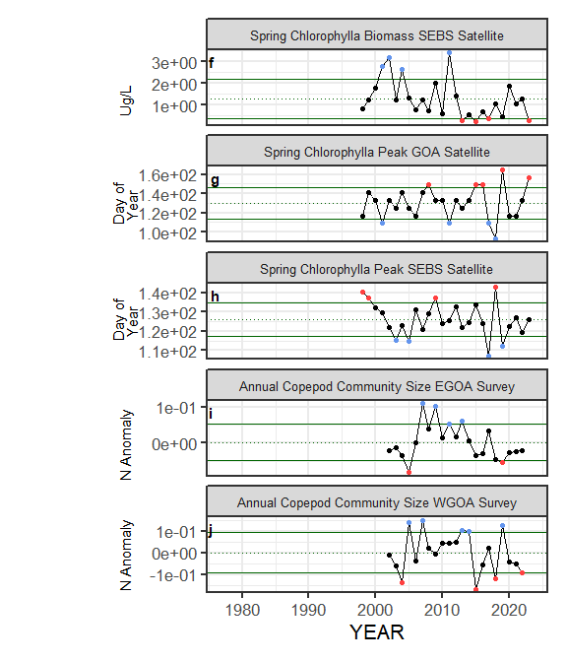

##### Figure ??. Selected ecosystem indicators for Sablefish with time series ranging from 1977 – present. Upper and lower solid green horizontal lines are plus and minus one standard deviation of the time series mean. Dotted green horizontal line is the mean of the time series.

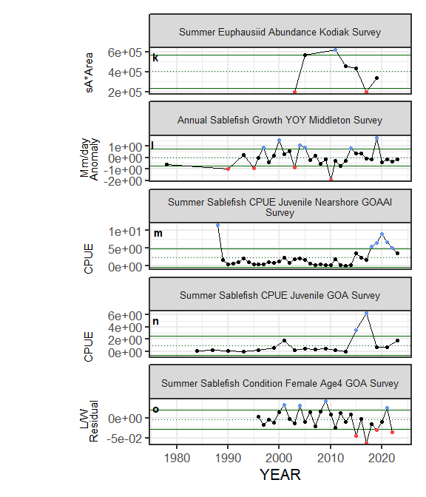

##### Figure ??. Selected ecosystem indicators for Sablefish with time series ranging from 1977 – present. Upper and lower solid green horizontal lines are plus and minus one standard deviation of the time series mean. Dotted green horizontal line is the mean of the time series.

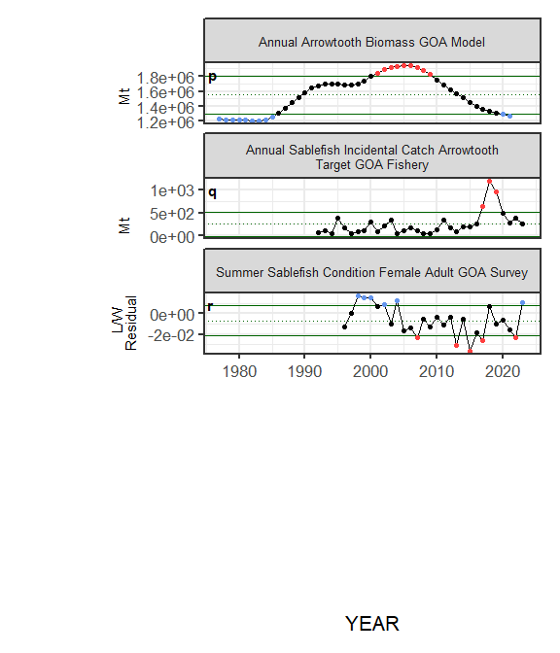

##### Figure ??. Selected ecosystem indicators for Sablefish with time series ranging from 1977 – present. Upper and lower solid green horizontal lines are plus and minus one standard deviation of the time series mean. Dotted green horizontal line is the mean of the time series.

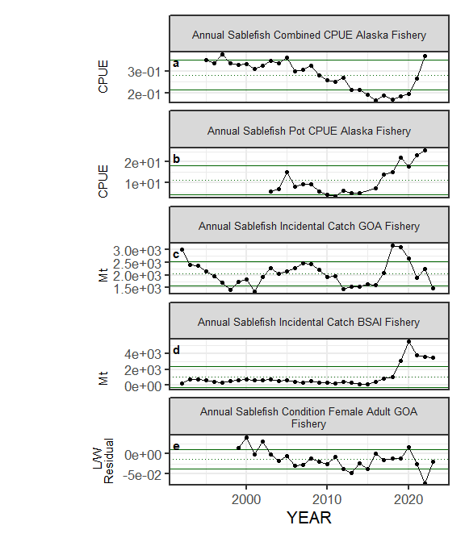

##### Figure ??. Selected socioeconomic indicators for Sablefish with time series ranging from 1977 – present. Upper and lower solid green horizontal lines are plus and minus one standard deviation of the time series mean. Dotted green horizontal line is the mean of the time series.

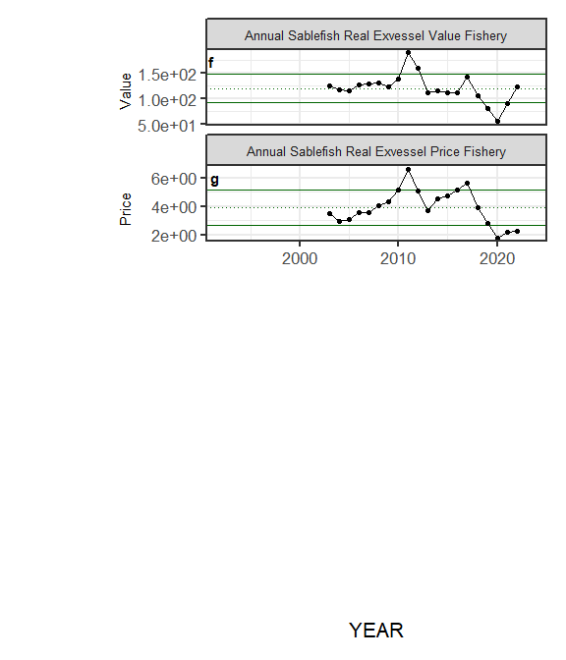

##### Figure ??. Selected socioeconomic indicators for Sablefish with time series ranging from 1977 – present. Upper and lower solid green horizontal lines are plus and minus one standard deviation of the time series mean. Dotted green horizontal line is the mean of the time series.

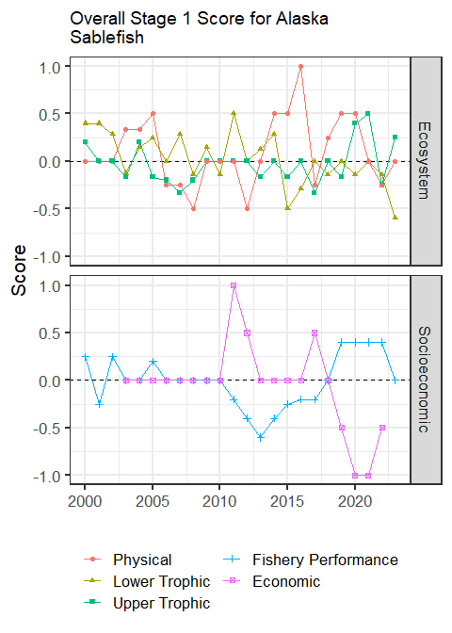

##### Figure 8. Simple traffic light score for overall ecosystem and socioeconomic categories from 2000 to present.



##### Figure 9. Bayesian adaptive sampling output showing (a) standardized covariates prior to subsetting and (b) the mean relationship and uncertainty (95% confidence intervals) with log Sablefish recruitment, in each estimated effect (left bottom graph), and marginal inclusion probabilities (right bottom graph) for each predictor variable of the subsetted covariate set