Appendix 1. Ecosystem and Socioeconomic Profile of the Tanner Crab stock in the EBS Report Card

Erin Fedewa, Kalei Shotwell, Abby Tyrell

Draft 2023



*With Contributions from:*

Kalei Shotwell, Abby Tyrell

# Current Year Update

The ecosystem and socioeconomic profile, or ESP, is a standardized framework for compiling and evaluating relevant stock-specific ecosystem and socioeconomic indicators and communicating linkages and potential drivers of the stock within the stock assessment process (Shotwell et al., 2023). The ESP process creates a traceable pathway from the initial development of indicators to management advice and serves as an on-ramp for developing ecosystem-linked stock assessments.

Please refer to the last full ESP, partial, and report card documents (*list references*) which are available within the Tanner Crab stock assessment and fishery evaluation or SAFE reports for further information regarding the ecosystem and socioeconomic linkages for this stock.

## Management Considerations

Summary conclusions from ESP for ABC (risk table)

## Modeling Considerations

Summary of indicators with high importance in the Bayesian adaptive sampling routine and discussion of which indicators have had consistent high importance. List of research ecosystem model runs that are currently ongoing and potential for operational use in the future.

# Assessment

## Ecosystem and Socioeconomic Processes

One paragraph description of ecosystem and socioeconomic (if available) conceptual model(s)

## Indicator Suite

One paragraph description of LME level indicators relevant to stock (ESR summary)

### Ecosystem Indicators:

#### 1. Larval Indicators

1. AMJ_Chlorophylla_Biomass_Tanner_Satellite: Derived chlorophyll a concentration during spring and summer season (April, May, June) in the south outer-middle shelft of the eastern Bering Sea from the ESA GlobColour blended satellite product
   * Contact: Erin Fedewa
   * Status and trends: **Information not present in database**
   * Factors influencing trends: **Information not present in database**
   * Implications: **Information not present in database**

#### 2. Juvenile Indicators

1. Summer_Temperature_Bottom_Tanner_Survey: Average summer bottom temperature in the eastern Bering Sea
   * Contact: Erin Fedewa
   * Status and trends: **Information not present in database**
   * Factors influencing trends: **Information not present in database**
   * Implications: **Information not present in database**
2. Summer_Cold_Pool_SEBS_Tanner_Survey: The areal extent of EBS bottom trawl survey stations with bottom temperatures < 2 degrees C
   * Contact: Erin Fedewa
   * Status and trends: **Information not present in database**
   * Factors influencing trends: **Information not present in database**
   * Implications: **Information not present in database**
3. Summer_Tanner_Juvenile_Temperature_Occupancy: Mean bottom temperature weighted by immature tanner crab CPUE at each station of the EBS summer bottom trawl survey
   * Contact: Erin Fedewa
   * Status and trends: **Information not present in database**
   * Factors influencing trends: **Information not present in database**
   * Implications: **Information not present in database**
4. Summer_Pacific_Cod_Density_Tanner_Survey: Summer Pacific cod biomass in eastern Bering Sea from the AFSC EBS bottom trawl survey
   * Contact: Erin Fedewa
   * Status and trends: **Information not present in database**
   * Factors influencing trends: **Information not present in database**
   * Implications: **Information not present in database**
5. Summer_Tanner_Juvenile_Disease_Prevalence: Prevalence of immature tanner crab showing visual evidence of Bitter Crab Syndrome during the summer EBS bottom trawl survey
   * Contact: Erin Fedewa
   * Status and trends: **Information not present in database**
   * Factors influencing trends: **Information not present in database**
   * Implications: **Information not present in database**

#### 3. Adult Indicators

1. Summer_Benthic_Invertebrate_Density_SEBS_Tanner_Survey: Summer benthic invertebrate biomass included in the 50th percentile of mean Tanner crab CPUE from the AFSC EBS bottom trawl survey
   * Contact: Erin Fedewa
   * Status and trends: **Information not present in database**
   * Factors influencing trends: **Information not present in database**
   * Implications: **Information not present in database**
2. Annual_Tanner_Size_Terminal_Molt_Model: Mean carapace width of male tanner crab at 50% probability of maturation, as determined from maturity ogive developed from EBS bottom trawl survey data
   * Contact: Jon Richar
   * Status and trends: **Information not present in database**
   * Factors influencing trends: **Information not present in database**
   * Implications: **Information not present in database**
3. Summer_Tanner_Male_Area_Occupied_SEBS_Survey: Calculated as the minimum area containing 95% of the cumulative male tanner crab CPUE during the EBS summer bottom trawl survey
   * Contact: Erin Fedewa
   * Status and trends: **Information not present in database**
   * Factors influencing trends: **Information not present in database**
   * Implications: **Information not present in database**
4. Summer_Tanner_Male_Center_Distribution_SEBS_Survey: CPUE-weighted average longtitude of the male tanner crab stock during the EBS summer bottom trawl survey
   * Contact: Erin Fedewa
   * Status and trends: **Information not present in database**
   * Factors influencing trends: **Information not present in database**
   * Implications: **Information not present in database**

### Socioeconomic Indicators:

#### 1. Fishery Performance Indicators

1. Annual_Tanner_Active_Vessels_EBS_Fishery: Annual number of active vessels in the tanner crab fishery to represent the level of fishing effort assigned to the fishery
   * Contact: Brian Garber-Yonts
   * Status and trends: **Information not present in database**
   * Factors influencing trends: **Information not present in database**
   * Implications: **Information not present in database**
2. Annual_Tanner_Incidental_Catch_EBS_Fishery: Annual incidental catch of tanner crab in other fisheries
   * Contact: Brian Garber-Yonts
   * Status and trends: **Information not present in database**
   * Factors influencing trends: **Information not present in database**
   * Implications: **Information not present in database**

#### 2. Economic Indicators

#### 3. Community Indicators

## Indicator Monitoring Analysis

References for statistical tests for monitoring indicator suite by stage where relevant

### Beginning Stage: Traffic Light Test

One paragraph summary of indicator status and trends over time and last five years trend Report scores by category (if applicable) and overall ecosystem and socioeconomic indicators.

### Intermediate Stage: Importance Test

One paragraph summary of importance results with analysis of highly explanatory variables for stock assessment input of interest (e.g., recruitment estimates)

### Advanced Stage: Research Model Test

Update on ecosystem linked model in development and link to relevant literature or report on model

# Data Gaps and Future Research Priorities

Copy from full ESP

# Tables

Table 1: First stage ecosystem indicator analysis for Tanner Crab, including indicator title and the indicator status of the last five years. The indicator status is designated with text, (greater than = "high", less than = "low", or within 1 standard deviation = "neutral" of long-term mean). Fill color of the cell is based on the sign of the anticipated relationship between the indicator and sablefish (blue = good conditions for sablefish, red = poor conditions, white = average conditions). A gray fill and text = "missing" will appear if there were no data for that year.

| **Indicator category** | **Indicator** | **2019 Status** | **2020 Status** | **2021 Status** | **2022 Status** | **2023 Status** |
| --- | --- | --- | --- | --- | --- | --- |
| Larval | AMJ Chlorophylla Biomass Tanner Satellite | neutral | neutral | **low** | neutral | **low** |
| Juvenile | Summer Temperature Bottom Tanner Survey | *high* | NA | neutral | neutral | neutral |
| Summer Cold Pool SEBS Tanner Survey | **low** | NA | **low** | neutral | neutral |
| Summer Tanner Juvenile Temperature Occupancy | **high** | NA | neutral | neutral | neutral |
| Summer Pacific Cod Density Tanner Survey | neutral | NA | *low* | neutral | neutral |
| Summer Tanner Juvenile Disease Prevalence | **high** | NA | neutral | **high** | **high** |
| Adult | Summer Benthic Invertebrate Density SEBS Tanner Survey | neutral | NA | neutral | neutral | neutral |
| Annual Tanner Size Terminal Molt Model | **low** | NA | neutral | neutral | **low** |
| Summer Tanner Male Area Occupied SEBS Survey | neutral | NA | neutral | neutral | *high* |
| Summer Tanner Male Center Distribution SEBS Survey | neutral | NA | neutral | neutral | **low** |

Table 2: First stage socioeconomic indicator analysis for Tanner Crab, including indicator title and the indicator status of the last five years. The indicator status is designated with text, (greater than = "high", less than = "low", or within 1 standard deviation = "neutral" of long-term mean). Fill color of the cell is based on the sign of the anticipated relationship between the indicator and sablefish (blue = good conditions for sablefish, red = poor conditions, white = average conditions). A gray fill and text = "missing" will appear if there were no data for that year.

| **Indicator category** | **Indicator** | **2019 Status** | **2020 Status** | **2021 Status** | **2022 Status** | **2023 Status** |
| --- | --- | --- | --- | --- | --- | --- |
| Fishery Performance | Annual Tanner Active Vessels EBS Fishery | neutral | neutral | neutral | neutral | neutral |
| Annual Tanner Incidental Catch EBS Fishery | low | neutral | neutral | neutral | low |

# Figures



##### Figure 1. Life history conceptual model for Tanner Crab summarizing ecological information and key ecosystem processes affecting survival by life history stage. Red text means increases in process negatively affect survival, while blue text means increases in process positively affect survival.

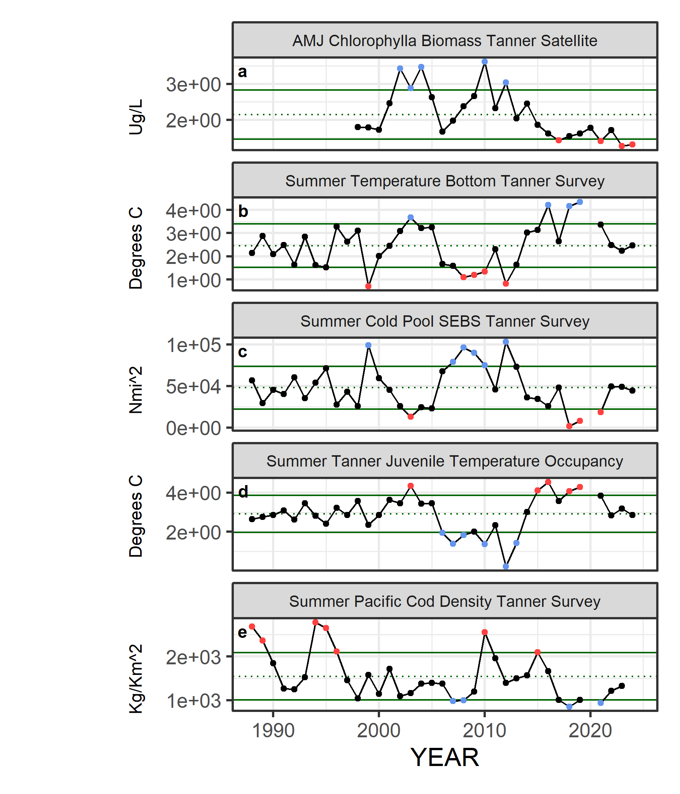

##### Figure ??. Selected ecosystem indicators for Tanner Crab with time series ranging from 1975 – present. Upper and lower solid green horizontal lines are plus and minus one standard deviation of the time series mean. Dotted green horizontal line is the mean of the time series.

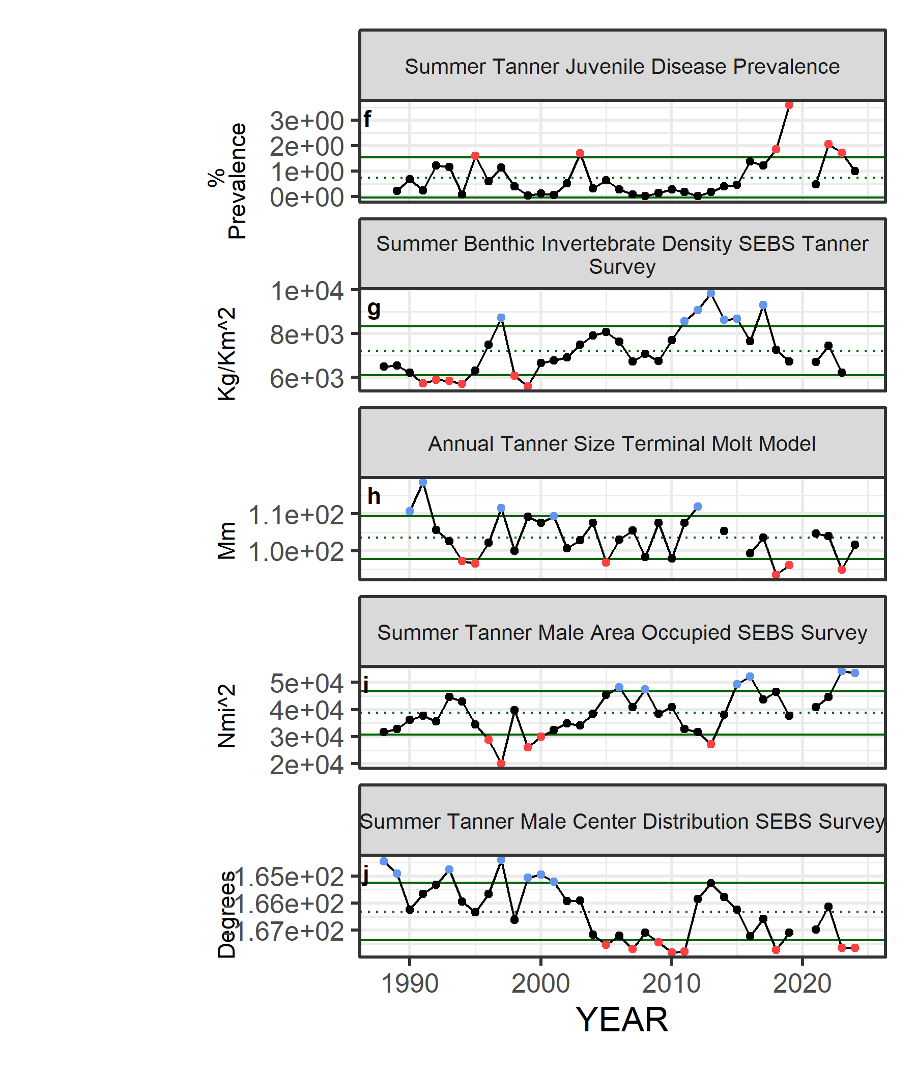

##### Figure ??. Selected ecosystem indicators for Tanner Crab with time series ranging from 1975 – present. Upper and lower solid green horizontal lines are plus and minus one standard deviation of the time series mean. Dotted green horizontal line is the mean of the time series.

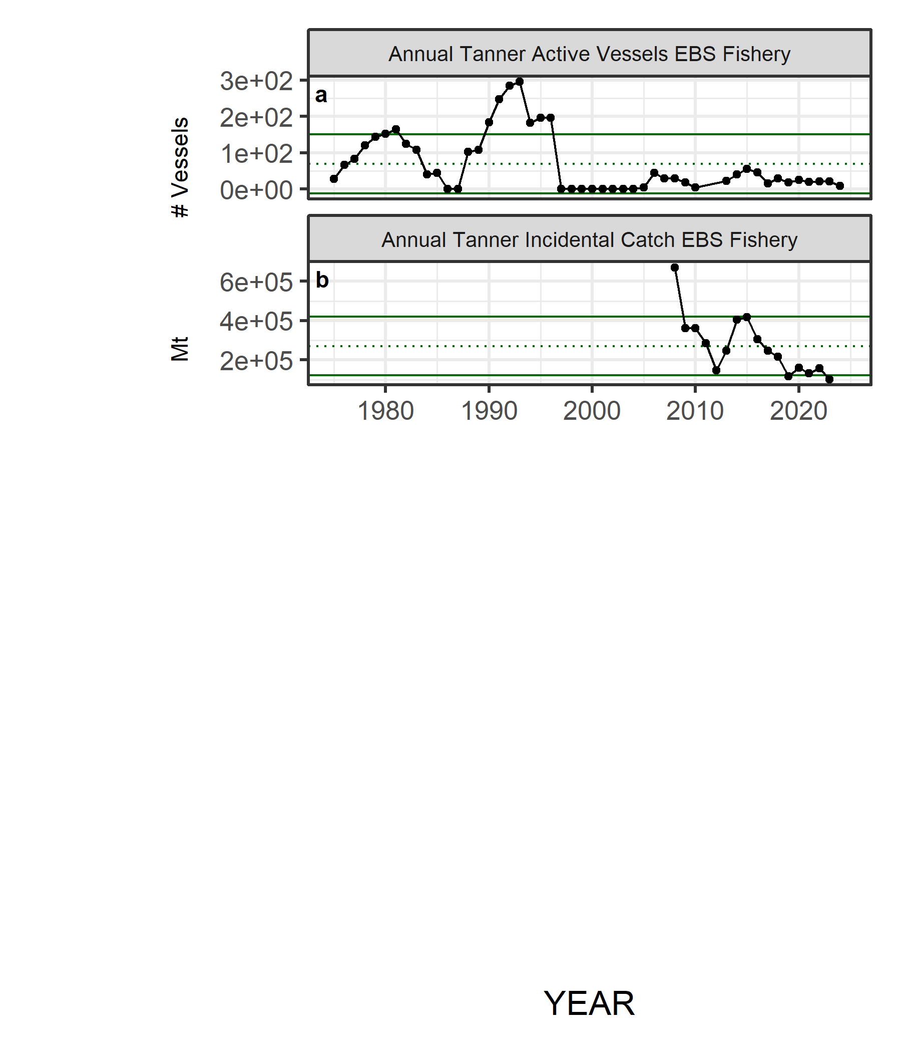

##### Figure 4. Selected socioeconomic indicators for Tanner Crab with time series ranging from 1975 – present. Upper and lower solid green horizontal lines are plus and minus one standard deviation of the time series mean. Dotted green horizontal line is the mean of the time series.

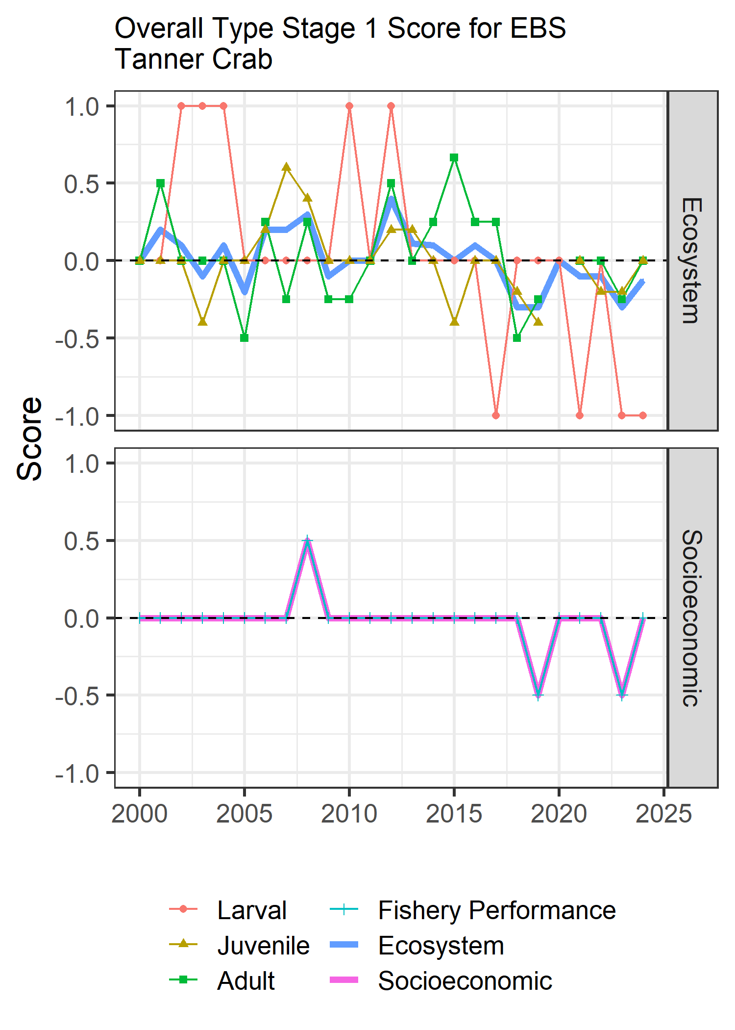

##### Figure 5. Simple traffic light score for overall ecosystem and socioeconomic categories from 2000 to present.



##### Figure 6. Bayesian adaptive sampling output showing (a) standardized covariates prior to subsetting and (b) the mean relationship and uncertainty (95% confidence intervals) with log Tanner Crab recruitment, in each estimated effect (left bottom graph), and marginal inclusion probabilities (right bottom graph) for each predictor variable of the subsetted covariate set