Appendix 1. Ecosystem and Socioeconomic Profile of the Sablefish stock in the Alaska - Report Card

Kalei Shotwell, Abby Tyrell

Draft 2021



*With Contributions from:*

Kalei Shotwell, Abby Tyrell

# Current Year Update

The ecosystem and socioeconomic profile or ESP is a standardized framework for compiling and evaluating relevant stock-specific ecosystem and socioeconomic indicators and communicating linkages and potential drivers of the stock within the stock assessment process (Shotwell et al., In Review). The ESP process creates a traceable pathway from the initial development of indicators to management advice and serves as an on-ramp for developing ecosystem-linked stock assessments. Please refer to the last full ESP and partial ESP documents for further information regarding the ecosystem and socioeconomic linkages for this stock (*list references*).

## Management Considerations

Summary conclusions from ESP for ABC (risk table)

## Modeling Considerations

Summary of indicators with high importance in the Bayesian adaptive sampling routine and discussion of which indicators have had consistent high importance. List of research ecosystem model runs that are currently ongoing and potential for operational use in the future.

# Assessment

## Ecosystem and Socioeconomic Processes

One paragraph description of ecosystem and socioeconomic (if available) conceptual model(s)

## Indicator Suite

One paragraph description of LME level indicators relevant to stock (ESR summary)

### Ecosystem Indicators:

1.) Physical Indicators

a.) Annual eddy kinetic energy (EKE) calculated from sea surface height in the Kodiak area : Annual eddy kinetic energy (EKE) calculated from sea surface height in the Kodiak area (contact: Wei Cheng)

Status and trends: As noted previously, region D (Kodiak area) has an opposite seasonal cycle phase than the other regions (high EKE in the autumn and low EKE in the spring), suggesting separate forcing mechanisms in the western GoA. In this region, EKE in winter of 2020/2021 is similar in amplitude to winter of 2017/2018 but lower than previous winter (2019/2020). EKE dropped below long-term mean (averaged over 1994-2020) by summer 2021, however.

Influential factors: In the eastern Gulf of Alaska, interannual changes in surface winds (related to the Pacific Decadal Oscillation, El Niño, and the strength of the Aleutian Low) modulate the development of eddies (Combes and Di Lorenzo, 2007; Di Lorenzo et al., 2013). Regional scale gap-wind events may also play a role in eddy formation in the eastern Gulf of Alaska (Ladd and Cheng, 2016). In the western Gulf of Alaska, variability is related both to the propagation of eddies from their formation regions in the east and to intrinsic variability.

b.) Spawning marine heatwave cumulative index over the central GOA: Spawning marine heatwave cumulative index over the central GOA (contact: Steve Barbeaux)

Status and trends: NA

Influential factors: NA

c.) Summer bottom temperatures where small Pacific cod (20-40 cm) have been sampled by the AFSC GOA bottom trawl survey from the CFSR dataset: Summer bottom temperatures where small Pacific cod (20-40 cm) have been sampled by the AFSC GOA bottom trawl survey from the CFSR dataset (contact: Steve Barbeaux)

Status and trends: NA

Influential factors: NA

d.) Winter spring spawning habitat suitability index from January to April in the central GOA shelf at GAK1 station: Winter spring spawning habitat suitability index from January to April in the central GOA shelf at GAK1 station (contact: Lauren Rogers)

Status and trends: Spawning habitat suitability was slightly lower than the long-term average in 2020 and 2021.

Influential factors: Recent heatwave years (2015, 2016, 2019) resulted in substantial declines in spawning habitat suitability due to temperatures at depth that were warmer than optimal for hatch success of Pacific cod eggs.

2.) Lower Trophic Indicators

a.) Common murre (piscivores) reproductive success at Chowiet Island: Common murre (piscivores) reproductive success at Chowiet Island (contact: Stephani Zador)

Status and trends: NA

Influential factors: NA

b.) Peak timing of the spring bloom averaged across individual ADF&G statistical areas in the western and central GOA region from the MODIS satellite: Peak timing of the spring bloom averaged across individual ADF&G statistical areas in the western and central GOA region from the MODIS satellite (contact: Jordan Watson)

Status and trends: NA

Influential factors: NA

c.) Spring Pacific cod larvae catch-per-unit-of-effort (CPUE) from the EcoFOCI spring survey: Spring Pacific cod larvae catch-per-unit-of-effort (CPUE) from the EcoFOCI spring survey (contact: Lauren Rogers)

Status and trends: Abundance of Pacific cod larvae has been low in recent survey years (2021, 2019), similar to the low catches observed during the marine heatwave in 2015.

Influential factors: Years of high abundance for the late winter to early spring shelf spawners (i.e., Pacific cod, walleye pollock, and northern rock sole) were associated with cooler winters and enhanced alongshore winds during spring. With temperature conditions being consistent with an “average” climate year, we expected to observe average abundances of Pacific cod, however, abundances were especially low in 2021 and the highest catches were outside of the core area, which is unusual.

d.) Summer euphausiid abundance for the eastern Bering Sea shelf from the AFSC acoustic survey: Summer euphausiid abundance for the eastern Bering Sea shelf from the AFSC acoustic survey (contact: Patrick Ressler)

Status and trends: NA

Influential factors: NA

e.) Summer large copepods for young-of-the-year (YOY) from the EcoFOCI summer survey: Summer large copepods for young-of-the-year (YOY) from the EcoFOCI summer survey (contact: Lauren Rogers)

Status and trends: No large copepod index was available for 2021 due to cancellation of the late-summer EcoFOCI survey.

Influential factors: Large copepod abundances are influenced by timing of the annual cohort of the dominant large species: C. marshallae, N. cristatus, and Neocalanus spp. The dominant large species in summer is C. marshallae as both other large species have likely entered diapause. Long-term variability in mesozooplankton in this region is thought to be driven by Pacific Decadal Oscillation (PDO) and El Nino-Southern Oscillation (ENSO) cycles .

f.) Summer Pacific cod catch-per-unit-of-effort (CPUE) of young-of-the-year (YOY) from the AFSC Kodiak beach seine survey: Summer Pacific cod catch-per-unit-of-effort (CPUE) of young-of-the-year (YOY) from the AFSC Kodiak beach seine survey (contact: Ben Laurel)

Status and trends: NA

Influential factors: NA

3.) Upper Trophic Indicators

a.) Arrowtooth flounder total biomass from the most recent stock assessment model in the GOA: Arrowtooth flounder total biomass from the most recent stock assessment model in the GOA (contact: Kalei Shotwell)

Status and trends: NA

Influential factors: NA

b.) Steller sea lion non-pup estimates for the GOA portion of the western Distinct Population Segment: Steller sea lion non-pup estimates for the GOA portion of the western Distinct Population Segment (contact: Katie Sweeney)

Status and trends: Endangered, increasing

Influential factors: NA

c.) Summer Pacific cod area occupied estimated by a spatio-temporal model using the package VAST on AFSC GOA bottom trawl survey data: Summer Pacific cod area occupied estimated by a spatio-temporal model using the package VAST on AFSC GOA bottom trawl survey data (contact: Zack Oyafuso)

Status and trends: The effective area occupied for Pacific cod was 126708 km2 in 2021, similar to 126962 km2 in 2019. The current (2021) effective area occupied is higher than the overall average (since 1984, 92413 km2) and has been increasing since 2009.

Influential factors: The scale of the effective area time series was slightly lower than that estimated in 2019 and 2020. The scale of the abundance estimates are sensitive to user-inputted VAST settings, including error distribution and spatial resolution of knots (Thorson et al. 2021), both of which differed in 2019, 2020, and 2021, and may have contributed to these systematic differences.

d.) Summer Pacific cod center of gravity northeastings estimated by a spatio-temporal model using the package VAST on AFSC GOA bottom trawl survey data: Summer Pacific cod center of gravity northeastings estimated by a spatio-temporal model using the package VAST on AFSC GOA bottom trawl survey data (contact: Zack Oyafuso)

Status and trends: The center of gravity for Pacific cod was generally in the central GoA, ranging from the boundary between Shumagin and Chirikof to just off the western coast of Kodiak Island. The center of gravity in 2021 was positioned near the eastern edge of this range towards Kodiak Island.

Influential factors: NA

e.) Summer condition for adult (>=420 mm) Pacific cod from the AFSC GOA shelf bottom trawl survey: Summer condition for adult (>=420 mm) Pacific cod from the AFSC GOA shelf bottom trawl survey (contact: Sean Rohan)

Status and trends: In 2021, the morphometric condition of adult Pacific cod in the GOA was neutral (within one standard deviation of the time series mean), which continues the trend of neutral morphometric condition during the prior two survey years (2017, 2019). Neutral morphometric condition in recent years (2018–2021) represents an increase from negative condition in 2015 (~ 1 standard deviation below the mean), a year which coincided with the 2015 marine heat wave in the Gulf of Alaska. Historically, the morphometric condition of adult Pacific cod in the GOA was more than one standard deviation above the mean in 1984 (2–3 standard deviations above the mean) and more than one standard deviation below the mean in 1987, 2003, 2005, and 2015.

Influential factors: Many factors contribute to variation in morphometric condition and it is unclear which specific factors contributed to neutral condition in of adult Pacific cod in the GOA in 2021. Factors that may contribute to variation in morphometric condition include environmental conditions that affect prey quality and temperature-dependent metabolic rates, survey timing, stomach fullness of individual fish, fish migration patterns, and the distribution of samples within survey strata. Temperature is an important factor that can influence the morphometric condition of Pacific cod by influencing metabolic rates, prey availability, and prey quality. Historically in the eastern Bering Sea (EBS), ‘cold’ years (with a small cold pool) were associated with negative morphometric condition (e.g., 1999, 2012) and warm years (e.g., 2002-2005) were associated with positive morphometric condition. However, during recent (2018–2021) exceptionally warm recent years, the morphometric condition of Pacific cod has been neutral for adult and juvenile Pacific cod in the EBS. Temperature can negatively affect growth rates if prey resources are insufficient to make up for increased metabolic demand. In GOA, elevated temperatures during the 2014–2016 marine heatwave in the Gulf of Alaska were associated with lower growth rates of Pacific cod and lower morphometric condition in 2015 (adults and juveniles combined), likely because diminished prey resources during the heatwave were insufficient to make up for increased metabolic demand (Barbeaux et al., 2020). Additional information about the morphometric condition indicator and factors that can influence estimates of morphometric condition based on length-weight residuals in the Gulf of Alaska are described in O’Leary et al. (In prep).

f.) Summer condition for juvenile (<420 mm) Pacific cod from the AFSC GOA shelf bottom trawl survey: Summer condition for juvenile (<420 mm) Pacific cod from the AFSC GOA shelf bottom trawl survey (contact: Sean Rohan)

Status and trends: In 2021, the morphometric condition of juvenile Pacific cod in the GOA was neutral (within one standard deviation of the time series mean) which continues the pattern of neutral morphometric condition since 1990. For most of the time series, the morphometric condition of juvenile Pacific cod in the GOA has fluctuated within one standard deviation of the time series mean, except for in 1990 (>3 standard deviations above the grand mean) and 1987 (>1 standard deviation below the grand mean).

Influential factors: Many factors contribute to variation in morphometric condition and it is unclear which specific factors contributed to neutral condition in of adult Pacific cod in the GOA in 2021. Factors that may contribute to variation in morphometric condition include environmental conditions that affect prey quality and temperature-dependent metabolic rates, survey timing, stomach fullness of individual fish, fish migration patterns, and the distribution of samples within survey strata. Temperature is an important factor that can influence the morphometric condition of Pacific cod by influencing metabolic rates, prey availability, and prey quality. Historically in the eastern Bering Sea (EBS), ‘cold’ years (with a small cold pool) were associated with negative morphometric condition (e.g., 1999, 2012) and warm years (e.g., 2002-2005) were associated with positive morphometric condition. However, during recent (2018–2021) exceptionally warm recent years, the morphometric condition of Pacific cod has been neutral for adult and juvenile Pacific cod in the EBS. Temperature can negatively affect growth rates if prey resources are insufficient to make up for increased metabolic demand. In GOA, elevated temperatures during the 2014–2016 marine heatwave in the Gulf of Alaska were associated with lower growth rates of Pacific cod and lower morphometric condition in 2015 (adults and juveniles combined), likely because diminished prey resources during the heatwave were insufficient to make up for increased metabolic demand (Barbeaux et al., 2020). Additional information about the morphometric condition indicator and factors that can influence estimates of morphometric condition based on length-weight residuals in the Gulf of Alaska are described in O’Leary et al. (In prep).

### Socioeconomic Indicators:

1.) Fishery Performance Indicators

2.) Economic Indicators

a.) Annual real ex-vessel price per pound of GOA Pacific cod from fish ticket information: Annual real ex-vessel price per pound of GOA Pacific cod from fish ticket information (contact: Ben Fissel)

Status and trends: NA

Influential factors: NA

b.) Annual estimated real ex-vessel value of GOA Pacific cod: Annual estimated real ex-vessel value of GOA Pacific cod (contact: Ben Fissel)

Status and trends: NA

Influential factors: NA

c.) Annual estimated real revenue per unit effort measured in weeks fished of GOA Pacific cod: Annual estimated real revenue per unit effort measured in weeks fished of GOA Pacific cod (contact: Ben Fissel)

Status and trends: NA

Influential factors: NA

3.) Community Indicators

a.) Regional quotient of Pacific cod for harvesting revenue of the highly engaged community of Kodiak: Regional quotient of Pacific cod for harvesting revenue of the highly engaged community of Kodiak (contact: Sarah Wise)

Status and trends: NA

Influential factors: NA

b.) Regional quotient of Pacific cod for harvesting revenue of three smaller highly engaged communities (Sand Point, King Cove, and Akutan) combined: Regional quotient of Pacific cod for harvesting revenue of three smaller highly engaged communities (Sand Point, King Cove, and Akutan) combined (contact: Sarah Wise)

Status and trends: NA

Influential factors: NA

c.) Regional quotient of Pacific cod for processing revenue of the highly engaged community of Kodiak: Regional quotient of Pacific cod for processing revenue of the highly engaged community of Kodiak (contact: Sarah Wise)

Status and trends: NA

Influential factors: NA

d.) Regional quotient of Pacific cod for processing revenue of three smaller highly engaged communities (Sand Point, King Cove, and Akutan) combined: Regional quotient of Pacific cod for processing revenue of three smaller highly engaged communities (Sand Point, King Cove, and Akutan) combined (contact: Sarah Wise)

Status and trends: NA

Influential factors: NA

## Indicator Monitoring Analysis

References for statistical tests for monitoring indicator suite by stage where relevant

### Beginning Stage: Traffic Light Test

One paragraph summary of indicator status and trends over time and last five years trend Report scores by category (if applicable) and overall ecosystem and socioeconomic indicators.

### Intermediate Stage: Importance Test

One paragraph summary of importance results with analysis of highly explanatory variables for stock assessment input of interest (e.g., recruitment estimates)

### Advanced Stage: Research Model Test

Update on ecosystem linked model in development and link to relevant literature or report on model

# Data Gaps and Future Research Priorities

Copy from full ESP

# Tables

Table 1: First stage ecosystem indicator analysis for Sablefish, including indicator title and the indicator status of the last five years. The indicator status is designated with text, (greater than = "high", less than = "low", or within 1 standard deviation = "neutral" of long-term mean). Fill color of the cell is based on the sign of the anticipated relationship between the indicator and sablefish (blue = good conditions for sablefish, red = poor conditions, white = average conditions). A gray fill and text = "missing" will appear if there were no data for that year.

| **Indicator category** | **Indicator** | **2017 Status** | **2018 Status** | **2019 Status** | **2020 Status** | **2021 Status** |
| --- | --- | --- | --- | --- | --- | --- |
| Physical | Spawning Heatwave GOA Model | neutral | neutral | *high* | neutral | neutral |
| Winter Spring Pacific Cod Spawning Habitat Suitability GAK1 Model | neutral | neutral | **low** | neutral | neutral |
| Summer Temperature Bottom GOA Model | neutral | neutral | *high* | neutral | neutral |
| Annual Eddy Kinetic Energy Kodiak Satellite | neutral | neutral | neutral | *high* | neutral |
| Lower Trophic | Spring Chlorophylla Peak WCGOA Satellite | **low** | **low** | *high* | **low** | neutral |
| Summer Large Copepod Abundance Shelikof Survey | **low** | NA | neutral | NA | NA |
| Summer Euphausiid Abundance Kodiak Survey | **low** | NA | neutral | NA | NA |
| Spring Pacific Cod CPUE Larvae Shelikof Survey | neutral | NA | neutral | NA | neutral |
| Annual Common Murre Reproductive Success Chowiet Survey | neutral | neutral | *high* | NA | neutral |
| Summer Pacific Cod CPUE YOY Nearshore Kodiak Survey | neutral | neutral | neutral | *high* | neutral |
| Upper Trophic | Summer Pacific Cod Condition Juvenile GOA Survey | neutral | NA | neutral | NA | neutral |
| Summer Pacific Cod Condition Adult GOA Survey | neutral | NA | neutral | NA | neutral |
| Summer Pacific Cod Center Gravity Northeast WCGOA Model | **low** | NA | *high* | NA | neutral |
| Summer Pacific Cod Area Occupied WCGOA Model | neutral | NA | *high* | NA | *high* |
| Annual Arrowtooth Biomass GOA Model | neutral | neutral | neutral | neutral | NA |
| Annual Steller Sea Lion Adult GOA Survey | neutral | neutral | neutral | NA | NA |

Table 2: First stage socioeconomic indicator analysis for Sablefish, including indicator title and the indicator status of the last five years. The indicator status is designated with text, (greater than = "high", less than = "low", or within 1 standard deviation = "neutral" of long-term mean). Fill color of the cell is based on the sign of the anticipated relationship between the indicator and sablefish (blue = good conditions for sablefish, red = poor conditions, white = average conditions). A gray fill and text = "missing" will appear if there were no data for that year.

| **Indicator category** | **Indicator** | **2017 Status** | **2018 Status** | **2019 Status** | **2020 Status** |
| --- | --- | --- | --- | --- | --- |
| Economic | Annual Pacific Cod Real Exvessel Value GOA Fishery | neutral | **low** | **low** | **low** |
| Annual Pacific Cod Real Exvessel Price GOA Fishery | neutral | neutral | *high* | neutral |
| Annual Pacific Cod Real Revenue Per Unit Effort GOA Fishery | neutral | neutral | *high* | **low** |
| Community | Annual Pacific Cod RQ Harvesting Revenue Kodiak Fishery | neutral | **low** | **low** | NA |
| Annual Pacific Cod RQ Processing Revenue Kodiak Fishery | **low** | **low** | **low** | NA |
| Annual Pacific Cod RQ Harvesting Revenue Small Communities GOA Fishery | **low** | **low** | **low** | NA |
| Annual Pacific Cod RQ Processing Revenue Small Communities GOA Fishery | neutral | **low** | **low** | NA |

# Figures



##### Figure 1. Life history conceptual model for Sablefish summarizing ecological information and key ecosystem processes affecting survival by life history stage. Red text means increases in process negatively affect survival, while blue text means increases in process positively affect survival.

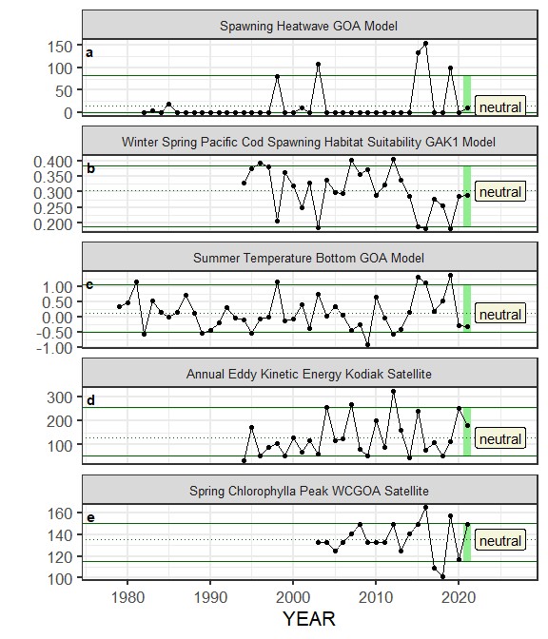

##### Figure ??. Selected ecosystem indicators for Sablefish with time series ranging from 1977 – present. Upper and lower solid green horizontal lines are 90th and 10th percentiles of time series. Dotted green horizontal line is the mean of the time series. Light green shaded areas represent the most recent year of the traffic light analysis results.

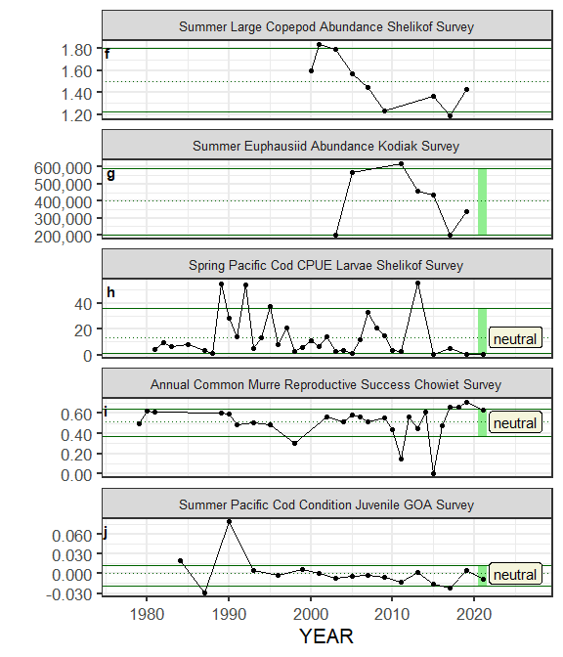

##### Figure ??. Selected ecosystem indicators for Sablefish with time series ranging from 1977 – present. Upper and lower solid green horizontal lines are 90th and 10th percentiles of time series. Dotted green horizontal line is the mean of the time series. Light green shaded areas represent the most recent year of the traffic light analysis results.

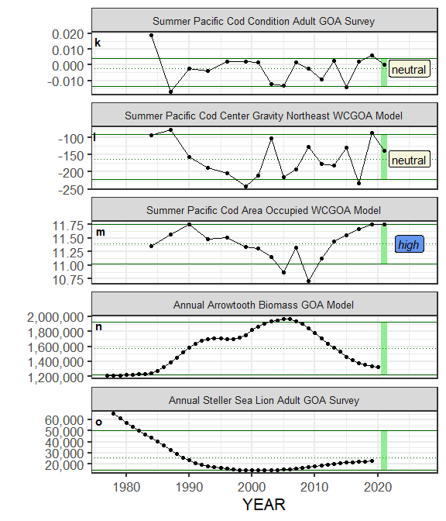

##### Figure ??. Selected ecosystem indicators for Sablefish with time series ranging from 1977 – present. Upper and lower solid green horizontal lines are 90th and 10th percentiles of time series. Dotted green horizontal line is the mean of the time series. Light green shaded areas represent the most recent year of the traffic light analysis results.

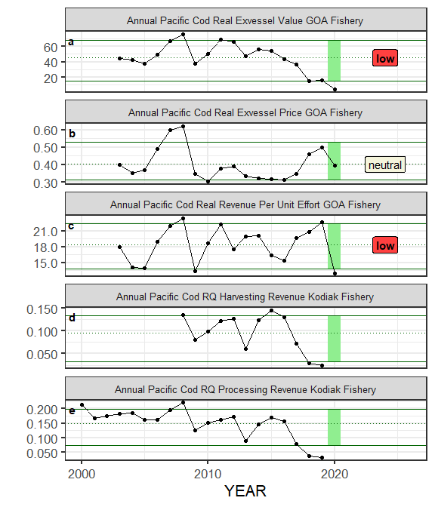

##### Figure ??. Selected socioeconomic indicators for Sablefish with time series ranging from 1977 – present. Upper and lower solid green horizontal lines are 90th and 10th percentiles of time series. Dotted green horizontal line is the mean of the time series. Light green shaded areas represent the most recent year of the traffic light analysis results.

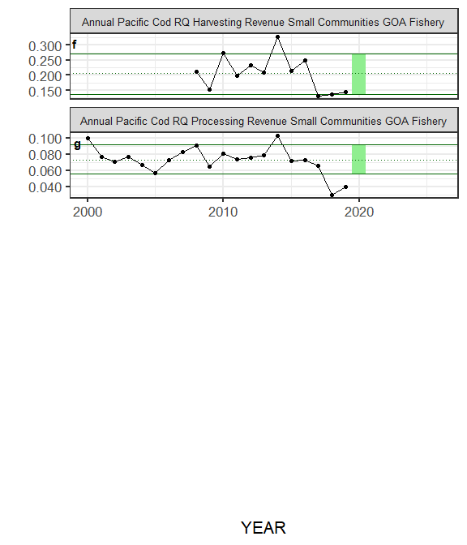

##### Figure ??. Selected socioeconomic indicators for Sablefish with time series ranging from 1977 – present. Upper and lower solid green horizontal lines are 90th and 10th percentiles of time series. Dotted green horizontal line is the mean of the time series. Light green shaded areas represent the most recent year of the traffic light analysis results.

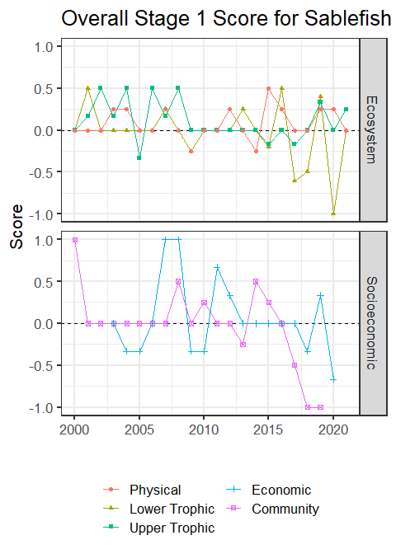

##### Figure 4. Simple traffic light score for overall ecosystem and socioeconomic categories from 1977 to present.



##### Figure 5. Bayesian adaptive sampling output showing (a) standardized covariates prior to subsetting and (b) the mean relationship and uncertainty (95% confidence intervals) with log Sablefish recruitment, in each estimated effect (left bottom graph), and marginal inclusion probabilities (right bottom graph) for each predictor variable of the subsetted covariate set