Appendix 1. Ecosystem and Socioeconomic Profile of the Red King Crab stock in the Bristol Bay - Report Card

Kalei Shotwell, Abby Tyrell

Draft 2021



*With Contributions from:*

Kalei Shotwell, Abby Tyrell

# Current Year Update

The ecosystem and socioeconomic profile or ESP is a standardized framework for compiling and evaluating relevant stock-specific ecosystem and socioeconomic indicators and communicating linkages and potential drivers of the stock within the stock assessment process (Shotwell et al., In Review). The ESP process creates a traceable pathway from the initial development of indicators to management advice and serves as an on-ramp for developing ecosystem-linked stock assessments. Please refer to the last full ESP and partial ESP documents for further information regarding the ecosystem and socioeconomic linkages for this stock (*list references*).

## Management Considerations

Summary conclusions from ESP for ABC (risk table)

## Modeling Considerations

Summary of indicators with high importance in the Bayesian adaptive sampling routine and discussion of which indicators have had consistent high importance. List of research ecosystem model runs that are currently ongoing and potential for operational use in the future.

# Assessment

## Ecosystem and Socioeconomic Processes

One paragraph description of ecosystem and socioeconomic (if available) conceptual model(s)

## Indicator Suite

One paragraph description of LME level indicators relevant to stock (ESR summary)

### Ecosystem Indicators:

1.) Upper Trophic Indicators

a.) Summer_Pacific_Cod_Biomass_BBRKC_Survey: Estimates of Pacific cod biomass were derived from the EBS bottom trawl survey catch data. (contact: Erin Fedewa)

b.) Summer_Benthic_Invertebrate_Biomass_BBRKC_Survey: . (contact: )

c.) Annual_Red_King_Crab_Recruit_Biomass_BBRKC_Model: . (contact: )

d.) Summer_Sockeye_Salmon_Abundance_EBS_Survey: . (contact: )

e.) Annual_Red_King_Crab_Catch_Distance_Shore_BBRKC_Fishery: . (contact: )

f.) Summer_Red_King_Crab_Area_Occupied_Male_BBRKC_Survey: . (contact: )

g.) Summer_Red_King_Crab_Area_Occupied_Female_BBRKC_Survey: . (contact: )

2.) Physical Indicators

a.) Summer_Cold_Pool_BBRKC_Survey: . (contact: )

b.) Summer_Temperature_Bottom_BBRKC_Survey: . (contact: )

c.) Summer_Wind_Stress_BBRKC_Satellite: . (contact: )

d.) Spring_Chlorophylla_Biomass_SEBS_Inner_Shelf_Satellite: . (contact: )

e.) Spring_pH_Index_BBRKC_Model: . (contact: )

f.) Winter_Spring_Arctic_Oscillation_Index_Model: . (contact: )

### Socioeconomic Indicators:

## Indicator Monitoring Analysis

References for statistical tests for monitoring indicator suite by stage where relevant

### Beginning Stage: Traffic Light Test

One paragraph summary of indicator status and trends over time and last five years trend Report scores by category (if applicable) and overall ecosystem and socioeconomic indicators.

### Intermediate Stage: Importance Test

One paragraph summary of importance results with analysis of highly explanatory variables for stock assessment input of interest (e.g., recruitment estimates)

### Advanced Stage: Research Model Test

Update on ecosystem linked model in development and link to relevant literature or report on model

# Data Gaps and Future Research Priorities

Copy from full ESP

# Tables

Table 1: First stage ecosystem indicator analysis for Red King Crab, including indicator title and the indicator status of the last five years. The indicator status is designated with text, (greater than = "high", less than = "low", or within 1 standard deviation = "neutral" of long-term mean). Fill color of the cell is based on the sign of the anticipated relationship between the indicator and sablefish (blue = good conditions for sablefish, red = poor conditions, white = average conditions). A gray fill and text = "missing" will appear if there were no data for that year.

| **Indicator category** | **Indicator** | **2017 Status** | **2018 Status** | **2019 Status** | **2020 Status** | **2021 Status** |
| --- | --- | --- | --- | --- | --- | --- |
| Physical | Spring Chlorophylla Biomass SEBS Inner Shelf Satellite | low | neutral | neutral | neutral | neutral |
| Spring pH Index BBRKC Model | neutral | neutral | neutral | low | low |
| Summer Cold Pool BBRKC Survey | neutral | low | low | NA | low |
| Summer Temperature Bottom BBRKC Survey | neutral | high | high | NA | neutral |
| Summer Wind Stress BBRKC Satellite | neutral | neutral | high | neutral | high |
| Winter Spring Arctic Oscillation Index Model | neutral | neutral | neutral | high | neutral |
| Upper Trophic | Annual Red King Crab Catch Distance Shore BBRKC Fishery | neutral | neutral | high | neutral | NA |
| Annual Red King Crab Recruit Biomass BBRKC Model | low | low | low | NA | low |
| Summer Benthic Invertebrate Biomass BBRKC Survey | neutral | neutral | neutral | NA | NA |
| Summer Pacific Cod Biomass BBRKC Survey | neutral | low | low | NA | NA |
| Summer Red King Crab Area Occupied Female BBRKC Survey | high | neutral | high | NA | high |
| Summer Red King Crab Area Occupied Male BBRKC Survey | high | high | high | NA | neutral |
| Summer Sockeye Salmon Abundance EBS Survey | NA | high | NA | NA | NA |

# Figures



#### Figure 1. Life history conceptual model for Red King Crab summarizing ecological information and key ecosystem processes affecting survival by life history stage. Red text means increases in process negatively affect survival, while blue text means increases in process positively affect survival.

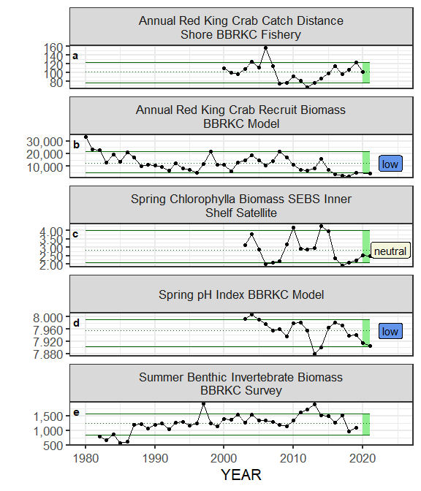

#### Figure ??. Selected indicators for Red King Crab with time series ranging from 1980 – present. Upper and lower solid green horizontal lines are 90th and 10th percentiles of time series. Dotted green horizontal line is the mean of the time series. Light green shaded areas represent the most recent year of the traffic light analysis results.

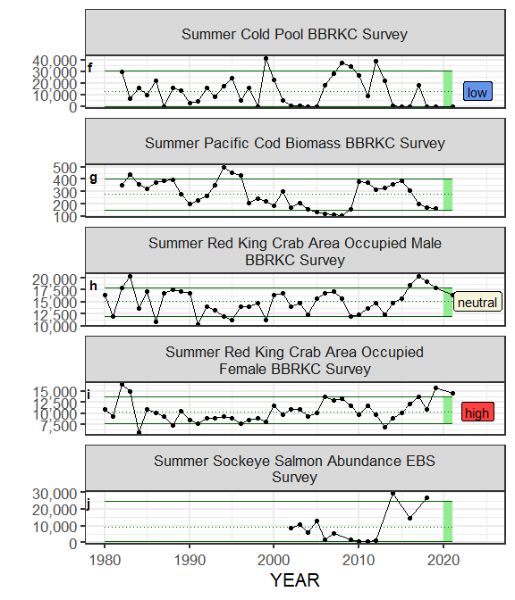

#### Figure ??. Selected indicators for Red King Crab with time series ranging from 1980 – present. Upper and lower solid green horizontal lines are 90th and 10th percentiles of time series. Dotted green horizontal line is the mean of the time series. Light green shaded areas represent the most recent year of the traffic light analysis results.

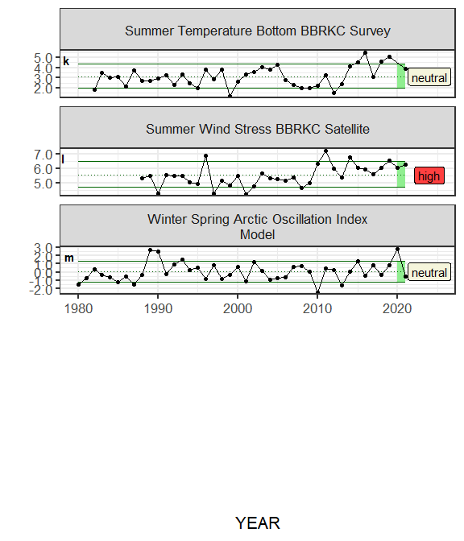

#### Figure ??. Selected indicators for Red King Crab with time series ranging from 1980 – present. Upper and lower solid green horizontal lines are 90th and 10th percentiles of time series. Dotted green horizontal line is the mean of the time series. Light green shaded areas represent the most recent year of the traffic light analysis results.

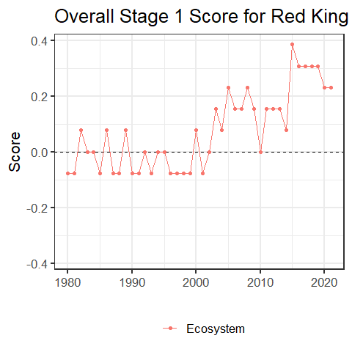

#### Figure 2. Simple traffic light score for overall ecosystem and socioeconomic categories from 1980 to present.



#### Figure 3. Bayesian adaptive sampling output showing (a) standardized covariates prior to subsetting and (b) the mean relationship and uncertainty (95% confidence intervals) with log Red King Crab recruitment, in each estimated effect (left bottom graph), and marginal inclusion probabilities (right bottom graph) for each predictor variable of the subsetted covariate set