Appendix 1. Ecosystem and Socioeconomic Profile of the Snow Crab stock in the Eastern Bering Sea

Erin Fedewa, Kalei Shotwell, Abby Tyrell

Draft 2022

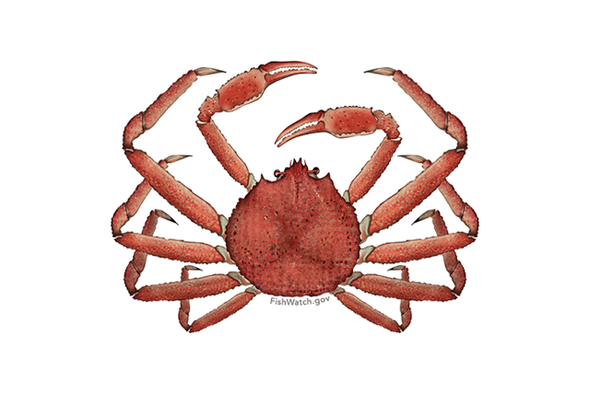

*With Contributions from:*

Kalei Shotwell, Abby Tyrell

# Executive Summary

National initiatives and North Pacific Fishery Management Council (NPFMC) recommendations suggest a high priority for conducting an ecosystem and socioeconomic profile (ESP) for the Eastern Bering Sea (Myabbrev) Snow Crab stock. In addition, annual guidelines for the Alaska Fisheries Science Center (AFSC) support research that improves our understanding of environmental and climate forcing of ecosystem processes with a focus on variables that can provide direct input into or improve stock assessment and management. The Myabbrev Snow Crab ESP follows the new standardized framework for evaluating ecosystem and socioeconomic considerations for Myabbrev Snow Crab, and may be considered a proving ground for potential use in the main stock assessment.

We use information from a variety of data streams available for the Myabbrev Snow Crab stock and present results of applying the ESP process through a metric and subsequent indicator assessment. Analysis of the ecosystem and socioeconomic processes for Myabbrev Snow Crab by life history stage along with information from the literature identified a suite of indicators for testing and continued monitoring within the ESP. Results of the metric and indicator assessment are summarized below as ecosystem and socioeconomic considerations that can be used for evaluating concerns in the main stock assessment or other management decisions.

## Ecosystem Considerations

Summary conclusions from metric or indicator assessment

## Socioeconomic Considerations

Summary conclusions from metric assessment or indicator assessment

## Responses to SSC and Plan Team Comments on ESPs in General

## Responses to SSC and Plan Team Comments Specific to this ESP

“The SSC noted the relatively strong correlations for snow crab and BBRKC with the Arctic Oscillation, and suggests this could be further explored to determine the mechanism. The SSC requests that the CPT or the crab assessment authors examine recruitment estimates across crab stocks to see if they share a common underlying pattern. The SSC recommends that an Ecosystem and Socioeconomic Profile (ESP) be developed for EBS snow crab as time allows that carefully considers what indicators directly affect this stock” (SSC, October 2020, pg. 16)

# Introduction

Ecosystem-based science is becoming a component of effective marine conservation and resource management; however, the gap remains between conducting ecosystem research and integrating it with the stock assessment. A consistent approach has been lacking for deciding when and how to incorporate ecosystem and socioeconomic information into a stock assessment and how to test the reliability of this information for identifying future change. This new standardized framework termed the ecosystem and socioeconomic profile (ESP) has recently been developed to serve as a proving ground for testing ecosystem and socioeconomic linkages within the stock assessment process [Shotwellinreview]. The ESP uses data collected from a variety of national initiatives, literature, process studies, and laboratory analyses in a four-step process to generate a set of standardized products that culminate in a focused, succinct, and meaningful communication of potential drivers on a given stock. The ESP process and products are supported in several strategic documents (Sigleretal2017; Dornetal2018; Lynchetal2018) and recommended by the NPFMC groundfish and crab Plan Teams and the Scientific and Statistical Committee (SSC).

This ESP for Myabbrev Snow Crab (Chionoecetes opilio) follows the template for ESPs [Shotwellinreview] and replaces the previous ecosystem considerations section in the main Myabbrev Snow Crab stock assessment and fishery evaluation (SAFE) report. Information from the original ecosystem considerations section may be found in Szuwalski (2021).

The ESP process consists of the following four steps:

Evaluate national initiative and stock assessment classification scores [Lynchetal2018] along with regional research priorities to assess the priority and goals for conducting an ESP.

Perform a metric assessment to identify potential vulnerabilities and bottlenecks throughout the life history of the stock and provide mechanisms to refine indicator selection.

Select a suite of indicators that represent the critical processes identified in the metric assessment and monitor the indicators using statistical tests appropriate for the data availability of the stock.

Generate the standardized ESP report following the guideline template and report ecosystem and socioeconomic considerations, data gaps, caveats, and future research priorities.

## Justification

National initiatives and NPFMC recommendations support conducting an ESP for the Myabbrev Snow Crab stock. The high commercial importance of the stock and the early life history habitat requirements created a high score for both stock assessment and habitat assessment prioritization (Hollowedetal2016; McConnaugheyetal2017). The vulnerability scores were in the low to moderate of all groundfish scores based on productivity, susceptibility [OrmsethSpencer2011], and sensitivity to future climate exposure [Spenceretal2019]. The new data classification scores for GOA Pacific cod suggest a data-rich stock with high quality data for catch, size/age composition, abundance, life history categories, and ecosystem linkages [Lynchetal2018]. These initiative scores and data classification levels suggest a high priority for conducting an ESP for Myabbrev Snow Crab particularly given the high level of life history information and current application of ecosystem linkages in the stock assessment model for natural mortality and catchability. Additionally, AFSC research priorities support studies that improve our understanding of environmental and climate forcing of ecosystem processes with focus on variables that provide direct input into stock assessment and management. Specifically, research that improves our understanding of Snow Crab dynamics in the Eastern Bering Sea.

## Data

Initially, information on Myabbrev Snow Crab was gathered through a variety of national initiatives that were conducted by AFSC personnel in 2015 and 2016. These include (but are not limited to) stock assessment prioritization, habitat assessment prioritization, climate vulnerability analysis, and stock assessment categorization. Data derived from this effort served as the initial starting point for developing the ESP metrics for stocks in the Bering Sea and Aleutian Islands (BSAI) and Gulf of Alaska (GOA) groundfish fishery management plans (FMP) and the BSAI king and tanner crab FMP. Please see (**Shotwellinreview?**), for more details.

Data used to generate ecosystem metrics and indicators for the Myabbrev Snow Crab ESP were collected from a variety of laboratory studies, remote sensing databases, fisheries surveys, regional reports and fishery observer data collections 1. Results from laboratory studies were specifically used to inform metrics and indicators relating to thermal tolerances, phenology and energetics across RKC life history stages. Larval indicator development utilized datasets from the NOAA Bering Arctic Subarctic Integrated Survey (BASIS) and blended satellite data products from NOAA, NASA and ESA. Data for late-juvenile through adult RKC stages were derived from the annual NOAA eastern Bering Sea bottom trawl survey and fishery observer data collected during the BBRKC fishery. Information on RKC habitat use was derived from essential fish habitat (EFH) model output and maps (Figure 3; Laman et al., 2017) as well as laboratory studies and collaborative RKC tagging efforts. Data from the NOAA Resource Ecology and Ecosystem Modeling (REEM) food habits database were used to determine species compositions of benthic predators on commercial crab species.

Data used to generate socioeconomic metrics and indicators were derived from fishery-dependent sources, including commercial landings data for BBRKC collected in ADFG fish tickets and the BSAI Crab Economic Data Report (EDR) database (both sourced from AKFIN), and effort statistics reported in the most recent ADFG Annual Management Report for BSAI shellfish fisheries estimated from ADF&G Crab Observer program data (Leon et al. 2017).

# Metrics Assessment

## National Metrics

Description of measures collected in the national initiatives relevant to the stock FMP

Description of ecosystem and socioeconomic stock vulnerabilities

Ecosystem metrics example: high recruitment variability (standard deviation of log recruitment estimates > 0.9), low fecundity, and small hatch size indicate vulnerabilities in early life

Socioeconomic metrics example: high commercial importance, high constituent demand indicate high value to fisheries and communities and vulnerability to fishing pressure

Graph of national initiative metric panel

## Ecosystem Processes

Data evaluated over ontogenetic shifts (e.g., embryo, larvae, juvenile, adult) may be helpful for identifying specific bottlenecks in productivity and relevant indicators for monitoring. As a first attempt, we summarized important ecosystem processes or potential bottlenecks across snow crab life history stages from the literature, process studies and laboratory rearing experiments. Details on why these processes were highlighted, as well as the potential relationship between ecosystem processes and stock productivity are described below.

After molting to maturity, female snow crab mate and extrude new egg clutches each spring, which remain attached to pleopods on the femaleâ€™s abdomen for a full year prior to hatching (Watson, 1970). Fecundity is positively correlated with female size, and primiparous females have a lower fecundity than multiparous females (Sainte-Marie, 1993). The optimal range for embryo development is 0 to 3°C, although laboratory studies indicate that incubation temperatures below 0°C can trigger diapause or a biennial reproduction cycle (Webb et al., 2007). Peak hatching of snow crab larvae occurs in April (Armstrong et al., 1981) and phyto-detritus may act as a chemical cue for larval release (Starr et al., 1994). Larval duration for each of the two zoeal stages is approximately 30 days (Incze et al., 1982). A longer larval stage associated with cooler temperatures may leave larvae more vulnerable to pelagic predators for a prolonged period. Furthermore, historical larval year-class failures have coincided with low zooplankton abundance over the middle shelf and low water column stability, suggesting that increased larval mortality is related to less favorable feeding conditions (Incze et al., 1987) and mismatches between larval release and the spring bloom (Somerton 1982). Likewise, laboratory studies suggest that relatively high prey densities are required for successful feeding in snow crab zoeae (Paul et al., 1979) Major predators of larval snow crab include yellowfin sole (Armstrong et al., 1980), walleye pollock, jellyfish and juvenile salmon (Kruse et al., 2007).

Snow crab larvae settle between late August to the end of October (Conan et al., 1992). Early benthic instars are cryptic and concentrate in shallow, cold water habitats (Lovrish et al., 1995; Murphy et al., 2010). Previous laboratory studies have shown that adequate energetic stores are prerequisites for molting, growth, and survival in snow crab early life history stages (e.g. Lovrich and Ouellet, 1994), indicating that variability in energetic reserves could represent a potential recruitment bottleneck in snow crab. Both settlement intensity and early benthic survival are likely critical determinants of year-class strength in snow crab (Sainte-Marie et al., 1996), and successful advection to areas of suitable temperature and muddy substrate are thought to be critical criteria for juvenile survival (Dionne et al., 2003). Density-dependence may also play a regulatory role due to high rates of cannibalism (Lovrich and Sainte-Marie 1997) and potential prey resource limitation in juvenile nurseries. Previous studies have shown that Pacific cod, sculpin, skates and halibut are major predators of juvenile snow crab (Livingston et al., 1993; Livingston and deReynier, 1996; Lang et al., 2003) and the cold pool may provide refuge from predators like Pacific cod that avoid waters less than 2°C (Ciannelli and Bailey, 2005). Juvenile snow crab are especially vulnerable to predation and cannibalism during and immediately following molting.

Spatial patterns in juvenile and adult snow crab distribution are determined largely by ontogenetic migrations linked to size- and sex-specific thermal requirements. Immature snow crab concentrate in colder, shallow waters of the NBS and EBS middle shelves, and have historically avoided thermal habitats >2°C (Kolts et al., 2015; Murphy, 2020). Likewise, primiparous female snow crab appear to track near-bottom temperature during a northeast to southwest ontogenetic migration to warmer waters near the shelf break (Ernst et al., 2005; Parada et al., 2010). Shifts in centers of distribution of mature female snow crab relative to prevailing currents may affect larval supply to nursery areas (Zheng and Kruse, 2006) and thermal occupancy patterns of snow crab depend on the availability of cold water habitat (Fedewa et al., 2020). While 2°C may represent a critical temperature threshold for immature snow crab (Murphy, 2020), negative effects on metabolic processes are not apparent in mature snow crab until temperatures exceed 7<U+25E6>C (Foyle et al., 1989). Temperature also influences molt timing (Dutil et al., 2010), growth rates (Yamamoto et al., 2015), energy stores (Hardy et al., 2000), and body condition (Dutil et al., 2010) of snow crab in the laboratory.

## Socioeconomic Processes

As described below, the set of socioeconomic indicators proposed in this ESP are categorized as Fishery Performance and Economic Performance and Community Effects indicators. Fishery Performance indicators are intended to represent processes most directly involved in prosecution of the EBS snow crab fishery, and thus have the potential to differentially affect the condition of the stock depending on how they influence the timing, spatial distribution, selectivity, and other aspects of fishing pressure. Economic Performance and Community Effects indicators are intended to capture key dimensions of the economic and social processes through which outputs, benefits and other effects flowing from commercial exploitation of the fishery are generated and distributed. Notwithstanding these categorical distinctions, the social and economic processes that affect, and are affected by, the condition of the stock are complex and interrelated at different time scales. Moreover, these processes are strongly influenced by the institutional structures of fishery management, which develop over time and include both discrete measures undertaken by in-season management, as well as comprehensive structural changes that induce complex, multidimensional change affecting numerous social and economic processes. Implementation of the Crab Rationalization (CR) Program in 2005 is an example of the latter (a full summary of the management history of the EBS snow crab fishery is beyond the scope of the ESP; see Nichols, et al., 2019).

A key distinction of most observable socioeconomic processes from ecosystem processes associated with the EBS snow crab fishery is that they occur during the fishery, and as such, cannot be captured in indicators that provide advance information for use in informing the current stock assessment. Moreover, data collection and monitoring of many aspects of socioeconomic processes is conducted following the fishing season such that the most recent available data point may be lagged by up to two years behind the current assessment. As such, in the context of the ESP, time series of socioeconomic indicators are largely limited to informing interpretation of historic patterns observed in other data series captured in the assessment, or to providing general context regarding the effects of historic fishery management.

Among other changes, the CR program resulted in rapid consolidation of the EBS snow crab fleet, from a high of 272 vessels in 1994 to 78 during the first year of the CR program, which has subsequently further consolidated to 59 vessels operating in the 2020/21 season. Allocation of tradable crab harvest quota shares, with leasing of annual harvest quota, facilitated fleet consolidation and improved operational and economic efficiency of the fleet, changing the timing of the fishery from short derby seasons to more extended seasons, and inducing extensive and ongoing changes in harvest sector ownership, employment, and income. Crab processing sector provisions of the CR program include allocation of transferable processing quota shares (PQS), leasing of annual processing quota and custom-processing arrangements that enable PQS holders that do not operate a processing plant to purchase IFQ crab landings and direct them to a processing plant for custom processing, and community protection measures, including regional designation on harvest quota, requiring associated catch to be landed to ports within a specified region. While these and other elements of CR program design facilitated similar operational and economic efficiencies in the sector, with more limited consolidation of processing capacity to somewhat fewer locations, and fewer plants in some ports, they have also limited some economic adjustments that would likely have occurred in their absence. Most notably, North regional designation of a large fraction of EBS snow crab IFQ has likely maintained a larger proportion of landings to St. Paul Island than would have occurred otherwise. St. Paul Island has historically and to-date received the largest share of EBS snow crab landings, with Akutan, King Cove, and Unalaska/Dutch Harbor representing the other principal landing ports for EBS landings historically and to-date. See the Councilâ€™s 10-Year Program Review for the CR Program for detailed description and analysis of program structure and management (Council, 2017).

These and other institutional changes continue to influence the geographic and inter-sectoral distribution of benefits produced by the EBS snow crab fleet, both through direct ownership and labor income in the EBS snow crab harvest and processing sectors, and indirect social and economic effects on fishery-dependent communities throughout Alaska and greater Pacific Northwest region. The full range of fishery, economic, and social processes cannot be captured within the scope of the ESP framework, and more comprehensive set of metrics and indicators intended to inform EBS snow crab fishery management and annual harvest specifications are provided in the annual Crab Economic SAFE.

# Indicators Assessment

## Indicator Suite

Brief literature review on ecosystem or socioeconomic indicators previously explored for stock that are currently available or updatable

### Ecosystem Indicators

1.) Physical Indicators

a.) Spring_Sea_Ice_Retreat_BS_Satellite: Anomalies of average daily sea-ice extent relative to 1978-2010 mean computed over ice-retreat season of March through May (contact: Muyin Wang)

Status and trends: NA

Influential factors: NA

b.) Summer_Cold_Pool_SEBS_Survey: The areal extent of EBS bottom trawl survey stations with bottom temperatures < 2Â¿ (contact: Erin Fedewa)

Status and trends: TBD

Influential factors: The cold pool provides predator refuge for juvenile snow crab and cold water habitat availability (< 2Â¿Â°C) has been proposed as a critical recruitment bottleneck (Dionne et al., 2003; Parada et al., 2010)

c.) Winter_Spring_Arctic_Oscillation_Index_Model: Winter-spring Arctic Oscillation index from the NOAA National Climate Data Center (contact: Erin Fedewa)

Status and trends: TBD

Influential factors: Poor snow crab recruitment is associated with positive values of the Arctic Oscillation

2.) Lower Trophic Indicators

a.) AMJ_Chlorophylla_Biomass_SEBS_Satellite: Derived chlorophyll a concentration during spring and summer season (April, May, June) in the northern middle southeastern Bering Sea from the MODIS satellite (contact: Jens Nielsen)

Status and trends: TBD

Influential factors: Larval growth and survival is dependent on high concentrations of diatoms (Paul et al., 1979)

b.) Summer_Benthic_Invertebrate_Biomass_SEBS_Survey: Species included in the benthic invertebrate biomass indicator (i.e. brittle stars, sea stars, sea cucumber, bivalves, non-commercial crab species, shrimp and polychaetes) are important prey sources for snow crab. Biomass estimates were determined from the EBS bottom trawl survey catch data for southeastern Bering Sea. (contact: Erin Fedewa)

Status and trends: TBD

Influential factors: Food availability may drive patterns in growth, energetic condition and survival of snow crab

3.) Upper Trophic Indicators

a.) Annual_Snow_Crab_Male_Size_Maturity_Model: Mean carapace width of male snow crab at 50% probability of maturation, as determined from maturity curves developed from EBS bottom trawl survey data (contact: Jon Richar)

Status and trends: TBD

Influential factors: Female size at maturity may be indicative of reproductive potential as fecundity increases with increasing female size

b.) Summer_Snow_Crab_Consumption_Pacific_cod_Model: The daily summer consumption of snow crab by Pacific cod in the EBS, estimated from Pacific cod diet compositions, EBS trawl survey CPUE, and temperature adjusted length-specific maximum consumption rates (contact: Kerim Aydin)

Status and trends: TBD

Influential factors: Pacific cod predation is a major source of immature snow crab mortality (Livingston, 1989) and in the past, geographic range contraction of snow crab has been attributed to cod predation (Orensanz et al., 2004).

c.) Summer_Snow_Crab_Female_Juvenile_Temperature_Occupancy: Mean bottom temperature weighted by immature female snow crab CPUE at each station of the EBS summer bottom trawl survey (contact: Erin Fedewa)

Status and trends: TBD

Influential factors: Immature female snow crab are highly sensitive to bottom temperatures and 2Â°C is an important maximum temperature threshold (Dionne et al., 2003; Murphy 2020).

d.) Summer_Snow_Crab_Juvenile_Disease_Prevalence: Prevalence of immature snow crab showing visual evidence of Bitter Crab Syndrome during the summer EBS bottom trawl survey (contact: Erin Fedewa)

Status and trends: TBD

Influential factors: Disease prevalence serves as an indicator of stock health because mortality rates of parasitized crab are believed to be high (Meyers and Burton 2009).

e.) Summer_Snow_Crab_Male_Area_Occupied_SEBS_Survey: Calculated as the minimum area containing 95% of the cumulative male snow crab CPUE during the EBS summer bottom trawl survey (contact: Erin Fedewa)

Status and trends: TBD

Influential factors: Shifts in the spatial extent of snow crab are driven by bottom temperatures and cold pool dynamics in the EBS (Fedewa et al., 2020).

f.) Summer_Snow_Crab_Male_Center_Distribution_SEBS_Survey: CPUE-weighted average latitude of the male snow crab stock during the EBS summer bottom trawl survey (contact: Erin Fedewa)

Status and trends: TBD

Influential factors: Shifts in stock centers may indicate temperature-driven shifts northward, or contraction of north-to-south ontogenetic migrations driven by thermal preferences (Orensanz et al., 2004).

### Socioeconomic Indicators

1.) Fishery Performance Indicators

a.) Annual_Snow_Crab_Active_Vessels_EBS_Fishery: Annual number of active vessels in the snow crab fishery to represent the level of fishing effort assigned to the fishery (contact: Brian Garber-Yonts)

Status and trends: TBD

Influential factors: TBD

b.) Annual_Snow_Crab_CPUE_Fishery: Annual catch-per-unit-effort (CPUE), expressed as mean number of crabs per potlift, in the snow crab fishery to represent relative efficiency of fishing effort (contact: Ben Daly)

Status and trends: TBD

Influential factors: TBD

c.) Annual_Snow_Crab_Center_Distribution_EBS_Fishery: Center of gravity, expressed in latitude, as an indices of spatial distribution for the snow crab fishery to monitor spatial shifts in fishery behavior (contact: Ben Daly)

Status and trends: TBD

Influential factors: TBD

d.) Annual_Snow_Crab_Incidental_Catch_EBS_Fishery: Annual incidental catch of snow crab in other fisheries (contact: Brian Garber-Yonts)

Status and trends: TBD

Influential factors: TBD

e.) Annual_Snow_Crab_Potlift_Fishery: Annual total potlifts in the snow crab fishery to represent the level of fishing effort expended by the active fleet (contact: Ben Daly)

Status and trends: TBD

Influential factors: TBD

2.) Economic Indicators

a.) Annual_Snow_Crab_Exvessel_Price_EBS_Fishery: Annual snow crab ex-vessel price per pound represents per-unit economic returns to the harvest sector, as a principal driver of fishery behavior (contact: Brian Garber-Yonts)

Status and trends: TBD

Influential factors: TBD

b.) Annual_Snow_Crab_Exvessel_Revenue_Share_EBS_Fishery: Annual snow crab ex-vessel revenue share, expressed as vessel-average proportion of annual gross landings revenue earned from the EBS snow crab fishery (contact: Brian Garber-Yonts)

Status and trends: TBD

Influential factors: TBD

c.) Annual_Snow_Crab_Exvessel_Value_EBS_Fishery: Annual snow crab ex-vessel value of the snow crab fishery landings represents gross economic returns to the harvest sector, as a principal driver of fishery behavior (contact: Brian Garber-Yonts)

Status and trends: TBD

Influential factors: TBD

3.) Community Indicators

## Indicator Monitoring Analysis

Description of statistical tests for monitoring indicator suite by stage where relevant (Stage 1: scoring test, Stage 2: importance test, Stage 3: modeling test)

Supportive graphs and/or tables of statistical tests where relevant

# Recommendations

Summary of main considerations separated by ecosystem and socioeconomic categories

## Ecosystem Considerations

Summary conclusions from metric assessment

Summary conclusions from indicator assessment

## Economic Considerations

Summary conclusions from metric assessment

Summary conclusions from indicator assessment

## Data Gaps and Future Research Priorities

Description of data gaps, future priorities for ecosystem and socioeconomic research that would support future versions of the ESP

# Acknowledgements

Include contributors, internal reviewers, Groundfish/Crab Plan Teams, SSC, AFSC personnel and divisions, other state, national, international contributing agencies

# Literature Cited

Include reference numbers at the end of the citations from the life history table

Include DOI or links to papers where possible

# Tables

Table 1: table of data used in the esp

| **X** | **Y** |
| --- | --- |
| A | 1 |
| B | 2 |
| C | 3 |

Table 2: First stage ecosystem indicator analysis for Snow Crab, including indicator title and the indicator status of the last five years. The indicator status is designated with text, (greater than = “high,” less than = “low,” or within 1 standard deviation = “neutral” of long-term mean). Fill color of the cell is based on the sign of the anticipated relationship between the indicator and sablefish (blue = good conditions for sablefish, red = poor conditions, white = average conditions). A gray fill and text = “missing” will appear if there were no data for that year.

| **Indicator category** | **Indicator** | **2018 Status** | **2019 Status** | **2020 Status** | **2021 Status** |
| --- | --- | --- | --- | --- | --- |
| Physical | Winter Spring Arctic Oscillation Index Model | neutral | neutral | **high** | neutral |
| Summer Cold Pool SEBS Survey | **low** | **low** | NA | **low** |
| Spring Sea Ice Retreat BS Satellite | **low** | **low** | neutral | NA |
| Lower Trophic | AMJ Chlorophylla Biomass SEBS Satellite | neutral | neutral | *high* | neutral |
| Summer Benthic Invertebrate Biomass SEBS Survey | neutral | neutral | NA | *high* |
| Upper Trophic | Summer Snow Crab Female Juvenile Temperature Occupancy | **high** | neutral | NA | **high** |
| Summer Snow Crab Juvenile Disease Prevalence | neutral | neutral | NA | neutral |
| Annual Snow Crab Male Size Maturity Model | **low** | neutral | NA | **low** |
| Summer Snow Crab Male Area Occupied SEBS Survey | neutral | **low** | NA | neutral |
| Summer Snow Crab Male Center Distribution SEBS Survey | neutral | neutral | NA | *high* |
| Summer Snow Crab Consumption Pacific cod Model | **high** | neutral | NA | NA |

Table 3: First stage socioeconomic indicator analysis for Snow Crab, including indicator title and the indicator status of the last five years. The indicator status is designated with text, (greater than = “high,” less than = “low,” or within 1 standard deviation = “neutral” of long-term mean). Fill color of the cell is based on the sign of the anticipated relationship between the indicator and sablefish (blue = good conditions for sablefish, red = poor conditions, white = average conditions). A gray fill and text = “missing” will appear if there were no data for that year.

| **Indicator category** | **Indicator** | **2018 Status** | **2019 Status** | **2020 Status** | **2021 Status** | **2022 Status** |
| --- | --- | --- | --- | --- | --- | --- |
| Fishery Performance | Annual Snow Crab Active Vessels EBS Fishery | neutral | neutral | neutral | neutral | low |
| Annual Snow Crab CPUE Fishery | neutral | neutral | neutral | neutral | NA |
| Annual Snow Crab Potlift Fishery | neutral | neutral | neutral | neutral | NA |
| Annual Snow Crab Center Distribution EBS Fishery | neutral | high | neutral | high | NA |
| Annual Snow Crab Incidental Catch EBS Fishery | neutral | neutral | neutral | neutral | neutral |
| Economic | Annual Snow Crab Exvessel Value EBS Fishery | neutral | neutral | neutral | NA | NA |
| Annual Snow Crab Exvessel Price EBS Fishery | high | high | high | NA | NA |
| Annual Snow Crab Exvessel Revenue Share EBS Fishery | neutral | neutral | high | NA | NA |

# Figures

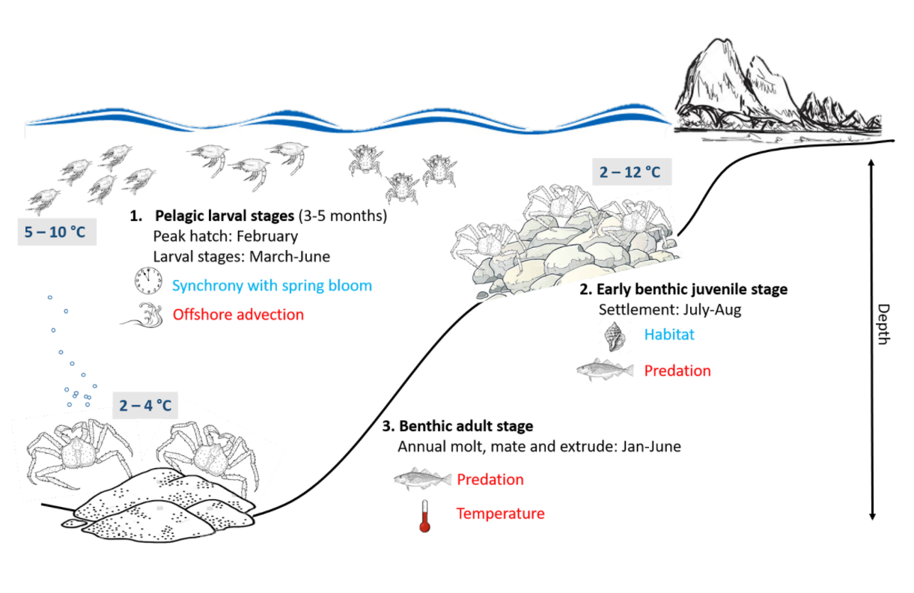

##### Figure 1. Life history conceptual model for Snow Crab summarizing ecological information and key ecosystem processes affecting survival by life history stage. Red text means increases in process negatively affect survival, while blue text means increases in process positively affect survival.

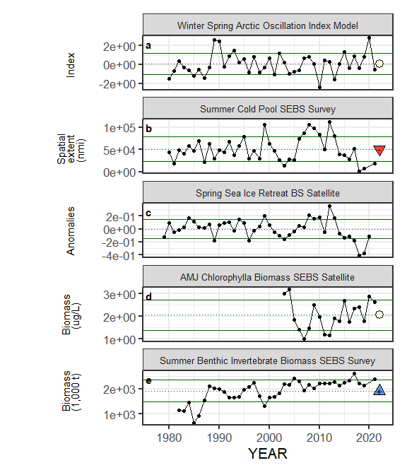

##### Figure 2. Selected ecosystem indicators for Snow Crab with time series ranging from 1977 – present. Upper and lower solid green horizontal lines are plus and minus one standard deviation of the time series mean. Dotted green horizontal line is the mean of the time series.

##### 

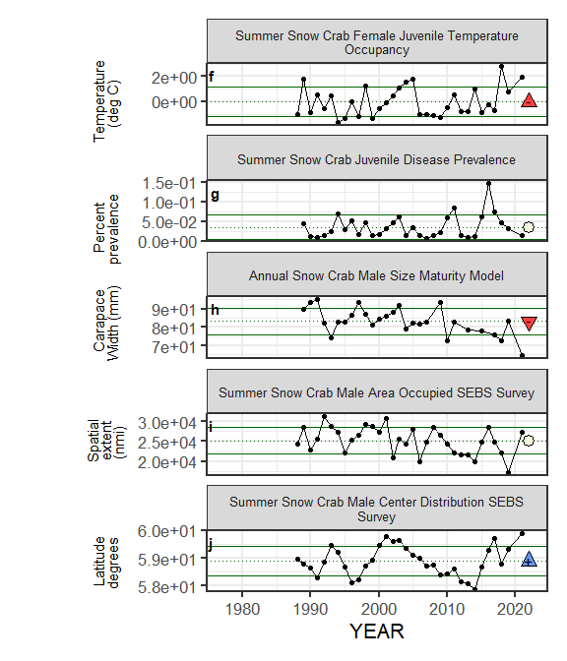

##### Figure 2. Selected ecosystem indicators for Snow Crab with time series ranging from 1977 – present. Upper and lower solid green horizontal lines are plus and minus one standard deviation of the time series mean. Dotted green horizontal line is the mean of the time series.

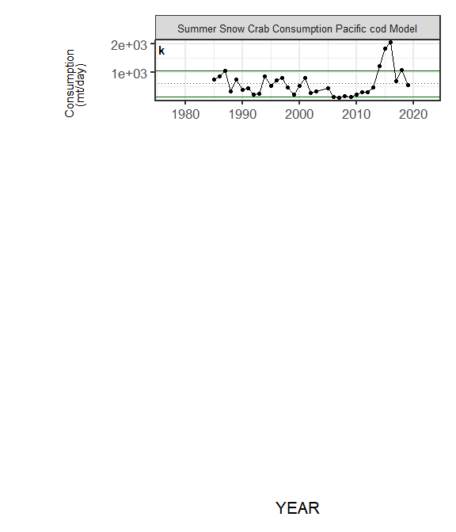

##### Figure 2. Selected ecosystem indicators for Snow Crab with time series ranging from 1977 – present. Upper and lower solid green horizontal lines are plus and minus one standard deviation of the time series mean. Dotted green horizontal line is the mean of the time series.

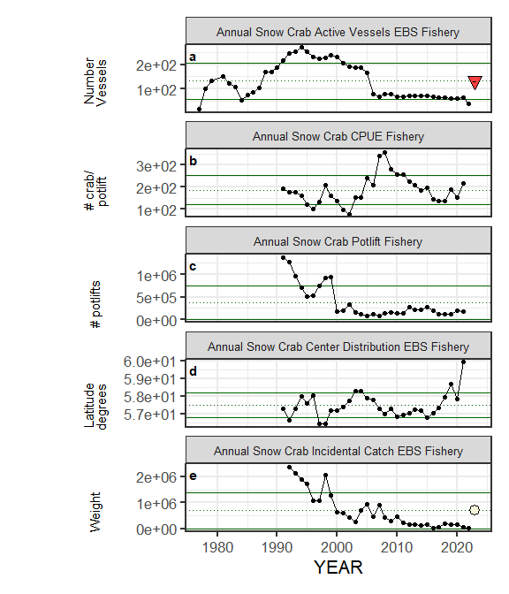

##### Figure 3. Selected socioeconomic indicators for Snow Crab with time series ranging from 1977 – present. Upper and lower solid green horizontal lines are plus and minus one standard deviation of the time series mean. Dotted green horizontal line is the mean of the time series.

##### 

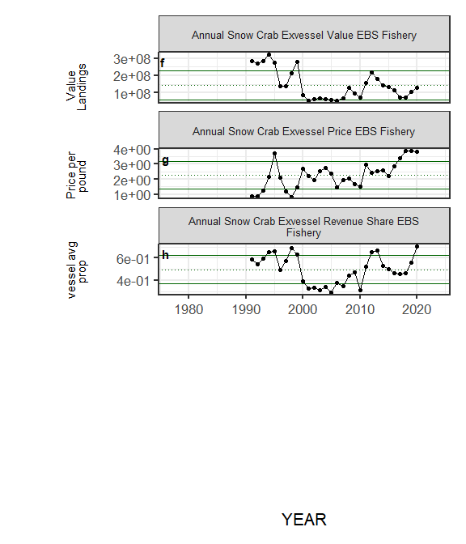

##### Figure 3. Selected socioeconomic indicators for Snow Crab with time series ranging from 1977 – present. Upper and lower solid green horizontal lines are plus and minus one standard deviation of the time series mean. Dotted green horizontal line is the mean of the time series.

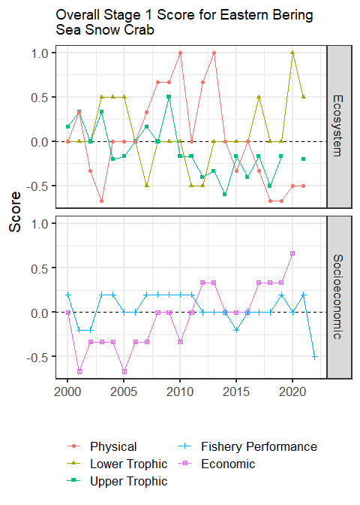

##### Figure 4. Selected socioeconomic indicators for Snow Crab with time series ranging from 1977 – present. Upper and lower solid green horizontal lines are plus and minus one standard deviation of the time series mean. Dotted green horizontal line is the mean of the time series.

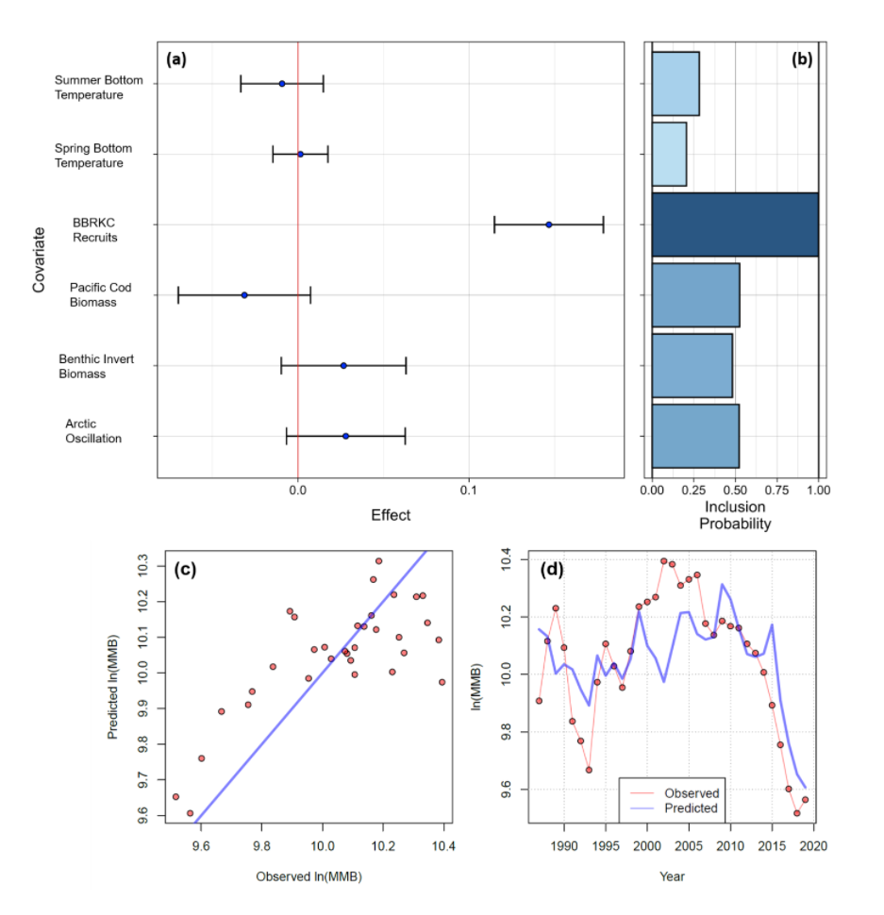

##### Figure 5. Bayesian adaptive sampling output showing (a) standardized covariates prior to subsetting and (b) the mean relationship and uncertainty (95% confidence intervals) with log Snow Crab recruitment, in each estimated effect (left bottom graph), and marginal inclusion probabilities (right bottom graph) for each predictor variable of the subsetted covariate set