Appendix 1. Ecosystem and Socioeconomic Profile of the Sablefish stock in the Alaska - Partial Update

Kalei Shotwell, Abby Tyrell

Draft 2022



*With Contributions from:*

Kalei Shotwell, Abby Tyrell

# Executive Summary

Short description of ESP process and justification for conducting an ESP for this stock (this will likely be consistent text for all partial ESPs) Please refer to the last full ESP document for further information regarding the ecosystem and socioeconomic linkages for this stock (Citation, available online at <https://â>€¦pdf).

## Summary of Changes in Assessment Inputs

### Changes in the Metric or Indicator Data

Brief summary of any changes to metric or indicator data from the most recent full ESP document. This may occur if you had a placeholder metric or indicator and were waiting for a more suited proxy to be finalized and became available during a partial update year.

### Changes in the Indicator Analysis

Brief summary of any changes to the indicator analysis from the most recent full ESP document. Generally there would not be changes in a partial ESP unless you were requested to make changes by the Plan Team, SSC, or Council or if the methods changed slightly for the ESPs based on recommendations from the Plan Team, SSC, or Council (e.g.Â addition of the traffic light score)

## Summary of Results

Brief literature review on any new ecosystem or socioeconomic indicators explored for stock since the last full ESP

### Indicator Suite

List of ecosystem indicators ordered by category (physical, zooplankton, larvae and young-of-the-year, juvenile, and adult). If the indicator occurred in the last full ESP, then just list the name of the indicator and reference the full ESP document. If the indicator was a replacement and is new, then provide a description as in the full document.

List of socioeconomic indicators ordered by category (fishery performance, economic, community). If the indicator occurred in the full ESP, then just list the name of the indicator and reference the full ESP document. If the indicator was a replacement and is new, then provide a description as in the full document.

Graph of indicator time series panel, same as in full document

### Indicator Analysis

Short description of three indicator analysis stages, 1) traffic light test, 2) importance test, 3) linked model test. If you only have one or two tests, just include the descriptions for those.

#### Stage 1: Traffic Light Test

Short description of test, reference to full ESP for more details

Summary of indicator changes from last full ESP, current trends

Report scores by category (if applicable) and overall ecosystem and socioeconomic indicators.

#### Stage 2: Importance Test

Short description of test, reference to full ESP for more details

Report update in importance results from last full ESP

#### Stage 3: Linked Model Test

Short description of ecosystem linked model and reference to model development report or paper

Updated performance table with comparison to current author recommended model, where applicable

If the performance table has not been completed but there is an ecosystem linked model in development, just describe here and state the plan for results to be presented in future ESP.

Table of indicators including short description, source or contact, recent trend (plus, minus, average), color for current year corresponding to relationship to stock (good=blue, stable=white, poor=red) and then category and overall simple score

Updated importance run output, where applicable

Updated comparison table for ecosystem linked assessment model run, where applicable

## Ecosystem Considerations

Updated summary conclusions from full metric assessment

Updated summary conclusions from full indicator assessment

## Economic Considerations

Updated summary conclusions from full metric assessment

Updated summary conclusions from full indicator assessment

## Data Gaps and Future Research Priorities

Description of data gaps, future priorities for ecosystem and socioeconomic research that would support future versions of the ESP

## Responses to SSC and Plan Team Comments on ESPs in General

List of general ESP comments since last full ESP, not required to respond but may if can do in a short paragraph or just state will respond in next full ESP

## Responses to SSC and Plan Team Comments Specific to this ESP

List of stock-specific ESP comments since last full ESP, not required to respond but may if can do in a short paragraph or just state will respond in next full ESP

# Acknowledgements

Include contributors, internal reviewers, Groundfish/Crab Plan Teams, SSC, AFSC personnel and divisions, other state, national, international contributing agencies

# Literature Cited

Include reference numbers at the end of the citations from the life history table

Include DOI or links to papers where possible

# Tables

Table 1: An example table

| **X** | **Y** |
| --- | --- |
| A | 1 |
| B | 2 |
| C | 3 |

Table 2: First stage ecosystem indicator analysis for Sablefish, including indicator title and the indicator status of the last five years. The indicator status is designated with text, (greater than = “high,” less than = “low,” or within 1 standard deviation = “neutral” of long-term mean). Fill color of the cell is based on the sign of the anticipated relationship between the indicator and sablefish (blue = good conditions for sablefish, red = poor conditions, white = average conditions). A gray fill and text = “missing” will appear if there were no data for that year.

| **Indicator category** | **Indicator** | **2018 Status** | **2019 Status** | **2020 Status** | **2021 Status** |
| --- | --- | --- | --- | --- | --- |
| Physical | Annual Heatwave GOA Model | neutral | *high* | neutral | neutral |
| Spring Temperature Surface EGOA Satellite | neutral | *high* | neutral | neutral |
| Spring Temperature Surface SEBS Satellite | *high* | *high* | *high* | neutral |
| Summer Temperature 250m GOA Survey | neutral | neutral | neutral | neutral |
| Lower Trophic | Spring Chlorophylla Biomass EGOA Satellite | neutral | neutral | **low** | neutral |
| Spring Chlorophylla Biomass SEBS Satellite | neutral | **low** | neutral | neutral |
| Spring Chlorophylla Peak EGOA Satellite | *low* | neutral | *low* | neutral |
| Spring Chlorophylla Peak SEBS Satellite | **high** | neutral | neutral | neutral |
| Annual Copepod Community Size EGOA Survey | **low** | **low** | neutral | NA |
| Annual Copepod Community Size WGOA Survey | **low** | *high* | neutral | NA |
| Summer Euphausiid Abundance Kodiak Survey | NA | neutral | NA | NA |
| Annual Sablefish Growth YOY Middleton Survey | neutral | *high* | neutral | neutral |
| Upper Trophic | Summer Sablefish CPUE Juvenile Nearshore GOAAI Survey | *high* | *high* | *high* | *high* |
| Summer Sablefish CPUE Juvenile GOA Survey | NA | neutral | NA | neutral |
| Annual Sablefish Mean Age Female Adult Model | neutral | **low** | **low** | NA |
| Annual Sablefish Age Evenness Female Adult Model | **low** | **low** | **low** | NA |
| Summer Sablefish Condition Female Age4 GOA Survey | neutral | **low** | neutral | NA |
| Annual Arrowtooth Biomass GOA Model | neutral | neutral | neutral | NA |
| Annual Sablefish Incidental Catch Arrowtooth Target GOA Fishery | **high** | **high** | neutral | neutral |
| Summer Sablefish Condition Female Adult GOA Survey | neutral | neutral | neutral | neutral |

Table 3: First stage socioeconomic indicator analysis for Sablefish, including indicator title and the indicator status of the last five years. The indicator status is designated with text, (greater than = “high,” less than = “low,” or within 1 standard deviation = “neutral” of long-term mean). Fill color of the cell is based on the sign of the anticipated relationship between the indicator and sablefish (blue = good conditions for sablefish, red = poor conditions, white = average conditions). A gray fill and text = “missing” will appear if there were no data for that year.

| **Indicator category** | **Indicator** | **2018 Status** | **2019 Status** | **2020 Status** | **2021 Status** |
| --- | --- | --- | --- | --- | --- |
| Fishery Performance | Annual Sablefish Longline CPUE GOA Fishery | low | low | neutral | neutral |
| Annual Sablefish Pot CPUE EBS Fishery | neutral | high | high | high |
| Annual Sablefish Incidental Catch GOA Fishery | high | high | high | low |
| Annual Sablefish Incidental Catch BSAI Fishery | neutral | high | high | high |
| Annual Sablefish Condition Female Adult GOA Fishery | neutral | neutral | high | low |
| Annual Sablefish Condition Female Adult BSAI Fishery | NA | NA | NA | NA |
| Economic | Annual Sablefish Real Exvessel Value Fishery | neutral | low | low | NA |
| Annual Sablefish Real Exvessel Price Fishery | neutral | low | low | NA |

# Figures



##### Figure 1. The NOAA logo.



##### Figure 2. Life history conceptual model for Sablefish summarizing ecological information and key ecosystem processes affecting survival by life history stage. Red text means increases in process negatively affect survival, while blue text means increases in process positively affect survival.

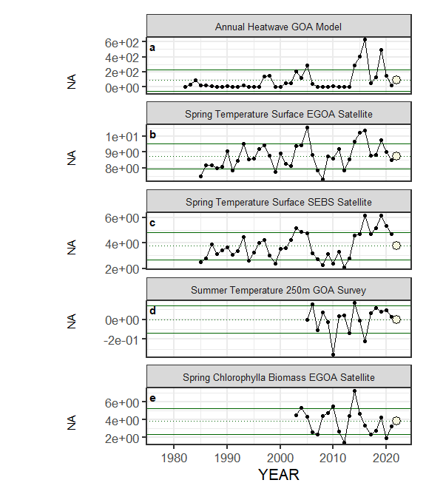

##### Figure 3. Selected ecosystem indicators for Sablefish with time series ranging from 1977 – present. Upper and lower solid green horizontal lines are plus and minus one standard deviation of the time series mean. Dotted green horizontal line is the mean of the time series.

##### Figure 3. Selected ecosystem indicators for Sablefish with time series ranging from 1977 – present. Upper and lower solid green horizontal lines are plus and minus one standard deviation of the time series mean. Dotted green horizontal line is the mean of the time series.

##### Figure 3. Selected ecosystem indicators for Sablefish with time series ranging from 1977 – present. Upper and lower solid green horizontal lines are plus and minus one standard deviation of the time series mean. Dotted green horizontal line is the mean of the time series.

##### Figure 3. Selected ecosystem indicators for Sablefish with time series ranging from 1977 – present. Upper and lower solid green horizontal lines are plus and minus one standard deviation of the time series mean. Dotted green horizontal line is the mean of the time series.

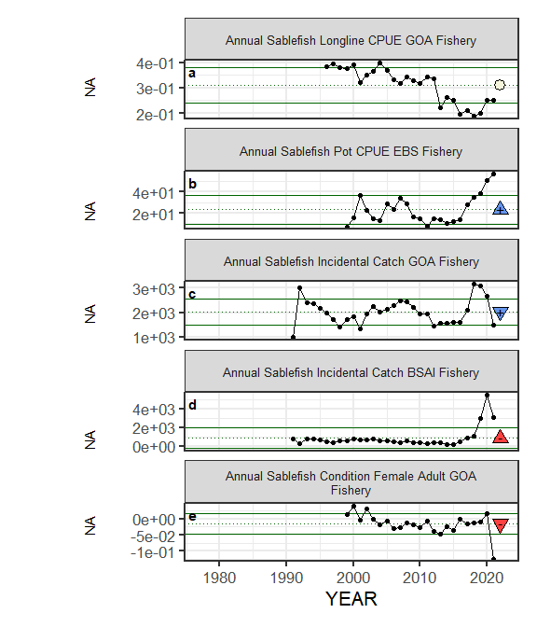

##### Figure 4. Selected socioeconomic indicators for Sablefish with time series ranging from 1977 – present. Upper and lower solid green horizontal lines are plus and minus one standard deviation of the time series mean. Dotted green horizontal line is the mean of the time series.

##### Figure 4. Selected socioeconomic indicators for Sablefish with time series ranging from 1977 – present. Upper and lower solid green horizontal lines are plus and minus one standard deviation of the time series mean. Dotted green horizontal line is the mean of the time series.

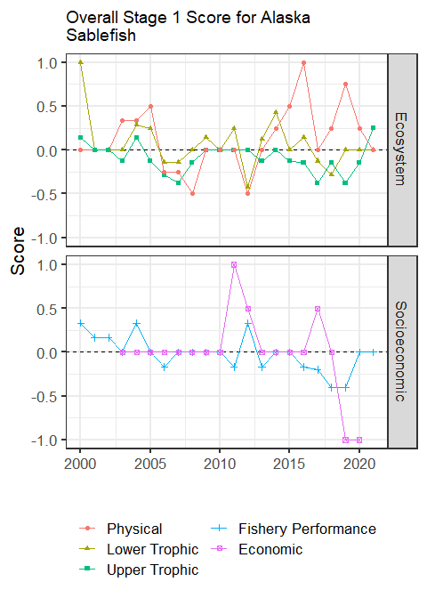

##### Figure 5. Selected socioeconomic indicators for Sablefish with time series ranging from 1977 – present. Upper and lower solid green horizontal lines are plus and minus one standard deviation of the time series mean. Dotted green horizontal line is the mean of the time series.



##### Figure 6. Bayesian adaptive sampling output showing (a) standardized covariates prior to subsetting and (b) the mean relationship and uncertainty (95% confidence intervals) with log Sablefish recruitment, in each estimated effect (left bottom graph), and marginal inclusion probabilities (right bottom graph) for each predictor variable of the subsetted covariate set

## 0.1 Full ecosystem traffic figures

Manually move these to their proper location above



##### Figure 3. Selected ecosystem indicators for Sablefish with time series ranging from 1977 – present. Upper and lower solid green horizontal lines are plus and minus one standard deviation of the time series mean. Dotted green horizontal line is the mean of the time series.

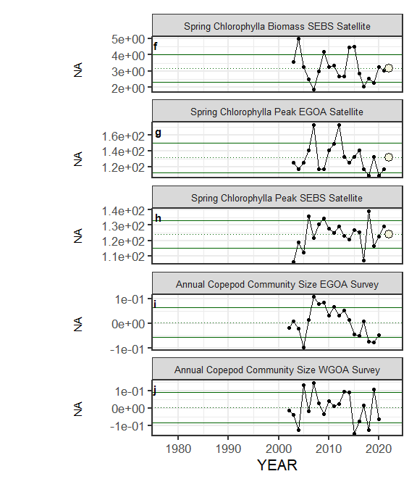

##### Figure 3. Selected ecosystem indicators for Sablefish with time series ranging from 1977 – present. Upper and lower solid green horizontal lines are plus and minus one standard deviation of the time series mean. Dotted green horizontal line is the mean of the time series.

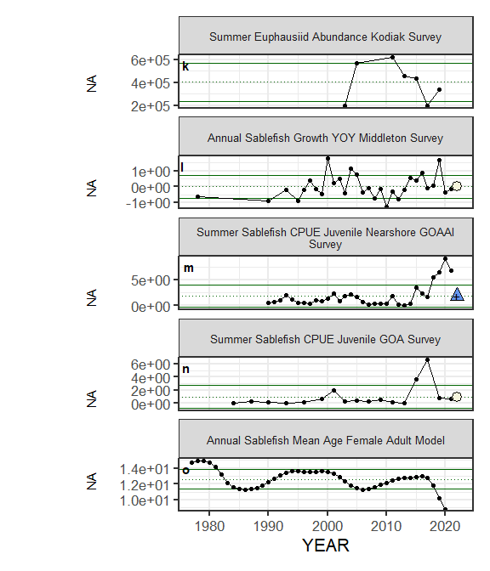

##### Figure 3. Selected ecosystem indicators for Sablefish with time series ranging from 1977 – present. Upper and lower solid green horizontal lines are plus and minus one standard deviation of the time series mean. Dotted green horizontal line is the mean of the time series.

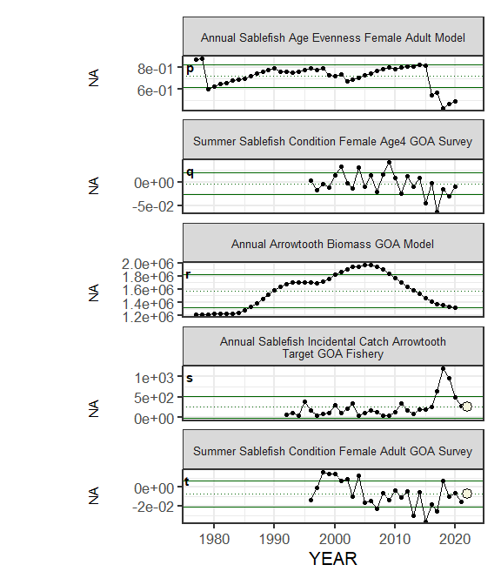

##### Figure 3. Selected ecosystem indicators for Sablefish with time series ranging from 1977 – present. Upper and lower solid green horizontal lines are plus and minus one standard deviation of the time series mean. Dotted green horizontal line is the mean of the time series.

## 0.2 Full socioeconomic traffic figures

Manually move these to their proper location above



##### Figure 4. Selected socioeconomic indicators for Sablefish with time series ranging from 1977 – present. Upper and lower solid green horizontal lines are plus and minus one standard deviation of the time series mean. Dotted green horizontal line is the mean of the time series.

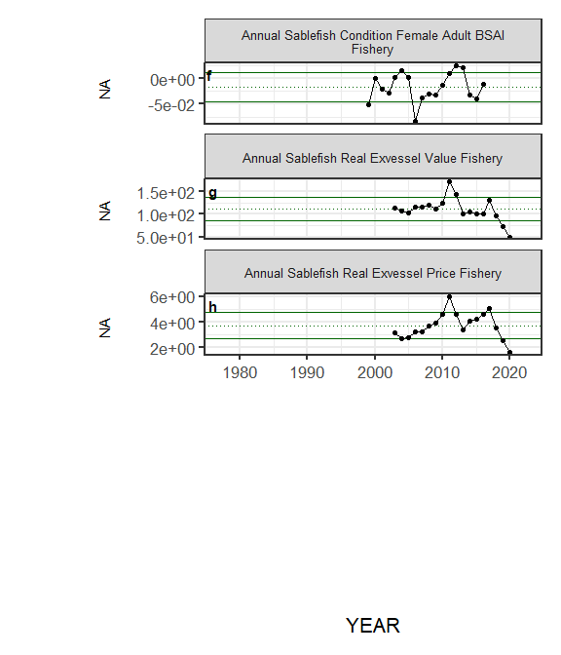

##### Figure 4. Selected socioeconomic indicators for Sablefish with time series ranging from 1977 – present. Upper and lower solid green horizontal lines are plus and minus one standard deviation of the time series mean. Dotted green horizontal line is the mean of the time series.