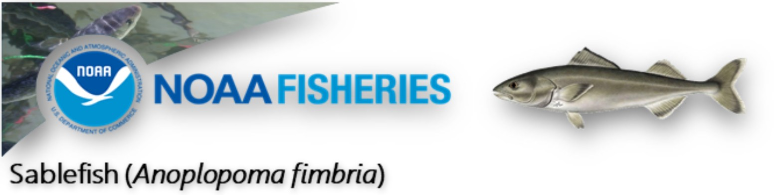

2e+00

0e+00

−2e+00

2e−01

0e+00

−2e−01

−4e−01

# Indicators

1e+05

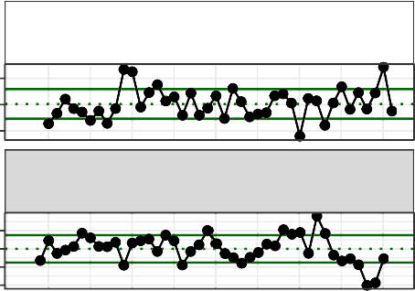

Spring Sea Ice Retreat BS Satellite

Winter Spring Arctic Oscillation Index Model

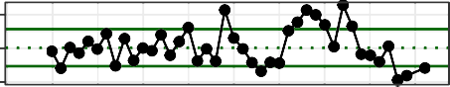

Summer Cold Pool SEBS Survey

5e+04

0e+00

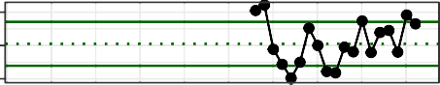

AMJ Chlorophylla Biomass SEBS Satellite

3e+00

2e+00

1e+00

some text

1.0

0.5

0.0

−0.5

1.0

0.5

0.0

−0.5

# Overall score

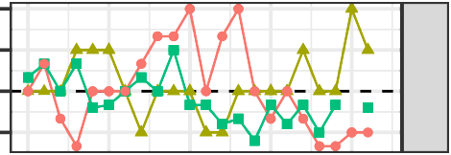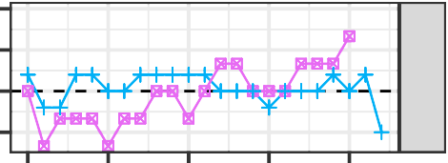2000 2005 2010 2015 2020

Ecosystem

Socioeconomic

2e+03

1e+03

2e+00

0e+00

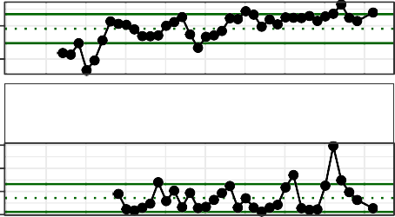

Summer Snow Crab Juvenile Disease Prevalence

Summer Benthic Invertebrate Biomass SEBS Survey

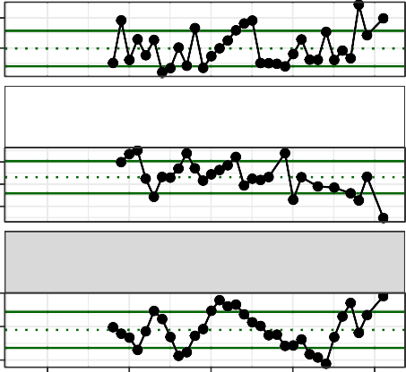

Summer Snow Crab Male Center Distribution SEBS Survey

Annual Snow Crab Male Size Maturity Model

Summer Snow Crab Female Juvenile Temperature Occupancy

Physical Lower Trophic Upper Trophic

Fishery Performance Economic

# Importance

1.5e−01

1.0e−01

5.0e−02

0.0e+00

9e+01

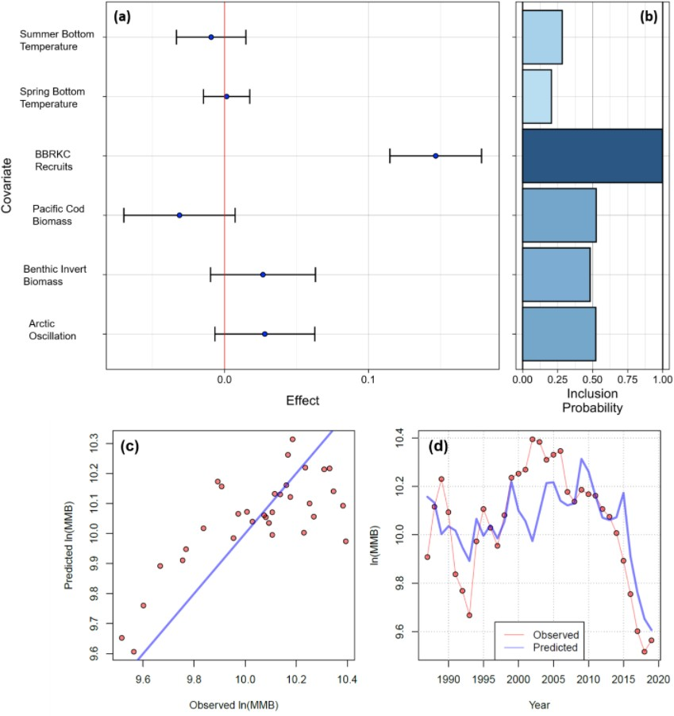8e+01

7e+01

3.0e+04

2.5e+04

2.0e+04

2e+03

1e+03

1980 1990 2000 2010 2020

6.0e+01

5.9e+01

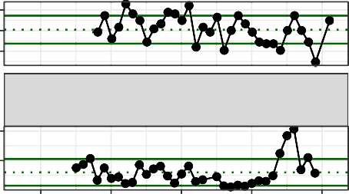

Summer Snow Crab Consumption Pacific cod Model

Summer Snow Crab Male Area Occupied SEBS Survey

5.8e+01

1980

1990

2000

2010

2020

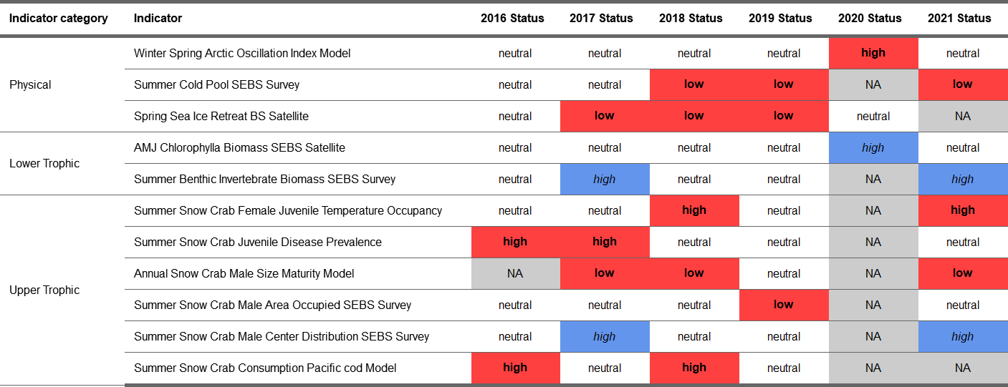Traffic light table

more text