Appendix 1. Ecosystem and Socioeconomic Profile of the Snow Crab stock in the Eastern Bering Sea

Erin Fedewa, Kalei Shotwell, Abby Tyrell

Draft 2022



*With Contributions from:*

Kalei Shotwell, Abby Tyrell

# Executive Summary

Short description of national initiative and regional recommendations to produce ESP

Short description of ESP process type (e.g., general, stage-based)

## Ecosystem Considerations

Summary conclusions from metric assessment

Summary conclusions from indicator assessment

## Socioeconomic Considerations

Summary conclusions from metric assessment

Summary conclusions from indicator assessment

# Introduction

Summary of regional ecosystem considerations priorities

Description of four-step ESP process and reference, include metric and indicator definition

Example reference: (Adams 1993). Without parentheses around names: Adams (1993). Year only: (1993).

## Justification

Scores in relevant national initiatives, stock assessment classification results

Stock-specific regional research priorities (e.g., Plan Team, SSC, Council recommendations, annual guidance memo, strategic plans, etc.)

## Data

Brief description of data streams used in the analysis, may reference main SAFE document

Table of data sources with references

# Metrics Assessment

## National Metrics

Description of measures collected in the national initiatives relevant to the stock FMP

Description of ecosystem and socioeconomic stock vulnerabilities

Ecosystem metrics example: high recruitment variability (standard deviation of log recruitment estimates > 0.9), low fecundity, and small hatch size indicate vulnerabilities in early life

Socioeconomic metrics example: high commercial importance, high constituent demand indicate high value to fisheries and communities and vulnerability to fishing pressure

Graph of national initiative metric panel

## Ecosystem Processes

Description of ecosystem metrics that identify dominant pressures on the stock, evaluate by life history stage where possible

Graph or Table of life history stage information (e.g., distribution, timing, duration, size)

## Socioeconomic Processes

Description of socioeconomic performance metrics that identify dominant pressures on the stock, evaluate by life history stage where possible

Table of socioeconomic performance information (e.g., price, value by fishery, number of vessels)

# Indicators Assessment

## Indicator Suite

Brief literature review on ecosystem or socioeconomic indicators previously explored for stock that are currently available or updatable

Description of indicator suite based on metric assessment and literature review

List of ecosystem indicators ordered by category (physical, zooplankton, larvae and young-of-the-year, juvenile, and adult)

List of socioeconomic indicators ordered by category (fishery performance, economic, community)

Graph of indicator time series panel, follow ecosystem status report card format

Table of indicators including description, source, relationship to stock, recent trend

## Indicator Monitoring Analysis

Description of statistical tests for monitoring indicator suite by stage where relevant (Stage 1: scoring test, Stage 2: importance test, Stage 3: modeling test)

Supportive graphs and/or tables of statistical tests where relevant

# Recommendations

Summary of main considerations separated by ecosystem and socioeconomic categories

## Ecosystem Considerations

Summary conclusions from metric assessment

Summary conclusions from indicator assessment

## Economic Considerations

Summary conclusions from metric assessment

Summary conclusions from indicator assessment

## Data Gaps and Future Research Priorities

Description of data gaps, future priorities for ecosystem and socioeconomic research that would support future versions of the ESP

# Acknowledgements

Include contributors, internal reviewers, Groundfish/Crab Plan Teams, SSC, AFSC personnel and divisions, other state, national, international contributing agencies

# Literature Cited

Include reference numbers at the end of the citations from the life history table

Include DOI or links to papers where possible

Adams, Peter. 1993. “The Title of the Work.” *The Name of the Journal* 4 (2): 201–13.

# Tables

Table 1: First stage ecosystem indicator analysis for Snow Crab, including indicator title and the indicator status of the last five years. The indicator status is designated with text, (greater than = "high", less than = "low", or within 1 standard deviation = "neutral" of long-term mean). Fill color of the cell is based on the sign of the anticipated relationship between the indicator and sablefish (blue = good conditions for sablefish, red = poor conditions, white = average conditions). A gray fill and text = "missing" will appear if there were no data for that year.

| **Indicator category** | **Indicator** | **2018 Status** | **2019 Status** | **2020 Status** | **2021 Status** |
| --- | --- | --- | --- | --- | --- |
| Physical | Winter Spring Arctic Oscillation Index Model | neutral | neutral | **high** | neutral |
| Lower Trophic | AMJ Chlorophylla Biomass SEBS Satellite | neutral | neutral | *high* | neutral |
| Upper Trophic | Annual Snow Crab Male Size Maturity Model | **low** | neutral | NA | **low** |
| Physical | Spring Sea Ice Retreat BS Satellite | **low** | **low** | neutral | NA |
| Lower Trophic | Summer Benthic Invertebrate Biomass SEBS Survey | neutral | neutral | NA | *high* |
| Physical | Summer Cold Pool SEBS Survey | **low** | **low** | NA | **low** |
| Upper Trophic | Summer Snow Crab Consumption Pacific cod Model | **high** | neutral | NA | NA |
| Summer Snow Crab Female Juvenile Temperature Occupancy | **high** | neutral | NA | **high** |
| Summer Snow Crab Juvenile Disease Prevalence | neutral | neutral | NA | neutral |
| Summer Snow Crab Male Area Occupied SEBS Survey | neutral | **low** | NA | neutral |
| Summer Snow Crab Male Center Distribution SEBS Survey | neutral | neutral | NA | *high* |

Table 2: An example table

| **X** | **Y** |
| --- | --- |
| A | 1 |
| B | 2 |
| C | 3 |

# Figures



##### Figure 1. Life history conceptual model for Snow Crab summarizing ecological information and key ecosystem processes affecting survival by life history stage. Red text means increases in process negatively affect survival, while blue text means increases in process positively affect survival.

delete the above figure!

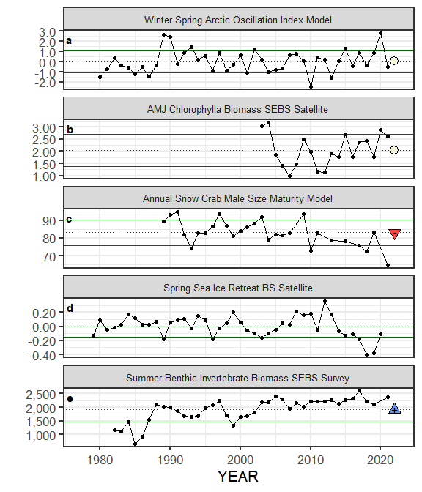

##### Figure 2. Selected ecosystem indicators forSnow Crab with time series ranging from1977– present. Upper and lower solid green horizontal lines are 90th and 10th percentiles of time series. Dotted green horizontal line is the mean of the time series. Light green shaded areas represent the most recent year of the traffic light analysis results.

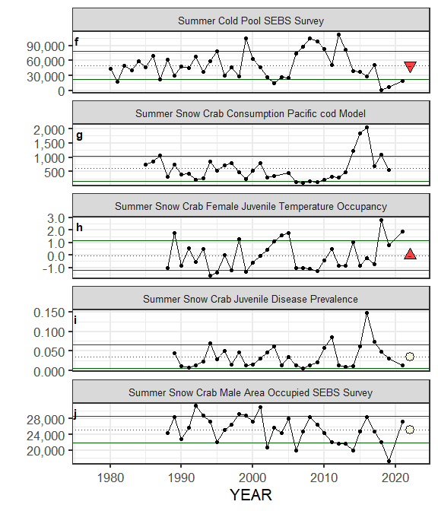

##### Figure 2. Selected ecosystem indicators forSnow Crab with time series ranging from1977– present. Upper and lower solid green horizontal lines are 90th and 10th percentiles of time series. Dotted green horizontal line is the mean of the time series. Light green shaded areas represent the most recent year of the traffic light analysis results.

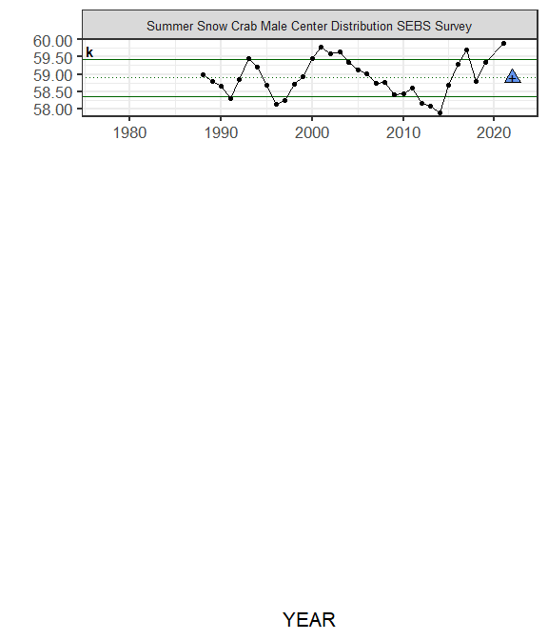

##### Figure 2. Selected ecosystem indicators forSnow Crab with time series ranging from1977– present. Upper and lower solid green horizontal lines are 90th and 10th percentiles of time series. Dotted green horizontal line is the mean of the time series. Light green shaded areas represent the most recent year of the traffic light analysis results.

delete the above figure!

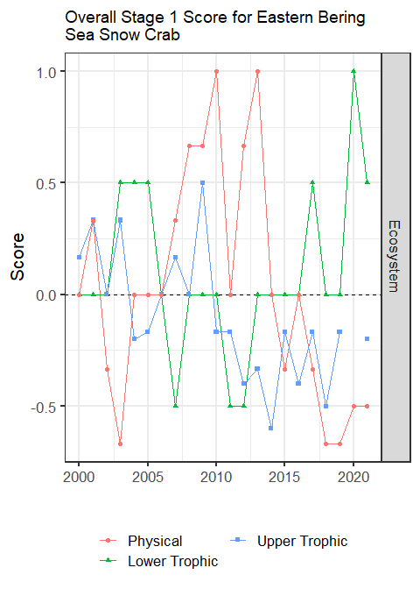

##### Figure 4. Simple traffic light score for overall ecosystem and socioeconomic categories from 2000 to present.



##### Figure 5. Bayesian adaptive sampling output showing (a) standardized covariates prior to subsetting and (b) the mean relationship and uncertainty (95% confidence intervals) with log Snow Crab recruitment, in each estimated effect (left bottom graph), and marginal inclusion probabilities (right bottom graph) for each predictor variable of the subsetted covariate set



##### Figure 6. The NOAA logo.