Appendix 1. Ecosystem and Socioeconomic Profile of the Myfish stock in the Myarea

Kalei Shotwell, Abby Tyrell

Draft 2021

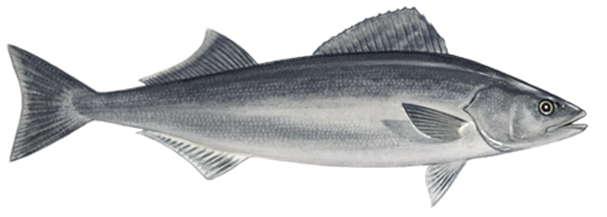

*With Contributions from:*

Kalei Shotwell, Abby Tyrell

# Executive Summary

Short description of national initiative and regional recommendations to produce ESP

Short description of ESP process type (e.g., general, stage-based)

## Ecosystem Considerations

Summary conclusions from metric assessment

Summary conclusions from indicator assessment

## Socioeconomic Considerations

Summary conclusions from metric assessment

Summary conclusions from indicator assessment

# Introduction

Summary of regional ecosystem considerations priorities

Description of four-step ESP process and reference, include metric and indicator definition

Example reference: (Adams 1993). Without parentheses around names: Adams (1993). Year only: (1993).

## Justification

Scores in relevant national initiatives, stock assessment classification results

Stock-specific regional research priorities (e.g., Plan Team, SSC, Council recommendations, annual guidance memo, strategic plans, etc.)

## Data

Brief description of data streams used in the analysis, may reference main SAFE document

Table of data sources with references

# Metrics Assessment

## National Metrics

Description of measures collected in the national initiatives relevant to the stock FMP

Description of ecosystem and socioeconomic stock vulnerabilities

Ecosystem metrics example: high recruitment variability (standard deviation of log recruitment estimates > 0.9), low fecundity, and small hatch size indicate vulnerabilities in early life

Socioeconomic metrics example: high commercial importance, high constituent demand indicate high value to fisheries and communities and vulnerability to fishing pressure

Graph of national initiative metric panel

## Ecosystem Processes

Description of ecosystem metrics that identify dominant pressures on the stock, evaluate by life history stage where possible

Graph or Table of life history stage information (e.g., distribution, timing, duration, size)

## Socioeconomic Processes

Description of socioeconomic performance metrics that identify dominant pressures on the stock, evaluate by life history stage where possible

Table of socioeconomic performance information (e.g., price, value by fishery, number of vessels)

# Indicators Assessment

## Indicator Suite

Brief literature review on ecosystem or socioeconomic indicators previously explored for stock that are currently available or updatable

Description of indicator suite based on metric assessment and literature review

List of ecosystem indicators ordered by category (physical, zooplankton, larvae and young-of-the-year, juvenile, and adult)

List of socioeconomic indicators ordered by category (fishery performance, economic, community)

Graph of indicator time series panel, follow ecosystem status report card format

Table of indicators including description, source, relationship to stock, recent trend

## Indicator Monitoring Analysis

Description of statistical tests for monitoring indicator suite by stage where relevant (Stage 1: scoring test, Stage 2: importance test, Stage 3: modeling test)

Supportive graphs and/or tables of statistical tests where relevant

# Recommendations

Summary of main considerations separated by ecosystem and socioeconomic categories

## Ecosystem Considerations

Summary conclusions from metric assessment

Summary conclusions from indicator assessment

## Economic Considerations

Summary conclusions from metric assessment

Summary conclusions from indicator assessment

## Data Gaps and Future Research Priorities

Description of data gaps, future priorities for ecosystem and socioeconomic research that would support future versions of the ESP

# Acknowledgements

Include contributors, internal reviewers, Groundfish/Crab Plan Teams, SSC, AFSC personnel and divisions, other state, national, international contributing agencies

# Literature Cited

Include reference numbers at the end of the citations from the life history table

Include DOI or links to papers where possible

Adams, Peter. 1993. “The Title of the Work.” *The Name of the Journal* 4 (2): 201–13.

# Tables

Table 1: First stage ecosystem indicator analysis for Myfish, including indicator title and the indicator status of the last five years. The indicator status is designated with text, (greater than = "high", less than = "low", or within 1 standard deviation = "neutral" of long-term mean). Fill color of the cell is based on the sign of the anticipated relationship between the indicator and sablefish (blue = good conditions for sablefish, red = poor conditions, white = average conditions). A gray fill and text = "missing" will appear if there were no data for that year.

| **Indicator category** | **Indicator** | **2017 Status** | **2018 Status** | **2019 Status** | **2020 Status** | **2021 Status** |
| --- | --- | --- | --- | --- | --- | --- |
| Physical | Annual Heatwave GOA Model | neutral | neutral | *high* | neutral | neutral |
| Spring Temperature Surface EGOA Satellite | neutral | neutral | *high* | neutral | neutral |
| Spring Temperature Surface SEBS Satellite | neutral | *high* | *high* | *high* | neutral |
| Summer Temperature 250m GOA Survey | neutral | neutral | neutral | neutral | neutral |
| Lower Trophic | Spring Chlorophylla Biomass EGOA Satellite | neutral | neutral | neutral | **low** | neutral |
| Spring Chlorophylla Biomass SEBS Satellite | **low** | neutral | **low** | neutral | neutral |
| Spring Chlorophylla Peak EGOA Satellite | neutral | *low* | neutral | *low* | neutral |
| Spring Chlorophylla Peak SEBS Satellite | *low* | **high** | neutral | neutral | neutral |
| Annual Copepod Community Size EGOA Survey | neutral | **low** | **low** | neutral | NA |
| Annual Copepod Community Size WGOA Survey | neutral | **low** | *high* | neutral | NA |
| Summer Euphausiid Abundance Kodiak Survey | **low** | NA | neutral | NA | NA |
| Annual Sablefish Growth YOY Middleton Survey | neutral | neutral | *high* | neutral | neutral |
| Upper Trophic | Summer Sablefish CPUE Juvenile Nearshore GOAAI Survey | neutral | *high* | *high* | *high* | *high* |
| Summer Sablefish CPUE Juvenile GOA Survey | *high* | NA | neutral | NA | neutral |
| Annual Sablefish Mean Age Female Adult Model | neutral | neutral | **low** | **low** | NA |
| Annual Sablefish Age Evenness Female Adult Model | **low** | **low** | **low** | **low** | NA |
| Summer Sablefish Condition Female Age4 GOA Survey | **low** | neutral | **low** | neutral | NA |
| Annual Arrowtooth Biomass GOA Model | neutral | neutral | neutral | neutral | NA |
| Annual Sablefish Incidental Catch Arrowtooth Target GOA Fishery | **high** | **high** | **high** | neutral | neutral |
| Summer Sablefish Condition Female Adult GOA Survey | **low** | neutral | neutral | neutral | neutral |

Table 2: First stage socioeconomic indicator analysis for Myfish, including indicator title and the indicator status of the last five years. The indicator status is designated with text, (greater than = "high", less than = "low", or within 1 standard deviation = "neutral" of long-term mean). Fill color of the cell is based on the sign of the anticipated relationship between the indicator and sablefish (blue = good conditions for sablefish, red = poor conditions, white = average conditions). A gray fill and text = "missing" will appear if there were no data for that year.

| **Indicator category** | **Indicator** | **2017 Status** | **2018 Status** | **2019 Status** | **2020 Status** | **2021 Status** |
| --- | --- | --- | --- | --- | --- | --- |
| Fishery Performance | Annual Sablefish Longline CPUE GOA Fishery | low | low | low | neutral | neutral |
| Annual Sablefish Pot CPUE EBS Fishery | neutral | neutral | high | high | high |
| Annual Sablefish Incidental Catch GOA Fishery | neutral | high | high | high | low |
| Annual Sablefish Incidental Catch BSAI Fishery | neutral | neutral | high | high | high |
| Annual Sablefish Condition Female Adult GOA Fishery | neutral | neutral | neutral | high | low |
| Annual Sablefish Condition Female Adult BSAI Fishery | NA | NA | NA | NA | NA |
| Economic | Annual Sablefish Real Exvessel Value Fishery | neutral | neutral | low | low | NA |
| Annual Sablefish Real Exvessel Price Fishery | high | neutral | low | low | NA |

Table 3: An example table

| **X** | **Y** |
| --- | --- |
| A | 1 |
| B | 2 |
| C | 3 |

# Figures

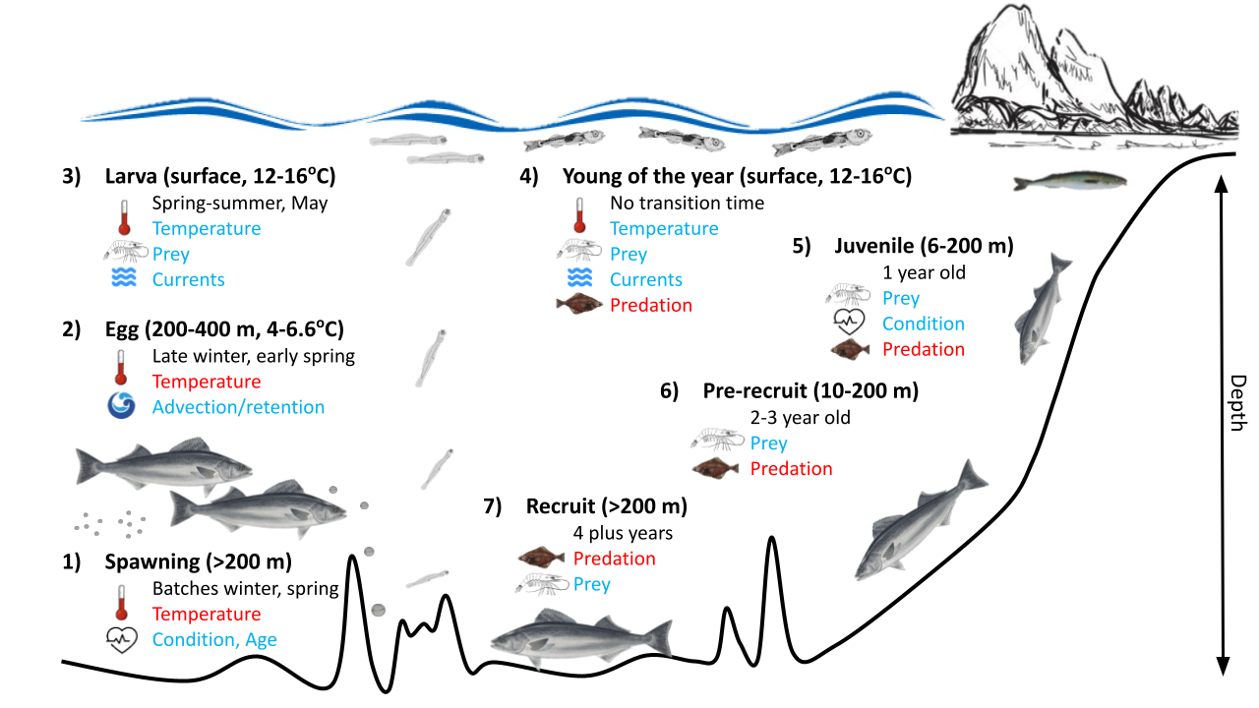

##### Figure 1. Life history conceptual model for Myfish summarizing ecological information and key ecosystem processes affecting survival by life history stage. Red text means increases in process negatively affect survival, while blue text means increases in process positively affect survival.

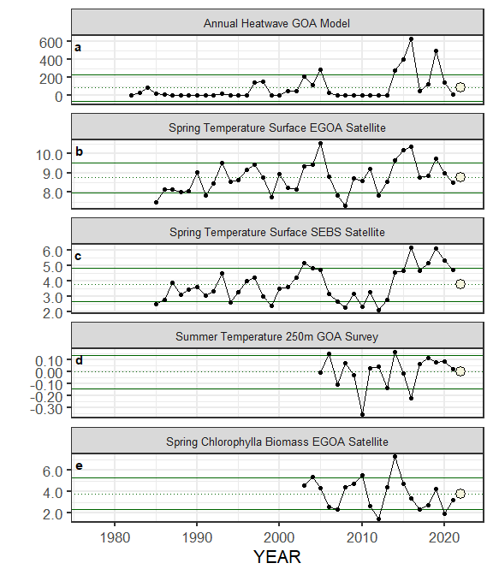

##### Figure ??. Selected ecosystem indicators for Myfish with time series ranging from 1977 – present. Upper and lower solid green horizontal lines are 90th and 10th percentiles of time series. Dotted green horizontal line is the mean of the time series. Light green shaded areas represent the most recent year of the traffic light analysis results.

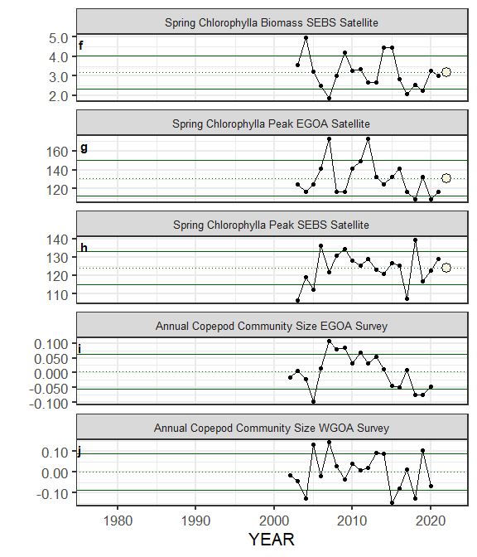

##### Figure ??. Selected ecosystem indicators for Myfish with time series ranging from 1977 – present. Upper and lower solid green horizontal lines are 90th and 10th percentiles of time series. Dotted green horizontal line is the mean of the time series. Light green shaded areas represent the most recent year of the traffic light analysis results.

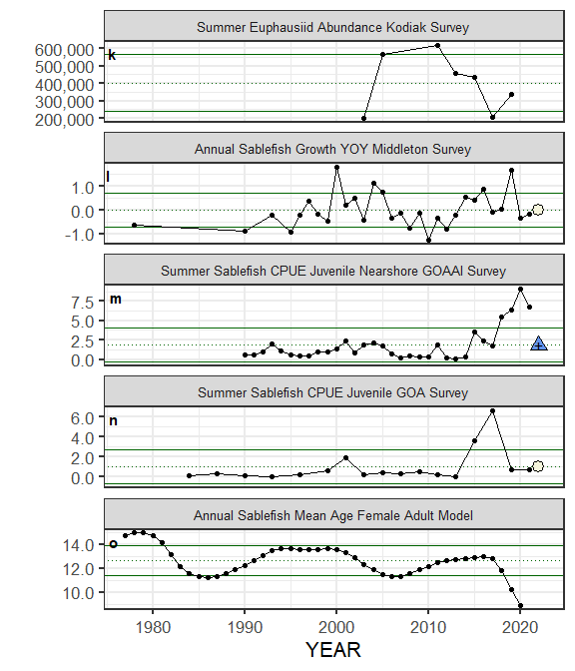

##### Figure ??. Selected ecosystem indicators for Myfish with time series ranging from 1977 – present. Upper and lower solid green horizontal lines are 90th and 10th percentiles of time series. Dotted green horizontal line is the mean of the time series. Light green shaded areas represent the most recent year of the traffic light analysis results.

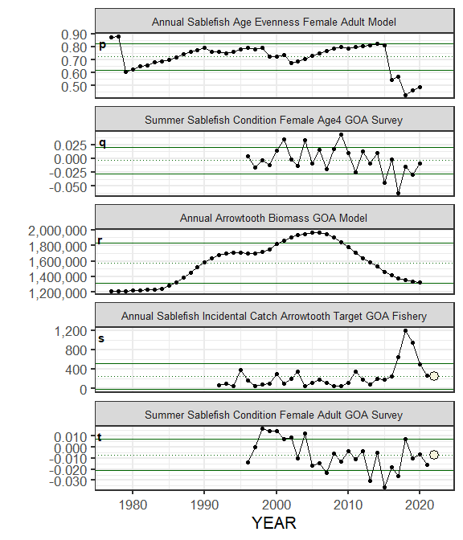

##### Figure ??. Selected ecosystem indicators for Myfish with time series ranging from 1977 – present. Upper and lower solid green horizontal lines are 90th and 10th percentiles of time series. Dotted green horizontal line is the mean of the time series. Light green shaded areas represent the most recent year of the traffic light analysis results.

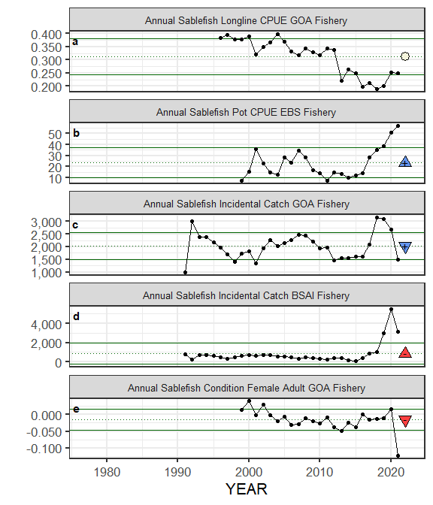

##### Figure ??. Selected socioeconomic indicators for Myfish with time series ranging from 1977 – present. Upper and lower solid green horizontal lines are 90th and 10th percentiles of time series. Dotted green horizontal line is the mean of the time series. Light green shaded areas represent the most recent year of the traffic light analysis results.

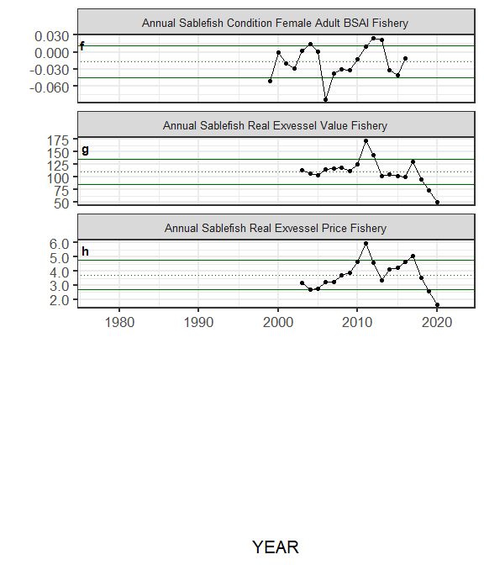

##### Figure ??. Selected socioeconomic indicators for Myfish with time series ranging from 1977 – present. Upper and lower solid green horizontal lines are 90th and 10th percentiles of time series. Dotted green horizontal line is the mean of the time series. Light green shaded areas represent the most recent year of the traffic light analysis results.

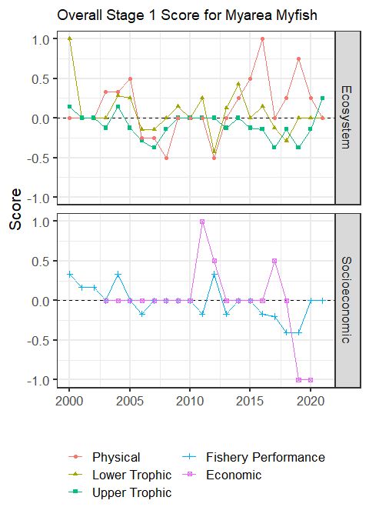

##### Figure 4. Simple traffic light score for overall ecosystem and socioeconomic categories from 2000 to present.

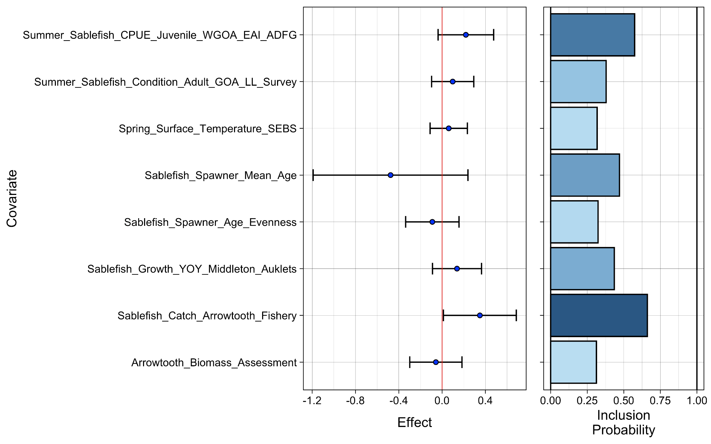

##### Figure 5. Bayesian adaptive sampling output showing (a) standardized covariates prior to subsetting and (b) the mean relationship and uncertainty (95% confidence intervals) with log Myfish recruitment, in each estimated effect (left bottom graph), and marginal inclusion probabilities (right bottom graph) for each predictor variable of the subsetted covariate set



##### Figure 6. The NOAA logo.