  

**CLOUD APPLICATION DEVELOPMENT (GROUP 1)**

**PHASE I: ASSIGNMENT NOTEBOOK SUBMISSION**

**NAME : HEMAVATHI.H**

**EMAIL:hemafemi11@gmail.com**

**Git repry URL: https://github.com/au11062**1**10**4**012/Hemavathi**.git

**TITTLE OF THE PROJECT :**

**PROJECT4 :**

**IMAGE RECOGITION WITH IBM CLOUD VISUAL RECOGNITION**

**Topic : Innovation**

**Consider incorporating features like product reviews, wishlists, and personalized recommendations to enhance user engagement and satisfaction.**

**ABSTRACT:**

Bird images are injected in a convolutional neural network (CNN) to localize prominent features. First, we create an image generator for the training data. Then, we load training images. After , we create a neural network and the convolutional layer. Finally, we load the unknown bird image and applied the argmax function to get a probability of bird features.

**INTRODUCTION:**

Many times ,you want to search a restaurant which serves a specific dish.And you know the possibility of remembering name of that dish is bleak,but you took a picture last time you had it.In such situation a feature to search a dish by image is sorely missed . In this blog we are going to learn how to create an application to find restaurants with the help of food image you have.You will also learn how to work with IBM Watson for Visual Recognition and use HERE location services for maps and location analytics .

**Phase 1: Problem Definition and Design Thinking**

**Problem Definition:** The project involves creating an image recognition system using IBM Cloud Visual Recognition. The goal is to develop a platform where users can upload images, and the system accurately classifies and describes the image contents. This will enable users to craft engaging visual stories with the help of AI-generated captions, enhancing their connection with the audience through captivating visuals and compelling narratives.

**TECHNOLOGY:**

How image recognition works: algorithms and technologies

Before diving into how image recognition works, let's look at the four primary purposes image recognition solves: detection, classification, tagging, and segmentation.

**Classification:**

Artificial neural networks identify objects in the image and assign them one of the predefined groups or classifications.

**Detection:**

The process of classification and localization of an object is called object detection. Once the object's location is found, a bounding box with the corresponding accuracy is put around it. Depending on the complexity of the object, techniques like bounding box annotation, semantic segmentation, and key point annotation are used for detection.

**Tagging:**

Tagging is similar to classification but aims for better accuracy. It tries to identify multiple objects in an image. Therefore, an image can have one or more tags. Returning to the example of the image of a road, it can have tags like 'vehicles,' 'trees,' 'human,' etc.

**Segmentation:**

Instance segmentation is the detection task that attempts to locate objects in an image to the nearest pixel. Instead of aligning boxes around the objects, an algorithm identifies all pixels that belong to each class. Image segmentation is widely used in medical imaging to detect and label image pixels where precision is very important.

Now, let’s move on to see how image recognition works in practice—

1. Data collection

To achieve image recognition, machine vision artificial intelligence models are fed with pre-labeled data to teach them to recognize images they’ve never seen before.

Some of the massive publicly available databases include Pascal VOC and ImageNet. They contain millions of labeled images describing the objects present in the pictures—everything from sports and pizzas to mountains and cats.

How image recognition evolved over time

Vision is the most amazing and complex of senses.

It took almost 500 million years of human evolution to reach this level of perfection. In recent years, we have made vast advancements to extend the visual ability to compute or machines

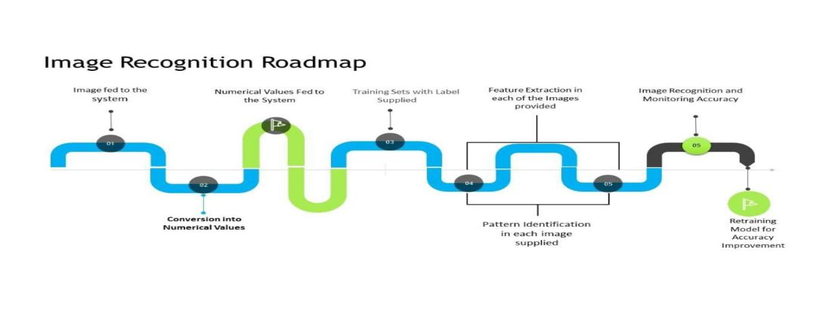

.image recognition roadmap

The first steps toward what would later become image recognition technology happened in the late 1950s. An influential 1959 paper is often cited as the starting point to the basics of image recognition, though it had no direct relation to the algorithmic aspect of the development.

APPLICATION :

* Gesture recognition
* 2D and 3D feature toolkits
* Human-computer interaction(HCI)
* Object identification

**CODING**

**import json;**

**from ibm_watson import VisualRecognitionV3**

**from ibm_cloud_sdk_core.authenticators import IAMAuthenticator**

**authenticator = IAMAuthenticator('IBM API KEY')**

**visual_recognition = VisualRecognitionV3(**

**version='2018-03-19',**

**authenticator=authenticator)**

**visual_recognition.set_service_url('IBM URL')**

**with open('./test.jpg', 'rb') as images_file:**

**classes = visual_recognition.classify(images_file=images_file,threshold='0.6',classifier_ids='food').get_result()**

**print(json.dumps(classes, indent=2))**

**{**

**"images": [**

**{**

**"classifiers": [**

**{**

**"classifier_id": "food",**

**"name": "food",**

**"classes": [**

**{**

**"class": "pepperoni pizza",**

**"score": 0.809,**

**"type_hierarchy": "/pizza/pepperoni pizza"**

**},**

**{**

**"class": "pizza",**

**"score": 0.918**

**}**

**]**

**}**

**],**

**"image": "test.jpg"**

**}**

**],**

**"images_processed": 1,**

**"custom_classes": 0**

**}**

**OUTPUT:**

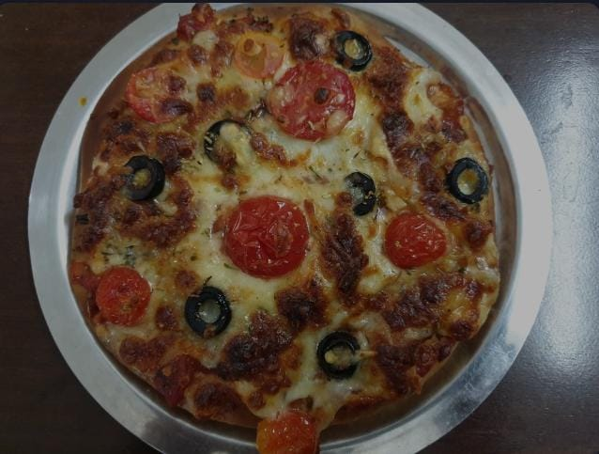

**HARDWARE REQUIREMENTS :**

* Pentium IV or higher.(PIV-300GHz recommended)
* 256 MB RAM
* Python 3.8
* 1 GB Hard Free Drive Space

**SOFTWARE REQUIREMENTS :**

* IBM cloud
* Mobile application
* Convolutional Neural Network (CNN)
* Matterport,Hive Moderation,Congnex VisionPro
* National Instruments Vision Builder
* Android Studio project using an API key

**CONCLUSION:**

The world is moving more and more toward automation and visual recognition is one of the best example of automation .The real question is how to use the output of Machine Learning and AI based model .We will explore the answer in the next part where we will take the name (pizza) and pass it to the HERE location services and map to built an amazing recipe .

Github Repository URL : https://github.com/au110621104021/sneha.git