**PHASE 2- AIR QUALITY MANAGEMENT**

Predictive modelling for forecasting air quality trends based on historical data is a valuable approach. It typically involves using machine learning algorithms to analyse past air quality data and make predictions about future trends. Here's a simplified outline of the steps involved:

**Data Collection**:

Gather historical air quality data from reliable sources. This data should include information on various pollutants (e.g., PM2.5, PM10, NO2, CO, etc.), weather conditions, geographical location, and time stamps.

**Data Preprocessing:**

Clean and preprocess the data to handle missing values, outliers, and inconsistencies. This may also involve feature engineering, where you create new variables or transformations of existing ones to improve model performance.

**Feature Selection:**

Identify relevant features that affect air quality and select them for model training. Weather variables like temperature, humidity, wind speed, and direction are often important.

**Model Selection:**

Choose appropriate machine learning algorithms for your predictive modeling task. Time series models like ARIMA (Autoregressive Integrated Moving Average), machine learning models like Random Forests or Gradient Boosting, or deep learning models like LSTM(Long Short-Term Memory) can be considered based on the nature of your data.

**Model Training:**

Split the data into training and testing sets. Train your chosen model(s) on the historical data, using a portion of the data to train and the rest to validate the model's performance.

**Hyperparameter Tuning:**

Fine-tune the model's hyperparameters to optimize its performance. This may involve techniques like grid search or random search.

**Model Evaluation:**

Assess the model's performance using appropriate evaluation metrics, such as Mean Absolute Error (MAE), Root Mean Square Error (RMSE), or R-squared. Cross-validation can help ensure the model's robustness.

**Forecasting:**

Once the model is trained and validated, use it to make air quality predictions for future time periods. Continuously update the model with new data for ongoing forecasting.

**Visualization:**

Present the forecasted air quality trends through visualizations like time series plots or interactive dashboards for easy interpretation.

**Monitoring and Maintenance:**

Regularly monitor the model's performance and retrain it as needed to adapt to changing air quality patterns.

**CIRCUIT DIAGRAM FOR AQM**:

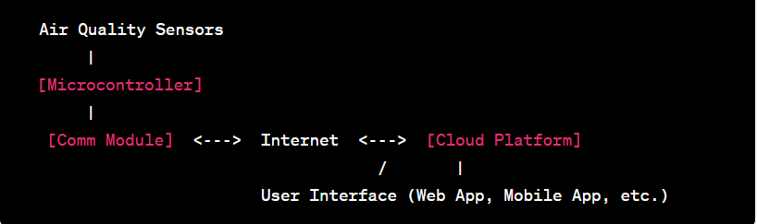

**COMPONENTS OF CIRCUIT DIAGRAM**:

**Air Quality Sensors**: These sensors can include gas sensors (e.g., for detecting CO, CO2, NO2, etc.), particulate matter (PM) sensors, temperature and humidity sensors, and more. These sensors measure various air quality parameters.

**Microcontroller (IoT Device):** An IoT microcontroller, such as an Arduino or Raspberry Pi, is the brain of the system. It collects data from the sensors and transmits it to the cloud for analysis.

**Communication Module:** This can be a Wi-Fi module, cellular module, or other IoT communication devices to connect to the internet and send data to a cloud platform.

**Cloud Platform**: Many platforms like AWS, Azure, Google Cloud, or IoT-specific platforms like ThingSpeak, Blynk, or Adafruit IO can be used. The cloud platform stores, analyzes, and visualizes the data and allows remote monitoring and control.

**User Interface**: To interact with the system, include a user interface such as a web application, mobile app, or dashboard that allows users to view air quality data and receive alerts.

**Power Supply**: Ensure a stable power supply for the system. Depending on the components used, this may include batteries, power adapters, or solar panels for remote and off-grid installations.