PHASE-2 Document Submission

Project Title: Smart Parking System with IoT

Presented By : Sivaranjini M

Roll No : 312821243036

# Project Description:

Develop a Smart Parking System that leverages IoT technology, including IoT sensors and Raspberry Pi devices, to efficiently manage parking spaces, reduce congestion, and enhance the overall parking experience for users. This system will provide real-time parking space availability information and optimize parking space allocation.

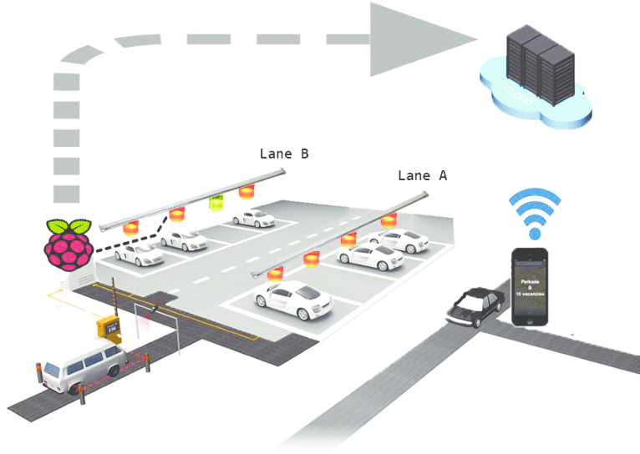

# Introduction

* Define Smart Parking: Smart parking refers to the integration of technology and data-driven solutions to optimize parking management. It involves real-time monitoring, booking systems, and automated processes for parking spaces.
* Significance of Smart Parking: Emphasize how efficient parking management is crucial for addressing the challenges of urbanization and increasing vehicle density in Indian cities.
* Indian Parking Scenario: Highlight India's urbanization rate and the consequent strain on parking infrastructure, which has led to congestion, pollution, and inefficiency.

# Challenges in Indian Urban Parking

* Rapid Urbanization: Discuss the rate at which Indian cities are growing and the strain this puts on existing parking facilities.
* Increasing Number of Vehicles: Mention the escalating vehicle ownership in India, leading to more cars on the road.
* Lack of Parking Space: Explain the scarcity of parking spaces, especially in densely populated areas.
* Congestion and Pollution: Address how improper parking management contributes to traffic congestion and pollution.
* Manual Parking Management: Highlight the outdated and often inefficient manual parking systems.

# Sensor Health Monitoring

Define Sensor Health Monitoring:

* Describe the concept of sensor health monitoring as a continuous process that checks the status and functionality of parking sensors.
* Sensor health monitoring ensures that sensors are working correctly and providing accurate data.

# Algorithm for Health Monitoring:

* Algorithmic approach used for sensor health monitoring, which includes:
* Regular diagnostic tests: Algorithms periodically run diagnostics to identify any anomalies or sensor malfunctions.
  + Real-time alerts: When a problem is detected, the system generates real-time alerts, allowing for prompt action.
  + Historical data analysis: Algorithms analyze historical data to identify patterns that might indicate sensor degradation or potential issues.

# Calibration Algorithms

Calibration Importance:

* + Highlight the significance of sensor calibration for ensuring the precision and accuracy of data collection in smart parking systems.
  + Calibration is the process of adjusting sensors to maintain their accuracy over time.

# Algorithmic Calibration:

* + Algorithms are used to calibrate sensors. This process may include:
  + Periodic recalibration: Algorithms schedule and execute recalibration tasks at regular intervals.
  + Real-time adjustment: Algorithms can also make real-time adjustments to sensor settings to account for changing conditions.
  + Sensor feedback: Sensors may provide feedback data to the algorithm, which is used to fine-tune their performance.

# Predictive Maintenance

Predictive Maintenance Defined:

* + Define predictive maintenance as a proactive approach to prevent sensor failures.
  + Predictive maintenance uses algorithms to anticipate sensor problems before they occur.

Algorithmic Predictive Maintenance:

* + How predictive maintenance algorithms work:
  + Data analysis: Algorithms analyze historical sensor data to identify degradation patterns or signs of impending failure.
  + Threshold-based alerts: When sensors approach predefined thresholds, the system triggers maintenance alerts.
  + Maintenance scheduling: Algorithms create maintenance schedules based on the predicted maintenance needs.

# Sensor Cleaning and Maintenance Scheduling

Sensor Cleaning:

* Cleaning is required to ensure that sensors remain free of debris and contaminants, which can affect their performance.
* Sensor cleaning can include tasks like cleaning the sensor lenses or adjusting their alignment.

# Maintenance Scheduling Algorithms:

* Algorithms are used to schedule routine sensor maintenance, including:
* Calendar-based scheduling: Algorithms can set regular maintenance intervals for cleaning and inspections.
* Sensor feedback: Sensors may provide data that algorithms use to recommend maintenance tasks.
* Dynamic scheduling: Algorithms can adjust maintenance schedules based on sensor health and usage patterns.

# Real Time Algorithmic Anomaly Detection:

* + Algorithms used for real-time anomaly detection, such as:
  + Statistical analysis: Algorithms compare real-time data to statistical models to identify anomalies.
  + Machine learning: Algorithms can use machine learning techniques to detect deviations from expected data patterns.
  + Immediate alerts: When anomalies are detected, the system generates immediate alerts for investigation and action.

# Benefits of Sensor Maintenance Algorithms

* + Improved Data Accuracy
  + Cost Reduction
  + Enhanced User Experience

# Challenges in Sensor Maintenance

* + Environmental factors (dust, weather)
  + Sensor aging and degradation
  + Integration with existing infrastructure

# Smart Parking Solutions

* + IoT-based Sensors: Explain how sensors can detect the presence of vehicles and provide real-time data for parking availability.
  + Mobile Apps for Parking Booking: Describe the convenience of booking parking spaces through mobile apps, allowing users to find and reserve spots in advance.
  + Automated Payment Systems: Discuss how automated payment solutions streamline transactions, reducing the need for physical payment methods.
  + Real-time Data Analytics: Show how data analytics can be used to optimize parking operations and predict parking demand.
  + Automated Vehicle Detection: Explain how smart parking can automatically detect vehicles, reducing the need for manual management.

# Benefits of Smart Parking

* + Reduced Traffic Congestion: Detail how smart parking minimizes the time spent searching for parking, thus reducing traffic congestion.
  + Environmentally Friendly: Discuss the environmental benefits, such as reduced emissions due to shorter idle times.
  + Enhanced User Experience: Highlight the improved experience for drivers who can quickly find and pay for parking.
  + Improved Safety: Address how automated systems can improve safety by reducing the risk of accidents caused by circling for parking.
  + Revenue Generation: Discuss the potential for revenue generation through paid parking and efficient space utilization.

# Case Study

Case Study 1: Mumbai - IoT-Based Sensors

* + - Background:Mumbai, known for its bustling streets and high population density, faced severe parking issues, resulting in traffic congestion.
    - Implementation: The city integrated IoT-based sensors across various parking zones. These sensors collected real-time data about parking space occupancy.
    - Impact:
    - Reduced Congestion: IoT sensors allowed drivers to find available parking quickly, significantly reducing traffic congestion.
    - Improved Revenue: The municipality saw increased revenue from better space utilization and efficient payment collection.
    - Lessons Learned: The success in Mumbai highlighted the importance of real-time data in managing urban parking and underlined the potential for revenue generation.

Case Study 2: Delhi - Mobile App-Based Parking Solutions

* + Background: Delhi, as the capital city, faced challenges with parking, especially in crowded market areas and business districts.
  + Implementation: Delhi introduced a mobile app that enabled users to find and reserve parking spots in advance. Users could also pay through the app.

Impact:

* Convenience: Drivers found it easier to locate parking and pay through the app, which improved the overall parking experience.
* Reduced Traffic Woes: The reduced search time for parking led to decreased traffic congestion.
* Lessons Learned: Delhi's mobile app-based solution emphasized the importance of user-friendly interfaces and the potential for technological solutions in easing parking hassles.

Case Study 3: Bangalore - Automated Multi-Level Parking

* Background: Bangalore, a rapidly growing tech hub, faced severe space constraints for parking in the city center.
* Implementation: Automated multi-level parking facilities were built at strategic locations, allowing for efficient space utilization.
* Impact:
* Space Optimization: Multi-level parking allowed more vehicles to be parked in a smaller footprint.
* Reduced Ground Space Usage: The city managed to preserve valuable ground space for other uses.
* Lessons Learned:Bangalore's multi-level parking project demonstrated the advantages of vertical parking structures in densely populated areas, as well as the potential for green parking solutions.

These case studies illustrate the versatility of smart parking solutions in addressing unique challenges across different Indian cities. While Mumbai focused on real-time data collection, Delhi emphasized user convenience, and Bangalore showcased the advantages of vertical parking. These examples highlight that the adoption of smart parking solutions can be tailored to meet the specific needs of each city, ultimately leading to improved urban mobility, reduced congestion, and better parking management.

Additionally, the success of these case studies serves as an inspiration for other Indian cities to implement similar solutions to tackle their parking challenges and enhance the quality of life for their residents and visitors.