Project Title: Smart Parking System with IoT

Presented By : Sivaranjini . M

Roll No : 312821243036

# Project Description:

Develop a Smart Parking System that leverages IoT technology, including IoT sensors and Raspberry Pi devices, to efficiently manage parking spaces, reduce congestion, and enhance the overall parking experience for users. This system will provide real-time parking space availability information and optimize parking space allocation.

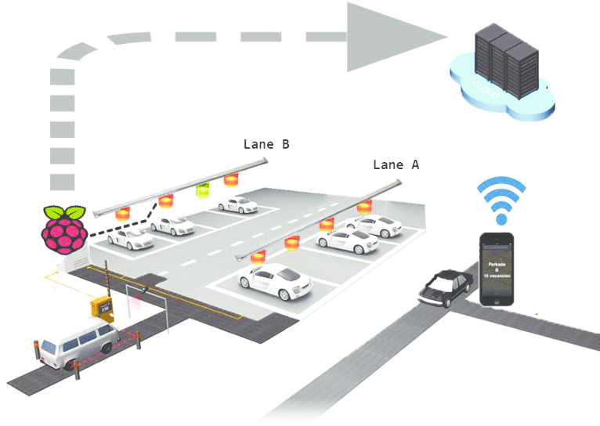

# Key Features and Components:

# 1. IoT Parking Sensors:

- Install IoT sensors in each parking space in the parking facility to detect the presence of vehicles.

- These sensors will use technologies like ultrasonic sensors, magnetic sensors, or infrared sensors.

- Sensors will wirelessly transmit data to Raspberry Pi devices.

# 2. Raspberry Pi Devices for Data Collection:

- Deploy Raspberry Pi devices strategically within the parking facility, each connected to a group of IoT sensors.

- Raspberry Pi devices will process occupancy data from connected sensors locally.

- Processed data will be sent to the central server at regular intervals via a secure internet connection.

- Local displays connected to Raspberry Pi devices will provide real-time availability information at specific parking section entrances.

# 3. Centralized Server:

- The central server will receive and process real-time data from Raspberry Pi devices.

- It will maintain a database of parking space occupancy status, updating it as vehicles enter and leave parking spaces.

- The server will manage user requests, reservations, and payment processing.

# 4. User-Friendly Mobile App:

- Users will download and install a mobile app on their smartphones, available for both iOS and Android platforms.

- The app will provide features such as real-time parking space availability, reservations, navigation to available spaces, and payment options.

# 5. Parking Guidance System:

- LED displays or signage at key points within the parking facility will guide drivers to available parking spaces.

- Guidance will be based on data from both sensors and Raspberry Pi devices.

# 6. Data Analytics:

- Data collected from sensors and Raspberry Pi devices will be analyzed to gain insights into parking patterns and usage.

- Facility operators can use these insights to optimize the parking facility.

# 7. Payment Integration:

- Payment processing will be integrated into the mobile app, allowing users to pay for parking within the app.

# User Experience:

- Users open the mobile app to view real-time parking availability data.

- Raspberry Pi-powered displays at parking section entrances provide immediate feedback on space availability.

- Users follow the guidance provided by displays and the app to quickly locate available parking spaces.

- The app continues to provide navigation instructions to the nearest available parking space.

# Benefits of Raspberry Pi Integration:

- Distributed data collection and processing reduce the load on the central server.

- Local displays enhance the user experience with immediate feedback.

- Scalable and cost-effective solution for larger or multiple parking facilities.

- Offers energy-efficient data processing capabilities.

# Challenges:

- Ensuring reliable connectivity between Raspberry Pi devices and the central server.

- Implementing data synchronization and redundancy measures.

- Securing Raspberry Pi devices against unauthorized access or tampering.

- Managing power requirements and backup solutions for Raspberry Pi devices.

This comprehensive "Smart Parking System with IoT" project aims to optimize parking space management, reduce congestion, and enhance user convenience by leveraging IoT technology, including IoT sensors and Raspberry Pi devices, in combination with a user-friendly mobile app and central server infrastructure.

# Conclusion:

The "Smart Parking System with IoT" project represents an innovative and efficient solution to address urban parking challenges. By integrating IoT sensors, Raspberry Pi devices, and a user-friendly mobile app, this system offers real-time parking space availability information, navigation guidance, and streamlined payment options. It not only enhances the overall parking experience for users but also helps reduce congestion, optimize parking facility management, and gather valuable data for future improvements. This project showcases the power of IoT technology to transform traditional parking facilities into smart, efficient, and user-centric spaces.