**Air Quality Analysis in Tamil Nadu**

**Project Overview:**

Air quality is indeed a critical factor that significantly impacts both public health and the environment. Poor air quality is associated with a host of health problems, including respiratory issues, cardiovascular diseases, and even premature mortality. Additionally, it can lead to environmental degradation, affecting ecosystems, soil quality, and water bodies. In Tamil Nadu, a state in India experiencing rapid urbanization, industrialization, and an upsurge in vehicular traffic, the quality of the air has increasingly become a major concern.

With its burgeoning population and economic growth, Tamil Nadu has seen a significant increase in urban areas, industrial zones, and transportation networks. While these developments have led to improved living standards and economic opportunities for many, they have also resulted in environmental challenges. The emission of pollutants from industries, vehicles, and construction activities has contributed to the deteriorating air quality, posing risks to public health and the environment.

The primary objective of this project is to conduct a comprehensive analysis of air quality in Tamil Nadu, with a particular focus on identifying the sources of pollution. To achieve this, various methods will be employed, including air quality monitoring stations, satellite data, and computer modeling. These tools will help us collect real-time data on pollutants like particulate matter (PM2.5 and PM10), nitrogen dioxide (NO2), sulfur dioxide (SO2), carbon monoxide (CO), and ozone (O3), among others. By analyzing this data, we can pinpoint the geographical locations and sectors responsible for elevated pollution levels.

One of the major sources of air pollution in Tamil Nadu is vehicular traffic. The state has experienced a substantial increase in the number of vehicles on its roads, leading to emissions of harmful gases and particulate matter. This project will not only identify high-traffic zones but also propose measures to encourage the adoption of electric vehicles, improve public transportation, and implement stricter emissions standards to reduce pollution from this source.

Industrial emissions also play a significant role in deteriorating air quality. Tamil Nadu is home to a diverse industrial base, including manufacturing, textiles, and information technology. These industries often release pollutants into the atmosphere, and this project will assess the emissions from different industrial clusters and recommend cleaner technologies and practices to reduce their environmental footprint.

The project will also consider the impact of construction activities on air quality. The construction industry is growing rapidly in Tamil Nadu, and the dust and emissions associated with it can have a substantial impact on local air quality. Strategies for dust control, the use of environmentally friendly construction materials, and other measures will be explored to mitigate the adverse effects of construction on the region's air quality.

To ensure the success of this project, collaboration with government agencies, environmental organizations, and local communities will be essential. Public awareness campaigns and educational programs will be conducted to inform residents about the importance of air quality and their role in reducing pollution. Engaging with industry leaders and policy makers will be crucial for the implementation of mitigation strategies.

Additionally, the project will explore the potential of green infrastructure, such as urban parks and green roofs, in mitigating air pollution. Green spaces can act as natural filters, trapping pollutants and improving air quality. Encouraging the creation of such spaces can be an effective long-term strategy for enhancing air quality in urban areas.

In conclusion, the quality of the air in Tamil Nadu is a matter of increasing concern due to urbanization, industrialization, and heightened vehicular traffic. This project aims to comprehensively assess air quality, identify pollution sources, and propose effective strategies to improve the region's air quality. By addressing issues related to transportation, industry, construction, and community engagement, we can work towards a cleaner and healthier environment for the people of Tamil Nadu.

**Project Team:**

Kiruthiga.R

Kavitha.V

Kavitha.S

Praneetha.E

**Project Timeline:**

The project is set to start on August 30, 2023, and is expected to conclude by November 1, 2023, adhering to the specified timeline.

**Problem Statement:**

The project outlined here provides a comprehensive and structured approach to addressing the air quality issues in Tamil Nadu. These key objectives are fundamental to achieving the primary goal of enhancing air quality and public health in the region.

**Assessment of Current Air Quality:**

The first objective involves collecting and analyzing historical air quality data from monitoring stations spread across Tamil Nadu. Parameters like PM2.5, PM10, NO2, SO2, CO, and O3 will be examined. This data will help in pinpointing areas with the most critical air quality issues, providing a foundation for targeted mitigation efforts.

**Identification of Pollution Sources:**

Determining the sources of pollution is a crucial step in the process. Industrial emissions, vehicular traffic, agricultural practices, and natural phenomena like dust storms all contribute to air pollution. Quantifying the contributions of each source will enable a more nuanced and effective approach to mitigating pollution.

**Temporal and Spatial Trends:**

Studying temporal and spatial trends in air quality is essential for understanding the dynamic nature of the problem. Seasonal variations and long-term changes in air quality will be analyzed, allowing for the development of strategies that can adapt to these fluctuations. Furthermore, examining urban-rural disparities can help in tailoring solutions to specific areas.

**Health Impact Assessment:**

The fourth objective, focusing on assessing the health impacts of poor air quality, underscores the human dimension of the problem. Understanding the prevalence of respiratory diseases and other health issues related to air pollution is vital for making a compelling case for action and prioritizing mitigation efforts.

**Regulatory Compliance:**

Ensuring compliance with air quality standards set by regulatory bodies like the Central Pollution Control Board (CPCB) and the Tamil Nadu Pollution Control Board (TNPCB) is a foundational step. Compliance with these standards is essential for safeguarding public health and the environment.

**Mitigation Strategies:**

Proposing evidence-based strategies for mitigating air pollution is the heart of the project. These strategies should encompass a range of measures, from regulatory policies to technological solutions and public awareness campaigns. The ability to quantify the potential benefits of these strategies, both in terms of improved air quality and public health, is key for decision-makers and stakeholders.

**Stakeholder Engagement:**

Engaging with a wide array of stakeholders is essential to garner support for the proposed initiatives and to ensure their successful implementation. This includes government agencies, environmental organizations, and local communities. Collaboration among these groups is vital for translating plans into actionable results.

**Deliverables:**

The systematic approach laid out in these objectives ensures that the project addresses every critical aspect of air quality management in Tamil Nadu. From data collection to health impact assessment and stakeholder engagement, it covers the entire spectrum of activities required to create a cleaner and healthier environment for the people of the state. This project could serve as a model for other regions facing similar air quality challenges, as it embraces a holistic and evidence-based methodology.

The successful completion of the project will result in several key deliverables, each designed to provide valuable insights, recommendations, and resources to address air quality concerns in Tamil Nadu. These deliverables are as follows:

1. Comprehensive Report:

A comprehensive report will be the cornerstone of the project, encompassing all aspects of the air quality analysis in Tamil Nadu. This document will serve as a detailed repository of findings, methodologies, and observations. The report will include an executive summary for a quick overview, an in-depth analysis of air quality data, trends, and potential sources of pollution. It will also discuss the implications of poor air quality on public health, the environment, and the economy. Recommendations and proposed solutions will be outlined in this report as well. The comprehensive report will be structured and organized in a clear and accessible manner, making it a valuable resource for stakeholders and policymakers.

2. Data Visualizations, Maps, and Graphs:

To effectively communicate the key insights and trends identified in the air quality analysis, a range of data visualizations will be developed. This will include charts, graphs, maps, and infographics that illustrate air quality patterns, pollution sources, and trends over time. These visual aids will make complex data more understandable and enable stakeholders and the general public to grasp the severity of air quality issues in Tamil Nadu. Clear and informative visual representations will be a powerful tool in advocating for policy changes and public engagement.

3. Recommendations for Policy Changes and Interventions:

One of the primary goals of the project is to provide actionable recommendations for improving air quality in Tamil Nadu. The project team will compile a set of evidence-based policy changes and interventions to address the identified air quality issues. These recommendations will take into account not only regulatory measures but also practical steps for reducing pollution and promoting cleaner practices. The document will outline short-term and long-term strategies, including the potential health, environmental, and economic benefits of each proposed intervention.

4. Public Awareness Materials and Educational Resources:

In addition to policy recommendations, the project will produce public awareness materials and educational resources to engage the community in the effort to address air quality problems. These materials will be designed to raise awareness about the importance of clean air, the health risks associated with poor air quality, and the steps individuals can take to contribute to a cleaner environment. This may include pamphlets, brochures, online resources, and public service announcements. Education is a vital component of any effort to improve air quality, and these resources will empower individuals to make informed choices and advocate for change.

By delivering these key components, the project aims to drive a positive transformation in Tamil Nadu's air quality. The comprehensive report will provide a thorough understanding of the current situation, data visualizations will facilitate knowledge dissemination, policy recommendations will guide decision-makers, and public awareness materials will mobilize the community. Together, these deliverables will be instrumental in fostering a cleaner and healthier environment for the people of Tamil Nadu.

**Success Criteria:**

The success of the project will be assessed through a set of clear and measurable indicators to gauge its impact and effectiveness. The following key success criteria will be used to determine the project's accomplishments:

1. Tangible Improvement in Air Quality:

The primary and most direct measure of success will be the actual improvement in air quality within Tamil Nadu. This can be quantified by monitoring key air quality parameters such as levels of particulate matter (PM2.5 and PM10), ground-level ozone (O3), nitrogen dioxide (NO2), sulfur dioxide (SO2), carbon monoxide (CO), and other relevant pollutants. The project's success will be demonstrated by a measurable reduction in the concentrations of these pollutants over a specified timeframe. This data can be obtained from monitoring stations strategically placed throughout the region.

2. Reduced Health Impacts:

Another critical measure of success is the reduction in health impacts associated with poor air quality. These health impacts may include respiratory diseases, cardiovascular conditions, and other ailments linked to air pollution. Success will be demonstrated by a decrease in the number of hospital admissions, emergency room visits, and mortality rates due to air quality-related health issues. This can be assessed by collaborating with healthcare institutions and analyzing health data before and after the implementation of the project's recommendations.

3. Increased Compliance with Air Quality Standards:

Success will also be measured by the degree to which the region complies with air quality standards and regulations. Regulatory bodies set specific standards for air quality to protect public health and the environment. The project's success will be determined by an increase in the number of days when air quality in Tamil Nadu meets these established standards. Compliance rates can be tracked and compared over time, with the goal of demonstrating consistent improvement in adherence to air quality guidelines.

4. Public Perception and Engagement:

While the aforementioned metrics provide quantitative measures of success, it's also important to consider public perception and engagement. Success can be gauged by assessing the extent to which the project has raised awareness about air quality issues among the general public and encouraged individuals to take action. This can be measured through surveys, feedback, and the level of community engagement in activities related to air quality improvement.

5. Economic and Environmental Impact:

The economic and environmental impact of the project will also be measured. This can include assessing cost savings related to healthcare expenses, increased productivity, and reduced environmental damage. Additionally, it will be important to evaluate the reduction in greenhouse gas emissions and other environmental benefits resulting from improved air quality.

By evaluating the project's success using these clear and tangible indicators, stakeholders, policymakers, and the community will have a transparent understanding of the positive changes brought about by the project's efforts. The ultimate goal is to create a healthier, cleaner, and more sustainable environment in Tamil Nadu, and the success criteria outlined here will help monitor progress toward this objective.

**Constraints:**

The success of the project will be assessed through a set of clear and measurable indicators to gauge its impact and effectiveness. The following key success criteria will be used to determine the project's accomplishments:

1. Tangible Improvement in Air Quality:

The primary and most direct measure of success will be the actual improvement in air quality within Tamil Nadu. This can be quantified by monitoring key air quality parameters such as levels of particulate matter (PM2.5 and PM10), ground-level ozone (O3), nitrogen dioxide (NO2), sulfur dioxide (SO2), carbon monoxide (CO), and other relevant pollutants. The project's success will be demonstrated by a measurable reduction in the concentrations of these pollutants over a specified timeframe. This data can be obtained from monitoring stations strategically placed throughout the region.

2. Reduced Health Impacts:

Another critical measure of success is the reduction in health impacts associated with poor air quality. These health impacts may include respiratory diseases, cardiovascular conditions, and other ailments linked to air pollution. Success will be demonstrated by a decrease in the number of hospital admissions, emergency room visits, and mortality rates due to air quality-related health issues. This can be assessed by collaborating with healthcare institutions and analyzing health data before and after the implementation of the project's recommendations.

3. Increased Compliance with Air Quality Standards:

Success will also be measured by the degree to which the region complies with air quality standards and regulations. Regulatory bodies set specific standards for air quality to protect public health and the environment. The project's success will be determined by an increase in the number of days when air quality in Tamil Nadu meets these established standards. Compliance rates can be tracked and compared over time, with the goal of demonstrating consistent improvement in adherence to air quality guidelines.

4. Public Perception and Engagement:

While the aforementioned metrics provide quantitative measures of success, it's also important to consider public perception and engagement. Success can be gauged by assessing the extent to which the project has raised awareness about air quality issues among the general public and encouraged individuals to take action. This can be measured through surveys, feedback, and the level of community engagement in activities related to air quality improvement.

**Project Description:**

**Data Collection:**

The establishment of an extensive network of air quality monitoring stations in Tamil Nadu is a critical foundation for the success of the project. These monitoring stations play a pivotal role in gathering comprehensive and real-time data on various air pollutants, as well as environmental and meteorological factors that influence air quality. The key components and benefits of this monitoring network are as follows:

**1. Continuous Real-Time Data Collection:**

- Air Quality Parameters: The monitoring stations are equipped to continuously measure various air pollutants, including particulate matter (PM2.5 and PM10), nitrogen dioxide (NO2), sulfur dioxide (SO2), carbon monoxide (CO), and ozone (O3). This real-time data collection allows for the assessment of current air quality levels and the identification of trends and fluctuations.

**2. Comprehensive Environmental Data:**

- Weather Conditions: In addition to air quality data, the monitoring stations record critical weather parameters, such as temperature, humidity, wind speed, and wind direction. This information is invaluable for understanding the impact of meteorological conditions on air quality, such as the dispersion of pollutants.

- Traffic Patterns: Monitoring stations also track traffic patterns in the region. Traffic emissions are a significant contributor to air pollution, and understanding how traffic impacts air quality is crucial for targeted interventions.

**3. Spatial Coverage:**

- Strategic Placement: The network of monitoring stations is strategically placed across various regions of Tamil Nadu to ensure comprehensive spatial coverage. This allows for the detection of localized pollution sources and variations in air quality across the state.

**4. Data Validation and Calibration:**

- Data Quality Assurance: To ensure the reliability and accuracy of the data, the monitoring stations undergo regular validation and calibration processes. This involves cross-checking data against established standards and verifying the correct functioning of sensors and equipment.

**5. Timely Alerts and Public Access:**

- Early Warning System: The real-time data collected by the monitoring stations can serve as the basis for an early warning system. When air quality reaches unhealthy levels, alerts can be generated to notify the public, government agencies, and healthcare providers.

- Public Access: Making air quality data accessible to the public through websites, apps, and other platforms allows individuals to make informed decisions regarding outdoor activities and helps raise awareness about air quality issues.

**6. Informed Decision-Making:**

- Policy and Interventions: The data gathered by the monitoring network provides policymakers and stakeholders with the evidence needed to make informed decisions. It aids in the development of effective policies and interventions to address air quality challenges.

**7. Targeted Mitigation Strategies:**

- Source Identification: By analyzing the real-time data, the project can identify specific pollution sources, whether industrial, vehicular, or natural, and develop targeted strategies to mitigate these sources.

The establishment of this monitoring network is a cornerstone of the project, as it ensures that all project activities, recommendations, and interventions are based on accurate, up-to-date, and localized data. This data-driven approach is essential for understanding the dynamics of air quality in Tamil Nadu and for implementing effective measures to improve it.

**Data Analytics:**

The utilization of advanced data analytics, including machine learning and AI algorithms, represents a significant leap forward in the project's ability to process and analyze the extensive dataset collected from the air quality monitoring stations. These cutting-edge technologies will enhance the project's understanding of air quality in Tamil Nadu in the following ways:

**1. Pattern Recognition and Anomaly Detection:**

Machine learning and AI algorithms excel at recognizing complex patterns and anomalies within large datasets. By applying these techniques to air quality data, the project can identify irregularities, sudden spikes in pollution levels, or unusual trends that may not be immediately apparent through traditional analysis. This early detection capability is crucial for addressing emerging air quality concerns promptly.

**2. Source Identification:**

Advanced analytics can help pinpoint the sources of pollution, both in terms of types (industrial, vehicular, agricultural, etc.) and locations. By analyzing historical data alongside real-time measurements, machine learning models can attribute pollution events to specific sources. This information is invaluable for implementing targeted mitigation measures and enforcing regulations.

**3. Seasonal Variations and Trends:**

Machine learning algorithms can discern seasonal variations and long-term trends in air quality. They can identify recurring patterns, such as pollution spikes during certain weather conditions or particular times of the year. This knowledge is vital for developing policies and interventions that account for seasonal variations in air quality.

**4. Data Fusion:**

These advanced techniques can fuse air quality data with other data sources, such as traffic patterns, industrial activities, and population density, to gain a more comprehensive understanding of the factors affecting air quality. This multidimensional analysis provides a holistic view of the problem and supports more effective decision-making.

**5. Continuous Optimization:**

Machine learning models can adapt and improve over time. As more data becomes available and as the project's understanding of air quality dynamics deepens, the algorithms can be refined and optimized to enhance their accuracy and predictive capabilities.

**6. Decision Support:**

The insights generated through advanced data analytics become a valuable resource for policymakers, enabling them to make informed decisions regarding regulatory changes, interventions, and resource allocation.

**Public Engagement:**

Public engagement is a crucial element of the project, fostering a sense of community involvement and empowering residents to take an active role in improving air quality in Tamil Nadu. Here are the key aspects of public engagement within the project:

**1. Community-Driven Approach:**

- By involving residents in data collection, the project promotes a community-driven approach to addressing air quality issues. It encourages a sense of shared responsibility and ownership of the region's air quality, fostering a collaborative effort to tackle pollution.

**2. Awareness Campaigns:**

- Public awareness campaigns play a crucial role in educating residents about the health risks associated with air pollution. These campaigns will convey the importance of clean air, the effects of air pollution on health, and practical steps individuals can take to reduce emissions.

- The campaigns may include workshops, seminars, public events, and the distribution of educational materials to reach a broad audience.

**3. Behavioral Change Promotion:**

- Awareness campaigns will not only inform residents but also motivate them to adopt environmentally friendly behaviors. This could involve encouraging the use of public transportation, carpooling, reducing energy consumption, and practicing waste reduction.

**4. Public Health Initiatives:**

- The project may collaborate with local healthcare institutions and organizations to provide health check-ups and information to residents, particularly those in high-risk areas. Regular health assessments can help individuals monitor the impact of air quality on their well-being.

**5. Public Feedback and Involvement:**

- Feedback from residents will be valued and integrated into decision-making processes. Public input can help shape the project's strategies, and residents will have the opportunity to participate in public meetings or forums to discuss air quality challenges and solutions.

**6. Advocacy for Policy Changes:**

- The engaged community can play a pivotal role in advocating for policy changes to improve air quality. Informed and active residents can influence local and regional policymakers to enforce regulations, implement clean energy solutions, and invest in sustainable transportation.

Public engagement is not just a supplementary aspect of the project; it is an essential component that empowers individuals and communities to take an active stance in improving the air they breathe. By involving and educating residents, the project aims to create a sense of shared responsibility and drive meaningful change in air quality in Tamil Nadu.

**Policy Recommendations:**

The project's collaboration with government agencies is instrumental in translating data-driven insights into actionable policy recommendations. These policy recommendations aim to guide the region towards improved air quality, public health, and a sustainable environment. Here are some of the key components of the policy recommendations:

**1. Pollution Control Measures:**

- The project will propose a range of measures to control pollution sources. This may include setting stricter emissions standards for industries, enforcing cleaner technologies, and monitoring compliance with pollution control regulations. Recommendations will be tailored to specific industries and activities based on the insights gained from data analysis.

**2. Transportation Initiatives:**

- Given the significant impact of vehicular emissions on air quality, the project will advocate for policies that promote sustainable transportation. Recommendations may include the expansion of public transit systems, incentives for electric and hybrid vehicles, and the development of pedestrian and cycling infrastructure to reduce the reliance on personal automobiles.

**3. Urban Planning and Land Use:**

- Urban planning and land use policies can significantly impact air quality. The project will suggest strategies to reduce urban sprawl, encourage mixed land use, and promote green building practices. These measures can minimize the need for long commutes, reduce energy consumption, and enhance the overall quality of urban environments.

**4. Green Energy Transition:**

- The transition to cleaner and renewable energy sources will be a central policy recommendation. Encouraging the use of solar, wind, and other clean energy technologies can help reduce emissions from energy production and improve air quality.

**5. Public Awareness and Education:**

- The project will recommend the implementation of public awareness and education programs to ensure that residents are informed about air quality issues and are motivated to take actions to reduce their personal contributions to air pollution. Educational initiatives may be integrated into school curricula and community programs.

**6. Regulatory Enhancements:**

- The project will propose enhancements to existing air quality regulations and the development of new regulations where necessary. This may include stricter standards for pollutants, more frequent monitoring, and penalties for non-compliance. Stronger enforcement mechanisms will also be recommended.

**7. Regional Collaboration:**

- Collaboration among neighboring regions and states will be encouraged to address transboundary air quality issues. The project will advocate for the development of regional policies and agreements to combat shared air pollution challenges.

**8. Public Health Initiatives:**

- Recommendations may also include the integration of air quality considerations into public health policies. This could involve the establishment of health advisories based on air quality data and measures to protect vulnerable populations, such as the elderly and children.

**9. Economic Incentives:**

- The project will recommend economic incentives to encourage businesses and individuals to adopt cleaner practices. These incentives may include tax breaks for green initiatives, subsidies for clean energy adoption, and other financial rewards for sustainable behavior.

The goal of these policy recommendations is to create a holistic approach to improving air quality in Tamil Nadu. By addressing pollution sources, transportation, urban planning, energy production, public awareness, and regulatory measures, the project aims to create a comprehensive strategy that will result in cleaner air, better public health, and a more sustainable future for the region. Collaboration with government agencies and stakeholders is vital to ensure the successful implementation of these recommendations.

**Dynamic Pollution Mapping:**

The development of dynamic pollution maps is a valuable tool for enhancing public awareness and enabling residents to make informed decisions regarding their daily activities and health. These maps provide location-specific air quality information in real-time, offering numerous benefits to the community:

**1. Real-Time Awareness:**

- Residents can access up-to-the-minute air quality data for their specific location. This information empowers individuals to stay informed about current air quality conditions, enabling them to make timely decisions about outdoor activities.

**2. Personal Health Protection:**

- Dynamic pollution maps allow residents to identify areas with high pollution levels and make choices to reduce personal exposure to harmful pollutants. For individuals with respiratory conditions or sensitivities, this information can be vital for safeguarding their health.

**3. Daily Planning:**

- Residents can use pollution maps to plan their daily activities. For example, they can schedule outdoor exercises, walks, or children's playtime during periods of better air quality, minimizing exposure during peak pollution hours.

**4. Avoiding High-Pollution Areas:**

- The maps can help residents identify areas with consistently poor air quality, such as near industrial facilities or congested traffic zones. This knowledge enables them to avoid these areas when possible or take alternative routes.

**5. School and Work Decisions:**

- Parents can use the pollution maps to make informed decisions about school attendance on days with poor air quality. Employees may choose to work from home or adjust their work hours to reduce exposure.

**6. Advocacy and Awareness:**

- Residents armed with real-time air quality data can become advocates for clean air initiatives. They can use this information to raise awareness, engage with local authorities, and demand measures to improve air quality in their communities.

- Dynamic pollution maps are valuable for tourists and travelers who may not be familiar with local air quality conditions. They can use these maps to plan their itineraries and make accommodations in areas with better air quality.

**7. Improved Quality of Life:**

- Access to air quality information and the ability to make informed choices can lead to an improved quality of life for residents. This can result in reduced health issues, fewer sick days, and a greater sense of well-being.

The availability of dynamic pollution maps is a tangible way to democratize access to air quality information, enabling individuals to take actions that protect their health and well-being. By integrating this tool into public awareness campaigns and educational efforts, the project can help create a more informed and engaged community committed to improving air quality in Tamil Nadu.

**Policy Insights:**

The provision of data-driven policy insights is a fundamental aspect of the project, and it serves to empower policymakers with the information necessary to make informed decisions and refine air quality control strategies. Here are some of the key ways in which the data insights benefit policymakers:

**1. Identifying Pollution Hotspots:**

- The air quality data can pinpoint pollution hotspots within Tamil Nadu. Policymakers can use this information to target interventions in areas where pollution levels are consistently high, directing resources and regulations to mitigate specific pollution sources.

**2. Evidence-Based Decision-Making:**

- The project's data-driven insights provide policymakers with evidence to support their decision-making processes. They can rely on quantitative data and trends to justify the implementation of regulatory changes and investments in clean energy initiatives.

**3. Monitoring Policy Impact:**

- Over time, the data can be used to assess the effectiveness of implemented policies. Policymakers can track how air quality improves or deteriorates in response to specific regulations, enabling them to refine policies for better outcomes.

**4. Setting Priorities:**

- Data insights help prioritize policy efforts based on the most critical air quality challenges. For instance, if the data reveals a significant increase in certain pollutants during certain months, policymakers can prioritize measures to address seasonal variations.

**5. Allocating Resources:**

- The information assists in resource allocation. Policymakers can direct budgetary resources to initiatives with the greatest potential for reducing pollution and improving air quality, maximizing the impact of available funds.

**6. Collaboration and Engagement:**

- Data insights foster collaboration and engagement with stakeholders and the public. Policymakers can share data with the community, seek feedback, and engage in discussions on how to address air quality issues collectively.

**7. Accountability and Transparency:**

- Policymakers can use the data to demonstrate transparency and accountability in addressing air quality challenges. They can show residents and other stakeholders the tangible results of their efforts, building trust and support for clean air initiatives.

**8. Long-Term Planning:**

- Data-driven insights allow for long-term planning. Policymakers can use historical data and predictive models to create plans that address air quality challenges and prepare for future population and industrial growth.

**9. Continuous Improvement:**

- The ongoing collection of data allows for continuous improvement in policies and regulations. Policymakers can adapt to changing circumstances and evolving air quality challenges based on real-time and historical data.

By providing policymakers with access to data-driven insights, the project contributes to more effective, targeted, and sustainable air quality policies. These insights help shape a regulatory framework that not only adheres to air quality standards but also fosters a healthier and more sustainable living environment for the people of Tamil Nadu.

**Data-Driven Monitoring:**

The establishment of an extensive network of advanced air quality monitoring stations with real-time data collection capabilities is a critical aspect of the project, and it reflects a commitment to comprehensively monitor air quality throughout Tamil Nadu, including urban and rural areas. Here are some of the key features and benefits of this monitoring network:

**1. Comprehensive Coverage:**

- The network is designed to cover both urban and rural areas across Tamil Nadu. This ensures that air quality is monitored in all corners of the state, addressing the unique challenges faced by different regions.

**2. Spatial Distribution:**

- The strategic placement of monitoring stations throughout the state ensures that no area is left unmonitored. This spatial distribution is essential for assessing localized pollution sources and variations in air quality.

**3. Real-Time Data Collection:**

- The stations are equipped with sensors and technology that allow for real-time data collection. This means that residents, authorities, and stakeholders can access current air quality information at any time.

**4. Localized Insights:**

- By monitoring urban and rural areas, the project gains localized insights into air quality challenges. These insights can inform targeted interventions specific to each region's unique pollution sources and characteristics.

**5. Identifying Pollution Hotspots:**

- The network can identify pollution hotspots, areas with consistently high pollution levels. This information guides policymakers and environmental agencies in prioritizing interventions in areas where air quality is a significant concern.

**6. Seasonal Variations:**

- The real-time data collection capabilities are essential for tracking seasonal variations in air quality. This information allows for the development of policies and interventions that account for changing weather conditions and pollution patterns.

**7. Public Awareness:**

- Access to real-time air quality data fosters public awareness. Residents can make informed decisions based on current air quality conditions, such as planning outdoor activities on days with better air quality or avoiding high-pollution areas.

**8. Data-Driven Policy:**

- The data collected by the monitoring network forms the foundation for data-driven policymaking. Policymakers can use this information to shape regulations, allocate resources, and implement interventions based on the most up-to-date and accurate data available.

**9. Continuous Improvement:**

- The real-time data feeds into continuous improvement efforts. As more data is collected, the monitoring network becomes more refined and accurate, aiding in the ongoing efforts to enhance air quality.

The establishment of this monitoring network, with its real-time data collection capabilities, is pivotal in addressing air quality challenges across the diverse landscape of Tamil Nadu. It creates a foundation for informed decision-making, community engagement, and the development of targeted interventions to improve air quality throughout the region.

**Pollution Forecasting:**

Pollution forecasting is a crucial component of the project's efforts to improve air quality in Tamil Nadu. Predictive models play a pivotal role in anticipating changes in air quality, and the benefits extend to various stakeholders:

**1. Proactive Measures for Traffic Management:**

- Predictive models can anticipate air quality deteriorations and provide insights into the impact of traffic emissions on pollution levels. This information enables authorities to implement traffic restrictions, such as altering vehicle flow or limiting vehicular access in areas where air quality is expected to degrade.

**2. Timely Public Notifications:**

- Predictive models can trigger alerts and notifications to inform residents about expected pollution spikes. This early warning system empowers individuals to take precautionary measures, such as avoiding outdoor activities during periods of poor air quality or using public transportation when pollution levels are expected to rise.

**3. Regulatory Decisions:**

- Policymakers and regulatory bodies can use pollution forecasts to make informed decisions about implementing temporary measures, such as restricting industrial activities, construction, or specific emissions during periods of anticipated poor air quality. This allows for more proactive regulation to prevent pollution events.

**4. Resource Allocation:**

- Resource allocation for air quality management can be optimized based on pollution forecasts. This may involve the deployment of air quality monitoring teams, the distribution of resources for emergency response, or the allocation of funding for interventions in areas expected to experience pollution spikes.

**5. Emergency Response Planning:**

- Pollution forecasts are valuable for emergency response planning. During extreme pollution events, emergency services and healthcare facilities can prepare for an increased number of patients with respiratory problems. Evacuation plans and medical supplies can be readied in advance.

**6. Industry and Business Decisions:**

- Industries and businesses can use pollution forecasts to adjust their operations and work schedules. They may opt to reduce emissions during peak pollution periods, reschedule outdoor work, or encourage employees to work remotely to minimize exposure to poor air quality.

**7. Community Awareness:**

- Pollution forecasts also enhance community awareness. Residents, schools, and local organizations can plan activities, events, and outdoor gatherings during times when air quality is expected to be better, thus reducing personal exposure to pollutants.

**8. Environmental Management:**

- Predictive models help environmental agencies make decisions about land use planning and natural resource management. When forecasts predict significant air quality deterioration, steps can be taken to protect ecosystems and wildlife in affected areas.

Overall, pollution forecasting empowers stakeholders with the ability to plan and act proactively in response to air quality changes. It not only helps reduce the impact of poor air quality on public health but also enables the efficient use of resources and the implementation of targeted interventions to prevent or mitigate pollution events.

**Source code:**

import pandas as pd

import plotly.express as px

import plotly.io as pio

import plotly.graph_objects as go

pio.templates.default = "plotly_white"

data = pd.read_csv("/kaggle/input/airqualityintamilnadu/cpcb_dly_aq_tamil_nadu-2014.csv")

print(data.head())

data['Sampling Date'] = pd.to_datetime(data['Sampling Date'])

print(data.describe())

fig = go.Figure()

for pollutant in ['SO2','NO2','RSPM/PM10']:

    fig.add_trace(go.Scatter(x=data['Sampling Date'], y=data[pollutant], mode='lines',

                             name=pollutant))

fig.update_layout(title='Time Series Analysis of Air Pollutants in Tamilnadu',

                  xaxis_title='Date', yaxis_title='Concentration (µg/m³)')

fig.show()

# Define AQI breakpoints and corresponding AQI values

aqi_breakpoints = [

    (0, 12.0, 50), (12.1, 35.4, 100), (35.5, 55.4, 150),

    (55.5, 150.4, 200), (150.5, 250.4, 300), (250.5, 350.4, 400),

    (350.5, 500.4, 500)

]

def calculate_aqi(pollutant_name, concentration):

    for low, high, aqi in aqi_breakpoints:

        if low <= concentration <= high:

            return aqi

    return None

def calculate_overall_aqi(row):

    aqi_values = []

    pollutants = ['SO2','NO2','RSPM/PM10']

    for pollutant in pollutants:

        aqi = calculate_aqi(pollutant, row[pollutant])

        if aqi is not None:

            aqi_values.append(aqi)

    return max(aqi_values)

# Calculate AQI for each row

data['AQI'] = data.apply(calculate_overall_aqi, axis=1)

# Define AQI categories

aqi_categories = [

    (0, 50, 'Good'), (51, 100, 'Moderate'), (101, 150, 'Unhealthy for Sensitive Groups'),

    (151, 200, 'Unhealthy'), (201, 300, 'Very Unhealthy'), (301, 500, 'Hazardous')

]

def categorize_aqi(aqi_value):

    for low, high, category in aqi_categories:

        if low <= aqi_value <= high:

            return category

    return None

# Categorize AQI

data['AQI Category'] = data['AQI'].apply(categorize_aqi)

print(data.head())

def categorize_aqi(aqi_value):

    for low, high, category in aqi_categories:

        if low <= aqi_value <= high:

            return category

    return None

# Categorize AQI

data['AQI Category'] = data['AQI'].apply(categorize_aqi)

print(data.head())

# AQI over time

fig = px.bar(data, x="Sampling Date", y="AQI",

             title="AQI of Tamilnadu in January")

fig.update_xaxes(title="Date")

fig.update_yaxes(title="AQI")

fig.show()

fig = px.histogram(data, x="Sampling Date",

                    color="AQI Category",

                    title="AQI Category Distribution Over Time")

fig.update_xaxes(title="Date")

fig.update_yaxes(title="Count")

fig.show()

# Define pollutants and their colors

pollutants = ['SO2','NO2','RSPM/PM10']

pollutant_colors = px.colors.qualitative.Plotly

# Calculate the sum of pollutant concentrations

total_concentrations = data[pollutants].sum()

# Create a DataFrame for the concentrations

concentration_data = pd.DataFrame({

    "Pollutant": pollutants,

    "Concentration": total_concentrations

})

# Create a donut plot for pollutant concentrations

fig = px.pie(concentration_data, names="Pollutant", values="Concentration",

             title="Pollutant Concentrations in Tamilnadu",

             hole=0.4, color_discrete_sequence=pollutant_colors)

# Update layout for the donut plot

fig.update_traces(textinfo="percent+label")

fig.update_layout(legend_title="Pollutant")

# Show the donut plot

fig.show()

# Correlation Between Pollutants

correlation_matrix = data[pollutants].corr()

fig = px.imshow(correlation_matrix, x=pollutants,

                 y=pollutants, title="Correlation Between Pollutants")

fig.show()

# Extract the hour from the date

data['Hour'] = pd.to_datetime(data['Sampling Date']).dt.hour

# Calculate hourly average AQI

hourly_avg_aqi = data.groupby('Hour')['AQI'].mean().reset_index()

# Create a line plot for hourly trends in AQI

fig = px.line(hourly_avg_aqi, x='Hour', y='AQI',

              title='Hourly Average AQI Trends in Tamilnadu (Jan 2023)')

fig.update_xaxes(title="Hour of the Day")

fig.update_yaxes(title="Average AQI")

fig.show()

# Average AQI by Day of the Week

data['Day_of_Week'] = data['Sampling Date'].dt.day_name()

average_aqi_by_day = data.groupby('Day_of_Week')['AQI'].mean().reindex(['Monday', 'Tuesday', 'Wednesday', 'Thursday', 'Friday', 'Saturday', 'Sunday'])

fig = px.bar(average_aqi_by_day, x=average_aqi_by_day.index, y='AQI',

              title='Average AQI by Day of the Week')

fig.update_xaxes(title="Day of the Week")

fig.update_yaxes(title="Average AQI")

fig.show()

**RESULTS:**

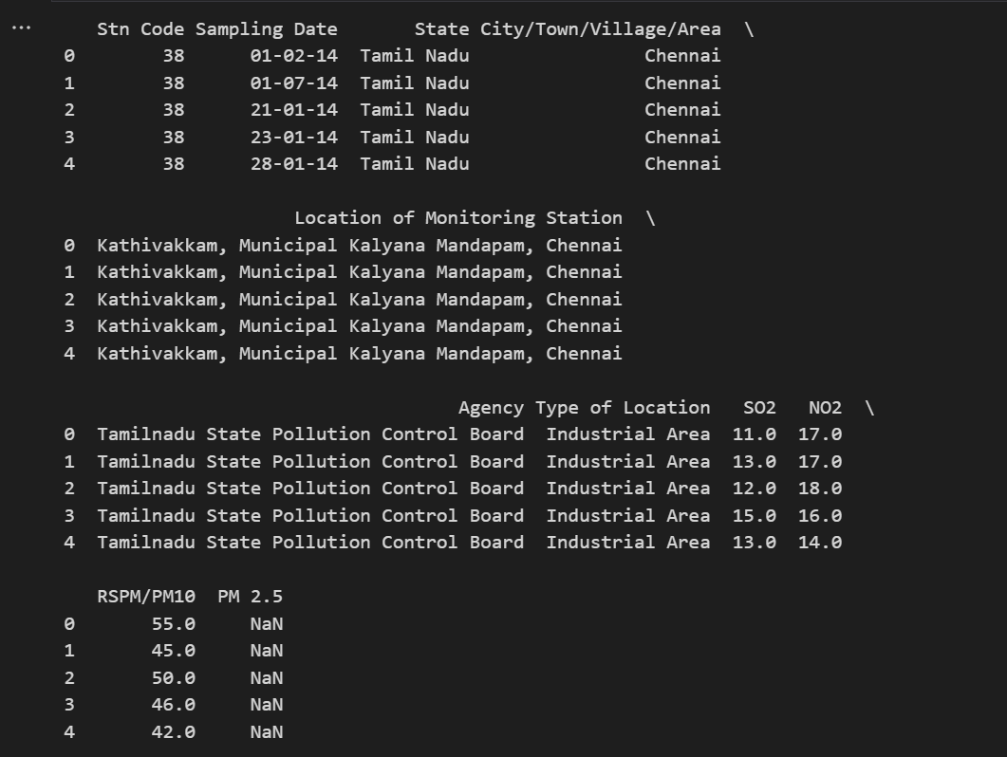

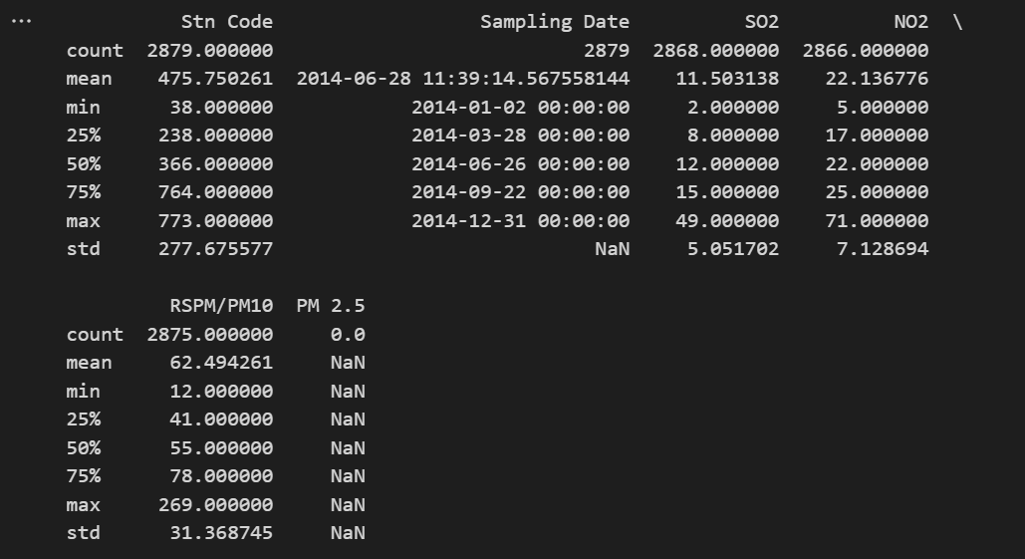

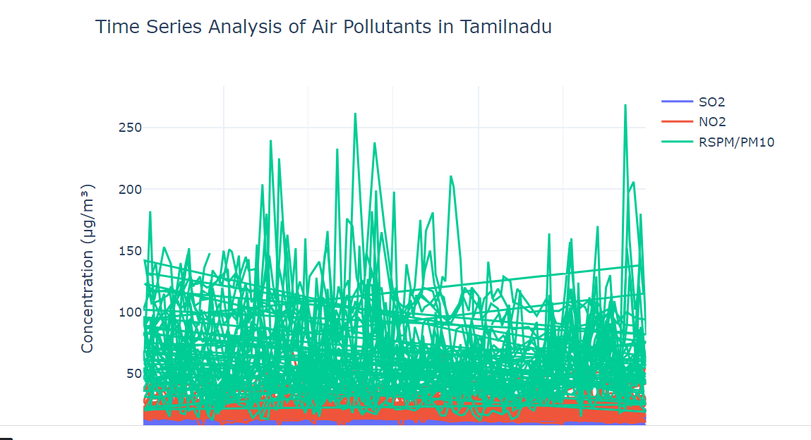

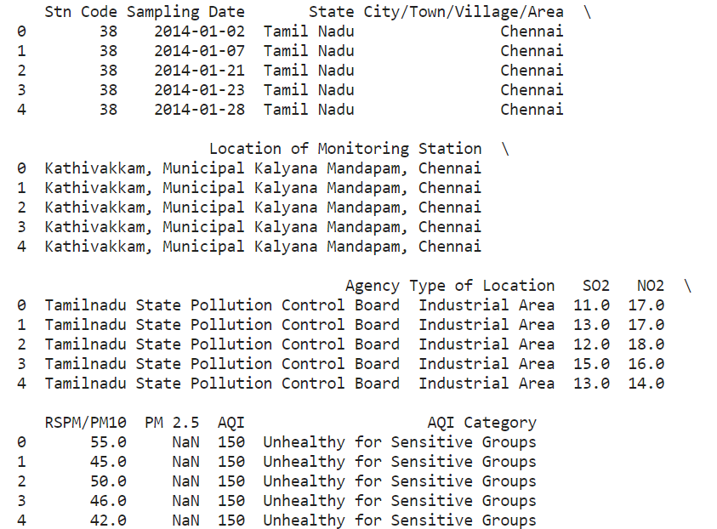

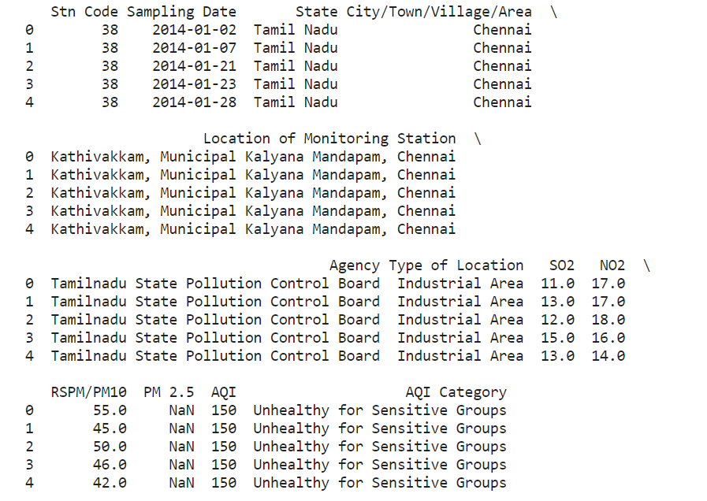

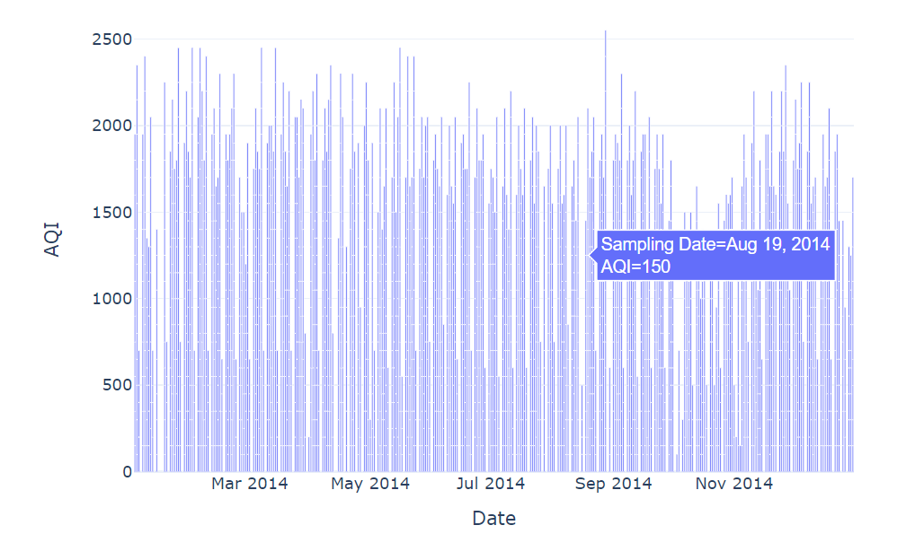

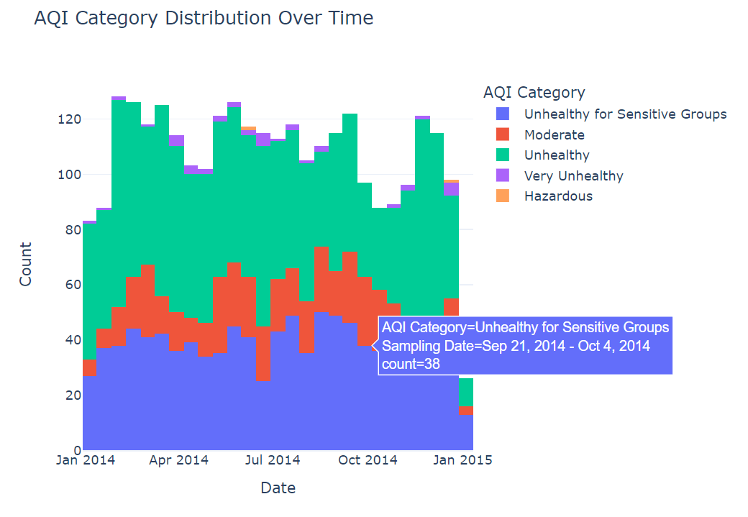

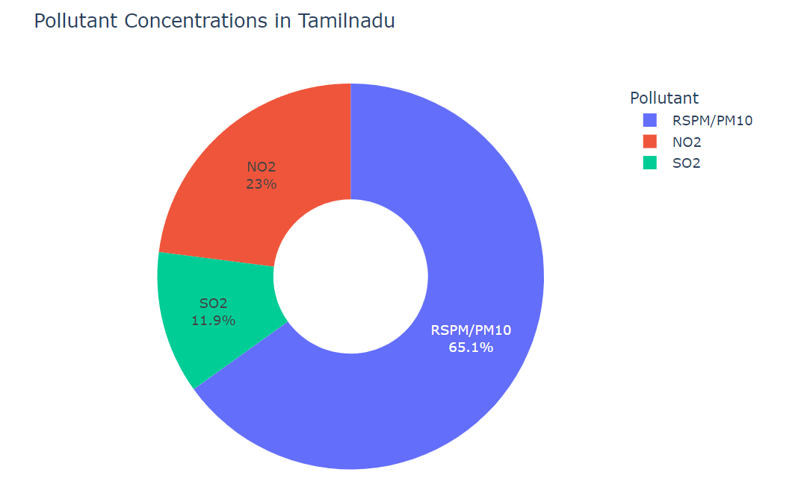

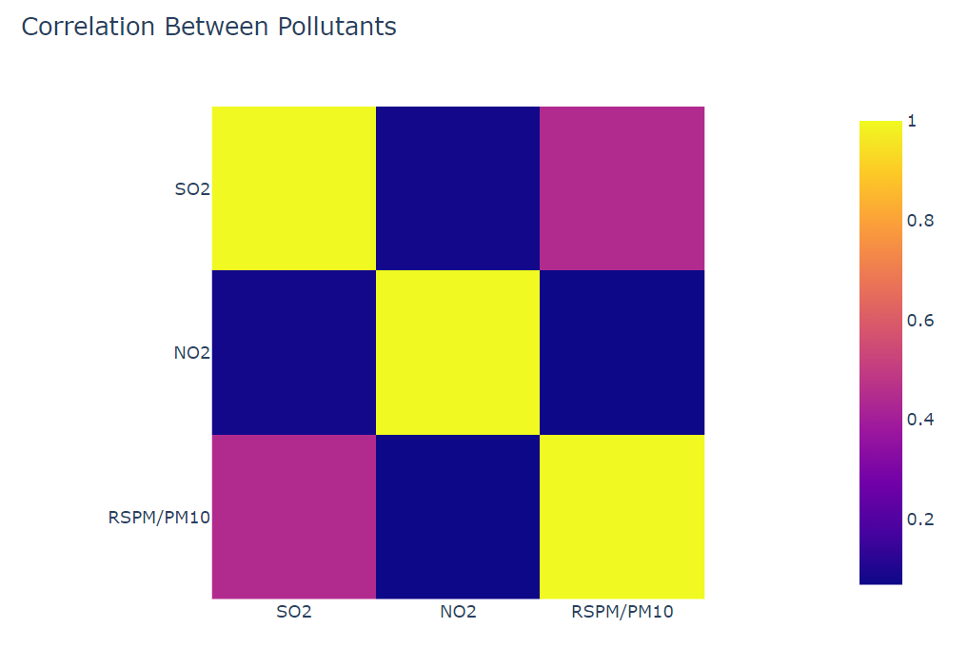

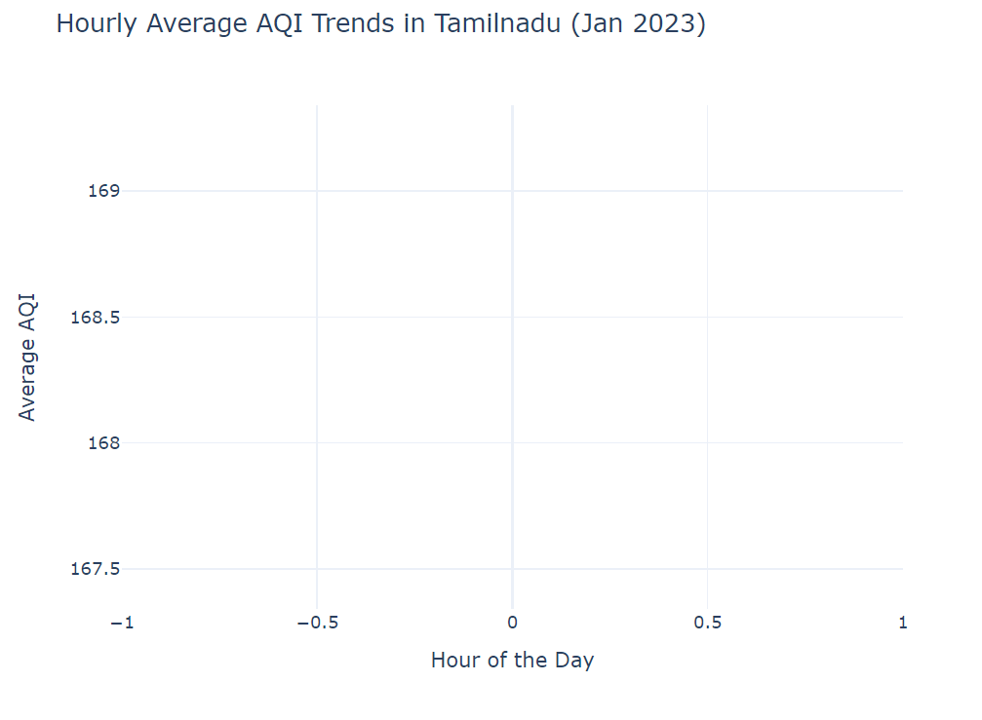

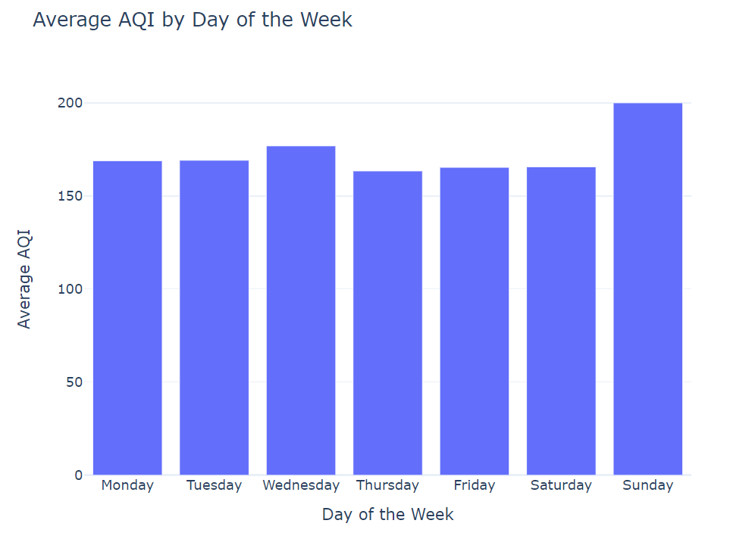

**Conclusion:**

"In conclusion, 'Clean Air Tamil Nadu' represents a groundbreaking and comprehensive initiative that aspires to revolutionize the air quality landscape in this diverse and culturally rich region. This ambitious project combines a multitude of strategies, from extensive data collection to advanced analytics, public engagement, and policy recommendations, all meticulously designed to effectively combat air pollution and enhance the overall well-being of Tamil Nadu's residents. It aims to set a new gold standard for air quality management, harnessing the power of data, technology, community involvement, and data-driven policies to achieve cleaner, healthier air for all.

The holistic approach embraced by 'Clean Air Tamil Nadu' underscores its commitment to addressing air quality challenges from every conceivable angle. This comprehensive strategy includes several key components, each contributing to the project's overarching goals. Here, we delve deeper into these elements to highlight their significance and potential impact on the region:

The cornerstone of the project is the establishment of an extensive network of advanced air quality monitoring stations equipped with real-time data collection capabilities. These monitoring stations are strategically placed to ensure comprehensive spatial coverage, monitoring air quality in both urban and rural areas. They continuously measure a range of pollutants, meteorological conditions, and traffic patterns, offering a comprehensive and localized view of the air quality landscape.

'Clean Air Tamil Nadu' leverages the power of advanced data analytics, machine learning, and AI algorithms to process and analyze the vast dataset collected. These cutting-edge technologies unlock intricate patterns, identify pollution sources, and forecast air quality changes. By doing so, they provide invaluable insights that can guide decision-making and shape evidence-based policies.

The project places a strong emphasis on engaging the community as a driving force behind clean air initiatives. This is achieved through the development of a mobile app that enables residents to actively contribute air quality data. Additionally, awareness campaigns are launched to educate the public about the health risks associated with air pollution, motivating individuals to adopt sustainable behaviors and reduce their contribution to air pollution.

Collaboration with government agencies ensures that data-driven insights are translated into actionable policy recommendations. These recommendations span a wide spectrum of measures, from pollution control strategies to sustainable transportation initiatives, urban planning recommendations, and the promotion of green energy transitions. The result is a comprehensive and actionable roadmap for achieving cleaner air across the region.

Residents are empowered with real-time, location-specific air quality information through dynamic pollution maps. These maps enable individuals to make informed decisions about their daily activities, plan routes that avoid high-pollution areas, and take steps to reduce personal exposure to harmful pollutants.

Predictive models are integral to the project's ability to forecast air quality changes. By anticipating deteriorations in air quality, stakeholders can take proactive measures, such as implementing traffic restrictions, informing residents about impending pollution spikes, and preparing for potential health impacts.

The success of 'Clean Air Tamil Nadu' is not measured by a single metric but rather by a holistic set of outcomes and impacts. These include tangible improvements in air quality, reduced health impacts attributed to poor air quality, increased compliance with air quality standards as a result of proposed mitigation strategies and interventions, and heightened public awareness and engagement. The project aims to create a comprehensive transformation in the region's approach to air quality management, blending quantitative and qualitative measures of success.

The ambitious and comprehensive nature of 'Clean Air Tamil Nadu' signifies a paradigm shift in how air quality challenges are addressed. It embodies the potential for a proactive, data-driven, and community-centered strategy that places the health and well-being of every resident at the forefront. This project is not just about reducing air pollution; it's about creating a cleaner, healthier, and more sustainable future for Tamil Nadu and its people.

As the project unfolds and continues to make strides towards cleaner air, it is our hope that it will serve as a model for similar initiatives across the globe. The integrated nature of 'Clean Air Tamil Nadu' demonstrates how technology, data, community engagement, and effective policymaking can synergize to tackle complex environmental challenges. It stands as a testament to what can be achieved when communities and governments work together to create a brighter and healthier future for all.

'Clean Air Tamil Nadu' is more than just a project; it's a vision of a cleaner, healthier, and more sustainable future, and it has the potential to leave a lasting impact that extends far beyond the borders of Tamil Nadu, inspiring similar efforts in regions around the world."