EDGE INTELLIGENCE
GOWTHAM V
25MML0046
IMPORT LIBRARIES
# Install dependencies (run once)
!pip install pillow torchvision torch requests matplotlib
# Import Libraries
# ----------------------------
import torch
from torchvision import transforms
import torchvision.transforms.functional as F
from PIL import Image
import numpy as np
import matplotlib.pyplot as plt
import requests
from io import BytesIO
# Load Image from URL
# ----------------------------
def load_image_from_url(url):
try:
response = requests.get(url)
response.raise_for_status()
img = Image.open(BytesIO(response.content)).convert("RGB")
return img
except Exception as e:
print(f"Error loading image: {e}")
return None

# Resize keeping aspect ratio + center crop
# ----------------------------
def resize_keep_aspect(img, size=224):
w, h = img.size
if h < w:
new_h = size
new_w = int(w * size / h)
else:
new_w = size
new_h = int(h * size / w)
img_resized = img.resize((new_w, new_h))
# Center crop
left = (new_w - size) // 2
top = (new_h - size) // 2
img_resized = img_resized.crop((left, top, left+size, top+size))
return img_resized
# Gaussian Blur
# ----------------------------
def gaussian_blur(img_tensor, kernel_size=5, sigma=1.0):
blur = transforms.GaussianBlur(kernel_size=kernel_size, sigma=sigma)
return blur(img_tensor)
# Auto Brightness & Contrast
# ----------------------------
def auto_brightness_contrast(img_tensor, target_mean=0.5):
mean = img_tensor.mean()
factor = target_mean / (mean + 1e-6)
img_tensor = torch.clamp(img_tensor * factor, 0, 1)
return img_tensor
# Normalize
# ----------------------------
def normalize(img_tensor, mean=[0.5,0.5,0.5], std=[0.5,0.5,0.5]):
return F.normalize(img_tensor, mean=mean, std=std)

# Preprocess with step-by-step display
# ----------------------------
def preprocess_step_by_step(img, size=224, apply_blur=True, apply_brightness_contrast=True):

# Step 1: Original
plt.imshow(img)
plt.title("Step 1: Original")
plt.axis("off")
plt.show()

# Step 2: Resized
img_resized = resize_keep_aspect(img, size)
plt.imshow(img_resized)
plt.title("Step 2: Resized")
plt.axis("off")
plt.show()

# Step 3: To Tensor
img_tensor = F.to_tensor(img_resized)

# Step 4: Gaussian Blur
if apply_blur:
img_tensor = gaussian_blur(img_tensor, kernel_size=5, sigma=1.1)
blurred_np = img_tensor.permute(1,2,0).numpy()
blurred_np = np.clip(blurred_np, 0, 1)
plt.imshow(blurred_np)
plt.title("Step 3: Gaussian Blur")
plt.axis("off")
plt.show()

# Step 5: Brightness/Contrast
if apply_brightness_contrast:
img_tensor = auto_brightness_contrast(img_tensor, target_mean=0.5)
bright_np = img_tensor.permute(1,2,0).numpy()
bright_np = np.clip(bright_np, 0, 1)
plt.imshow(bright_np)
plt.title("Step 4: Brightness/Contrast")
plt.axis("off")
plt.show()

# Step 6: Normalize
img_tensor = normalize(img_tensor, mean=[0.5,0.5,0.5], std=[0.5,0.5,0.5])
normalized_np = img_tensor.permute(1,2,0).numpy()
normalized_np = (normalized_np*0.5)+0.5
normalized_np = np.clip(normalized_np,0,1)
plt.imshow(normalized_np)
plt.title("Step 5: Normalized")
plt.axis("off")
plt.show()

return img_tensor

# ----------------------------
# Example usage
# ----------------------------
url = "https://raw.githubusercontent.com/pytorch/hub/master/images/dog.jpg"
img = load_image_from_url(url)
processed_tensor = preprocess_step_by_step(img)

print("Final processed tensor shape:", processed_tensor.shape)
OUTPUT:
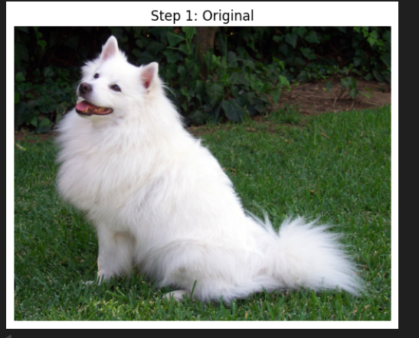
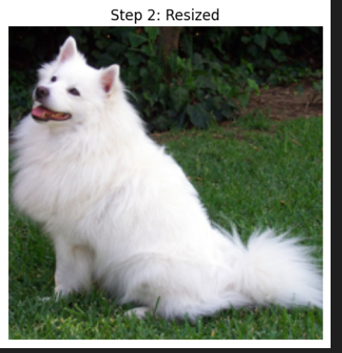

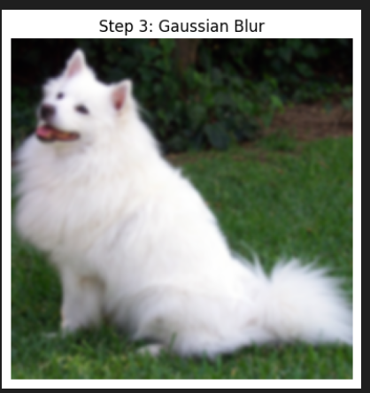
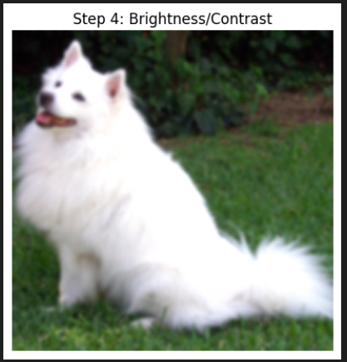
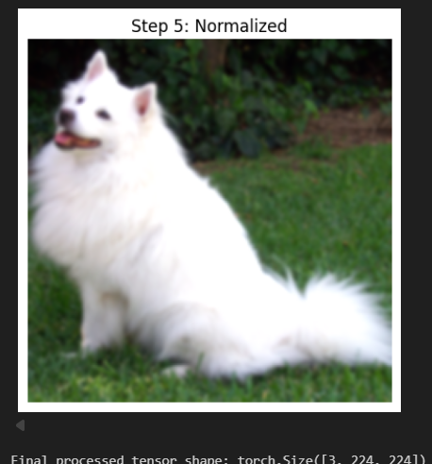

Final processed tensor shape: torch.Size([3, 224, 224])

