* **6115- MAHENDRA INSTITUTE OF ENGINEERING AND** **TECHNOLOGY**

**Traffic Mangement System**

**Role of IOT in Traffic Management System:**

The role of IoT in traffic management is transformative, introducing a paradigm shift in how cities optimize and regulate their transportation systems.

By embedding sensors and connectivity into vehicles, roads, traffic lights, and other infrastructure, IoT enables the collection of real-time data on traffic patterns, congestion, vehicle movements, and more.

This data is then processed and analyzed to make informed decisions, dynamically adjusting traffic signals, rerouting vehicles, and improving overall traffic flow.

This intelligent management level enhances road safety, reduces congestion, lowers emissions, and creates more efficient and sustainable urban mobility systems.

**EXISTING SYSTEM:**

In general, our research cover the literature review from various sources based on traffic control and vehicle tracking.

This method examine the adaptive fine tuning algorithm to create a set of design parameters of two well defined mutually interacting modules of the trafficresponsive urban control(TUC)strategy for the large scale urban road network of the city of China, Greece.

Computer simulation outcome are given, demonstrating that the network performance in terms of the daily mean speed, which is attained by the proposed adaptive optimization methodology, is significantly better than the original TUC System in the case in which the-aforementioned design parameters are mutually fine-tuned to virtual perfection by the system operation [1].The system will develop the trafficlight configuration, which will be able to determine three street case (empty street case, normal street case and crowded street case) by using small associative memory.

The experiments presented provides promising results when the proposed approach was applied by using a program to monitor intersection in penesa island in Malaysia. The program could determine the street cases with different atmospheric conditions depending on the stream of images, which are extracted from the street video cameras[2]. To handle congestion in urban traffic flow through next generation artificial intelligence techniques is an important research area.

Various intelligent and approach have been developed using sot computing techniques to tackle with this problem. This paper is an attempt towards revisiting such approach in developing modern traffic control systems[3].

This study focus on the utilization of RFID as a way of traffic flow detection, which transmits collection information connected to traffic flow straight to a control system using an RS 232 interface, At the same time, the sensor analyzes and Judges the information using an extension algorithm designed to accomplish the subjective of controlling the flow of traffic.

In add-on, the traffic flow condition is also transmitted to a remote monitoring control system through ZigBee wireless network communication technology.

The traffic flow control system developed in this study can execute remote transmission and reduce traffic accidents. And it can also effectively control traffic flow while reducing traffic delay time andmaintain the smooth flow of traffic [4].

This system includes RFID technology and Lab view software. The RFID reader reads the Identification number from the related ambulance RFID tag and then it is sends the data to micro controller LPC 1768H, which is programmed, with the help of embedded C instructions. Those microcontroller is capable of communicating with input and output modules.



**Diagrammatic Representation**

**PROPOSED SYSTEM :**

The solution we provide for Traffic management by reading the RFID tag of each car by a RFID reader at traffic junctions for real time traffic density calculation. It also concentration on changing the traffic lights according to vehicle tightness on the road, thereby intent at reducing the traffic congestion on roads.

In turn, it'll reduce fuel consumption and waiting time. In case of emergency vehicle like ambulance Radio Frequency module will be used so that red traffic light signals will be turned to green in order to provide a clear way for the emergency vehicles.

It will also provide significant data which can help in future road planning and analysis. It is also used to detect or track stolen vehicle. It also alerts the owner of thevehicle to top up the credit which is used in toll booth.

In further time period multiple traffic lights are often synchronized with one another with an goal of even fewer traffic jam and free flow of traffic. The vehicles are detected by the system through RFID tag which is read by the RFID reader. RFID reader is present in some meters away from the signal and another RFID reader is placed alongside the traffic light. It will capture the number of vehicles in that particular lane.

RFID is a better technique to control the state change of the traffic light since RFID is mandatory for all the vehicles in India. It shows that it can decrease the traffic jam and avoids the nonce wasted by a green light on an empty road. It is also more certain in estimating vehicle existence.

**OVERVIEW OF PROPOSED SYSTEM:**



Black diagram of proposed system



A signal junction with RFID reader.



**ADVANTAGE OF PROPOSED SYSTEM** :

* Reduces traffic jams at the signals and on the streets
* Real-time vehicular movement monitoring
* A large chunk of vehicles can transit the signals efficiently
* Tracking lost vehicles using RFID
* Efficient and accurate traffic monitoring
* Instant traffic clearance for emergency vehicle

- THANK YOU -



**IOT Based Traffic Management System**

# 1.INTRODUCTION

#### A smart traffic management system utilizing camera data, communication and automated algorithms is to be developed to keep traffic flowing more smoothly. The aim is to optimally control the duration of green or red light for a specific traffic light at an intersection.

#### The traffic signals should not flash the same stretch of green or red all the time, but should depend on the number of vehicles present. When traffic is heavy in one direction, the green lights should stay on longer; less traffic should mean the red lights should be on for a longer time interval.

#### This solution is expected to eliminate inefficiencies at intersections and minimize the cost of commuting and pollution.

# II. LTERATURE SURVEY



The Internet of Things (IoT), also sometimes referred to as the Internet of Everything (hardware. These devices, often called ”connected” or ”smart” devices, can sometimes talk to other related devices, a process called machine-to-machine(M2M) communication, and acThe Internet of Things (IoT), also sometimes referred to as the Internet of Everything (IoE), consists of all the web-enabled devices that collect, send and act on data they acquire from their surrounding environments using embedded sensors, processors and communication hardware. These devices, often called ”connected” or ”smart” devices, can sometimes talk to other related devices, a process called machine-to-machine(M2M) communication, and act on the information they

#### get The existing traffic system is generally controlled by the traffic police. The main drawback of this system controlled by the traffic police is that the system is not smart enough to deal with the traffic congestion.

#### The traffic police official can either block a road for more time or let the vehicles on another road pass by i.e. the decision making may not be smart enough and it entirely depends on the official’s decision. Moreover, even if traffic lights are used, the time interval for which the vehicles will be shown a green or red signal is fixed.

### Therefore, it may not be able to solve the problem of traffic congestion. In India, it has been seen that even after the presence of traffic lights, traffic police officials are on duty, which means that in this system more manpower is required and it is not economical in nature.from one another. Humans can interact with the gadgets to set them up, give them instructions or access the data, but the devices do most of the work on their own without human intervention. Their existence has been made possible by all the tiny mobile components that are available these days, as well as the always-online nature of our home and business networks. Connected devices also generate massive amounts of Internet traffic, including loads of data that can be used to make the devices useful, but can also be mined for other purposes. All this new data, and the Internet-accessible nature of the devices, raises both privacy and security concerns. But this technology allows for a level of real-time information that we have never had before.

### We can monitor our homes and families remotely to keep them safe. Businesses can improve processes to increase productivity and reduce material waste and unforeseen downtime. Sensors in city infrastructure can help reduce road congestion and warn us when infrastructure is in danger of crumbling. Gadgets out in the open can monitor for changing environmental conditions and warn us of impending disasters.

# SYSTEM ANALYSIS:

**A.** EXISTING SYSTEM:

#### The camera transmits the data at specified time intervals to the processor (raspberry pi), it processes the data and sends the processed data to the controller. The computed data from Raspberry pi is then transmitted to the controller through Wi-Fi connectivity. The controller makes use of the collected data to perform the Intelligent Traffic routing.

#### In this system, the primary aim is to gather the information of moving vehicles and provide them a clear path till their destinations and traffic signals should switch automatically to give a clear way for these vehicles.

### 

#### In this proposed system, the traffic lights are LEDs and the cameras. Both blocks are connected to a raspberry Pi using physical wires. The Node MCU is the traffic light controller which receives the collected camera data and manages the traffic lights by switching between green, yellow and red. The raspberry pi computes the number of vehicles in the street of the intersection it is monitoring based on the distances measured by the camera and the timing between those measurements. The raspberry pi thensends the number of cars every minute to the database.

#### The database is used to train the module in order to better predict the changes in timings of the traffic light and its density. This communication is done using Wi-Fi. More specifically, the cloud server uses an equation that takes the data received (number of cars) as input then determines the time interval of LED’s needed for a smooth traffic flow. This calculated time is then compared to the current actual time of the LEDs (this data is saved in a database).

#### The processor then comes up with a decision. If the current actual green time is less than the calculated time, the decision is to increase the green time, else to decrease the green time.

# IV. SYSTEM DESIGN

## The Architecture system consists of six modules:

## Raspberry Pi

## LED lights which are used for the purpose of signaling.

## Traffic cameras which are used for monitoring traffic.

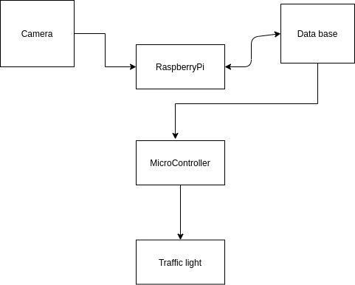

# FLOW CHART

**VI. CONCLUSION**

#### Smart Traffic Management System has been developed by using multiple features of hardware components in IoT. Traffic optimization is achieved using IoT platform for efficient utilizing allocating varying time to all traffic signal according to available vehicles count in road path.



**6115-MAHENDRA INSTUTE OF ENGINEERING AND TECHNOLOGY TRAFFIC MANAGEMENT**

**Abstract:**

Traffic Management Is A Critical Aspect Of Urban Planning And Transportation Systems Worldwide. As Urban Populations Continue To Grow, The Challenges Associated With Traffic Congestion, Safety, And Environmental Impact Have Become Increasingly Pressing. This Abstract Provides An Overview Of Innovative Approaches And Emerging Technologies Aimed At Addressing These Challenges And Enhancing The Efficiency And Sustainability Of Traffic Management.

**Module:**

1.Smart Traffic Control Systems

2.Connected Vehicles And V2x Communication 3.Public Transportation Enhancement

4.Urban Planning And Design

5.Electric And Autonomous Vehicles

6.Data Driven Decision-Making 7.Environmental Considerations

8.Community Engagement

**Hardware Requirements:** 1.Traffic Surveillance Cameras 2.Traffic Sensors

3.Varible Message Signs

4.Traffic Signal Control Equipment

5.Communication Infrastructure

6.Data Storage And Servers

7.Traffic Management Software

8.Control Centre Hardware

9.Power Supply And Backup

10.Environmental Enclosures

11.Maintenance And Diagnostic Tools

12.Vehicle Detection And Identification Systems 13.Scalability And Expansion

**Software Requirements:**

1.Traffic Management Software

2.Traffic Signal Control Software

3.Traffic Data Collection And Analysis Software 4.Gis(Geographic Information System)Software 5.Vehicle Detection And Recognition Software

6.Traffic Simulation Software

7.Communication And Network Management Software 8.Variable Message Sign(Vms) Control Software 9.Incident Detection And Management Software

10.Mobile Applications

11.Database Management Systems

12.Security And Access Control Software

13.Dashboard And Reporting Software

14.Integration And Api (Appplication Programming Interface)Support 15.User Interfaces

16.Redundancy And Failover Software

17.Maintanance And Diagnostics Tools

* **6115- MAHENDRA INSTITUTE OF ENGINEERING AND** **TECHNOLOGY**

**Traffic Mangement System**

FACULTY MENTOR NAME**:**

**SANTHANARAJ M**

**Features Of Engineering:**

The future of engineering traffic management is expected to involve innovative technologies and strategies to address growing urban congestion and promote sustainability. Some key trends and developments include.

1. Smart Traffic Management:

Utilizing sensors,cameras, and data analytics to monitor and optimize traffic flow in real time. This can lead to reduced congestion and improved safety.

2. Connected and Autonomous Vehicles (CAVs):CAVS can communicate with each other and traffic infrastructure to enhance traffic management. They may also reduce accidents and traffic jams.

3. Urban Planning: Focusing on creating more walkable and bike-friendly cities, along with improved public transportation, to educe the reliance on individual cars.

4. Electric and Sustainable Transportation: Encouraging the use of electric vehicles and investing in sustainable transportation options to reduce emissions and congestion.

5. Mobility as a Service (MaaS): Integrating various transportation modes, such as ridesharing, public transit, and bike-sharing, into a single, easy-to-use platform for commuters.

6. Predictive Analytics: Using data to predict traffic patterns, enabling authorities to proactively manage traffic and improve road safety.

7. Traffic Simulation and Modeling: Developing advanced simulation tools to test traffic management strategies and infrastructure changes before implementation.

8. Environmental Considerations: Traffic management will increasingly need to consider environmental impacts, leading to the development of greener solutions.

9. Public-Private Partnerships: Collaboration between governments and private companies to fund and implement innovative traffic management solutions.

10. Resilience and Disaster Management: Preparing for extreme weather events and other disruptions that can affect traffic flow.The future of traffic management is all about using technology, data, and sustainable practices to create more efficient and eco- friendly transportation systems while reducing congestion and improving safety.

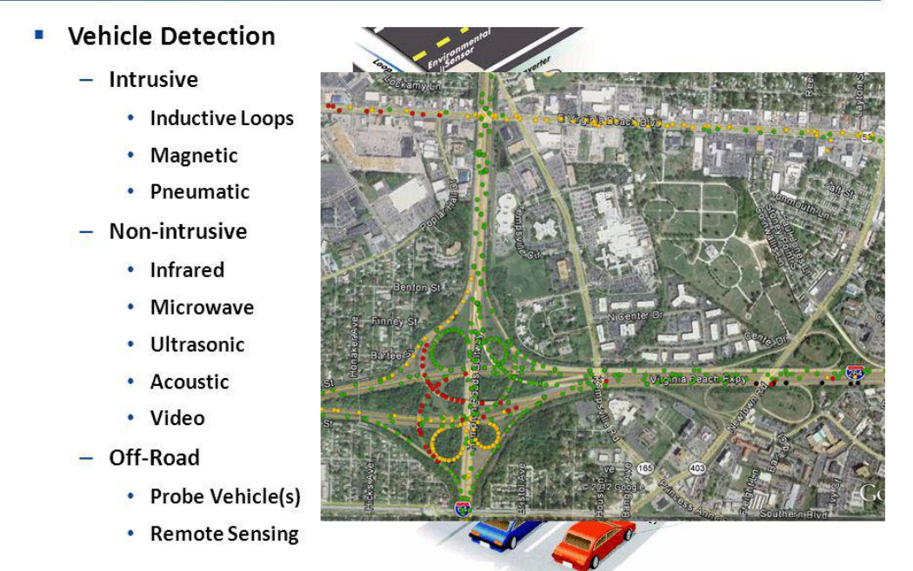

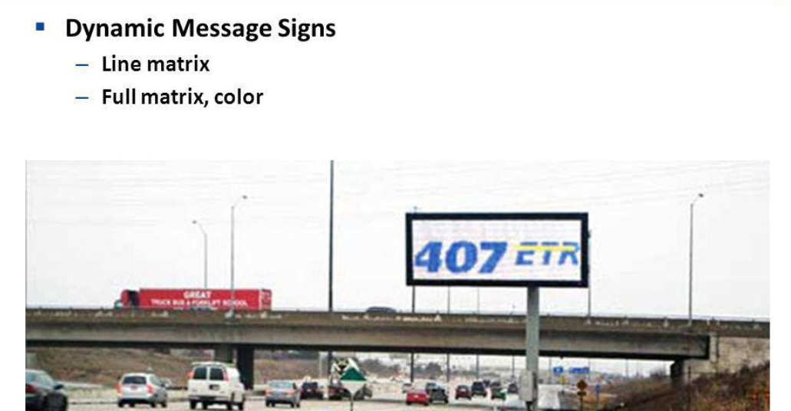

**Technologies Used:**

* Android, Microsoft .NET, SQLite, Bluetooth 4.0

**Model Training:**

Due to short period of time for the projects our team has prepared limited dataset are model to training the dataset for the implementation of Traffic management system

**Code:**

**Sample:1**

import RPi.GPIO as GPIO

import SimpleMFRC522

reader = SimpleMFRC522.SimpleMFRC522()

try:

print("Place an RFID tag near the reader...")

id, text = reader.read()

print("Tag ID: {}".format(id))

print("Tag Text: {}".format(text))

finally:

GPIO.cleanup()

**Sample:2**

import RPi.GPIO as GPIO

import SimpleMFRC522

import time

# Initialize the RFID reader

reader = SimpleMFRC522.SimpleMFRC522()

try:

while True:

print("Place an RFID tag near the reader...")

id, text = reader.read()

print("Tag ID: {}".format(id))

print("Tag Text: {}".format(text))

# Perform actions based on the tag data

if "access_granted" in text:

# Access granted, perform some action (e.g., unlock a door)

print("Access granted! Unlocking the door...")

elif "access_denied" in text:

# Access denied, perform a different action (e.g., sound an alarm)

print("Access denied! Sounding an alarm...")

else:

# Handle other tag data as needed

print("Unknown tag data, no action taken")

# Wait for a moment before checking the next tag

time.sleep(2)

finally:

GPIO.cleanup()

**Output :**

Reference for <https://i.stack.imgur.com/hi4Ll.jpg>

**Evaluation:**

The evaluation of traffic management is likely to focus on several key aspects to measureits effectiveness and impact on urban mobility and safety. Here's how traffic management might be evaluated in 2025.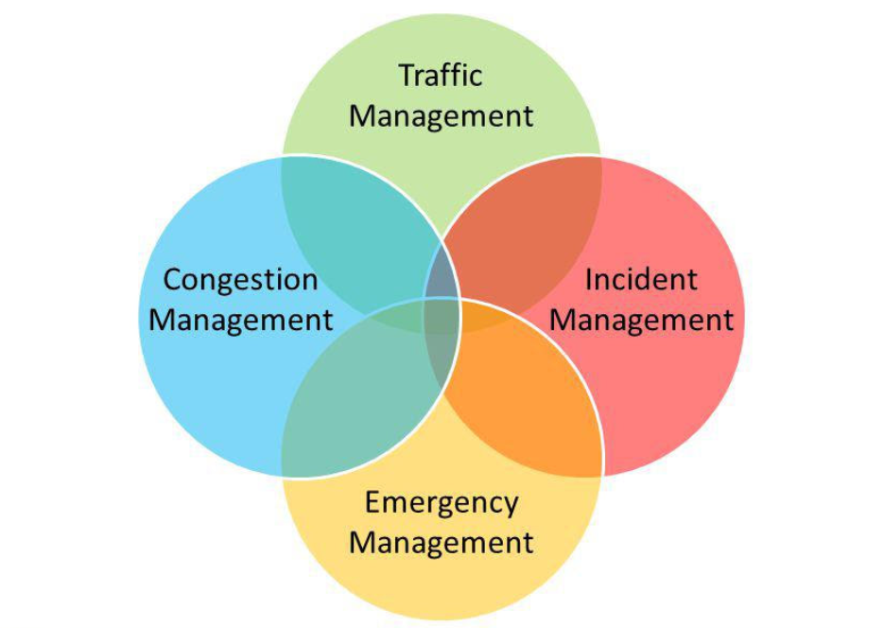

1. Traffic Flow and Congestion: An assessment of how well traffic management systems have improved the flow of traffic and reduced congestion in urban areas. Data on average commute times, peak-hour traffic, and congestion hotspots will be crucial.

2. Safety: Evaluation of the impact on road safety,including a reduction in accidents and fatalities. This assessment would also consider the effectiveness of measures such as speed limits,traffic signs, and traffic calming devices.

3.Environmental Impact: An analysis of how traffic management strategies have contributed to reduced emissions and improved air quality.This would involve measuring the adoption of electric and sustainable transportation options.

4. Public Transportation: An examination of the effectiveness of public transportation systems,including ridership numbers and ease of access, to determine if they have become more convenient and widely used.

5. Infrastructure Utilization: Assessment of the use of existing road infrastructure and its condition, including maintenance and potential expansion or upgrades.

6. Technology Integration: Evaluation of the integration and reliability of smart traffic management technologies, including real-time data collection and analytics,

7. Cost Efficiency: Analysis of the cost-of traffic management systems, considering both initial investment and ongoing maintenance.

8. Public Perception and Satisfaction: Measuring public satisfaction with traffic management improvements, taking into account surveys and feedback from commuters.

9. Accessibility and Inclusivity: Ensuring that traffic management considers the needs of all citizens, including those with disabilities, by assessing the availability of accessible transportation options.

10. Emergency Response and Disaster Preparedness: Evaluation of the efficiency of traffic management during emergencies and disasters, such as evacuation plans and adaptability to extreme weather events.

11. Future-Readiness: Assessing the adaptability of traffic management to future transportation trends, including the integration of autonomous vehicles and new mobility solutions.Overall, the evaluation of traffic management in 2025 will likely focus on creating more efficient, safe, and sustainable transportation systems while improving the quality of life for urban residents. Data-driven assessments will play a significant role in this process.

***”Thank you”***