**6115 – MAHENDRA INSTIUTE OF ENGINEERING AND TECHNOLOGY**

6115-AIR QUALITY MONITORING

**TEAM : proj_223287_Team_1**

**TEAM ID : 569**

**YEAR : |||**

TEAM MEMBERS NAME

SIDDARTH.K

SHAM.P

SATHISH KUMAR.K

SENTHI MURUGAN.R

SASI KUMAR.V

SARATHI.S

**MENTOR NAME : SANTHANARAJ.M**

IOT INNOVATION FOR AIR QUALITY MONITORING: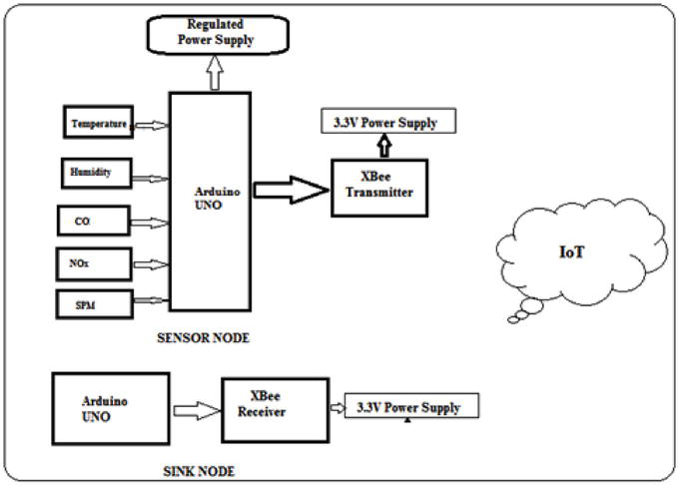

One IOT innovation for air quality monitoring is the use of smart sensors and devices that can measure various pollutants in real-time.

These sensors can be installed in homes, offices, or public spaces to continuously monitor air quality and provide data on pollutants such as particulate matter (PM2.5 and PM10), volatile organic compounds (VOCs), carbon monoxide (CO), nitrogen dioxide (NO2), and ozone (O3).

These smart sensors can connect to a central hub or cloud-based platform through wireless networks, allowing users to access real-time air quality data from their smartphones or other devices.

This enables individuals to make informed decisions about their activities, such as adjusting ventilation systems, avoiding outdoor exercise during high pollution periods, or taking precautions to protect their health

AIR QUALITY READING: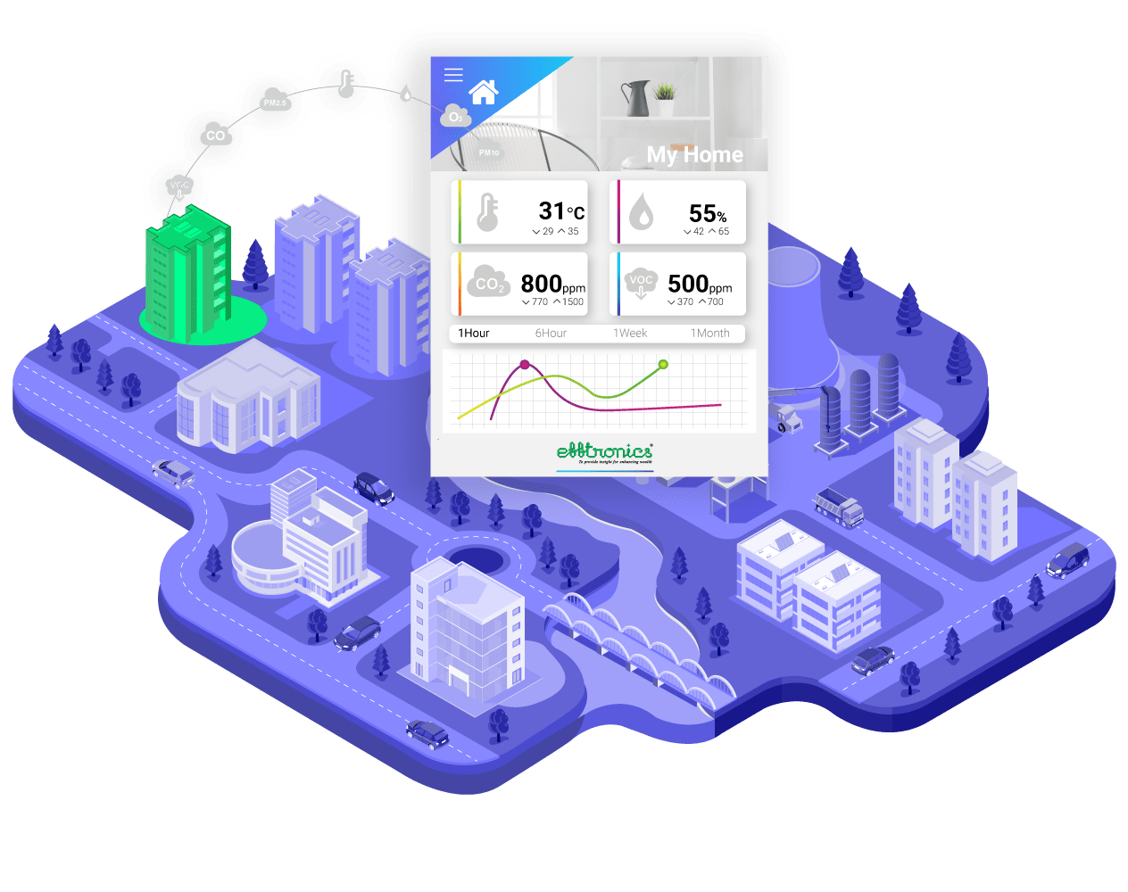

The IOT-based air pollution monitoring system can be used in various settings, including residential, industrial, and urban areas. It can also be integrated with existing air pollution monitoring systems to enhance their capabilities. The system can provide valuable data to government agencies, researchers, and the public to make informed decisions about air pollution.

One of the significant advantages of an IOT-based air pollution monitoring system is its scalability. The system can be easily scaled up or down based on the needs of the users. It can be customized to meet the specific requirements of a particular location, making it a versatile solution for air pollution monitoring.

In conclusion, an IOT-based air pollution monitoring system is a revolutionary solution that can provide accurate and real-time data about the air quality in a particular area. It can help identify the sources of pollution and take necessary measures to reduce it, protecting the environment and human health.

IOT REDUCE AIR POLLUTION:

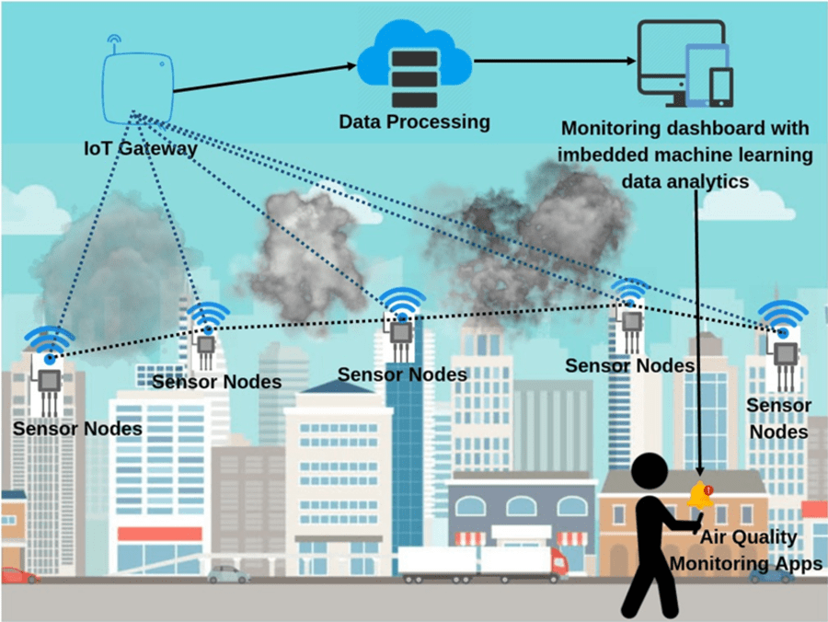

IOT (Internet of Things) plays a crucial role in reducing air pollution through its ability to collect real-time data and enable smart decision-making. IOT devices, such as air quality sensors, can monitor pollutant levels in various environments, including cities, industries, and homes.

This data can be analyzed to identify pollution sources, implement targeted mitigation strategies, and track the effectiveness of pollution control measures. IOT-enabled smart city solutions optimize transportation, waste management, and energy consumption, reducing emissions and improving air quality.

Furthermore, IOT-based personal air quality monitors empower individuals to make informed choices and avoid high-pollution areas. By leveraging IOT technology, we can proactively address air pollution, create sustainable solutions, and promote healthier environments for present and future generations.

AIR QUALITY GUIDE :

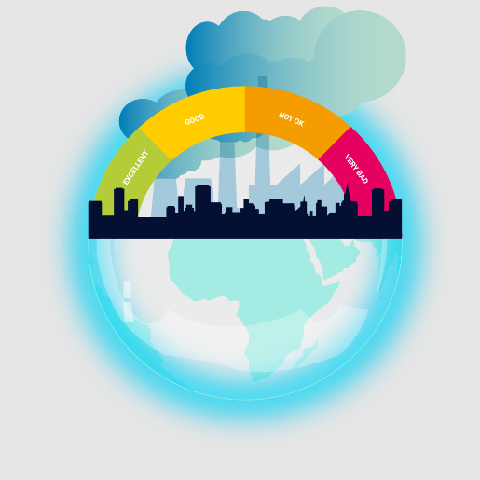

The [WHO Global air quality guidelines](https://www.who.int/publications-detail-redirect/9789240034228)(AQG)offer global guidance on thresholds and limits for key air pollutants that pose health risks.

These guidelines are of a high methodological quality and are developed through a transparent, evidence-based decision-making process.

In addition to the guideline values, the WHO Global air quality guidelinesprovide interim targets to promote a gradual shift from high to lower concentrations.

**\*\*! THANKING YOU !\*\***