# Public Transportation Optimization

# **INTRODUCTION :**

With the progress of technology, there are more and more objects which are being installed with sensors and are having the ability to communicate with each other. The way in which information is getting transferred is changing as the physical world outside is becoming more of an information system. Internet of things (hereafter referred to as IOT) deals with having physical objects we see around us in a network in one form or the other. It mainly deals with RFID, infrared sensors, global positioning systems and scanners. These have helped the objects to not only sense information but also interact with the physical world.

# With rapid population growth, there is always a strain on the transportation facilities. This strain can be reduced by having an intelligent transportation system.

# LITERATURE REVIEW

Bangalore Metropolitan Transport Corporation, abbreviated as BMTC, is a government agency that operates the public transport bus service in Bangalore, India. The BMTC was formed in 1997, as the result of a split of the Karnataka State Road Transport Corporation. The bus transportation system is extremely poor in terms of passenger satisfaction. Bus capacity is a major concern as it could not keep pace with the increasing population.

**Advanced systems for buses around the world :**

Many advanced bus transport systems have been designed around the wo r l d namely Bus R a p i d Transport

System which has been implemented in various countries such as Brazil, Australia, South America and few other parts of Asia. The success of this system has enabled majority of the commuters to shift from taking their own vehicles to taking public bus transport.

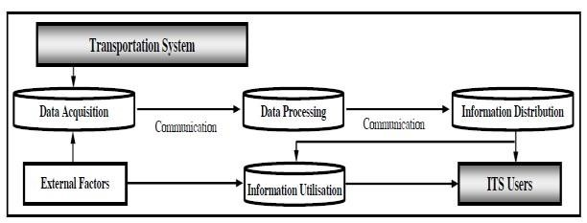

Its systems work with information and controlled technologies which provide the core ITS functionalities such as loop detectors.

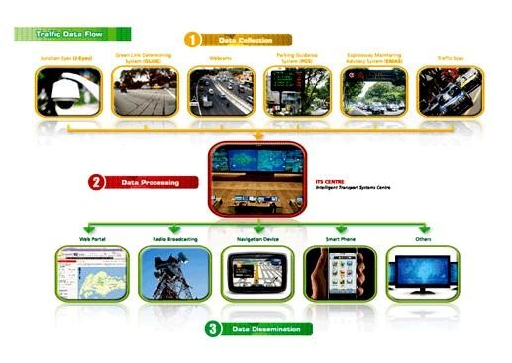

Smart home systems:

Components like sensors, actuators and networks are installed in the home network to provide t h e v a r i o u s f u n c t i o n a l i t i e s t h e s e researchers have proposed a semantic Web-based methodology called SPIDER as given in the figure below. A lot of research is done to explore the benefits and possibilities of smart homes thus creating an interconnected smart environment with the help of sensors and actuators.

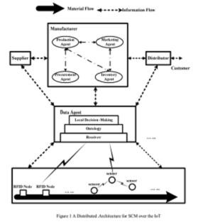

**Seoul’s Bus Transport system :**

This below diagram gives the overview of the usage of internet of things in different fields in South Korea.

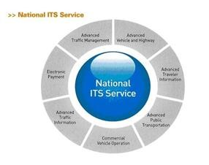

Source Code :

import random

import time

# Simulated sensor data for bus stops (distance from a central hub)

sensor_data = {

'Stop1': 5,

'Stop2': 8,

'Stop3': 12,

'Stop4': 15,

}

def collect_sensor_data():

return {stop: random.randint(1, 20) for stop in sensor_data.keys()}

def optimize_route(sensor_data):

best_route = None

min_distance = float('inf')

for route in itertools.permutations(sensor_data.keys()):

route_distance = sum(sensor_data[route[i]] for i in range(len(route)))

if route_distance < min_distance:

best_route = route

min_distance = route_distance

return best_route, min_distance

def send_data_to_server(route, distance):

# Simulated function to send data to a central server

print(f"Sending route {route} with distance {distance} to server")

def main():

while True:

sensor_data = collect_sensor_data()

best_route, min_distance = optimize_route(sensor_data)

send_data_to_server(best_route, min_distance)

time.sleep(300) # Simulated 5-minute interval for data collection

if _name_ == "_main_":

main()

# **CONCLUSION**

An in depth study on the use of IoT in different sectors revealed that most of the research was concentrated on the future benefits to be derived by using IoT. This research has been done for smart home systems, retail and supply chain management, insurance, healthcare, transport among many others. However, through our study we found that there was a dearth of research in IoT in the transportation sector. We also found that the bus transportation system and the bus application currently used in Bangalore have huge potential of further improvement. Therefore, the research was aimed to find out the feasibility of using of Internet of things in the bus transportation system in Bangalore and to validate whether it improves the consumer experience.