PUBLIC TRANSPORTATION OPTIMIZATION

Team members

622621121048:S.SATHIYAVATHI

Phase 4:DEVELOPMENT PART 2

Topic:IOT Based Public Transportation

Optimiza

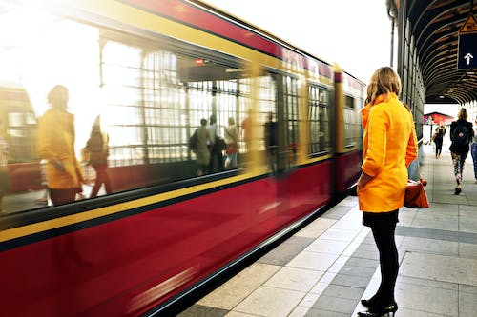

INTRODUCTION

Public transportation, often referred to as public transit or mass transit, is a crucial component of urban and suburban infrastructure that provides shared mobility services for the general public. It encompasses a variety of modes of transportation designed to efficiently move people from one location to another within a city or region. These modes typically include buses, trams, subways, commuter trains, ferries, and sometimes even shared bicycle and scooter systems.

**KKey Features and Benefits:K**

**1. Accessibility:** Public transportation is designed to be accessible to all members of the community, regardless of their individual means of transportation. It serves as a vital lifeline for those without access to private vehicles.

**2. Efficiency:** Public transportation aims to provide a cost-effective and efficient means of travel, especially during peak hours when individual car use can lead to traffic congestion.

**3. Environmental Benefits:**By reducing the number of private vehicles on the road, public transportation contributes to lower emissions and improved air quality, making it a more sustainable choice for urban mobility.

**4.Cost Savings:**Public transit can be more economical than owning and maintaining a personal vehicle, as it eliminates costs related to fuel, insurance, parking, and maintenance.

**5. Traffic Reduction:** Public transportation can help alleviate traffic congestion in crowded urban areas, leading to shorter travel times and reduced stress for commuters.

**6. Variety of Modes:** Public transit includes diverse options, such as buses, subways, light rail, commuter trains, and ferries, allowing passengers to choose the mode that best suits their needs.

**7. Community Benefits:**Public transportation plays a role in fostering a sense of community, reducing dependence on private vehicles, and enhancing urban development by promoting accessible and walkable neighborhoods.

**8. Safety:** Public transit systems are generally considered safer than private car travel, with fewer accidents per passenger mile.

**Benefits:**

* Reduced waiting times and improved punctuality.
* Enhanced passenger experience through real-time information.
* Lower operational costs due to predictive maintenance.
* Reduced traffic congestion and environmental impact.
* Enhanced safety and security.

**Objective:**

To improve the efficiency, safety, and convenience of public transportation systems through the implementation of IoT technologies.

**Components:**

Fleet Management: Install GPS and IoT sensors on buses, trams, and trains to monitor their real-time locations and conditions.

**Passenger Information Systems:** Provide real-time information to passengers about bus and train schedules, delays, and crowdedness through mobile apps and digital displays at stops.

**Smart Ticketing:** Implement contactless payment systems (like RFID cards or mobile wallets) for seamless and cashless ticketing.

**Traffic Management:** Use IoT sensors to monitor traffic conditions, and adjust transit routes and schedules dynamically to avoid congestion.

**Maintenance and Diagnostics:** Equip vehicles with sensors for real-time monitoring of mechanical and electrical systems. Predictive maintenance can prevent breakdowns and improve reliability.

**Energy Efficiency:** Implement IoT solutions to optimize energy usage in vehicles, such as turning off heating/cooling when no passengers are on board.

**Security and Safety:** Install surveillance cameras and sensors for passenger safety, and incorporate emergency communication systems.

**Python coding for public transportation**

**Optimization:**

**from pulp import \***

**# Create a Linear Programming problem**

**problem = LpProblem("BusScheduling", LpMinimize)**

**# Define the decision variables**

**# Example: x[i][j] represents the number of buses on route i during time period j**

**routes = ["Route1", "Route2", "Route3"]**

**time_periods = ["AM", "PM"]**

**x = LpVariable.dicts("Buses", (routes, time_periods), lowBound=0, cat=LpInteger)**

**# Define the objective function: Minimize the number of buses**

**problem += lpSum(x[route][time] for route in routes for time in time_periods)**

**# Define constraints**

**# Constraints to ensure that each route meets passenger demand in each time period**

**# Example: 2x[Route1]["AM"] + 3x[Route1]["PM"] >= 100**

**demand = {"Route1": {"AM": 100, "PM": 150}, "Route2": {"AM": 80, "PM": 120}, "Route3": {"AM": 60, "PM": 90}}**

**for route in routes:**

**for time in time_periods:**

**problem += lpSum(x[route][time]) >= demand[route][time]**

**# Constraints to limit the total number of buses available**

**problem += lpSum(x[route][time] for route in routes for time in time_periods) <= 20**

**# Solve the problem**

**problem.solve()**

**# Print the results**

**print("Status:", LpStatus[problem.status])**

**for route in routes:**

**for time in time_periods:**

**print(f"{route} - {time}: {x[route][time].varValue} buses")**

**print("Total number of buses:", value(problem.objective))**

This is a highly simplified example and doesn't cover all aspects of public transportation optimization, such as real-time data integration, dynamic scheduling, predictive maintenance, and passenger information systems. Public transportation optimization projects are usually much more complex and require extensive data and infrastructure. Actual projects may also require the use of specialized optimization libraries and tools.

**USING ARTIFICIAL INTELLIGENCE IN PUBLIC TRANSPORTATION:**

Artificial Intelligence (AI) is increasingly being used in public transportation to enhance efficiency, safety, and passenger experience.

**Applications of AI in public transportation:**

**Route Optimization:** AI algorithms can analyze historical data on routes, traffic conditions, and passenger demand to optimize transit schedules, reducing waiting times and improving route efficiency.

**Predictive Maintenance:** AI can predict when transportation vehicles require maintenance, reducing downtime and increasing reliability. Sensors and data analytics help identify potential issues before they become major problems.

**Real-time Passenger Information:** AI-driven systems provide passengers with real-time information about transit schedules, delays, and crowdedness. Chatbots and mobile apps enable passengers to access information and plan their journeys more efficiently.

**Traffic Management:** AI can monitor and manage traffic flow in real-time, adjusting transit routes to avoid congestion. This minimizes delays and optimizes public transit schedules.

**Fare Optimization:** AI-driven fare systems can adjust pricing dynamically based on demand, encouraging off-peak travel and reducing congestion during peak hours.

**Safety and Security:** AI-powered surveillance cameras and sensors help monitor passenger safety. These systems can detect unusual behavior or security threats and alert authorities.

**Autonomous Vehicles:** Some cities are experimenting with AI-driven autonomous buses and shuttles to improve efficiency and reduce labor costs. These vehicles can also operate safely and predictably with AI at the helm.

**Smart Ticketing:** AI facilitates contactless and mobile ticketing, streamlining the payment process for passengers and reducing the need for paper tickets.

**Demand Forecasting:** AI can analyze historical data to forecast passenger demand accurately. Transit authorities can use this information to allocate resources efficiently.

**Personalized Services:** AI can provide personalized travel recommendations, helping passengers plan their journeys based on preferences, accessibility needs, and real-time conditions.

**Accessibility Improvements:** AI can help design transit systems and services that are more accessible for people with disabilities, making public transportation more inclusive.

**Environmental Impact:** AI can be used to monitor and reduce the environmental impact of public transportation systems, such as optimizing vehicle energy usage and reducing emissions**.**

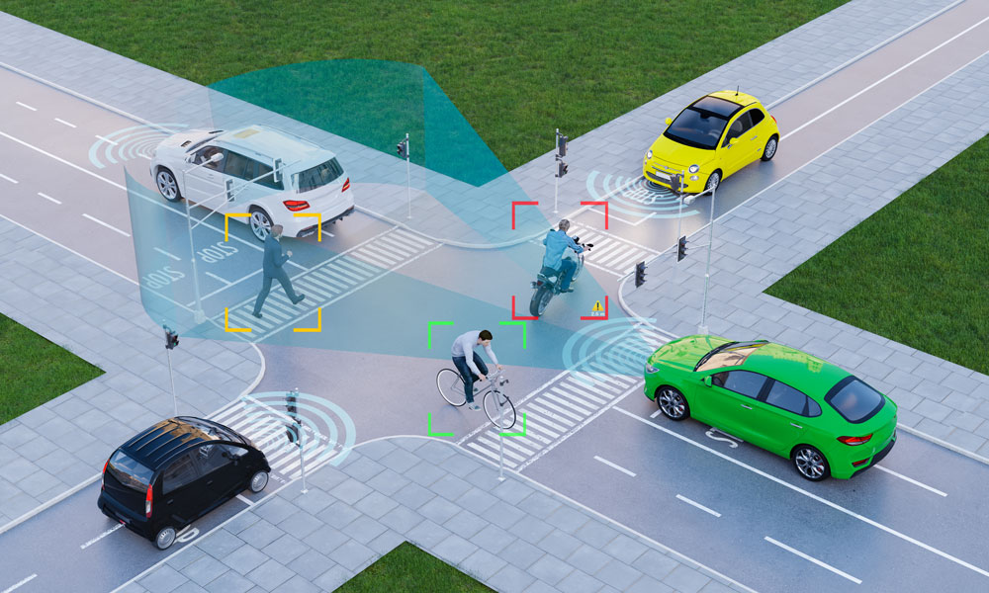

**Role of ADS In Public transportation Optimization:**

Autonomous Driving Systems (ADS), commonly known as self-driving vehicles, play a significant role in public transportation optimization. They offer a range of benefits and applications that can enhance the efficiency, safety, and accessibility of public transportation.

**Improved Efficiency:**Autonomous buses and shuttles can operate with precise control, leading to more efficient routes, reduced fuel consumption, and minimized waiting times for passengers.Autonomous vehicles can operate 24/7, optimizing the use of transit assets and increasing system capacity.

**Reduced Labor Costs:**By eliminating the need for human drivers, public transportation agencies can reduce labor costs, making transit more cost-effective.

**Increased Accessibility:**Autonomous vehicles can be designed with accessibility in mind, making public transportation more inclusive for people with disabilities and those with limited mobility.

**Dynamic Routing:**Autonomous vehicles can adapt to real-time traffic conditions and passenger demand, leading to more flexible and dynamic routing to avoid congestion and delays.

**Enhanced Safety:**Autonomous vehicles are equipped with sensors and AI algorithms that can enhance safety by detecting and reacting to potential collisions, pedestrians, and other hazards more quickly than human drivers.

**Predictive Maintenance:**ADS technology can predict maintenance needs based on vehicle data, reducing downtime and maintenance costs for transit agencies.

**Reduction in Emissions:**Autonomous vehicles can be programmed to operate in an eco-friendly manner, reducing fuel consumption and emissions, which aligns with sustainability goals.

**On-Demand Transportation:**Autonomous ride-sharing services and microtransit solutions can provide on-demand, personalized public transportation, improving passenger convenience and reducing the need for private car ownership.

**First/Last Mile Connectivity:**Autonomous shuttles can help bridge the gap between public transit stations and passengers' final destinations, improving the accessibility of transit networks.

**Demand-Responsive Services:**ADS can help public transit agencies offer demand-responsive services that adjust routes and schedules based on passenger requests, enhancing efficiency.

**Traffic Management:**Autonomous vehicles can communicate with traffic management systems to optimize traffic flow, reducing congestion and improving overall transportation efficiency.

**Role of DAC in public Transportation Optimization:**

DAC, which stands for Data Analytics and Control, plays a crucial role in public transportation optimization. It involves the use of data analytics and control systems to collect, process, and analyze data related to public transportation operations. Here's how DAC contributes to optimizing public transportation.

**Real-Time Data Collection:** DAC systems collect real-time data from various sources, such as GPS, sensors, cameras, and passenger information. This data includes vehicle locations, passenger counts, traffic conditions, and weather information.

**Data Processing and Analysis:** DAC systems use data analytics and machine learning algorithms to process and analyze the collected data. This analysis provides insights into transportation patterns, demand, and operational efficiency.

**Optimized Scheduling:** By analyzing historical and real-time data, DAC can optimize transportation schedules, routes, and frequencies. This leads to reduced waiting times, increased passenger satisfaction, and efficient resource allocation.

**Predictive Maintenance:** DAC helps predict maintenance needs by monitoring the health and performance of transportation vehicles. This proactive maintenance approach reduces vehicle breakdowns, operational disruptions, and maintenance costs.

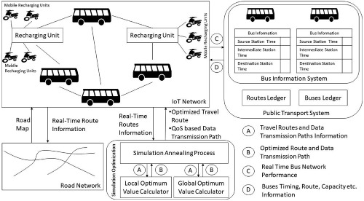

**Role of IOT using in Public Transportation Optimization:**

The Internet of Things (IoT) plays a significant role in optimizing public transportation by providing real-time data, connectivity, and automation. Here are several ways in which IoT contributes to the optimization of public transportation.

**Real-time Vehicle Tracking:** IoT sensors and GPS devices on public transportation vehicles provide real-time location data, allowing transit authorities and passengers to track vehicles, reduce waiting times, and make more informed travel decisions.

**Traffic Management:** IoT sensors on roadways and traffic signals can communicate with public transportation vehicles to optimize traffic flow and reduce congestion, leading to shorter travel times and improved efficiency.

**Predictive Maintenance:** IoT sensors monitor the condition of transportation vehicles and infrastructure. They can predict maintenance needs and prevent breakdowns, reducing downtime and improving service reliability.

**Passenger Information Systems:** IoT-based displays at transit stops and mobile apps provide passengers with real-time information about schedules, delays, and the availability of seats, enhancing the passenger experience.

**Smart Ticketing:** IoT-enabled contactless payment systems, such as RFID cards or mobile wallets, streamline ticketing processes and reduce the use of paper tickets.

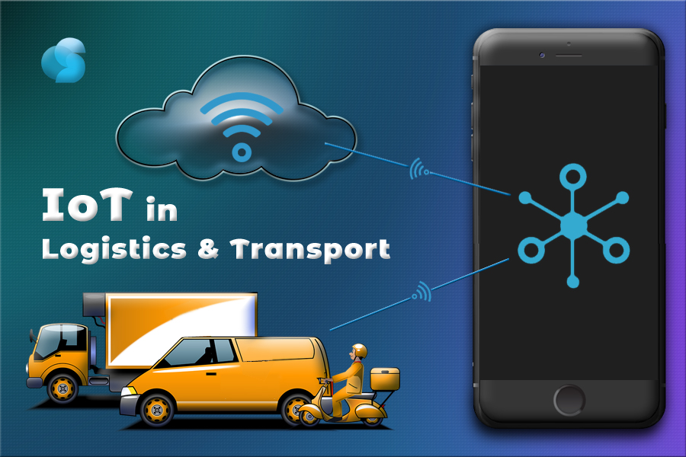

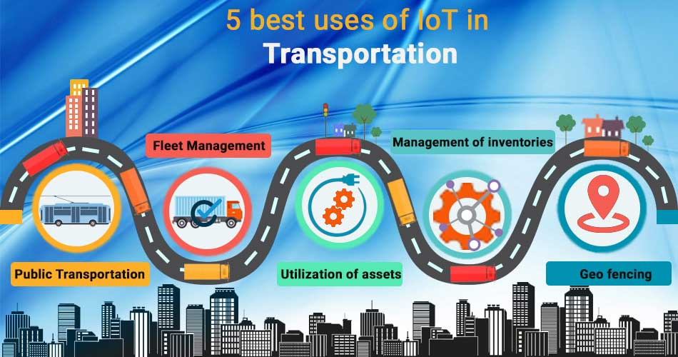

**Role of CAD in Public Transportation**

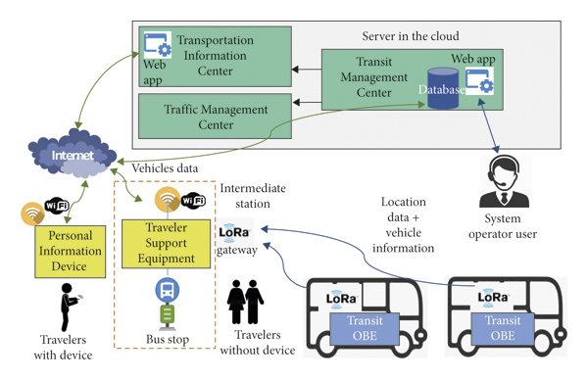

Computer-Aided Design (CAD) plays a vital role in public transportation optimization by assisting in the design, planning, and management of various aspects of transportation infrastructure and systems. Here are some key roles of CAD in public transportation optimization.

**Infrastructure Design:** CAD is used to design transportation infrastructure, including bus stops, train stations, and transit hubs. Accurate and detailed CAD drawings facilitate the efficient use of space and ensure that transit facilities are accessible and user-friendly.

**Route Planning:** CAD software assists in the planning of transit routes, allowing transportation authorities to determine optimal paths, stops, and connections based on factors such as passenger demand, traffic patterns, and accessibility requirements.

**Fleet Management:** CAD helps in the design and layout of transportation depots and garages, ensuring efficient storage and maintenance of vehicles. It assists in determining the capacity and arrangement of parking areas for buses, trams, or trains.

**Timetable Design:** CAD aids in creating accurate and efficient transit schedules. It considers factors like travel time, passenger boarding and alighting times, and synchronization with other modes of transportation.

**Accessibility Improvements:** CAD can be used to design transportation facilities that are accessible to people with disabilities, ensuring that transit systems are inclusive and compliant with accessibility standards.

**Traffic Management:** CAD software can model and simulate traffic flows, helping transportation authorities optimize traffic signal timings, road configurations, and other traffic management strategies to reduce congestion and improve transit efficiency.

**Environmental Impact Analysis:** CAD can assist in assessing the environmental impact of public transportation projects, including evaluating potential emissions and suggesting mitigation measures.

**3D Visualization:** CAD allows for the creation of 3D visualizations of transportation projects. This helps in communicating project plans to stakeholders, conducting virtual site visits, and making design adjustments.

**Safety and Security Planning:** CAD can be used to design safety and security features in transit facilities, such as the placement of surveillance cameras, emergency exits, and communication systems.

**Cost Estimation:** CAD software provides tools for estimating construction and operational costs associated with public transportation projects, enabling budget planning and financial optimization.

**Asset Management:** CAD aids in asset management by creating detailed inventories of transportation infrastructure and systems. This information is essential for maintenance and upgrade planning.Intermodal Connectivity: CAD can be used to design transportation hubs and intermodal connections, ensuring smooth transitions between various modes of public transportation.

**CONCLUSION**:

In conclusion, public transportation optimization is a multifaceted and dynamic endeavor that aims to enhance the efficiency, accessibility, and sustainability of transit systems. Through the integration of various technologies and strategies, public transportation can better serve the needs of communities and promote environmentally friendly mobility solutions.