**Project Title: Noise Pollution Monitoring**

**Phase 2: Innovation**

**Sensor:**

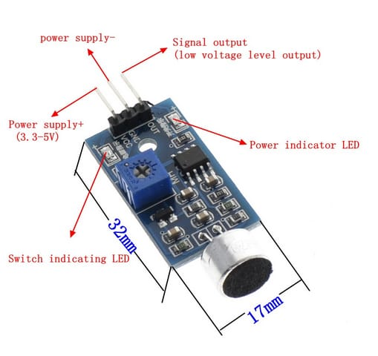

A) Sound Sensor

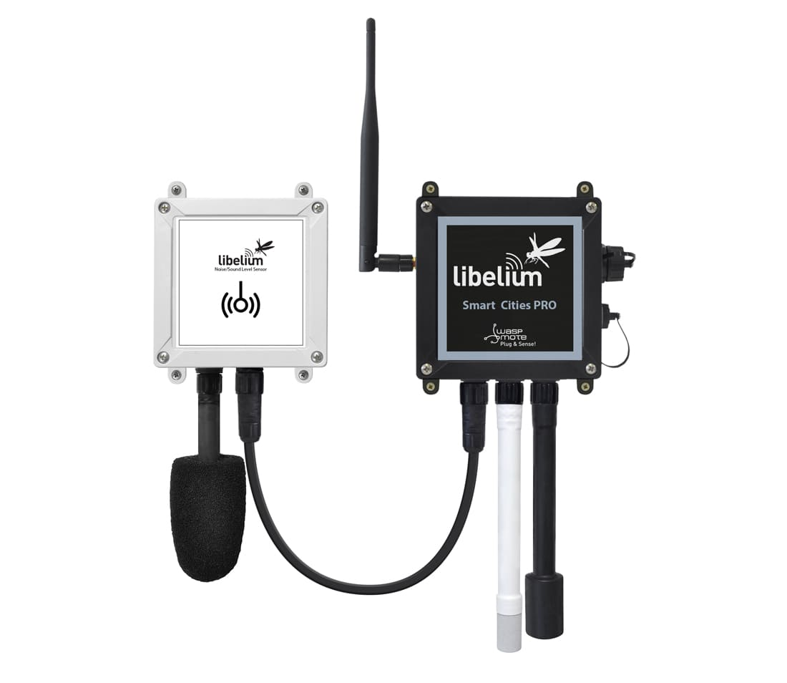

B) Advanced Sound Sensor

**Definition for sensor:**

1. **Sound sensor:**

The sound sensor is one type of module used to notice the sound. Generally, this module is used to detect the intensity of sound. The application of this module mainly include switch as well as monitoring. The accuracy of this sensor can be changed for the ease of usage.

This sensor employs a microphone to provide input to buffer, peak detector and an amplifier. This sensor notices a sound, processes an output voltage signal to a microcontroller. After that, it executes required processing.

**B) Advanced sound sensor:**

The new noise level sensor for plug and sense! Has been designed following the specifications of the IEC61672 standard for sound meters.

The value given is the Equivalent continuous sound level, with A weighting that allows to calculate the average sound pressure level.

**Features:**

* Target parameter
* Microphone sensitivity: 12.7mV/Pa
* Range of the sensor: 50 dBA to 100 dBA
* Accuracy: +/-0.5dBA
* Frequency range: 20 Hz-20KHz
* Sound pressure level measurement (no weighting filter)
* FAST mode (125ms) and SLOW mode (1 second)

**Steps For Flowchart:**

STEP 1: Start the **program**.

STEP 2: Turn on the Sound sensor or Advanced sound sensor.

STEP 3: Collect the data:

I. Read the sound concentration.

II. Measure sound and hearing level.

STEP 4: Analyse Data:

I. Check if sound concentration is within safe limits.

II. Check if sound and hearing level is within comfort range.

STEP 5: Display results:

I. Show sound concentration on display.

II. Show hearing value and percentage on display.

STEP 6: Take necessary action:

I. If sound concentration is high, activate alarm or ventilation.

II. If hearing level is too high or low, adjust noise level system.

STEP 7: Wait for a set time.

STEP 8: Repeat 3-7 continuously.

STEP 9: End the program.

**FLOWCHART:**

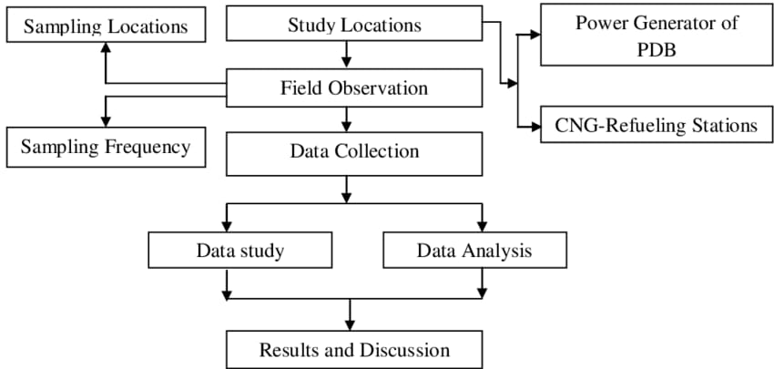

**BLOCK DIAGRAM:**

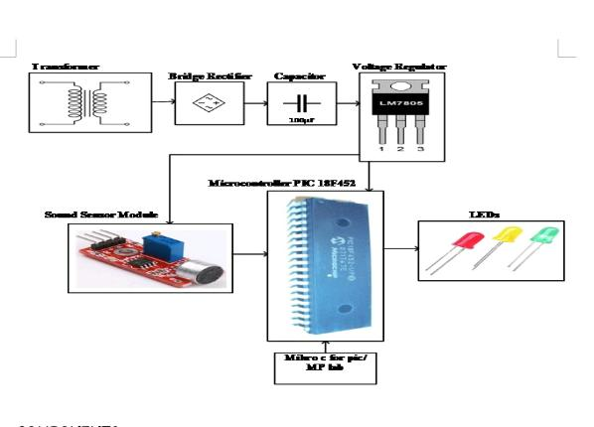

**Block Diagram Description:**

1. **Microcontroller:**

This is the brain of the system, collecting data from sensor and process it and managing output actions and displays.

**2. Bridge Rectifier:**

The bridge rectifier is said to be a widely used circuit among many electronic circuits. Bridge Rectifier are widely used for supplying power to various electronic basic components.

The purpose of the Bridge Rectifier is to convert the AC power into DC power. It is the most resourceful rectifier circuit from others.

**3. Finesse Voltage Regulator:**

The key to understanding the “finesse” approach is to realize that noise voltage is many orders of magnitude below the regulated voltage, even when integrated over a wide bandwidth.

**4. Sound sensor module:**

The noise sensor module can accurately measure the noise levels in the ambient air. The lightweight sound level monitor design is monitoring the ambient noise on a real-time basis.

This sound level module works on the principle of capacitance. It provides a uniform response to sounds arriving from different angles simultaneously.

**5. Power supply:**

Provides power to the entire system. This could be batteries, or a direct power source.

**NOISE LEVEL AREAS IN INDIA:**

**(2011-2018)**

