Assignment
1)Create a blog or website using blogspot and WordPress Customize the theme design and post new article with 500 words. Blogspot:
Link: https://brownieeeeee.blogspot.com/2023/09/star-icecream-parlour.html

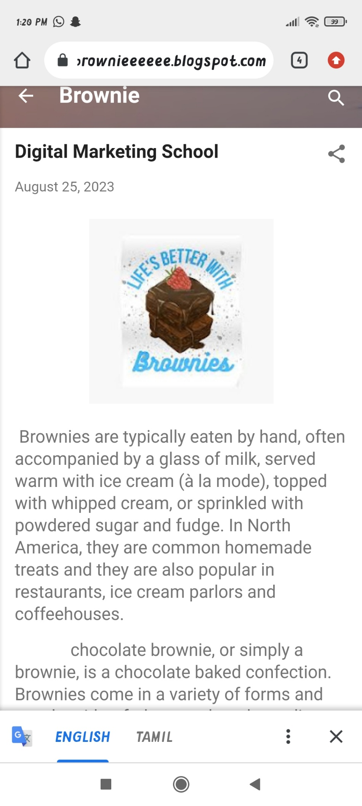

WordPress:
Link: https://jenisanajakumar.wordpress.com/2023/10/20/smartphone/

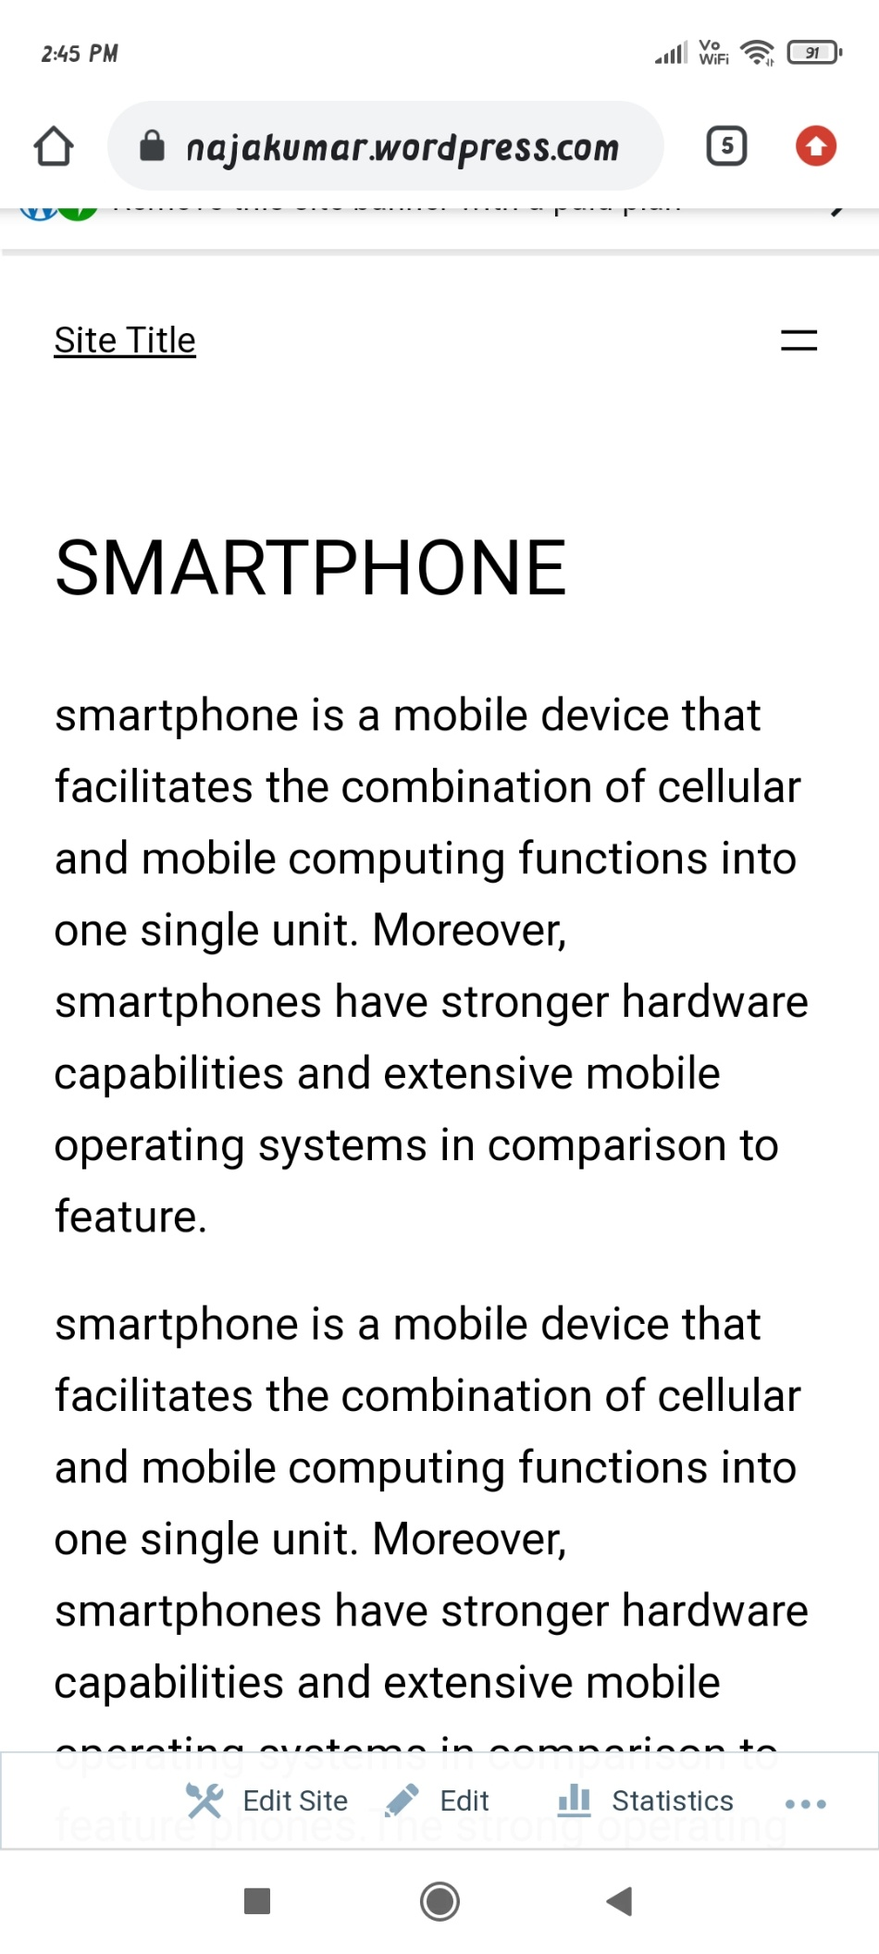

2)Create a New Facebook Business page and post one social media poster for your brand

Link: https://www.facebook.com/the.icecream.quarters?mibextid=ZbWKwL

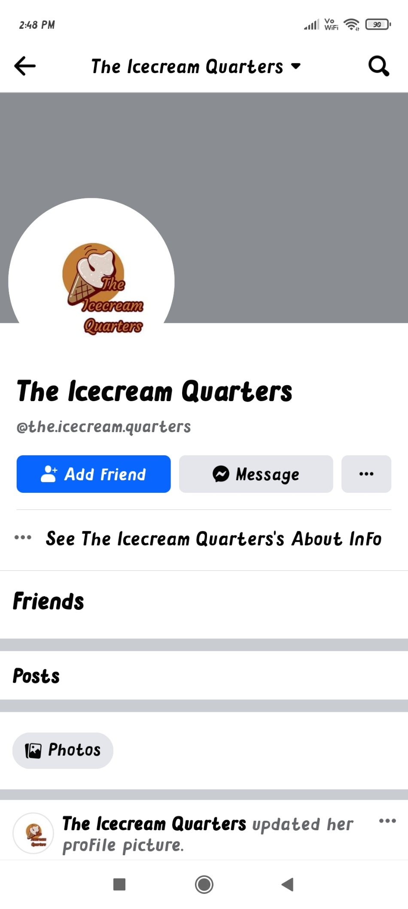
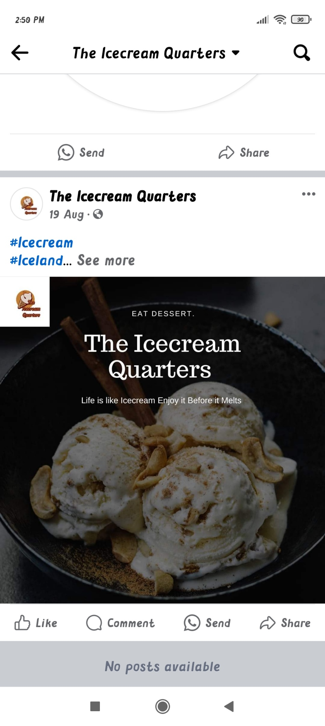

3)Create and design a social media advertisement poster using Canva

Link: https://instagram.com/fashion__fix____?igshid=MXV5dTh1dG93emI5bA==

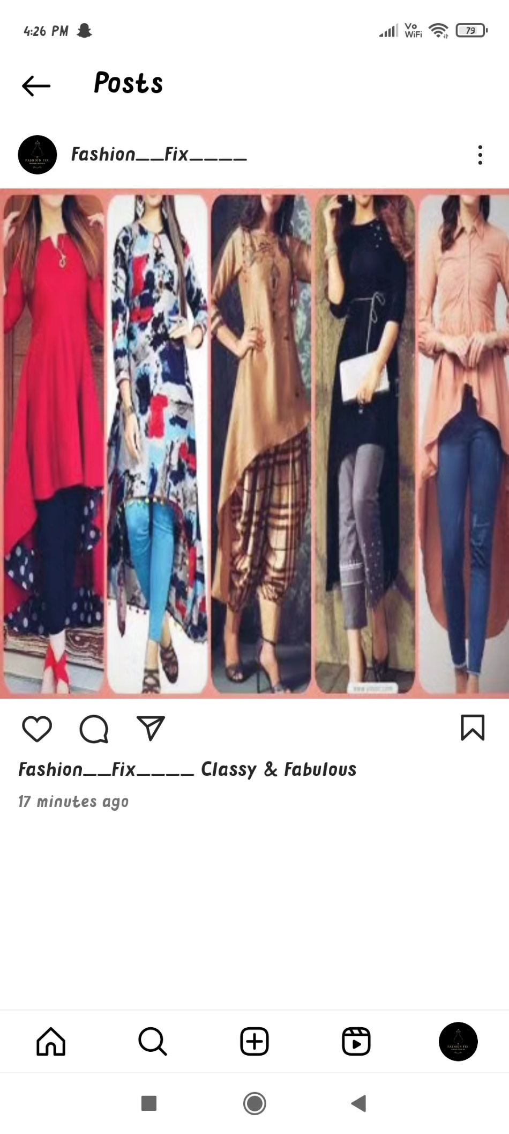

4)Create email newsletter design using Mail champ or Canva tool

Link: https://brownieeeeee.blogspot.com/2023/09/email-newsletter-thankyou-subscribers.html

