**Creating sponserd poster for instagram**

In this document I have developed the cutomize poster using canva site .

* Open the canva website and select template based on your requirements.
* select the print option size A1 and click cutomize the template.

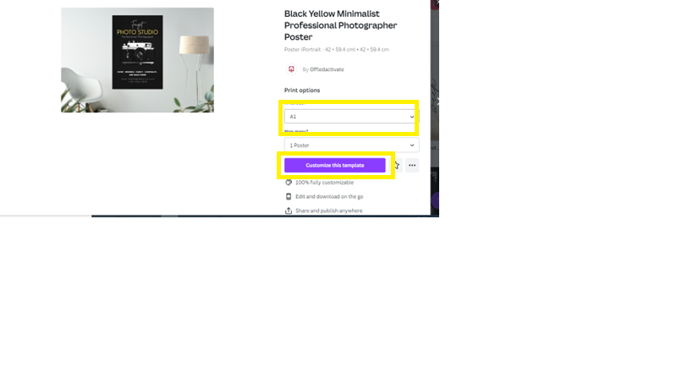

* Type your brand name cutomize the font name, size and colour based on your requirment.

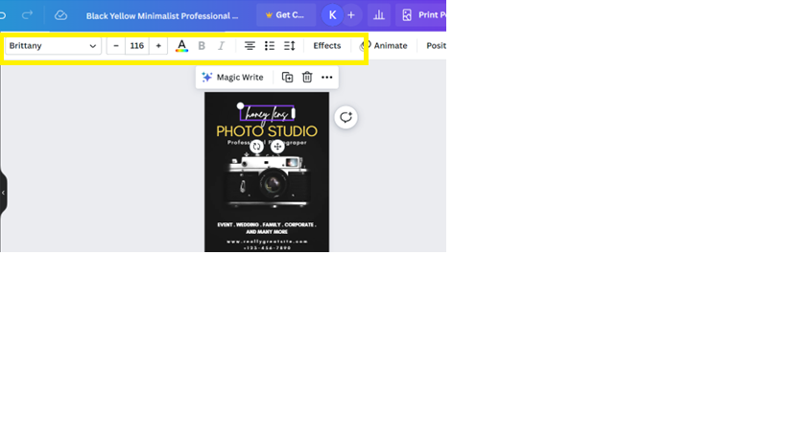

* Then click the magic write button here enable the font animation also.

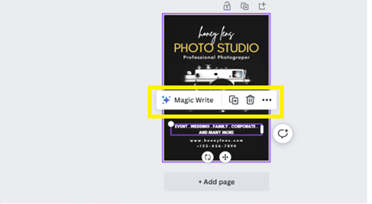

* Use the smart crop option cropping your brand background image based on your requirements.

* The select the font effect based on your theme and colour.

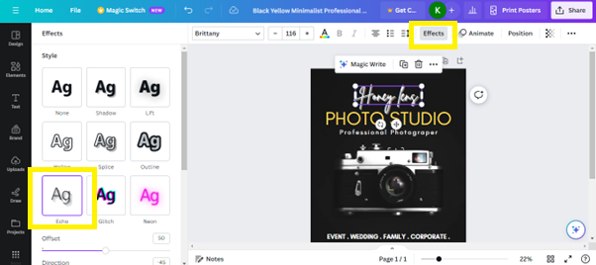

* Use highlights your text using bold font.

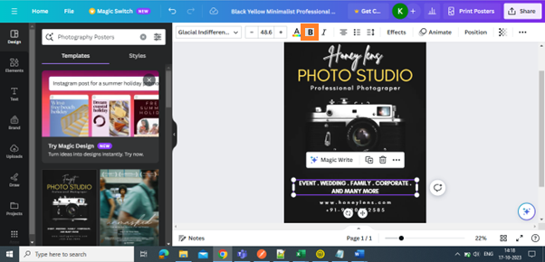

* Must ensure background colour and font colour is suitable for poster.

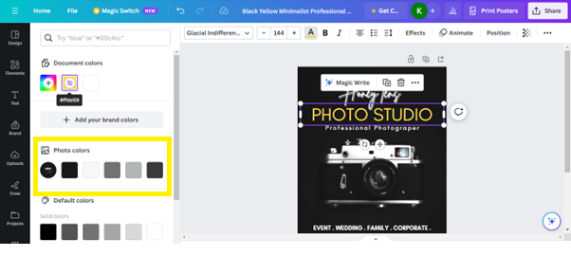

* Once developed your brand poster click share button and download the poster.

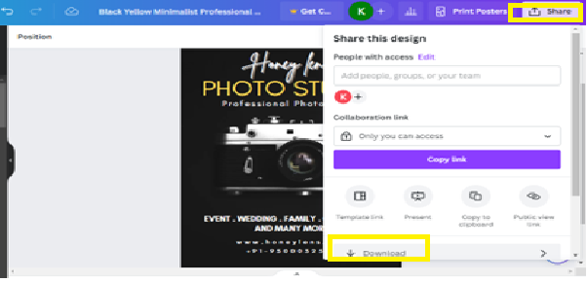

* Here is our final poster output for Honey lens photography studio.

**THANK YOU**