# Digital Marketing Project

Project: Instagram Reel

Brand Name: Thanu Fashion

##### Logo:



##### Instagram Account:

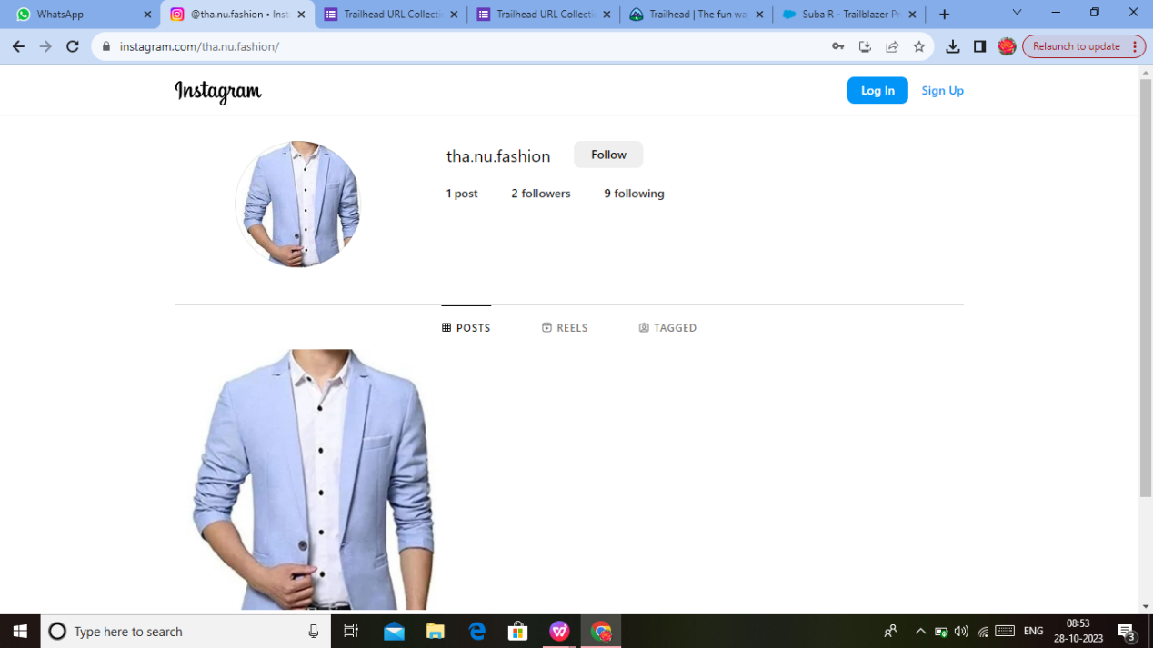

Link: <https://instagram.com/tha.nu.fashion?utm_source=qr&igshid=MzNlNGNkZWQ4Mg==>

## Reels:

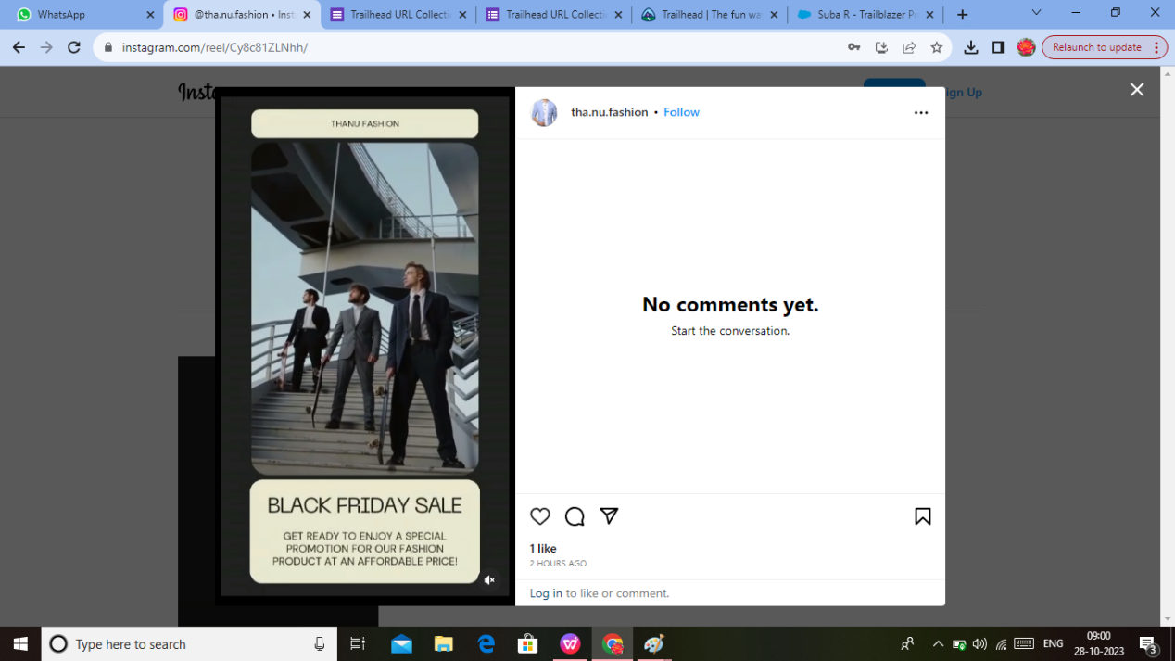

Link: <https://www.instagram.com/reel/Cy8c81ZLNhh/?igshid=MTc4MmM1YmI2Ng==>