Result Summary

My project is to simulate the evolution of a gravity system: many particles moving around the center mass. The system initialize with many particles moving in the circle of different radius. Then add small disturbance to the particles and model the crash of the particles. Try to find how this system will develop.

Here is my result:

The trace of single particle

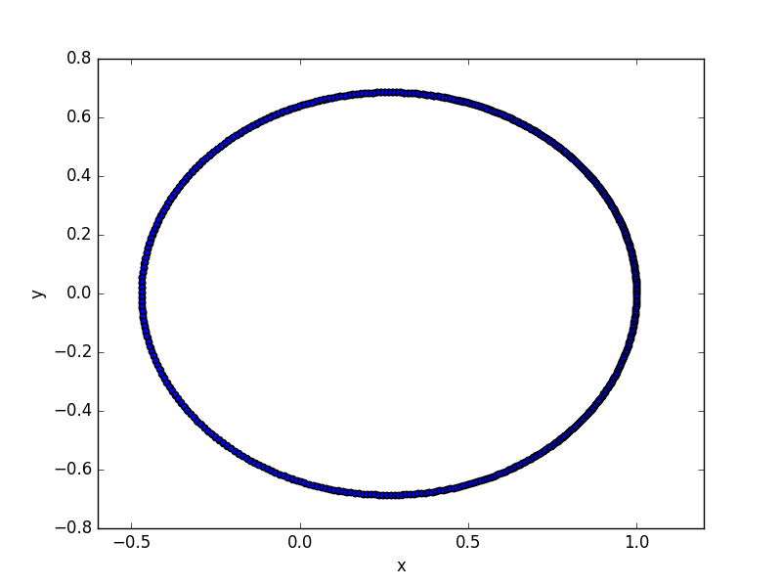

The energy of the particle (Ep is potential energy and Ek is kinetic energy, E = Ep + Ek)

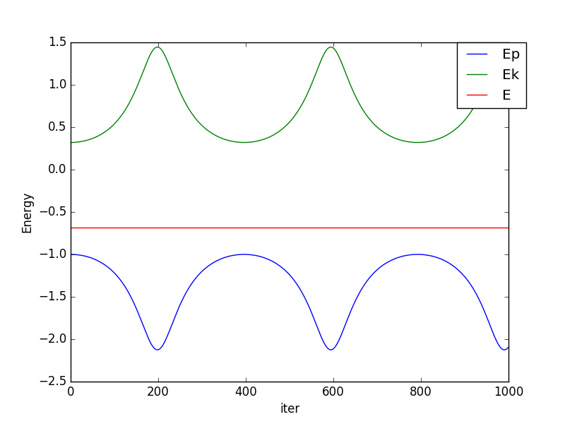

The trace of many particles:

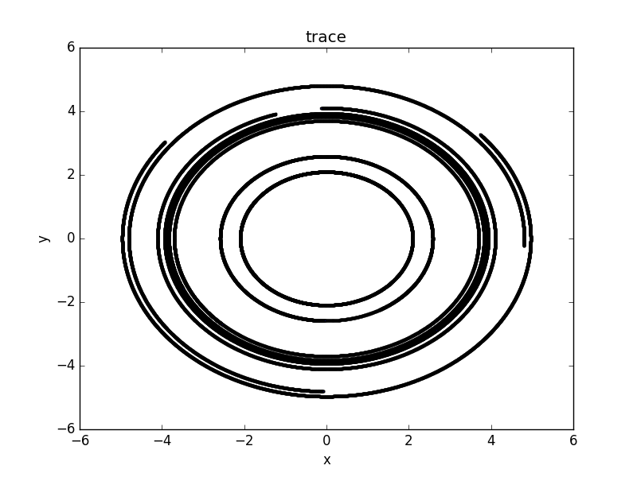

Add the gravity interaction between two particles

1. Assumptions
   1. There are N small particlesin the system, running around center mass.
   2. There’s no outside force to the system and the only interaction within the system is gravity. (There is no crash between particles and center mass)
   3. The center massstays still. I build the coordinate according toand all the other particles moving relatively to
   4. The gravity force between particles andfollows Newton’s Law.
   5. Each time step, when calculate the next state of particle i, assume that other particles stay still.
   6. Delay update: at each time step, update the state of the particles all at once, after calculate the new state of each particle according to the previous state
   7. Consider the interaction in the plane
2. Symbols

|  |  |
| --- | --- |
| Symbols | Descriptions |
|  | Center mass |
| N | Number of particles moving around Center mass |
|  | The mass of ith particle |
|  | The velocity of ith particle at time step n |
|  | The acceleration of ith particle at time step n |
|  | The acceleration of ith particle at time step n caused by particle j |
|  | The position of ith particle at time step n |
|  | The relative position of ith particle from jth particle at time step n: |
| h | time stride |
|  | the state of particle i at time step n |

1. Update rules





from (1),(2):



The update rule: (follow assumption 5 and 6)



1. Simulation result: (set G*M = 1 and the start radius of two particles is uniformly random choose between 2 and 2.1)
   1. set G*mi = 0, get the previous result:
      1. trace:

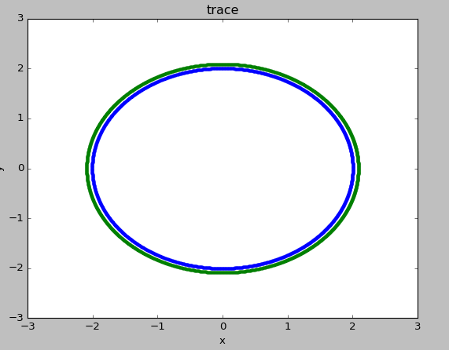

* + 1. radius history:

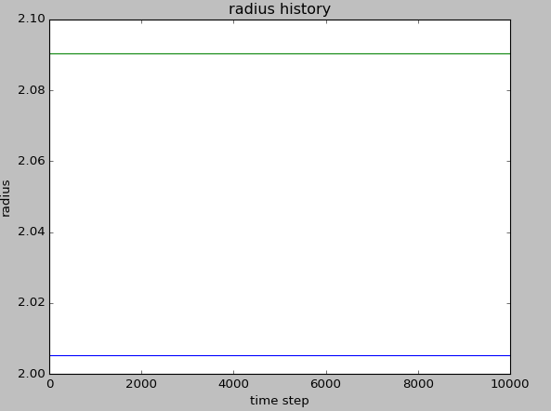

* 1. set G*mi = 0.0001, see the interaction between two particles
     1. trace:

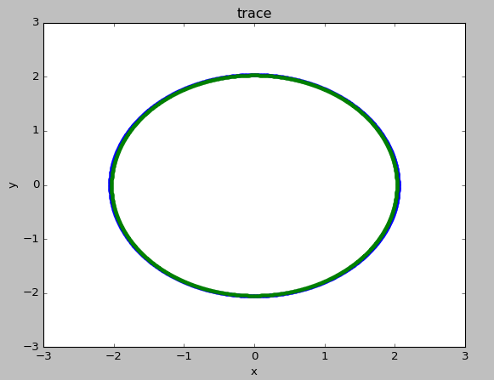

* + 1. radius history:

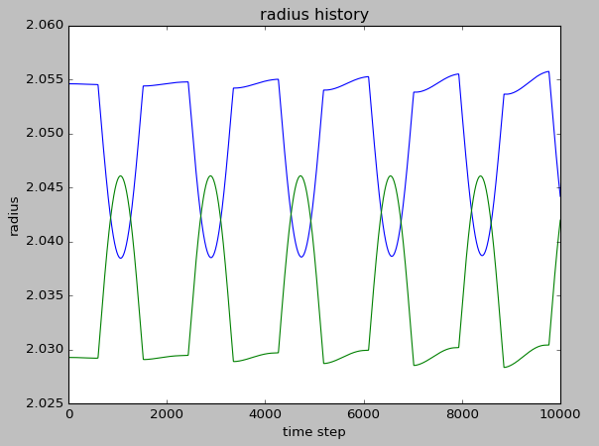

and the two particle do have chance to crash, although I haven’t model it, and it can just pass through each other.

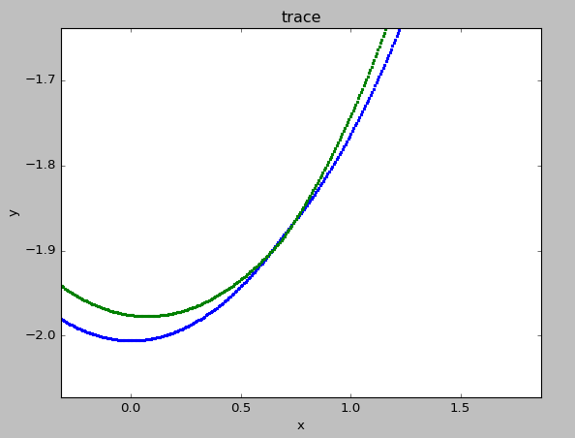

but sometime the radius not very stable: (although it not often happens)

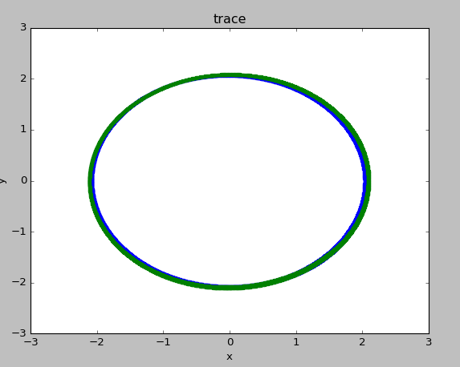

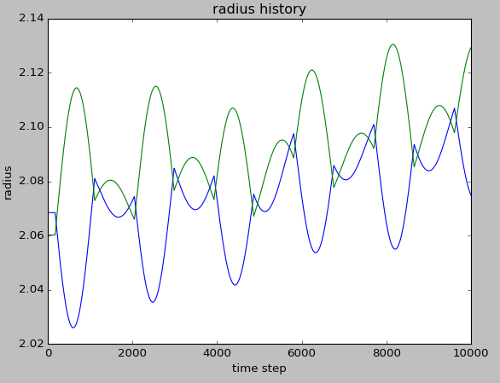

* 1. set G*mi = 0.01, the particles end up fall to the center mass, after which the they get a huge velocity and escape the system
     1. trace:

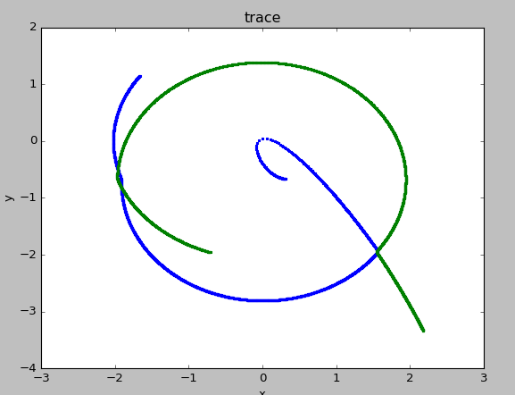

first crash:

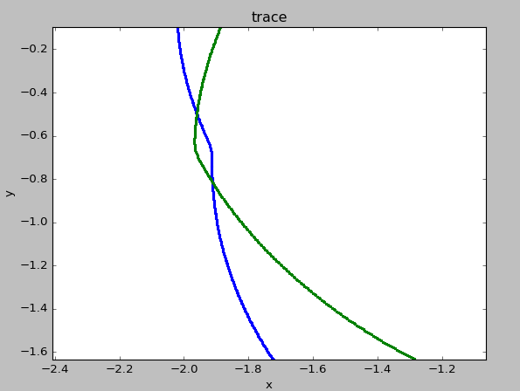

second crash:

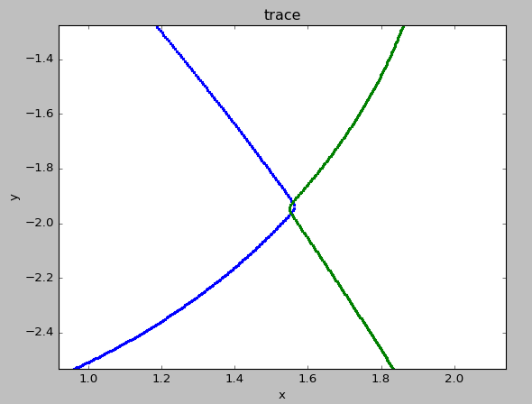

fall into the center mass

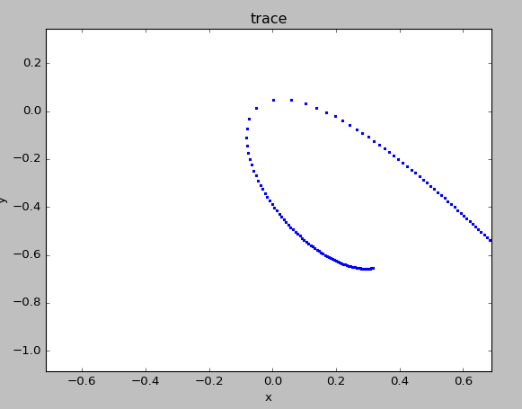

then escape:

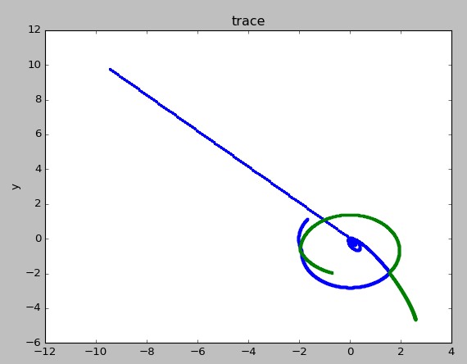

the green one fall into the center mass after the blue one escape:

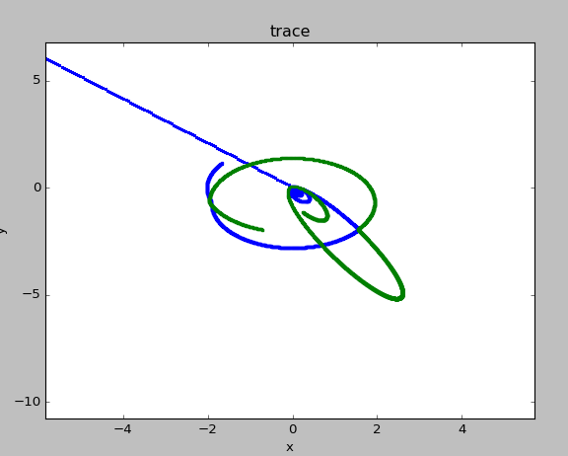

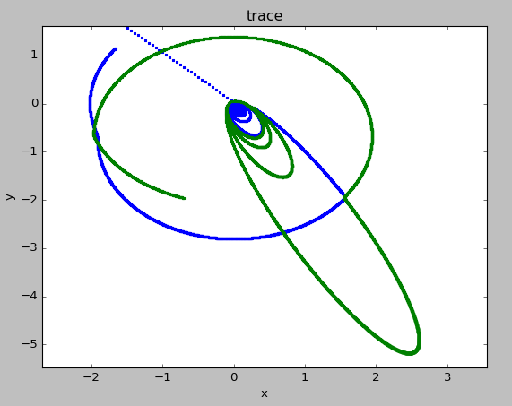

after falling the green escape as well

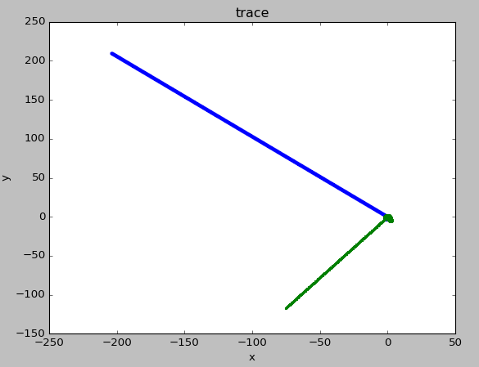

but in reality, I suppose they shall crash and may end up falling together

* + 1. radius history:

