Result Summary

My project is to simulate the evolution of a gravity system: many particles moving around the center mass. The system initialize with many particles moving in the circle of different radius. Then add small disturbance to the particles and model the crash of the particles. Try to find how this system will develop.

Here is my result:

The trace of single particle

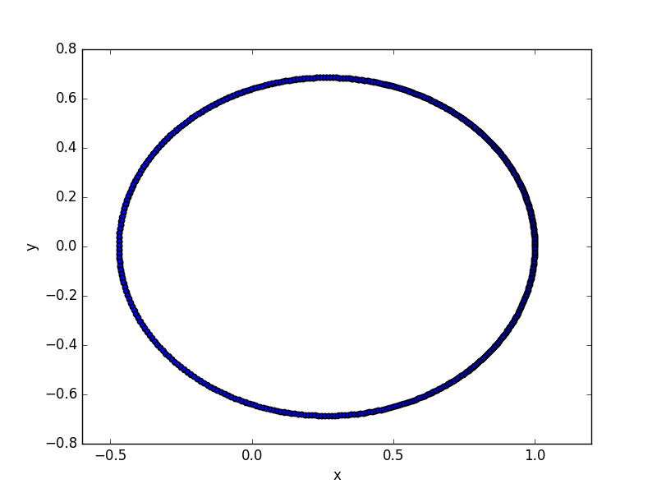

The energy of the particle (Ep is potential energy and Ek is kinetic energy, E = Ep + Ek)

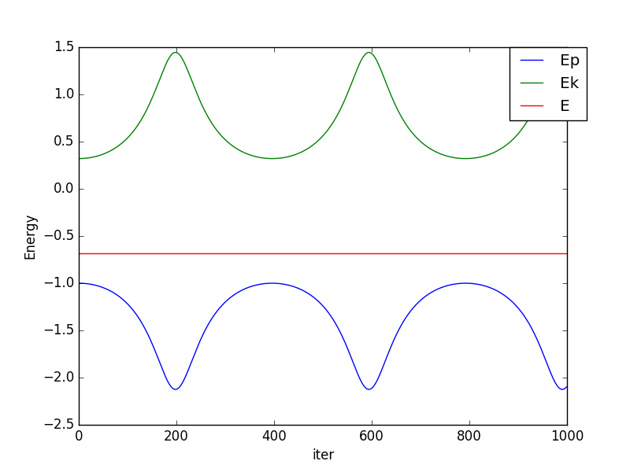

The trace of many particles:

