1AC

1AC --- FBK

1AC --- Framing

The subject’s entry into the symbolic order of ethics and relationality requires mediation through language which creates a disconnect between the real experience and the subject’s ability to convey it via linguistic interactions.

This causes ALIENATION: the failure to bridge the gap between experience and language creates a terminally incomplete subject with a lack at its core because A) signifiers are defined in relation to other signifiers. If I told you “I went to Plano West,” but Nigel said “I went to Evanston Township,” “I” comes to signify two different experiences which makes it impossible to pin the signifier down to one universal meaning in a vacuum and B) every individual relates to language differently because they interpret experience in unique ways since it is contextually produced with respect to temporality and cultures.

Only this can resolve the motivational question: out of this lack emerges a constant effort for subjects to articulate themselves in pursuit of a lost Object that would finally make them whole. That comes first because A) it proves why subjects are motivated to do certain things which matters since it determines how a subject will act on certain principles, B) this drive is intrinsic to all subjects inhabiting the post-linguistic state and C) there is no objective account of the ‘good’ since each agent relates to it in different ways, the manifestation of their motivations are unique, and differing beliefs haven’t been converted into a unified ethic.

Thus, the standard is to embrace the lack. Your ethical imperative is to avoid attempts to move away from the constitutive loss that makes up the core of the subject and dwell within it instead. Don’t mediate anxiety but rather confront its relationship to desire and the Other through the process of enjoyment.
McGowan ’3---Todd McGowan [Professor in the Department of English and Cultural Theory at the University of Vermont] “Enjoying What We Don’t Have: The Political Project of Psychoanalysis,” University of Nebraska Press, page 20-22, 2013, ask me for pdf } angel
Conceiving politics in terms of the embrace of repetition rather than the construction of a good society takes the movement that derails traditional political projects and reverses its valence. This idea of politics lacks the hopefulness that Marxism, for instance, can provide for overcoming antagonism and loss. With it, we lose not just a utopian ideal but the idea of an alternative future altogether — the idea of a future no longer beset by intransigent limits — and this idea undoubtedly mobilizes much political energy. 33 What we gain, however, is a political form that addresses the way that subjects structure their enjoyment. It is by abandoning the terrain of the good and adopting the death drive as its guiding principle that emancipatory politics can pose a genuine alternative to the dominance of global capitalism rather than incidentally creating new avenues for its expansion and development. The death drive is the revolutionary contribution that psychoanalysis makes to political thought. But since it is a concept relatively foreign to political thought, I will turn to various examples from history, literature, and film in order to concretize what Freud means by the death drive and illustrate just what a politics of the death drive might look like. The chapters that follow trace the implications of the death drive for thinking about the subject as a political entity and for conceiving the political structure of society. Part 1 focuses on the individual subject, beginning with an explanation of how the death drive shapes this subjectivity. The various chapters in part 1 trace the implications of the death drive for understanding how the subject enjoys, how the drive relates to social class, how the drive impacts the subject as an ethical being, and how the subject becomes politicized. The discussion of the impact of the death drive on the individual subject serves as a foundation for articulating its impact on society, which part 2 of the book addresses, beginning with the impact of the death drive on the constitution of society. Part 2 then examines how the conception of the death drive helps in navigating a path through today’s major political problems: the inefficacity of consciousness raising, the seductive power of fantasy, the growing danger of biological reductionism and fundamentalism, the lure of religious belief, and the failure of attempts to lift repression. The two parts of the book do not att empt to sketch a political goal to be attained for the subject or for society but instead to recognize the structures that already exist and silently inform both. The wager of what follows is that the revelation of the death drive and its reach into the subject and the social order can be the foundation for reconceiving freedom. The recognition of the death drive as foundational for subjectivity is what occurs with the psychoanalytic cure. Through this cure, the subject abandons the belief in the possibility of finding a solution to the problem of subjectivity. The loss for which one seeks restitution becomes a constitutive loss — and becomes visible as the key to one’s enjoyment rather than a barrier to it. A political project derived from psychoanalytic thought would work to broaden this cure by bringing it outside the clinic and enacting 21 Introduction on society itself. The point is not, of course, that everyone would undergo psychoanalysis but that psychoanalytic theory would function as a political theory. Politically, the importance of psychoanalysis is theoretical rather than practical. Politically, it doesn’t matt er whether people undergo psycho- analytic therapy or not. This theory would inaugurate political change by insisting not on the possibility of healing and thereby attaining the ultimate pleasure but on the indissoluble link between our enjoyment and loss. We become free to enjoy only when we have recognized the intractable nature of loss. Though psychoanalytic thought insists on our freedom to enjoy, it understands freedom in a counterintuitive way. It is through the death drive that the subject attains its freedom. The loss that founds this drive frees the subject from its dependence on its social environment, and the repetition of the initial loss sustains this freedom. By embracing the inescapability of traumatic loss, one embraces one’s freedom, and any political project genuinely concerned with freedom must orient itself around loss. Rather than looking to the possibility of overcoming loss, our political projects must work to remain faithful to it and enhance our contact with it. Only in this way does politics have the opportunity to carve out a space for the freedom to enjoy rather than restricting it under the banner of the good.

PREFER.

1---INTERNALISM. A) Externalism collapses to internal ethics since the only reason agents follow external demands is that those demands are consistent with their internal account of the good. B) No description of another individual’s experience will bridge the epistemic gap between my experience and others because of the lack which makes a universal understanding of experience impossible. C) Subjects prefer internal decision making over external pressures and considerations.
Fink et al. ’24---Lior Fink [Ben-Gurion University of the Negev, Beer-Sheva, Israel] Leorre Newman [Department of Industrial Engineering and Management, Ben-Gurion University of the Negev] and Uriel Haran [Guilford Glazer Faculty of Business and Management, Ben-Gurion University of the Negev] “Let me decide: Increasing user autonomy increases recommendation acceptance,” Science Direct, Computers in Human Behavior vol. 156, July 2024 <https://www.sciencedirect.com/science/article/abs/pii/S0747563224001122?via%3Dihub> angel
The use of algorithm assistance for decision making is vastly increasing in recent years, largely in online settings wherein users receive advice from recommendation systems. Despite the prevalence of such augmented decision making, users sometimes demonstrate aversion toward algorithms and even reject the recommendations of highly accurate systems. Research in behavioral decision making on the one hand, and in information systems on the other, has yet to fully comprehend these phenomena. We build on insight from these two research streams, as well as from self-determination theory, in identifying the psychological need for autonomy as a driver of decreasing algorithm aversion and increasing recommendation acceptance. We identify two concrete autonomy mechanisms—choice autonomy and control autonomy—which may increase the willingness of users to accept algorithmic recommendations. In three online experiments, simulating the process of selecting a vacation package, we consistently find that showing users multiple recommendations instead of a single recommendation, thereby increasing their choice autonomy, significantly increases recommendation acceptance, both when the system is perfectly accurate (Study 1) and when it is not (Studies 2 and 3). Furthermore, we find in Study 3 that allowing users control over whether they receive single or multiple recommendations, thereby increasing their control autonomy, has a positive moderating effect on the relationship between choice autonomy and recommendation acceptance, suggesting a complementarity between the two autonomy mechanisms. In so doing, we provide theoretical grounding and empirical evidence for the positive consequences of increasing user autonomy on the effectiveness of recommendation systems.

2---BINDINGNESS: A) Alienation is constitutive of all subjects which makes it an inescapable quality of being. B) All moral judgements occur within the symbolic world of linguistic interaction. C) Debating concedes it since it proves that all actions are mediated through signification.

3---DEDUCTION. A) The probability equation would result in an ‘undefined’ result absent an arbitrary limit since infinity is not a number we can calculate.
Masrani ’20---Vaden Masrani [I am CEO & Founder of Sophia AI, a technical engineering studio specializing in data science, machine learning, and artificial intelligence. Previously I was a Senior Research Scientist at Huawei Technologies Canada, working in the area of machine learning and artificial intelligence. My CV is here. I completing my Ph.D (thesis) at the University of British Columbia as a member of the Pacific Laboratory for Artificial Intelligence (PLAI) lab in 2023. These days, when I’m not at Z-Space, I co-host the Increments podcast, and occasionally write about applied epistemology] “A Case Against Strong Longtermism,” Vaden Masrani, December 10, 2020 <https://vmasrani.github.io/blog/2020/against_longtermism/> angel
In expectation, the future is undefined The set of all possible futures is infinite, regardless of whether we consider the life of the universe to be infinite. Why is this? Add to any finite set of possible futures a future where someone spontaneously shouts “1”!, and a future where someone spontaneously shouts “2”!, and a future where someone spontaneously shouts “3!” … While this may seem like a trivial example, it has crucial implications for the ways in which we talk about probabilities and expectations. Namely, reasoning about probabilities over infinite, arbitrary futures is a fundamentally meaningless exercise. In the spirit of Hilbert’s Grand Hotel, let’s consider an infinite sequence of white and black balls in alternating order8 W B W B W B W B W... Our intuitions might tempt us to say that the proportion or “relative frequency” of white balls and black balls in this infinite sequence is 1:1, which would lead to the “probability” of drawing a black ball being 1/2. However, let’s now imagine reordering the infinite set as follows: B B W B B W B B W B B W... From the perspective of longtermism, these black balls might represent possible futures in which we’ve been annihilated by a given existential risk. But what do we think the “probability” of observing a black ball is now? It appears to be 2/3! We could imagine doing this again and again, so that the “probability” moves from 2/3, to 4/5, to 5/6, ad infinitum. Clearly, there is a problem here. For this reason, “the probability of drawing a black ball” from this infinite set literally has no meaning. It’s undefined. We are used to estimating probabilities by tallying up counts, and dividing by a denominator. This clearly works over finite sets, where the denominator is just the count of all total observations9, but in infinite sets this results in ∞/∞, which again, is undefined. This is known as a “veridical paradox” - a result that appears absurd, but is demonstrated to be true nonetheless. Wikipedia describes the situation succinctly: Initially, this state of affairs might seem to be counter-intuitive. The properties of “infinite collections of things” are quite different from those of “finite collections of things”. The paradox of Hilbert’s Grand Hotel can be understood by using Cantor’s theory of transfinite numbers. Thus, while in an ordinary (finite) hotel with more than one room, the number of odd-numbered rooms is obviously smaller than the total number of rooms. However, in Hilbert’s aptly named Grand Hotel, the quantity of odd-numbered rooms is not smaller than the total “number” of rooms. (emphasis mine) But don’t we apply probabilities to infinite sets all the time? Yes - to measurable sets. A measure provides a unique method of relating proportions of infinite sets to parts of itself, and this non-arbitrariness is what gives meaning to the notion of probability. While the interval between 0 and 1 has infinitely many real numbers, we know how these relate to each other, and to the real numbers between 1 and 2. By contrast, we do not have a measure over the set of white and black balls, or over the set of infinite futures. In the above example, we saw that this allowed us to shuffle the ordering so as to rig the deck in favor of whichever outcome we wanted. For this reason, probabilities, and thus expectations, are undefined over the set of all possible futures. This observation - that in expectation, the future is not vast, but undefined - passes a few basic sanity checks. First, we know from common sense that we cannot predict the future, in expectation or otherwise. Prophets have been trying this for millennia with little success - it would be rather surprising if the probability calculus somehow enabled it. Second, we know from basic results in epistemology (discussed here before) that predicting the future course of human history is impossible when that history depends on future knowledge, which we by definition don’t know. We cannot know today what we will only learn tomorrow. It is not the case that someone standing in 1200 would assign a “low credence” to the statement “the internet will be invented in the 1990’s”. They wouldn’t be able to think the thought in the first place, much less formalize it mathematically. We should prefer good things to happen sooner In section 2.2 they state their second assumption: Our second assumption is that, for the purposes of moral decision-making and evaluation, all the consequences of one’s actions matter, and (once we control for the degree to which the consequence in question is predictable at the time of action) they all matter equally. In particular, this assumption rules out a positive rate of pure time preference. Such a positive rate would mean that we should intrinsically prefer a good thing to come at an earlier time rather than a later time. If we endorsed this idea, our argument would not get off the ground. To see this, suppose that future well-being is discounted at a modest but significant positive rate — say, 1% per annum. Consider a simplified model in which the future certainly contains some constant number of people throughout the whole of an infinitely long future, and assume for simplicity that lifetime well-being is simply the time-integral of momentary well-being. Suppose further that average momentary well-being (averaged, that is, across people at a time) is constant in time. Then, with a well-being discount rate of 1% per annum, the amount of discounted well-being even in the whole of the infinite future from 100 years onwards is only about one third of the amount of discounted well-being in the next 100 years. While this calculation concerns total well-being rather than differences one could make to well-being, similar considerations will apply to the latter.
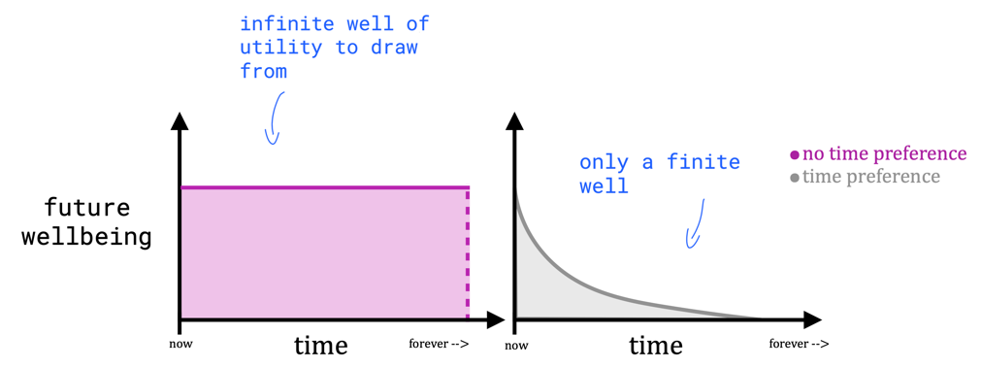
[Figure 1: The "all consequences matter equally" assumption.] If one does not discount the future, then one is equally concerned about every moment in time, hence the phrase “all consequences matter equally”. Mathematically, this implies (with the unbounded future assumption) that there is an infinite amount of possible well-being in the future to concern ourselves with (the pink area above). This assumption is why longtermism states it is always better to work on x-risks than anything else one might want to do to improve the short-term. That is, that pink well of utility (ui above) will always be large enough to compensate for any arbitrarily small probability (pi) of a successful intervention. This last point can be understood like this:
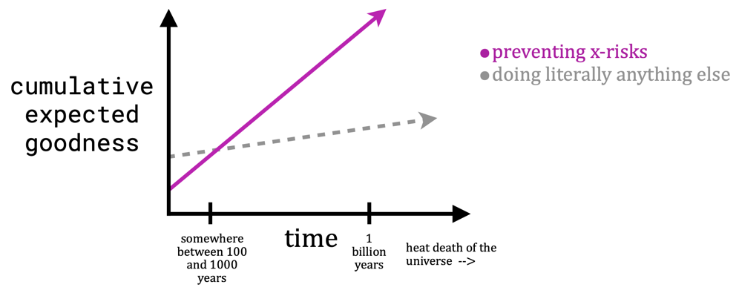
[Figure 2: The utility of different actions according to longtermism (cf. section 2.3).] Thus with these assumptions, they have unintentionally granted themselves unlimited flexibility to adjust ui and pi so that the pink line always overtakes the grey one. This puts the “strong” into “strong longtermism” and is what they say “renders axiological strong longtermism plausible”. I think however, that it just renders strong longtermism unfalsifiable. Nothing could possibly refute an argument like this, because there are an unlimited number of degrees of freedom to adjust, and no data to be constrained by10. These degrees of freedom can always be tuned to strip funding for any charitable organization whatsoever. It could even be used to squash funding for “x-risks” themselves, by inventing an even larger class of risk (“super x-risks”), with even larger utilities and probabilities, and playing their argument back at them. This is frivolous. ~ Still, we must address the content of their assumption in order to decide if it’s reasonable. We can simplify their second paragraph to see more plainly the position they endorse: We should not be biased towards the present. It appears to me that such an extreme position must be argued for, and not simply asserted. But disappointingly, the only argument they provide is: For present purposes, we take the assumption of a zero rate of pure time preference to be fairly uncontroversial. We know of no moral philosophers and few theoretical economists who defend a non-zero rate of pure time preference. I’m tempted to invoke Hitchens’s razor here, that “What can be asserted without evidence can be dismissed without evidence”. But that feels like a bit of a cop-out, so I’ll attempt to make the opposite case, namely: one should absolutely be biased towards the present. This seems to follow almost immediately from another assumption made by the authors - that there might be an impending x-risk in the future. We should be biased towards the present for the simple reason that tomorrow may not arrive. The further out into the future we go, the less certain things become, and the smaller the chance is that we’ll actually make it there. Preferring good things to happen sooner rather than later follows directly from the finitude of life. And let us not forget that good things don’t happen to us, they happen because of us. We are not just waiting arms outstretched for “good things” to be sprinkled down to us from the heavens. We are (all of us, humanity as a whole) the ones actively working to bring these good things about.

B) Moral judgements rely on the application of principles.
Dancy ’17---Jonathan Dancy [a British philosopher, who has written on ethics and epistemology. He is currently Professor of Philosophy at University of Texas at Austin and Research Professor at the University of Reading] “Moral Particularism,” Stanford Encyclopedia of Philosophy, September 22, 2017 date of last revision <https://plato.stanford.edu/entries/moral-particularism/> angel
2. What the Particularist Does Not Believe It is standard, at least in cultures informed by the Christian tradition, to think of the moral person as the person of principle. This person is the person who has learnt, or developed for herself, a sufficient range of sound moral principles (of either type), and who has sufficient skill at applying these principles to cases as they crop up. There is no need to underestimate the sort of skill that would be required for this; the matter is certainly far from mechanical. One needs judgement both to discern whether a principle applies at all and, if it does, what exactly it requires of one. Nonetheless, however difficult it may be, moral judgement is conceived here as the application of principles to cases. If moral judgement is a rational enterprise, it must be subject to constraints of consistency. What is demanded of us when we are required to be consistent in our moral judgements? The answer is that we are required to apply our principles consistently, that is, to apply the same principle to similar cases. It is inconsistent to apply the principle ‘don’t lie’ to cases involving one’s friends and not to those that involve strangers. If you want to behave in that sort of way, your principle is going to have to be ‘don’t lie to your friends’. What this tells us, of course, is that consistency is not the only requirement. Our moral principles are supposed to be impartial, and it is not obvious that the principle ‘don’t lie to your friends’ meets this condition. But at least someone who takes it as his principle can tell the truth to his friends and lie to strangers without inconsistency. Why do we think of the moral person as the person of principle, and why do we think of moral judgement as subject to this sort of consistency constraint? (As we will see later, there are other forms that the consistency constraint could have taken.) The answer, I think, is that we suppose that without moral principles there could be no such thing as the difference between right and wrong. Rightness and wrongness are peculiar properties, and the only way that an action can get them is by being related to a principle in one way or another. So unless there are principles saying which sorts of actions are right and which wrong, none would be right and none wrong. If this were so, it would hardly be surprising that the good moral judge would be the person capable of following in her mind the way in which actions get to be right or wrong, which requires knowing the relevant principles and seeing that they have this effect here and that effect there. And it would be hardly surprising that consistency in judgement would amount to no more than applying similar principles to similar cases. A rather different argument appeals not so much to a metaphysical need for principles as to an epistemological need. If there is a distinction between right and wrong actions, how are we to detect it? There must be a detectable difference between the properties of the right ones and the properties of the wrong ones. Now if an action is wrong, it is wrong because of certain other features it has—the non-moral features that make it wrong. Those non-moral features will be detectable in the ordinary way, whatever that is. Good moral judges, having detected them, can somehow work out whether they make the action right or wrong. But if this ability is not a matter of magic, it must rest on an at least implicit knowledge of regularities connecting the non-moral features of actions and their moral properties. Moral principles specify such regularities. So if moral judgement is to be even possible, there must be a set of principles connecting moral properties to non-moral properties, contrary to what the particularist claims. If this is our picture of the individual trying to decide what she ought to do, how are we likely to conceive of the way to resolve disagreements between two individuals? Of course there are the facts of the matter to be sorted out between them. Then presumably they have to try to agree at least on which principles are to be taken as relevant (that is, to agree on the principles, and to agree that they are the relevant ones in the present case). Finally, they have to agree on the course of action that those principles recommend in the situation that faces them. This would be, as we might put it, a full resolution of any initial disagreement. Otherwise we are looking for a compromise of one form or another. It is possible, for instance, for a disagreement on the principles not to make any practical difference as things turn out, so that it can be left to be sorted out another day. Overall, then, we are offered a way in which moral reasons work, and an account of the perfectly moral agent whose decision processes fit the way the reasons work, that is, fit the way in which an action can get to be right or wrong. But the way moral reasons work is probably very different from the way that other reasons work. Other reasons are not principle-driven. Morality is special, since without principles it is impossible. (Remember that the two arguments given above for the need for principles appealed to the special nature of rightness and wrongness, or of moral properties in general.)

1AC --- Offense

The United States ought to rewild substantial tracts of land.

