Lighting Bible for an Earth-like Planet
in a Triple-Star System
Scientifically grounded art direction, time-of-day rules, shadows, eclipses, and engine implementation notes
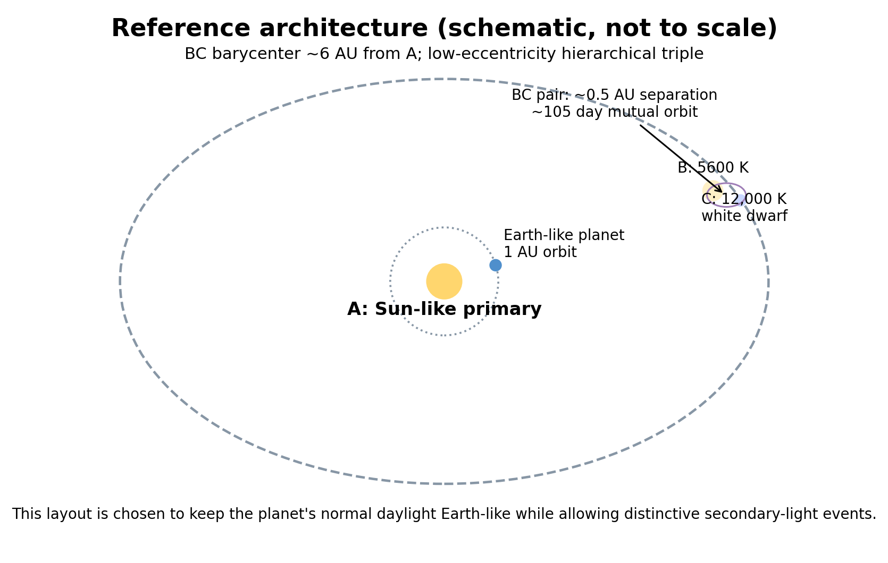
Purpose
Give lighting, VFX, rendering and gameplay teams one internally consistent reference. Values marked “reference model” are a plausible baseline, not a claim that there is one unique triple-star configuration. If the star or orbit design changes, recompute the ratios with the formulas in Section 3.

1. Executive summary
- Normal daytime can remain surprisingly Earth-like. In the reference model, the Sun-like primary supplies about 98% of direct stellar illuminance when all three stars are high. The warm companion adds about 2%, and the compact hot companion about 0.008%.
- The strongest “alien” signatures are conditional: colored fill inside the primary shadow, multiple offset shadows when exposure permits, prolonged or repeated twilight, secondary daylight after the primary sets, and abrupt spectral changes during eclipses.
- A literal saturated purple normal star is not physically realistic. Stellar thermal spectra lie near the Planckian locus and progress toward blue-white at high temperature, not purple. The defensible visual target is blue-white / lavender, optionally with a mild magenta art-direction bias.
- An Earth-like atmosphere still produces Rayleigh-dominated blue skies and red/orange low-altitude stars. A hot blue-white companion becomes less blue as it approaches the horizon because short wavelengths are preferentially scattered out of the direct beam.
- Treat the three stars as three independent directional lights and sum them in linear HDR space. Do not collapse them into one averaged color temperature: that destroys colored shadows and eclipse transitions.
Engine warning
Unreal Engine 5.8 Sky Atmosphere supports two Atmosphere Sun Light indices. For a three-star system, let A and B drive the stock atmosphere and render C as a separate directional light plus custom sky disk/scattering approximation. Unity HDRP Physically Based Sky supports multiple celestial bodies; still test shadow and volumetric cost. [13-18]

Developer-readiness note
The scientific sections define what the light should do. Sections 6.3-6.7 now define how a Godot 4.7.x implementation should represent it for a 2.5D isometric game, including the contract an AI coding agent can implement and validate.

2. Reference system and assumptions
The following configuration is deliberately conservative: it keeps the world broadly habitable and the daytime recognizable while still producing strong special-event lighting. It is a hierarchical triple, a standard class of dynamically stable multiple-star architecture when the orbital scales are well separated. Planetary stability in triples is a numerical problem; published work shows that binary stability criteria are a useful first approximation for hierarchical triples except in more extreme regimes. [11-12]
Body | T (K) | Radius (Rsun) | Luminosity (Lsun) | Nominal distance | High-altitude direct light | Angular diameter
A - Primary | 5,772 | 1.000 | 1.0000 | 1 AU from planet | 120,000 lx | 0.5330°
B - Warm companion | 5,600 | 0.900 | 0.7177 | ~6 AU | 2,392 lx | 0.0800°
C - Hot compact companion | 12,000 | 0.012 | 0.0027 | ~6 AU | 9 lx | 0.0011°
Reference orbital geometry: the B-C pair has a nominal separation of 0.5 AU, giving a mutual orbital period of about 105 days for the adopted masses. Their barycenter orbits A at about 6 AU, with an illustrative period of about 9.3 years. With an outer eccentricity near 0.05, the Holman-Wiegert binary approximation gives a circumprimary stability boundary of roughly 1.33 AU, so a 1 AU planet lies inside the estimated stable region. This is a plausibility check, not a substitute for an N-body integration of the final lore system. [11-12]
Why this specific compact hot star?
A white dwarf is genuinely much smaller than the Sun while remaining hot. NASA describes typical white dwarfs as roughly Earth-sized stellar remnants. A 12,000 K white dwarf is still blue-white rather than purple; its tiny angular diameter also produces unusually sharp shadows when it is bright enough to matter. [9]

3. Would it look like Earth?

3.1 Most of the ordinary day: yes
Under clear skies with A high, the dominant phenomenology remains Earth-like: blue sky, warm low Sun, white-to-warm direct daylight, red/orange sunsets, and a strong single primary shadow. NASA measures Earth’s total solar irradiance near 1 AU at about 1361 W/m², while Unreal’s physically based sky documentation recommends about 120,000 lux for a zenith Sun with an angular diameter near 0.545°. [2,15]
In this reference model, B contributes about 1.99% of A’s high-altitude direct illuminance and C about 0.0075%. The total additional stellar energy is therefore modest. If climate fidelity matters, move the planet very slightly outward or tune atmosphere/albedo to compensate; do not assume lighting and climate are independent.

3.2 Where it stops looking like Earth
- Inside A-shadow: surfaces are still illuminated by B and C, so shadows acquire a warmer cream component plus a very faint cool component instead of being illuminated only by the blue sky.
- After A sets while B remains above the horizon: the world enters a “secondary day” at a few thousand lux rather than ordinary night. Colors remain visible, but the sky is much dimmer than terrestrial daylight.
- If only C is above the horizon: the scene becomes a cool, high-contrast twilight/night with a very sharp shadow source. C is bright enough in the reference model to matter visually but not to resemble normal daylight.
- During eclipses: illumination can change by many exposure stops in seconds to minutes and, crucially, can change color family rather than simply getting darker.

4. Physical rules the game should preserve

4.1 Stellar brightness
For a star of luminosity L at distance d, irradiance scales as L/d². Relative to the Sun at 1 AU:
relative flux = (L / Lsun) / (d / AU)²
For a thermal emitter, the Stefan-Boltzmann relation gives L proportional to R²T⁴, so relative luminosity can be estimated from radius and effective temperature. Stars are not perfect blackbodies, but NASA notes that a blackbody curve describes the overall stellar continuum well and that hotter stars appear bluer. [3]

4.2 Star color: the purple constraint
A normal photosphere produces a broad thermal spectrum. The CIE defines the Planckian locus as the chromaticity path of Planckian radiators at different temperatures; it runs through red, yellowish-white, white and blue-white regions. A normal hot star therefore does not become a saturated purple lamp. [5]
Art direction rule for C
Base C on 10,000-15,000 K blue-white light. If the fiction requires “purple”, apply only a restrained magenta bias (roughly a lavender impression, not neon violet) and preserve atmospheric reddening near the horizon. Treat that tint as art direction, not astrophysics.

4.3 Atmosphere: why all three stars change color with elevation
In an Earth-like atmosphere, Rayleigh scattering preferentially redirects short-wavelength light; aerosols add Mie scattering and haze. This is why the daytime sky is blue and why low-angle sunlight becomes yellow, orange and red after travelling through a longer atmospheric path. NOAA and NASA describe the same mechanism; Unreal and Unity physically based skies implement Rayleigh and Mie scattering for this purpose. [6,14,18]
Important consequence: C should not remain saturated blue/lavender at the horizon. It trends toward white, pink/rose and eventually orange-red in the direct beam as its blue/violet photons are scattered away. The surrounding sky can still retain cool scattered light.

4.4 Twilight thresholds
Use stellar elevation angles rather than clock time. The U.S. Naval Observatory defines civil twilight down to -6°, nautical to -12°, and astronomical to -18° for the Sun’s center. Apply these thresholds to A for the primary day-cycle state, then evaluate B and C independently. [7]
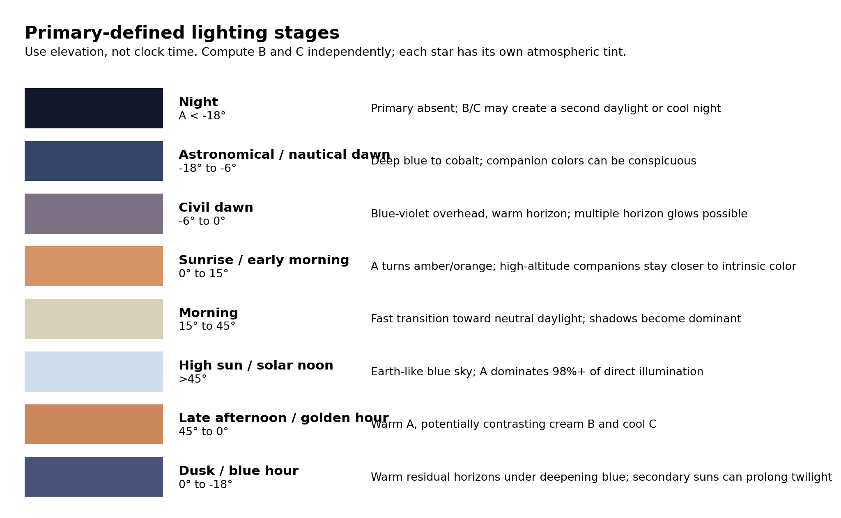

4.5 Shadows and source size
Every star produces its own shadow direction. Shadow softness is governed by apparent source size: the primary is about 0.53° across; B is about 0.08° in the reference geometry; C is effectively point-like at about 0.001°. Unreal exposes Source Angle specifically as the angular size of a directional light source and defaults to roughly the angular diameter of our Sun. [16]
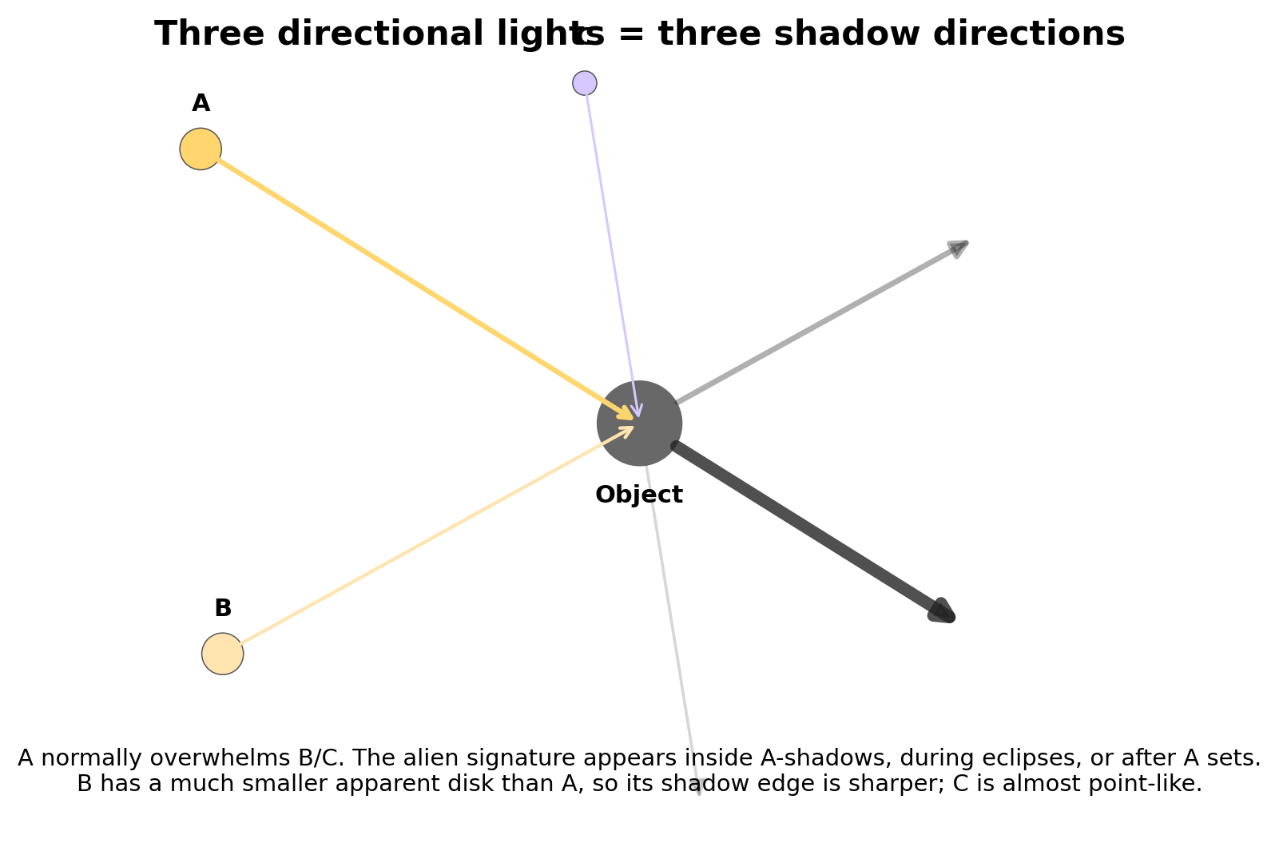

5. Art-direction lighting sequence
This section is the practical handoff. It assumes clear weather and a roughly Earth-like atmosphere. The entries describe the primary-defined stage; B and C can be anywhere in their own sky arcs. If a companion is below the horizon, remove its direct light but keep only whatever tiny atmospheric contribution your sky model physically produces.
Stage | A elevation | Expected look | Developer rule
Deep night | A < -18° | If B/C are also down: Earth-like dark sky. If B is up: secondary day, creamy directional light, dim blue atmosphere. If only C is up: cool blue-white/lavender night, very sharp shadows. | Avoid a universal “night LUT”. Night depends on which stellar sources are actually above the horizon.
Astronomical + nautical dawn | -18° to -6° | A creates a dark cobalt-to-blue horizon gradient. B above horizon can add a separate pale-gold dome; C can add a cool lavender-blue lobe. | Keep saturation low. Multiple horizon glows are more believable than bathing the whole sky in three colors.
Civil dawn | -6° to 0° | Blue-violet upper sky; A-side horizon becomes peach/orange. High B stays yellow-white; high C stays blue-white. | Companions may be visible as bright disks before A rises. Colored shadows begin once direct companion light exceeds the diffuse sky locally.
Sunrise / early morning | 0° to 15° | A is orange to warm gold and quickly brightens. B stays cream if high, but becomes amber if also low. C can contrast cool if high, or turn rose/white if low. | This is the best everyday window for visibly “three-color” lighting without breaking physics.
Morning / afternoon | 15° to 45° | A approaches neutral warm-white. Sky turns familiar blue. B is a subtle warm fill; C mostly appears in deep A-shadow or specular highlights. | Do not over-tint base colors. Let shadow regions and reflective materials reveal the secondaries.
High sun / solar noon | >45° | Very Earth-like. A dominates. B changes exposure by only ~2%; C is negligible in broad diffuse appearance. | Alien cues should come from extra disks, faint secondary shadowing, lens/volumetric behavior, and world design - not a purple noon wash.
Golden hour / sunset | 15° to 0° descending | A becomes amber/orange/red. A high B can remain cream, giving warm-on-warm dual shadows; a high C gives a cool counter-light. | Allow each source its own horizon reddening. Three differently elevated stars can create simultaneous warm and cool rims.
Dusk / blue hour | 0° to -18° | A direct light vanishes; residual atmosphere cools. If B remains up, the world may brighten again into secondary day. If B sets later, expect a second golden-hour and second dusk. | This is the system’s strongest recurring identity: twilight is not a single transition.

6. Game-ready reference values
Use these as starting values in a physically based renderer. Keep all three lights separate and add them in linear HDR. “Zenith lux” is a directional-light input/reference, not the final illuminance on every surface; surface incidence follows geometry, while atmospheric transmittance should be handled by the atmosphere model where possible.
Source | Directional intensity | Base CCT | Optional color treatment | Source angle | Role
A | 120,000 lx | 5770 K | No hue filter; let atmosphere warm it | 0.53° | Primary daylight / climate driver
B | 2,400 lx nominal | 5600 K | Slight cream only if desired | 0.08° | Warm secondary daylight / shadow fill
C | 9 lx nominal | 12,000 K | Optional subtle magenta bias to read lavender | ~0.001° | Cool night source / eclipse signature

6.1 Unreal Engine 5.x
Epic documents physically based units for lights: directional lights use direct normal illuminance in lux, and Sky Atmosphere models Rayleigh/Mie scattering. Epic also documents a zenith Sun around 120,000 lux and a solar angular diameter around 0.545°. [13-16]
- Create three Directional Lights with independent shadows and source angles.
- Assign A and B to Atmosphere Sun Light Index 0 and 1. The stock system supports two atmosphere lights; render C’s disk and additional scattering with a custom sky material or a controlled volumetric approximation while keeping C as a real directional light on geometry.
- Use per-pixel atmosphere transmittance when appropriate so low-altitude stars naturally attenuate and redden instead of using a hard-coded RGB animation.
- Keep auto exposure in an extended EV100 range. A primary eclipse can be a several-stop event and B-to-C transitions can be even larger.

6.2 Unity HDRP
Unity documents lux as an illuminance unit and supports color temperature on lights. HDRP Physically Based Sky models Rayleigh and Mie scattering and supports multiple celestial bodies. [17-18]
- Use three directional lights / celestial bodies, each with its own lux, temperature/color and shadow settings.
- Keep linear intensity enabled when using color temperature.
- Use the physical sky for atmospheric scattering and reserve post-processing for the final perceptual look, not for faking the astronomical color relationships.
- Profile simultaneous shadow maps and volumetrics; the visual hierarchy means C can use lower-cost shadowing except in C-only night or eclipse sequences.
Critical implementation mistake to avoid
Do not animate all three stars through the same “sunrise color curve”. Each source must redden according to its own elevation and atmospheric path. A can be orange at the horizon while B remains pale yellow-white high overhead and C remains cool blue-white elsewhere.

6.3 Godot 4.7.x - recommended implementation for this project
This project is a particularly good fit for Godot's 3D renderer even though the artwork is 2D: keep world space, depth, collision, shadows and the three stellar lights in 3D, then present characters and props as camera-facing or camera-aligned 2D artwork. As of 7 October 2026, Godot 4.7.2 is the current stable 4.x maintenance release used as the reference for the API names below. [19]
Recommended baseline for this game
Godot 4.7.2, Forward+ renderer, an orthographic Camera3D, three DirectionalLight3D nodes, physical light units enabled, one WorldEnvironment, and a dedicated TripleStarLightingController. Forward+ is strongly preferred because directional PCSS from angular source size and auto exposure are not available in Mobile/Compatibility. [20-21, 28]
- Enable ProjectSettings.rendering/lights_and_shadows/use_physical_light_units. With this enabled, DirectionalLight3D exposes light_intensity_lux in real lux. Use A = 120,000 lx, B = 2,400 lx, and C = 9 lx as the high-altitude reference values from Section 6. These values may then be reduced by atmospheric transmittance and eclipse visibility. Do not convert them to arbitrary Energy values unless physical units are deliberately disabled. [21]
- Set light_temperature to the current effective direct-light CCT and use light_color only for residual spectral/art-direction bias. For C, start from a hot blue-white temperature and apply only the restrained lavender bias defined earlier. Near the horizon, reduce that bias and warm the effective color.
- Set light_angular_distance to approximately A = 0.53 degrees, B = 0.08 degrees, and C = 0.001 degrees. Godot uses this value to soften DirectionalLight3D shadows in Forward+. C is effectively point-like; using 0.0 degrees is an acceptable performance approximation. [21]
- Rotate each DirectionalLight3D to match its astronomical azimuth/elevation. Its position does not matter: DirectionalLight3D emits parallel light along the node's -Z direction. Keep A, B and C as separate nodes so their colors, highlights, eclipse states and shadow directions remain independent. [20]
- For the sky, choose deliberately. ProceduralSkyMaterial can consume up to four DirectionalLight3D suns and is cheap enough for continuous updates, but it is intentionally simplified. PhysicalSkyMaterial is more realistic but supports only one sun. For a visible three-sun sky, use ProceduralSkyMaterial for the first pass or a custom sky shader for the final atmospheric look; do not expect PhysicalSkyMaterial alone to represent all three stars. [22-23]
- Use a WorldEnvironment for global background, ambient/reflected light, tonemapping and post-processing. Direct stellar illumination must still come from the three DirectionalLight3D nodes. The ambient contribution should be driven by an authored/physical sky state, not by simply adding the three direct lux values to a global ambient color. [28]
- Use CameraAttributesPractical for the production isometric camera unless a photographic exposure model is specifically desired. Auto exposure is available in Forward+; during eclipses, cap or slow adaptation so exposure does not immediately erase the intended brightness collapse. [28]

Godot node/resource mapping
System | Godot implementation | Agent requirement
World light rig | Node3D: LightingRig | Own all stellar lights and the controller under one stable root.
Primary A | DirectionalLight3D: StarA | Lux 120,000 reference; 0.53 degree angular diameter; highest-priority real-time shadow.
Warm B | DirectionalLight3D: StarB | Lux 2,400 reference; 0.08 degree angular diameter; independent color and shadow direction.
Hot C | DirectionalLight3D: StarC | Lux 9 reference; approximately point-source shadow; blue-white/lavender treatment only after physical color.
Global ambience | WorldEnvironment + Environment | Sky/ambient/tonemap only. Never replace the three direct lights with one ambient tint.
Camera | Camera3D, orthographic | Fixed isometric orientation and stable size; world remains truly 3D.
Time/orbit state | TripleStarLightingController.gd | Computes or receives azimuth, elevation, transmittance, eclipse fraction and stage for each star.
Authoring data | StarLightingProfile Resource x3 | Stores reference lux, temperature, angular diameter, elevation-color curves and shadow policy.
Eclipse state | EclipseState Resource or plain data object | One visible_fraction value per stellar disk plus optional corona/event flags.

Suggested scene tree
World
LightingRig
StarA : DirectionalLight3D
StarB : DirectionalLight3D
StarC : DirectionalLight3D
TripleStarLightingController : Node
WorldEnvironment
CameraRig
Camera3D (Projection = Orthogonal)
LevelGeometry
ActorsAndSpriteProps

6.4 Runtime lighting contract for an AI coding agent
The agent should implement the system as a data-driven controller with clean separation between astronomy, atmospheric appearance, renderer output and art overrides. This allows the real orbital model to be replaced by authored gameplay curves later without rewriting the renderer integration.
- Astronomy/state layer: for A, B and C produce azimuth, elevation, disk visible_fraction (0 to 1), and optional event flags. It may be a real orbital solver or authored curves; the lighting layer must not care.
- Atmosphere layer: from elevation and weather, evaluate direct-beam transmittance plus a color/CCT shift. Each star has its own elevation curve. C must redden/desaturate near the horizon rather than staying neon purple.
- Direct-light layer: set light_intensity_lux = reference_lux * atmospheric_transmittance * visible_fraction. Do not multiply the light by sin(elevation) or N dot L in the controller: rotating the DirectionalLight3D already lets the renderer apply surface-incidence geometry. Only atmospheric loss and occultation belong in the source lux value.
- Direction layer: rotate each DirectionalLight3D so its -Z emission direction matches the star vector. Do not move the light to simulate celestial distance.
- Color layer: set effective light_temperature/equivalent RGB after atmosphere, then multiply by any approved art tint. Keep all operations in linear/HDR rendering; color grading comes after lighting.
- Shadow layer: choose shadow enablement from source relevance and the quality tier. A is normally shadowed. B should cast when its offset shadow is visually meaningful; C may be shadowless during ordinary A-day but should cast during C-only, eclipse or validation states.
- Environment layer: update ambient sky color/energy, fog and visible sky independently of direct lights. Use the weighted sky state to illuminate shaded faces, but never collapse the three direct lights into one averaged color.
- Exposure layer: apply a slow/limited adaptation curve for large events. An A total eclipse must still read as a large drop before the camera/eye adapts.

Minimal data model
StarLightingProfile
reference_lux: float
base_temperature_k: float
angular_diameter_deg: float
elevation_to_transmittance: Curve
elevation_to_temperature_or_color: Gradient/Curve
art_tint: Color
normal_shadow_policy: enum
StarRuntimeState
azimuth_deg: float
elevation_deg: float
visible_fraction: float
event_flags: bitfield

Implementation pseudocode
for each star:
state = astronomy.get_state(star, game_time)
t = atmosphere.direct_transmittance(star, state.elevation_deg, weather)
light.light_intensity_lux = profile.reference_lux * t * state.visible_fraction
light.light_temperature = atmosphere.effective_temperature(profile, state.elevation_deg)
light.light_color = atmosphere.art_bias(profile, state.elevation_deg)
light.light_angular_distance = profile.angular_diameter_deg
rotate_light_minus_z_toward(light, state.azimuth_deg, state.elevation_deg)
light.shadow_enabled = shadow_policy(star, state, current_quality_tier)
update_environment_from_all_stars_and_weather()
update_exposure_from_stage_and_eclipse_state()

6.5 2.5D isometric rendering rules - 2D art in a 3D lit world
The main implementation risk is not the triple-star math; it is making flat artwork respond believably to 3D light. The rules below are intended to keep the art readable while preserving true 3D depth, occlusion and shadows.
Asset class | Recommended representation | Lighting / shadow rule
Hero characters, large creatures, important props | MeshInstance3D with QuadMesh + ShaderMaterial, fixed to the isometric camera orientation | Use albedo + alpha + authored normal map; receive all three lights. Prefer a separate low-detail shadow proxy when the silhouette shadow must be stable.
Simple props and minor animated actors | Sprite3D or AnimatedSprite3D | Enable shaded. Use alpha scissor for cutout art. Fixed orientation is preferred to full billboarding for predictable shadows.
Trees / complex cutout silhouettes | Sprite3D or quad visual + shadow-only proxy mesh | Proxy can use GeometryInstance3D SHADOWS_ONLY to cast a stable 3D shadow without drawing the proxy itself. [27]
Soft VFX: smoke, glows, magic, clouds close to camera | Transparent quads/particles | Treat as non-shadow-casting unless there is a deliberate special solution; ordinary transparent materials have sorting/depth limitations.
Ground and architecture | Real MeshInstance3D geometry | Opaque/PBR where possible. This is the receiver that makes sprite shadows and multiple stellar directions legible.
- Camera: use Camera3D in orthographic projection for the canonical isometric view. Godot explicitly notes that 3D games made to look 2D often use orthographic projection. [25]
- Do not use a full billboard merely because an asset is a sprite if the gameplay camera never rotates. Rotate the visual quad once to the fixed camera orientation. This keeps the sprite plane and its shadow geometry stable. SpriteBase3D warns that billboards that cast shadows face the camera during the shadow pass, which can make shadow intent ambiguous in more complex camera setups. [24]
- Important sprites need normal information. A flat quad with one geometric normal cannot convincingly describe a head, torso, folds or rounded foliage under three moving directional lights. Author a tangent-space normal map per frame/atlas, or use a custom pseudo-normal shader for deliberately stylized assets.
- For hard-edged sprite silhouettes, prefer alpha scissor/alpha testing over ordinary alpha blending. Godot documents that alpha testing avoids many transparency-sorting problems and is faster for mostly opaque/transparent textures. [26]
- For hero assets that need reliable shadows, consider a hidden shadow proxy: a simple capsule/stacked-card/low-poly mesh with cast_shadow = SHADOW_CASTING_SETTING_SHADOWS_ONLY. The visible 2D art then stays clean while the proxy generates consistent ground shadows for A/B/C. [27]
- Keep actor feet/pivots in true 3D world coordinates. Depth sorting should come from 3D depth wherever possible, not from manually ordering sprites like a pure 2D engine.
- Normal maps and lighting must be authored for the fixed isometric view. If the camera can rotate by 90-degree steps, either provide view-specific sprite/normal sets or explicitly rotate the shading basis with the visual.
- Do not expect normal alpha-blended VFX to participate in the same shadow/GI path as opaque geometry. Transparent materials are rendered later and have feature limitations; reserve them for effects where that tradeoff is acceptable. [26, 29]

6.6 Performance tiers and shadow policy
Three shadow-casting directional lights are feasible in a small 2.5D scene, but they are not free. Treat secondary shadows as a visual feature that can be scheduled by importance rather than forcing all three shadow maps at maximum quality every frame.
Tier | A shadow | B shadow | C shadow | Use case
High | On, PCSS 0.53 degrees | On when above horizon, PCSS 0.08 degrees | On when visually relevant; hard/near-point | Desktop/high-end; captures full triple-shadow signature.
Medium | On | On only if B contribution is significant or A is weak/eclipsed | On only for C-dominant events | Recommended production default.
Low | On | Off except scripted events | Off except scripted events | Lower-end hardware; preserve color contribution even when secondary shadows are omitted.
Important: turning off a secondary shadow is a performance approximation, not permission to turn off its light. B and C can still contribute color and specular response even when their shadow maps are disabled. Godot notes that real-time shadows have a significant performance cost, and PCSS from nonzero angular size adds further cost. [21]

6.7 Definition of done for the coding agent
1. The project contains three independently controllable DirectionalLight3D nodes and no code path that averages them into one sun light.
2. Physical light units are enabled, and a debug overlay can display each source's current elevation, visible fraction, effective lux, effective color/temperature and shadow state.
3. A neutral gray/white test scene reproduces the Section 9 validation states: normal noon, primary shadow, B-only day, C-only night, A totality with B, A totality with C, all-three-near-horizon and overcast.
4. The A-totality test changes both brightness and spectral hierarchy; auto exposure is not allowed to normalize it instantly.
5. Important 2D assets receive 3D light with either an authored normal map or a documented deliberate flat-shading style. Their ground shadows remain stable in the fixed isometric camera.
6. Cutout sprite materials use an alpha-test/scissor path wherever the artwork permits it; soft transparency is reserved for effects that actually need it.
7. Shadow quality can be switched High/Medium/Low without changing the physical direct-light values or the astronomical state.
8. All reference values live in Resources/configuration, not as duplicated magic numbers inside scene scripts.
9. The lighting system can accept authored star elevation/azimuth curves as well as a future true orbital solver through the same runtime-state interface.
AI coding-agent handoff rule
The agent should implement Sections 6.3-6.7 first as a vertical slice using the fixed test scene, then tune art-facing curves against Sections 5, 7 and 9. The scientific numbers are constraints and starting points; the Godot section defines how those constraints enter the renderer.

7. Special events and eclipses
NASA defines solar-eclipse geometry in terms of umbra (full occultation), penumbra (partial occultation), and antumbra (annular eclipse). During totality on Earth the scene becomes twilight-like, the solar corona appears, and a sunset-like glow can be visible around the horizon. The same geometry applies to A, B or C, but their different angular sizes and brightnesses produce very different lighting outcomes. [8,10]
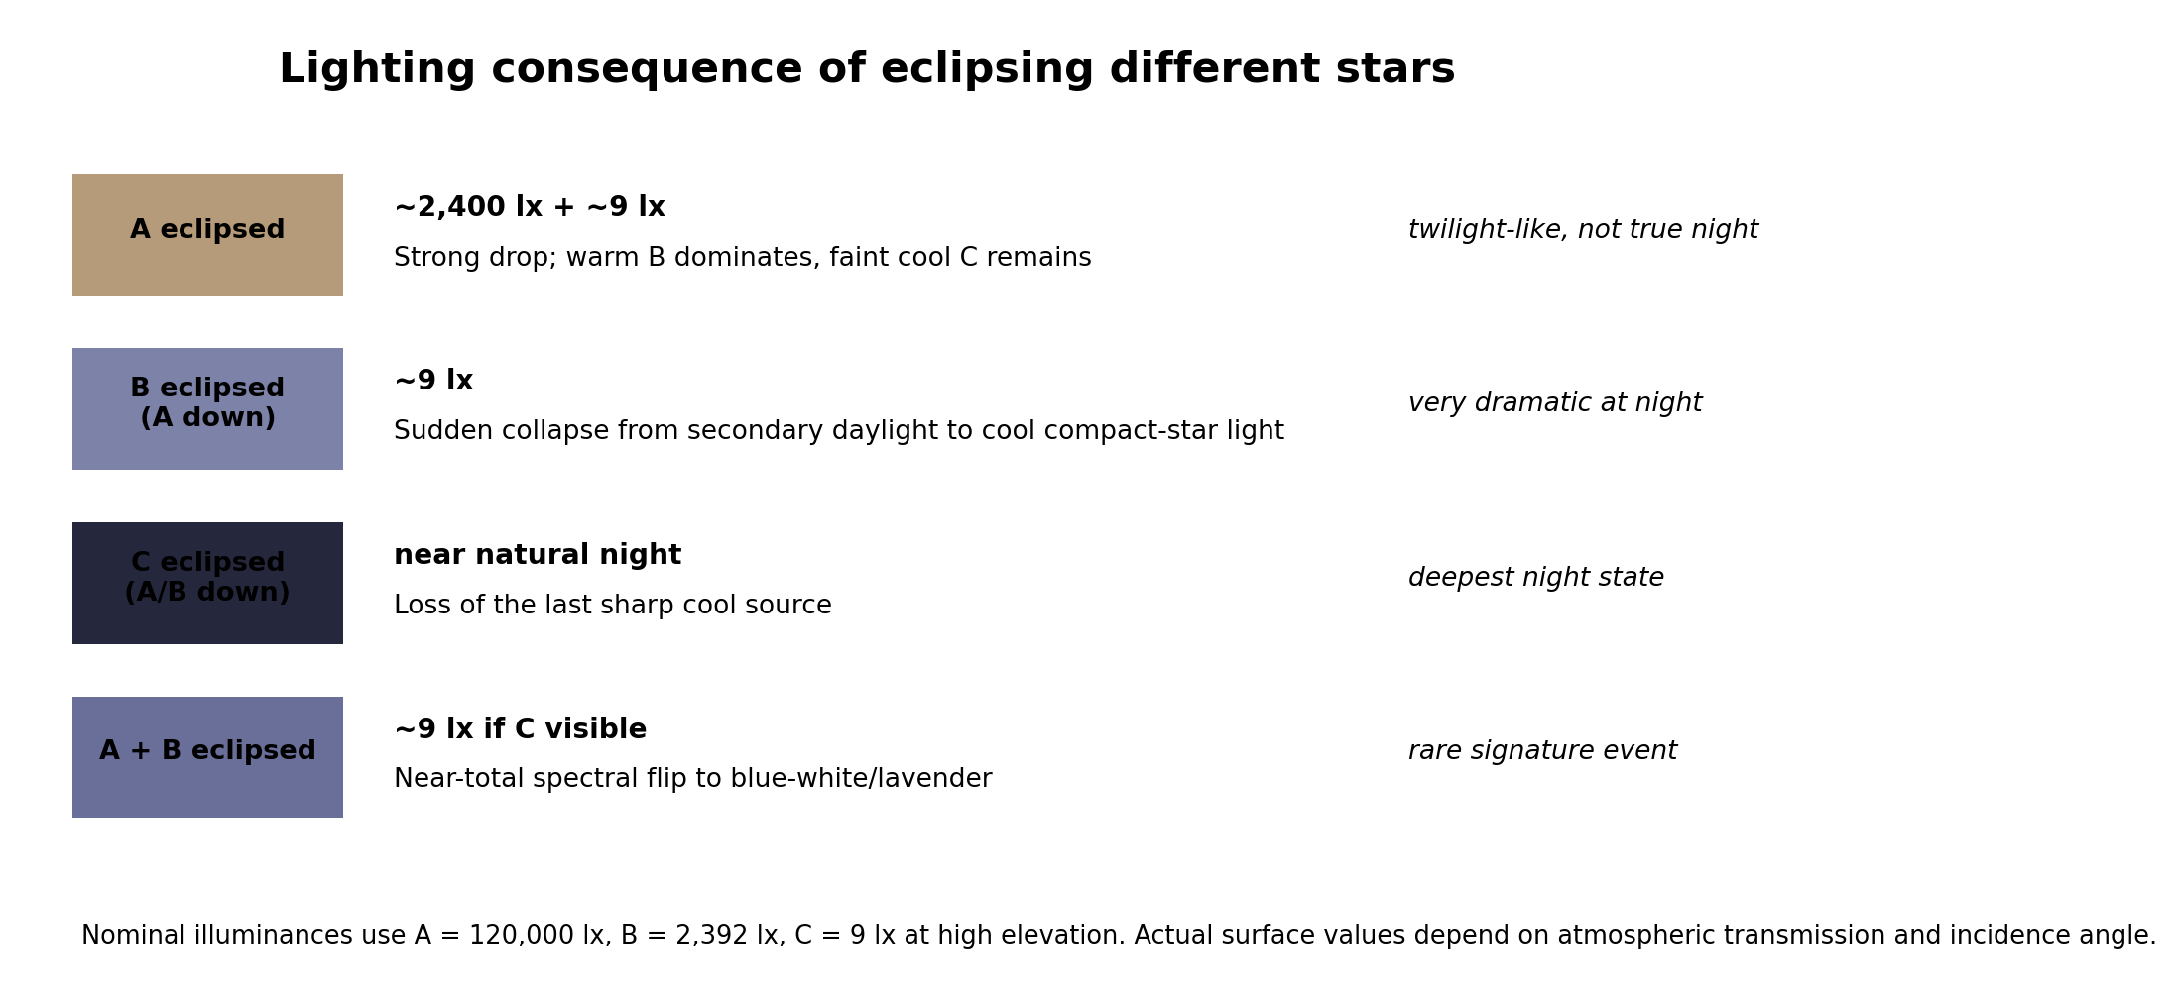
Event | Physics | Recommended visual result
Total eclipse of A; B and C above horizon | A direct beam disappears. Illumination falls from ~120,000 lx to roughly 2,400 lx + 9 lx before atmospheric effects: about a 5.6-stop reduction in direct-source level. | World remains brightly readable, but the color hierarchy flips: creamy B becomes key, C becomes cool accent. Keep A corona and a 360° sunset-like horizon ring. This is not midnight.
Total eclipse of A; B below horizon; C above | Primary vanishes and only ~9 lx C remains directly. | Very sudden blue-white/lavender twilight. Primary corona can coexist with a cool cast from C and warm residual horizons from A’s uneclipsed atmosphere outside the umbral footprint.
Moon occults B while A is down | B disappears; C remains. | One of the most dramatic repeatable events: secondary daylight collapses to C-only twilight/night. Because B’s apparent disk is much smaller than A’s, a Moon-like satellite can cover it completely for much longer than ordinary solar totality.
Moon occults C while A and B are down | C disappears. | True-dark-night transition. Excellent for stealth/gameplay beats because the source is tiny and the shadow loss is abrupt.
Partial or annular A eclipse | Some A disk remains visible. | Reduce A according to visible photospheric area, but do not simply dim the whole sky uniformly. Penumbral ground lighting, sky scattering and glare change nonlinearly.
Mutual B-C eclipse / occultation | One companion passes in front of the other in their ~105-day binary orbit, if orbital inclination is favorable. | Usually subtle during A-day. At night it can be a clear, periodic change in brightness and color; useful as a predictable calendar event.
Double / triple conjunction | Two or three stellar disks approach the same direction in the sky. | Atmospheric halos and glare overlap; shadow directions converge. A true simultaneous occultation requires extremely precise alignment and should be rare.
Lunar eclipse of the planet’s moon | The planet blocks one star’s rays to the moon. | Unlike Earth, the moon may remain illuminated by the other stars. An “A-lunar eclipse” can leave the moon cream-lit by B and faintly cool-lit by C instead of turning uniformly red/dark.

7.1 Eclipse contact details worth rendering
- A eclipse: preserve Baily’s-bead / diamond-ring style behavior only if the moon has rough limb topography and A is nearly fully covered. During totality, render A’s corona as a separate, far dimmer emissive phenomenon rather than as ordinary directional light.
- Horizon: keep warm light around directions that are still outside the moving umbral footprint. NASA’s “360-degree sunset” description is a useful Earth analogue. [10]
- Exposure: do not instantly auto-expose to maintain constant scene brightness. A short adaptation lag is part of the perceptual drama; otherwise the eclipse reads as a hue swap rather than a collapse in illumination.
- Shadow structure: as A becomes a crescent, its effective source shape becomes asymmetric. A high-end implementation can morph the penumbra rather than merely reducing intensity.

8. Weather, terrain and materials

Clouds
Clouds turn directional starlight into diffuse skylight and weaken or erase multiple shadows. Their color should be the weighted spectral mix of whichever stars illuminate their sunward faces; a low A can paint orange cloud bottoms while a high C leaves cool upper rims.

Fog and aerosols
More Mie scattering increases bright forward halos and washes out sky saturation. It also makes each visible stellar disk a strong local volumetric feature. This is a better way to make C feel “mystical” than saturating the entire sky purple.

Snow / pale sand
High-albedo ground increases bounce light, reducing shadow saturation and making the sky-ground color coupling stronger.

Water / metals
Specular materials are where the secondary stars remain legible even when their diffuse contribution is small. Preserve independent specular highlights for A, B and C.

Vegetation / skin
Under normal A-day, keep familiar coloration. During B-only and C-only states, expect strong color adaptation and unusual but coherent color rendering; avoid correcting everything back to neutral with a single aggressive white-balance LUT.

9. Required visual test shots
1. Clear high noon: A/B/C high. Validate that the image still reads Earth-like and B/C are not over-saturated.
2. Primary-shadow test: Place a white/gray calibrated object so A is blocked but B and C remain visible. Confirm the shadow is warmer than ordinary sky shadow and may contain a subtle cool secondary edge.
3. B-only secondary day: A below horizon, B high, C high. Confirm few-thousand-lux readability, warm direct key, blue atmosphere, sharp B shadow.
4. C-only night: A and B below horizon, C high. Confirm low-lux exposure, blue-white/lavender key and very crisp shadow.
5. A totality with B visible: Confirm ~5-6 stop source-level drop, B becoming dominant, A corona, 360° warm horizon and no accidental “midnight” look.
6. A totality with only C visible: Confirm drastic spectral and exposure shift and distinguish it clearly from normal blue hour.
7. All three near horizon: Verify each star reddens independently and no star remains neon purple at the horizon.
8. Overcast: Confirm multiple shadows disappear and cloud illumination mixes sources plausibly.
9. Specular validation: Use chrome, rough metal, water and glass to verify three independent highlights.
10. Exposure lock test: Repeat eclipse shots with fixed exposure to validate physical ratios before enabling auto exposure / adaptation.

10. Parameters developers can safely expose
These are art-directable without breaking the conceptual model, provided their physical consequences remain linked:
- Companion distances: changes intensity by inverse square and apparent angular size inversely with distance.
- Companion temperatures: changes spectral color and atmospheric scattering; hot means blue-white, not purple.
- Companion radii: changes luminosity through R²T⁴ and changes source angular diameter / shadow softness.
- Atmospheric Rayleigh density: changes blue-sky strength and color separation.
- Aerosol / Mie density and anisotropy: changes haze, halos and sunset warmth.
- Orbital inclination / phase: changes whether mutual eclipses occur and where B/C rise/set relative to A.
- Moon angular size and orbital speed: controls whether each stellar disk can be totally or annularly eclipsed and how long occultations last.
Do not expose this as one global “alienness” slider
If art direction needs a stronger alien look, increase the *relative brightness* of B or C, change their sky geometry, or change the atmosphere. A global purple grade breaks the physically motivated relationships between direct light, sky, shadows, haze, and eclipses.

11. Sources and technical references
Official/primary sources are prioritized; peer-reviewed celestial-mechanics papers are used for the stability discussion. Accessed 7 October 2026.
[1] NASA Science. Sun: Facts. https://science.nasa.gov/sun/facts/ Sun type and photospheric temperature.
[2] NASA Goddard Space Flight Center. Solar Irradiance Science. https://earth.gsfc.nasa.gov/climate/projects/solar-irradiance/science Modern total solar irradiance near 1361 W/m².
[3] NASA / ESA / STScI. Spectroscopy 101 - Types of Spectra and Spectroscopy. https://science.nasa.gov/mission/webb/science-overview/science-explainers/spectroscopy-101-types-of-spectra-and-spectroscopy/ Blackbody continuum and temperature-color relationship.
[4] European Space Agency / Gaia. What colour do they have? - Gaia DR3. https://www.cosmos.esa.int/web/gaia/dr3-what-colour-do-they-have Observed stellar colors become bluer with increasing effective temperature.
[5] CIE. Planckian locus, CIE S 017:2020 terminology. https://cie.co.at/eilvterm/17-23-059 Definition of the blackbody/Planckian chromaticity locus.
[6] NOAA NESDIS. Why Is the Sky Blue?. https://www.nesdis.noaa.gov/about/k-12-education/atmosphere/why-the-sky-blue Rayleigh scattering and sunset reddening.
[7] U.S. Naval Observatory. Rise, Set, and Twilight Definitions. https://aa.usno.navy.mil/faq/RST_defs Civil, nautical and astronomical twilight thresholds.
[8] NASA Science. Why Do Eclipses Happen?. https://science.nasa.gov/eclipses/geometry/ Umbra, penumbra, antumbra, total/partial/annular eclipse geometry.
[9] NASA/JPL. White Dwarfs: Small and Strong. https://www.jpl.nasa.gov/images/pia16886-white-dwarfs-small-and-strong/ White dwarf scale: roughly Earth-sized but stellar-mass.
[10] NASA Science. What to Expect: A Solar Eclipse Guide. https://science.nasa.gov/feature/solar-eclipse-guide/ Corona, planets/stars and 360-degree sunset-like horizon during totality.
[11] Holman & Wiegert, The Astronomical Journal (1999). Long-Term Stability of Planets in Binary Systems. https://arxiv.org/abs/astro-ph/9809315 Empirical circumstellar/circumbinary stability limits.
[12] Verrier & Evans, MNRAS 382 (2007). Planetary stability zones in hierarchical triple star systems. https://academic.oup.com/mnras/article/382/4/1432/1142027 Planet stability in hierarchical triples; binary criteria as an approximation.
[13] Epic Games. Using Physical Lighting Units in Unreal Engine. https://dev.epicgames.com/documentation/unreal-engine/using-physical-lighting-units-in-unreal-engine Directional light illuminance in lux and exposure workflow.
[14] Epic Games. Sky Atmosphere Component in Unreal Engine. https://dev.epicgames.com/documentation/en-us/unreal-engine/sky-atmosphere-component-in-unreal-engine Rayleigh/Mie scattering, Earth-like default atmosphere and physically based sky guidance.
[15] Epic Games. Sky Atmosphere Component - physically based sky lighting notes. https://dev.epicgames.com/documentation/unreal-engine/sky-atmosphere-component-in-unreal-engine Zenith Sun around 120,000 lux and ~0.545° angular diameter guidance.
[16] Epic Games. Directional Lights in Unreal Engine. https://dev.epicgames.com/documentation/unreal-engine/directional-lights-in-unreal-engine Source Angle and two Atmosphere Sun Light indices.
[17] Unity Technologies. Light.colorTemperature and LightUnit.Lux. https://docs.unity3d.com/6000.0/Documentation/ScriptReference/Light-colorTemperature.html Color-temperature workflow; Unity also defines lux for illuminance.
[18] Unity HDRP. Physically Based Sky. https://docs.unity.cn/Packages/com.unity.render-pipelines.high-definition%408.0/manual/Override-Physically-Based-Sky.html Physical sky model with Rayleigh and Mie scattering; HDRP documentation also supports celestial bodies.
[19] Godot Engine. Maintenance release: Godot 4.7.2. https://godotengine.org/article/maintenance-release-godot-4-7-2/ Stable-version reference used for this implementation section.
[20] Godot Engine 4.7 Documentation. DirectionalLight3D. https://docs.godotengine.org/en/4.7/classes/class_directionallight3d.html Directional-light behavior, -Z emission direction, sky modes and cascaded directional shadows.
[21] Godot Engine 4.7 Documentation. Light3D. https://docs.godotengine.org/en/4.7/classes/class_light3d.html Physical light units, DirectionalLight3D lux, color temperature, angular distance, PCSS renderer limits and shadow cost.
[22] Godot Engine 4.7 Documentation. ProceduralSkyMaterial. https://docs.godotengine.org/en/4.7/classes/class_proceduralskymaterial.html Lightweight sky and support for up to four DirectionalLight3D suns.
[23] Godot Engine 4.7 Documentation. PhysicalSkyMaterial. https://docs.godotengine.org/en/4.7/classes/class_physicalskymaterial.html Preetham physical sky model and its one-sun limitation.
[24] Godot Engine 4.7 Documentation. SpriteBase3D. https://docs.godotengine.org/en/4.7/classes/class_spritebase3d.html Shaded 2D sprites in a 3D environment, billboarding and alpha-cut behavior.
[25] Godot Engine 4.7 Documentation. Camera3D. https://docs.godotengine.org/en/4.7/classes/class_camera3d.html Orthographic projection and guidance for 3D games that visually resemble 2D.
[26] Godot Engine 4.7 Documentation. 3D rendering limitations. https://docs.godotengine.org/en/4.7/tutorials/3d/3d_rendering_limitations.html Transparency-sorting limits and recommendation to use alpha scissor/testing for cutout textures.
[27] Godot Engine 4.7 Documentation. GeometryInstance3D. https://docs.godotengine.org/en/4.7/classes/class_geometryinstance3d.html Shadow-casting modes including SHADOW_CASTING_SETTING_SHADOWS_ONLY for proxy geometry.
[28] Godot Engine 4.7 Documentation. Environment and post-processing; CameraAttributesPractical. https://docs.godotengine.org/en/4.7/tutorials/3d/environment_and_post_processing.html and https://docs.godotengine.org/en/4.7/classes/class_cameraattributespractical.html World environment, tonemapping and Forward+-only auto exposure.
[29] Godot Engine 4.7 Documentation. Spatial shaders. https://docs.godotengine.org/en/4.7/tutorials/shaders/shader_reference/spatial_shader.html Spatial lighting hooks, normal mapping, alpha pipeline and transparent-material shadow limitations.
Scientific status of this document
The radiative and atmospheric rules are standard physics; the numerical reference system is a deliberately chosen plausible configuration for art/engineering. A final production canon should be validated with an N-body orbital simulation and, if climate matters, a stellar-spectrum + atmospheric climate model. The document intentionally labels the only major nonphysical element - saturated “purple” - as an optional art-direction tint.

