Challenge 4

Abdulmalik oladipupo

2025-02-27

Table of Contents

[Manuscript](https://doi.org/10.1094/PDIS-06-21-1253-RE)

## Load required packages

library (tidyverse)

## ── Attaching core tidyverse packages ──────────────────────── tidyverse 2.0.0 ──  
## ✔ dplyr 1.1.4 ✔ readr 2.1.5  
## ✔ forcats 1.0.0 ✔ stringr 1.5.1  
## ✔ ggplot2 3.5.1 ✔ tibble 3.2.1  
## ✔ lubridate 1.9.4 ✔ tidyr 1.3.1  
## ✔ purrr 1.0.4   
## ── Conflicts ────────────────────────────────────────── tidyverse_conflicts() ──  
## ✖ dplyr::filter() masks stats::filter()  
## ✖ dplyr::lag() masks stats::lag()  
## ℹ Use the conflicted package (<http://conflicted.r-lib.org/>) to force all conflicts to become errors

library (ggpubr)  
library (ggrepel)  
library(ggplot2)

## Setting color palet

cbbPalette <- c("#000000", "#E69F00", "#56B4E9", "#009E73", "#F0E442", "#0072B2", "#D55E00", "#CC79A7")

## Load the data in

mycotoxin.data <- read.csv("MycotoxinData.csv", na.strings = "na")   
str (mycotoxin.data)

## 'data.frame': 375 obs. of 6 variables:  
## $ Treatment : chr "Fg" "Fg" "Fg" "Fg" ...  
## $ Cultivar : chr "Wheaton" "Wheaton" "Wheaton" "Wheaton" ...  
## $ BioRep : int 2 2 2 2 2 2 2 2 2 3 ...  
## $ MassperSeed_mg: num 10.29 12.8 2.85 6.5 10.18 ...  
## $ DON : num 107.3 32.6 416 211.9 124 ...  
## $ X15ADON : num 3 0.85 3.5 3.1 4.8 3.3 6.9 2.9 2.1 0.71 ...

## Make cultivar and treatment a factor

mycotoxin.data$Cultivar <- as.factor(mycotoxin.data$Cultivar)   
mycotoxin.data$Treatment <- as.factor(mycotoxin.data$Treatment)

## Plot DON against treatment

don.treatment.1 <- ggplot (mycotoxin.data, aes(x = Treatment, y = DON, fill = Cultivar)) +  
 geom_boxplot(position = "dodge") +  
 #geom_point(position = position_jitterdodge(0.6)) +  
 geom_jitter(pch = 21, position = position_jitterdodge(), color = "black") +  
 xlab("") +  
 ylab("DON(ppm)") +  
 scale_fill_manual(values = c(cbbPalette[[3]], cbbPalette[[4]])) +  
 theme_classic() +   
 facet_wrap(~Cultivar, scales = "free")  
don.treatment.1

## Warning: Removed 8 rows containing non-finite outside the scale range  
## (`stat_boxplot()`).

## Warning: Removed 8 rows containing missing values or values outside the scale range  
## (`geom_point()`).

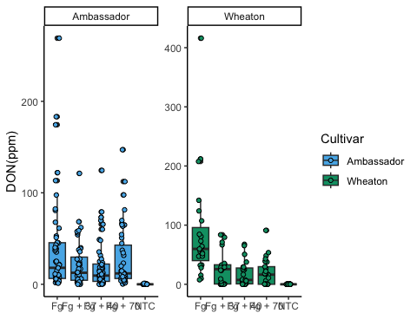

## Change the factor order level so that the treatment

mycotoxin.data$Treatment <- factor(mycotoxin.data$Treatment, levels = c ("NTC", "Fg", "Fg + 37", "Fg + 40", "Fg + 70"))

## Plot X15ADON against treatment

don.treatment.2 <- ggplot (mycotoxin.data, aes(x = Treatment, y = X15ADON, fill = Cultivar)) +  
 geom_boxplot(position = "dodge") +  
 #geom_point(position = position_jitterdodge(0.6)) +  
 geom_jitter(pch = 21, position = position_jitterdodge(), color = "black") +  
 xlab("") +  
 ylab("15ADON") +  
 scale_fill_manual(values = c(cbbPalette[[3]], cbbPalette[[4]])) +  
 theme_classic() +   
 facet_wrap(~Cultivar, scales = "free")  
don.treatment.2

## Warning: Removed 10 rows containing non-finite outside the scale range  
## (`stat_boxplot()`).

## Warning: Removed 10 rows containing missing values or values outside the scale range  
## (`geom_point()`).

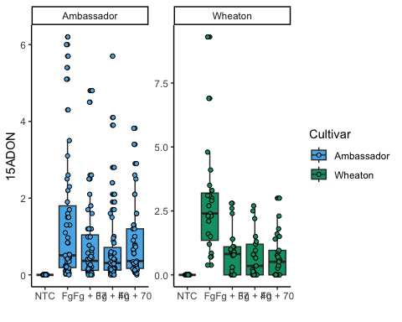

## Plot Massperseed against treatment

don.treatment.3 <- ggplot (mycotoxin.data, aes(x = Treatment, y = MassperSeed_mg, fill = Cultivar)) +  
 geom_boxplot(position = "dodge") +  
 #geom_point(position = position_jitterdodge(0.6)) +  
 geom_jitter(pch = 21, position = position_jitterdodge(), color = "black") +  
 xlab("") +  
 ylab("Seed Mass (mg)") +  
 scale_fill_manual(values = c(cbbPalette[[3]], cbbPalette[[4]])) +  
 theme_classic() +   
 facet_wrap(~Cultivar, scales = "free")  
don.treatment.3

## Warning: Removed 2 rows containing non-finite outside the scale range  
## (`stat_boxplot()`).

## Warning: Removed 2 rows containing missing values or values outside the scale range  
## (`geom_point()`).

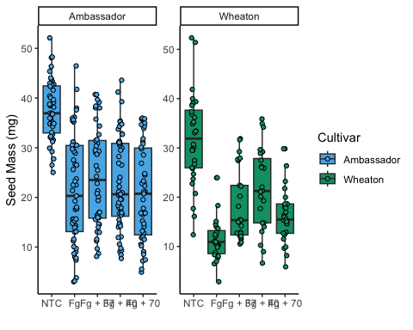

## Perfrom a t-test comparison of treatments

Plot1 <- don.treatment.1 +   
 geom_pwc(aes(group = Treatment), method = "t_test", label = "p.adj.format")  
  
Plot2 <- don.treatment.2 +   
 geom_pwc(aes(group = Treatment), method = "t_test", label = "p.adj.format")  
  
Plot3 <- don.treatment.3 +   
 geom_pwc(aes(group = Treatment), method = "t_test", label = "p.adj.format")

## Stick many the three figures together for a publication ready figure

Figure_2 <- ggarrange(  
 Plot1,   
 Plot2,  
 Plot3,  
 nrow = 1,  
 ncol = 3,  
 labels = "auto",  
 common.legend = TRUE  
)

## Warning: Removed 8 rows containing non-finite outside the scale range  
## (`stat_boxplot()`).

## Warning: Removed 8 rows containing non-finite outside the scale range  
## (`stat_pwc()`).

## Warning: Removed 8 rows containing missing values or values outside the scale range  
## (`geom_point()`).

## Warning: Removed 8 rows containing non-finite outside the scale range  
## (`stat_boxplot()`).

## Warning: Removed 8 rows containing non-finite outside the scale range  
## (`stat_pwc()`).

## Warning: Removed 8 rows containing missing values or values outside the scale range  
## (`geom_point()`).

## Warning: Removed 10 rows containing non-finite outside the scale range  
## (`stat_boxplot()`).

## Warning: Removed 10 rows containing non-finite outside the scale range  
## (`stat_pwc()`).

## Warning: Removed 10 rows containing missing values or values outside the scale range  
## (`geom_point()`).

## Warning: Removed 2 rows containing non-finite outside the scale range  
## (`stat_boxplot()`).

## Warning: Removed 2 rows containing non-finite outside the scale range  
## (`stat_pwc()`).

## Warning: Removed 2 rows containing missing values or values outside the scale range  
## (`geom_point()`).

Figure_2

