QUESTIONS

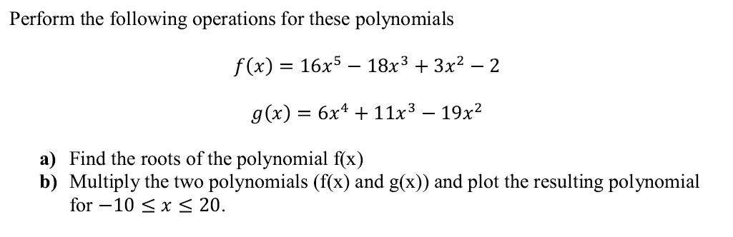 **1)**

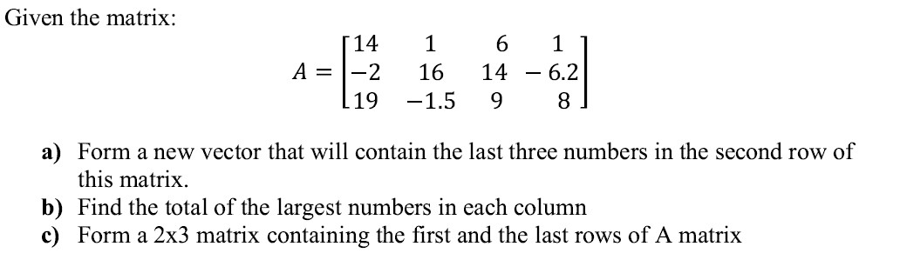**3)**

1. The acceleration due to the Earth’s gravity at any height h above the surface of the Earth is given by the equation

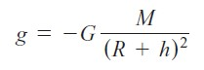

where G is the gravitational constant (6.672 × 10-11 N m2 / kg2), M is the mass of the earth (5.98 × 1024 kg), R is the mean radius of the Earth (6371 km), and h is the height above the Earth’s surface. If M is measured in kg and R and h in meters, then the resulting acceleration will be in units of meters per second squared. Write a program to calculate the acceleration due to the Earth’s gravity in 500 km increments at heights from 0 km to 40,000 km above the surface of the Earth. Also, plot the acceleration versus height by using Matlab.

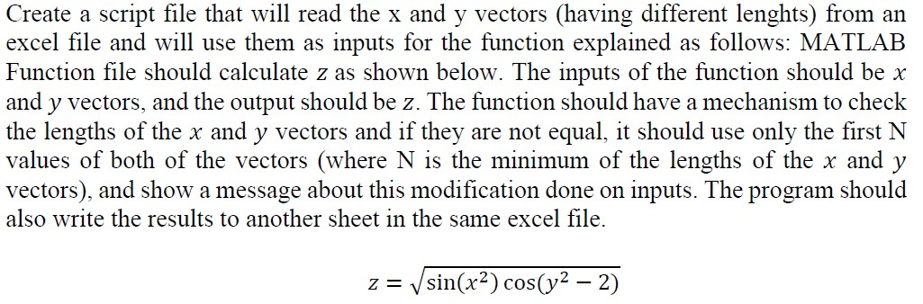**7)**

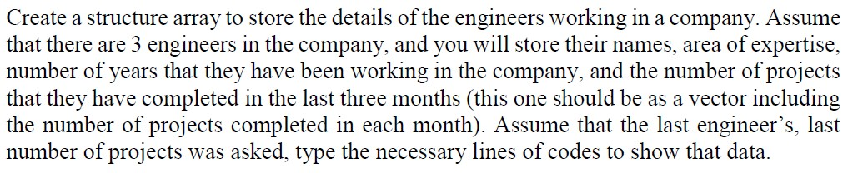**9)**