TASK 1: ArcGIS Online Web Mapping: Link here🡪 [Create a policy map to address health conditions | Documentation](https://learn.arcgis.com/en/projects/get-started-with-map-viewer/arcgis-online/index.html). See below for screengrabs of my various web maps at specific key points in the ESRI tutorial. I used the final Alabama web map to create by web application:

WEB APP: <https://tamu.maps.arcgis.com/apps/instant/media/index.html?appid=56cebde693354a158fa5078e19d76b67>

WEB MAPS: <https://tamu.maps.arcgis.com/apps/mapviewer/index.html?webmap=7984a2deb4c244dba7bbb86c86136de7>

<https://tamu.maps.arcgis.com/apps/mapviewer/index.html?webmap=1a28e6655ebd447c808a69fa4222499d>

<https://tamu.maps.arcgis.com/apps/mapviewer/index.html?webmap=a58aad482cd6451db7cff8188c73cadb>

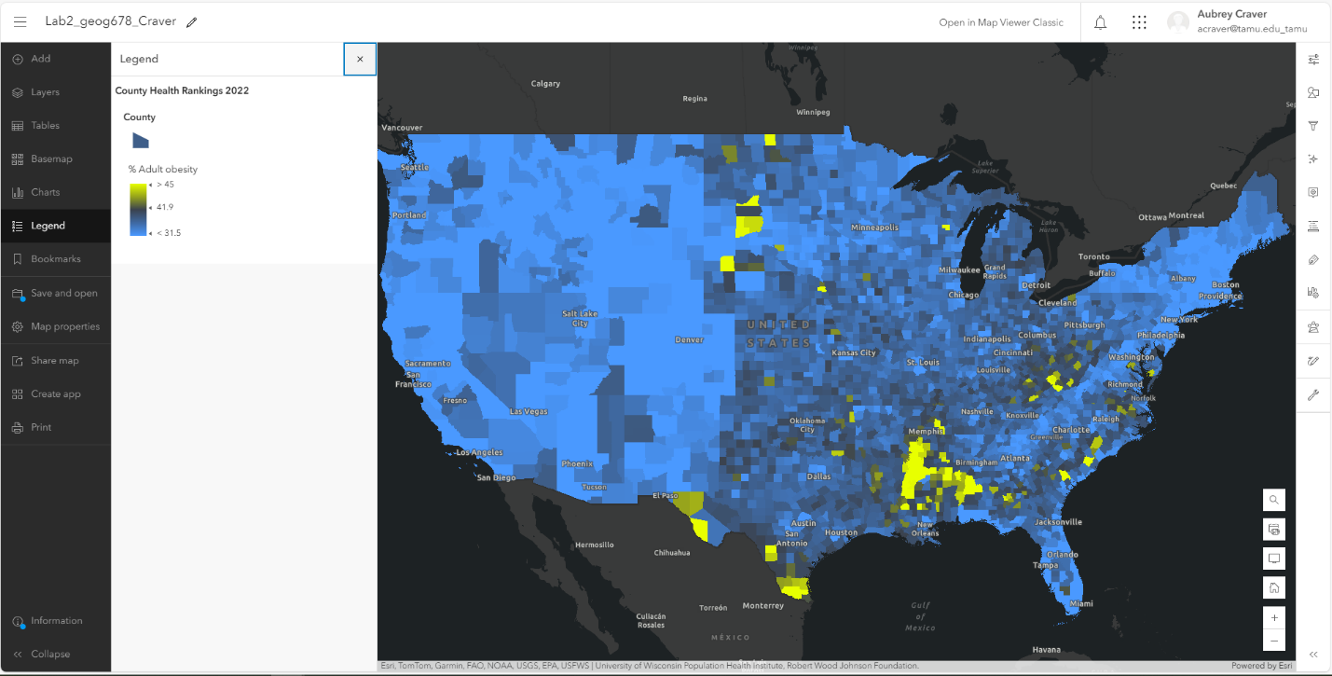

TASK 2: Collector for ArcGIS: Parks_AEC Feature Layer created

<https://www.esri.com/arcgis-blog/products/collector/field-mobility/make-your-first-collector-map/>

