**GRANT NARRATIVE FORMAT**

1. S&PF PROGRAM – Forest Health Protection

2. STATE AGENCY NAME – University of Guam, College of Applied and Natural Science

3. PROJECT COORDINATOR(S) –

Glenn Dulla, Ph.D.

Research Affiliate, University of Guam

Invasive Species Coordinator, Guam Department of Agriculture

USDA Plant Inspection Station

17-3306 Neptune Ave.

Barrigada, Guam 96913

(671) 486-6205

[Glenn.dulla@doag.guam.gov](mailto:Glenn.dulla@doag.guam.gov)

Cathleen Moore-Linn

Research Corporation of the University of Guam

UOG Dean Circle, House #33

Mangilao, GU 96923

(671)735-0336

[Cmoore@triton.uog.edu](mailto:Cmoore@triton.uog.edu)

4. STATEMENT OF NEED/PURPOSE –

Little fire ant (LFA), *Wasmannia auropunctata*, was detected in November 2011

in Yigo, a northern village of Guam, at the side of a green waste repository. Subsequent LFA surveys throughout Guam found it to be established at over 35 widely dispersed sites. Previous LFA infestations in the Pacific Basin include those of the five major islands of Hawaii, New Caledonia, French Polynesia and Northern Queensland, Australia. The devastating effects of LFA on agriculture and forest ecosystems observed in these other Pacific jurisdictions are being repeated on Guam and may potentially occur on other Micronesian islands that are LFA-free. LFA’s spread into and throughout Guam is due to human transport of plant related material.

The Guam Invasive Species Management Plan identifies LFA as a Priority Invasive Species (p.15) and recommendations “to seek grants and other mechanisms to provide the LFA working group with the needed tools and resources to continue control efforts and subsequently the eventual eradication of the LFA from Guam” (p.35). Additionally, the Regional Biosecurity Plan for Micronesia and Hawaii (Attachment L, Guam, p.L-12) recommends to “Improve Post Border Biosecurity” through the high priority action item to “Determine the extent of Little Fire Ant infestation and then to manage and/or eradicate this species”.

The Forestry Division of Guam Department of Agriculture (GDOAG) maintains a 70-acre conservation acacia forest in Santa Rita, a southern village of Guam. The Cotal Conservation Forest is a long-term reforestation project to return nutrients to the soil, replace acacia trees with native flora such as the endangered *Seriianthese nelsonii* and ultimately reintroduce native fauna such as the endangered Guam Rail. The forest is directly bordered on the west by residential homes. Further southwest is Department of Defense (DoD) land on which the US Naval Base Guam Munitions site is situated. LFA was identified in the residential neighborhood in 2015 and subsequent surveys by the University of Guam (UOG) showed rampant spread throughout the area. The Center for Environmental Management of Military Lands also conducted surveys in 2017 to delineate LFA infestation at the Naval Base Guam Munitions site. LFA were found at 22 sites along the northeast border of the munitions site. A preliminary survey by the DOAG-Biosecurity division in 2017 identified LFA at 33 points along walking trails throughout the forest and along the residential border. Although unconfirmed, LFA infestation is believed to have originated in the residential area from contaminated backfill soil. UOG personnel, lead Dr. Ross Miller, began survey and treatment in 6/2018 and ended in 2/2019 after depletion of funds, Figure 1. DOAG resumed treatment of ~25-acre infestation in 6/2019 as funds and personnel were made available. Survey results from 2/2020 (Figure 2) show significant progress towards eradication, yet a substantial amount of area still infested despite approximately two years of treatment.

This project proposes to continue LFA eradication efforts in the conservation forest and establish and maintain a perimeter/buffer zone to prevent further infestation from surrounding areas. Currently, an ongoing joint effort by DOAG (funded by Department of the Interior) and UOG (funded by DoD) is working to eradicate LFA in the forest. Techniques developed by the University of Hawaii-Hilo Ant Lab, that have proven effective on Hawaii, are transferrable to Guam. We utilize these methods and adapted them for aerial drone use. Application drones allow for faster and safer treatment of technically challenging areas such the forest canopy or dense impassable jungle. Significant resources have been invested in reclamation of this forest and LFA infestation compromises future restoration work. If successful, the eradication will also reduce the threat of DoD land infestation posed by LFA in the neighboring forest.

This project addresses Guam State-Wide Assessment and Resource Strategy (SWARS), Strategy 2: Protect, Conserve and Restore Forests On State, Private, And Other Nonmilitary Lands (p.103). The eradication of LFA will increase forest resiliency and conservation can be achieved by “reduce(ing) stressors to existing forest through enhancement of current stands” (p.108)

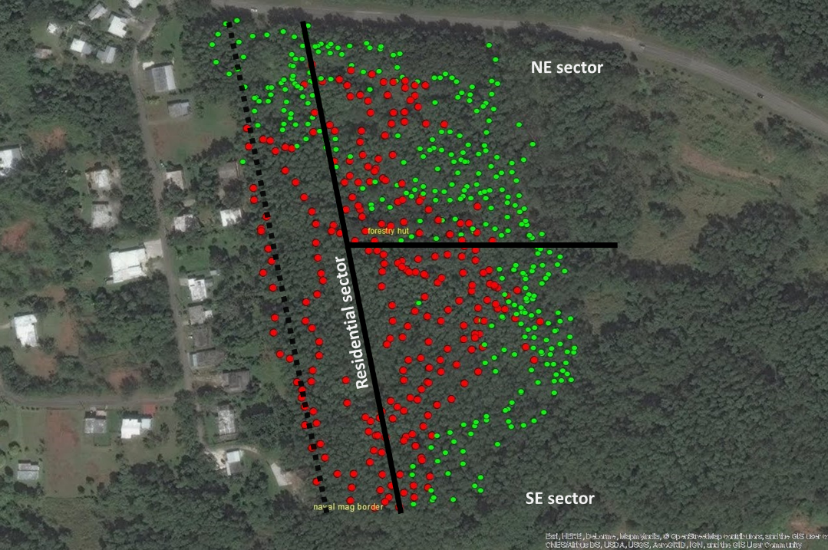

Figure 1. Initial delineation of LFA in the Cotal Conservation Forest section south of Cross Island Rd. on 6/2018. Red dots denote presence of LFA and green dots denote no LFA. Broken line represents buffer area proposed in objective 2. Data collected by UOG, edited by G.Dulla.

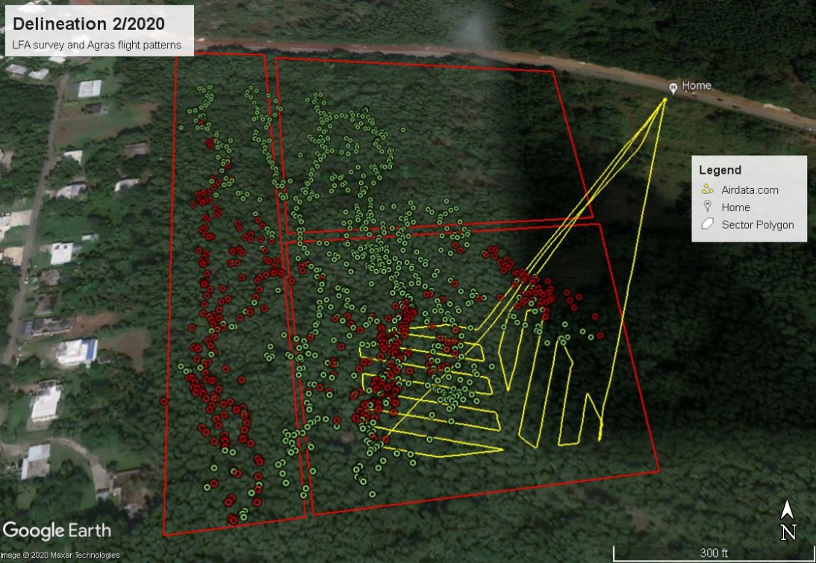

Figure 1. Delineation of LFA in the Cotal Conservation Forest section south of Cross Island Rd. on 2/2020. Red dots denote presence of LFA and green dots denote no LFA. Yellow lines are examples of aerial treatment patterns utilizing drone dispersal. Data collected by DOAG.

5. GOALS –

The project’s overall goal is to eradicate LFA from the 70-acre conservation forest in Santa Rita, Guam and develop the capacity within DOAG to treat LFA on a large scale with limited personnel. This is an ongoing project to eradicate LFA from the Cotal conservation forest with working objectives to clear all LFA in the forest and prevent re-infestation through a monitored buffer and/or eradicate LFA from the adjoining residences. It is anticipated that the Biosecurity and Forestry Divisions will maintain these after the end of the funding period.

6. OBJECTIVES –

The following objectives address Guam SWARS, Strategy 2: Protect, Conserve and Restore Forests On State, Private, And Other Nonmilitary Lands (p.103). The eradication of LFA will increase forest resiliency (p.108) and conservation can be achieved by “reduce(ing) stressors to existing forest through enhancement of current stands.”

1. Eradication of LFA from forest

2. Establish buffer zone around forest to prevent re-infestation

3. Provide training workshops and direct assistance for neighboring residents on LFA recognition, prevention of infestations, and treatment of LFA.

-This objective addresses the “Next Step and action: Identify a short list of likely landowners that would be willing to participate in a forest protection program”. (Guam SWARS, p.111)

7. SPECIFIC ACTIVITIES –

1. Eradication of LFA from forest

Eradication of LFA from the forest requires a combination of surveying and pesticide treatment. Current routines will be maintained for the extension of this management project which includes monthly surveillance of targeted infested areas and quarterly surveillance of the ~25-acre portion of forest initially delineated and infested with LFA. Manual treatment with Tango (liquid pesticide-bait mixture@ up to 4-gallons/acre) and Siesta/Probait (granular pesticide@ 1.5lb/acre) is focused on the 6.5-acre section bordering the residential homes. Drone pesticide dispersal (granules @1.5lbs/acre: Amdro, MaxForce, Advion, Extinguish/ liquid: Tango) is utilized on the southeastern 7.2-acre sector where terrain make treatment difficult and dangerous. Treatment of the 7.9-acre northeast sector will cease on 7/2020 but continued surveying will occur quarterly.

- Progress will be measured in the reduction of LFA infested survey points or area throughout the project period.

2. Establish buffer zone around forest to prevent re-infestation

The border between the forest and the residential neighborhood is currently heavily infested with LFA. Treatment is ongoing with slow but significant progress. Once this 6.5-acre area is cleared of LFA, regular monthly surveying will continue along a 380m long by 5m wide path along the border. Treatment will be done as needed.

- Progress will be measured in the reduction of LFA infested survey points or area throughout the project period and regularity of monitoring along buffer.

3. Provide training workshops and direct assistance for neighboring residents on LFA recognition, prevention of infestations, and treatment of LFA.

To treat the root cause of the LFA infestation and potentially eliminate the perpetual need to survey and treat the buffer zone, this project proposes the teach the residents how to treat LFA on their property. Previous work has developed a residential workshop for LFA detection and treatment. There are 16 homes along the forest border and other willing residents will be offered the workshop. DOAG will provide treatment supplies, manage treatment schedules and regularly follow-up with resident households to ensure completion. Surveys will be completed by DOAG personnel.

- Success will be measured in the reduction of positive LFA survey points or area throughout the project period and regularity of resident treatment.

All activities above will be led by Ashley Toves, the current Research Associate I/field supervisor. Treatment, surveys and outreach are performed by the project coordinator, field supervisor and one or two field technicians. Grant administration and funds management will be managed by the Research Corporation of the University of Guam (RCUOG). RCUOG policies align with CRF 200 procurement services regarding micro purchase, small purchase, and competitive bidding thresholds.

8. KEY PERSONNEL –

Ashley Toves, Research Associate I, hired 6/2019.

- B.S. in Biology, Guam EPA Core pesticide certification and FAA small UAS Remote Pilot Certificate

- Current duties include fieldwork (treatment and surveys) supervision, data management, supplies procurement, human resources, website editing and drone operation.

Trevor Boykin, Research Assistant III, hired 11/2019.

- College coursework in Life Sciences, Guam EPA Core pesticide certification

- Current duties include fieldwork (treatment and surveys), outreach and education, and drone operation under supervision of licensed pilots.

9. RESPONSIBILITIES – No special responsibilities are required of the Forest Service or others.

10. MONITORING & EVALUATION –

The project coordinator is responsible for monitoring and reporting project activity. Daily activity progress will be tracked in weekly activity reports by paid employees and reviewed by project coordinator. Quarterly survey results will be mapped and the reduction of LFA positive points and infested area will be quantified. Bi-annual reports, including objective progress narratives and standard federal financial forms, will be provided to USDA-FS 30 days after reporting period.

Consultation and project review by DOAG-Forestry and USDA-FS will determine if goals and Guam SWARS #2 is adequately addressed.

11. BUDGET –

**PROGRAM:**

| **Budget Items by**  **SF 424A Object Class Categories** | **Federal**  **$** | **State Match**  **$** | **Other Match**  **$** | **Source of**  **“Other Match”** |
| --- | --- | --- | --- | --- |
| **a. Personnel** |  |  |  |  |
| *Research Associate I, fulltime @$20.34/hour, 2080hrs* | *$42,307* | *$0* |  |  |
| *Research Assistant III, fulltime or 2x halftime @ $14.75/hour, 2080hrs* | *$30,680* | *$0* |  |  |
| **b. Fringe Benefits** |  |  |  |  |
| *Social Security and Medicare (7.65% of Salaaries)* | *$5,584* | *$0* |  |  |
| **c. Travel** |  |  |  |  |
| *none* | *$0* | *$0* |  |  |
| **d. Equipment** |  |  |  |  |
| *none* | *$0* | *$0* |  |  |
| **e. Supplies** |  |  |  |  |
| *Fuel, ~7,488miles, work truck 20MPG, $4.50/gallon* | *$1,685* | *$0* |  |  |
| *Survey Supplies; peanut butter, chopsticks, fluorescent tape/flags, ziplock bags* | *$500* | *$0* |  |  |
| *Wrist Garmin GPS units (2x $180)* | *$360* | *$0* |  |  |
| **f. Contractual** |  |  |  |  |
| *none* | *$0* | *$0* |  |  |
| **g. Construction** |  |  |  |  |
| *none* | *$0* | *$0* |  |  |
| **h. Other** |  |  |  |  |
| RCUOG Admin fee(15% of total, $81,116) | *$12,168* | *$0* |  |  |
| **i. Total Direct Charges** (sum of a-h) | $93,284 | *$0* |  |  |
| **j. Indirect Charges** | $0 | *$0* |  |  |
| **k. Totals** (i + j) | $93,284 | *$0* |  |  |
| **l. Program Income** | *$0* | *$0* |  |  |