AL/BI 345 – General Entomology – Exam 1 – October 3, 2019 Name:_________________

- Use these names to build a taxonomic hierarchy for the oriental flower beetle: Protaetia, Arthropoda, Coleoptera, Animalia, orientalis, Scarabaeidae, Insecta (7 points)

Kingdom _______________

Phylum _______________

Class _______________

Order _______________

Family _______________

Genus _______________

Species epithet _______________

- Insects, spiders, millipedes and centipedes are all arthropods. Give two characteristics of insects which can be used to differentiate them from other arthropods. (2 points)

a. _________________________________________________________________

b. _________________________________________________________________

- Which letters point to the following structures on an insect's head? (4 points)
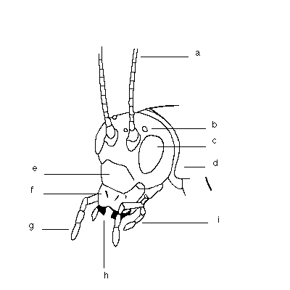
Compound eye _____

Ocellus _____

Mandible _____

Antenna _____

- Match the following terms with their definitions. (10 points)

Chrysalis
Instar
Incomplete metamorphosis
Molt
Complete metamorphosis
Larva
Pupa
Cocoon
Naiad
Ovipositor

The immature form of an aquatic insect with incomplete metamorphosis
A stage of insect larval development between molts
A butterfly pupa which is not protected by a cocoon
Insect life cycle with four major stages: egg, larva, pupa, adult
An immature insect
A silk covering which protects pupae of some insects
An egg laying tube found on the abdomen of many female insects
The life stage in which a larva transitions into an adult
Insect life cycle with three major stages: egg, larva, adult
Process of shedding exoskeleton to allow growth

- Sometimes you may see white cockroaches. How do you explain this? (1 point)

_________________________________________________________

- True or False: All adult insects have wings. (1 point)

- True or False: Insects can fly only after they have become adults? (1 point)

- True or False: Insects can fly only after becoming an adult. (1 point)

- True or False: Male bees, wasps, and ants do not sting. (1 point)

- More advanced orders of insects undergo complete metamorphosis. What advantage is gained from using this type of life style? (2 points)

- Musca sorbens is the scientific name for the dog dung fly. (2 points)
  - What genus does the dog dung fly belong to? __________________________________
  - What is species does the dog dung fly belong to? _______________________________

- Which of the following demonstrates incorrect formatting of a scientific name? (4 points)

  - Musca sorbens (correct / incorrect)

  - Musca sorbens (correct / incorrect)

  - Musca sorbens (correct / incorrect)

  - Musca Sorbens (correct / incorrect)

- True or False: Many species of insects collected in the Mariana Islands have been found nowhere else in the world. (1 point)

14. A lot of insects have evolved coloration which camouflages them in their normal habitat. Some insects enhance this protection by behaving in particular ways. Explain: (1 point)

15. True or False: Coleoptera is the insect order which contains the largest number of species. (1 point)

16. The insect order with only one pair of wings are called (1 point):
- Dermaptera or the earwigs
- Lepidoptera or butterflies and moths
- Diptera or the flies
- Psocoptera or psocids

17. Insects with complete metamorphosis have (1 point):
- Four life stages (egg, imago, pupa and adult)
- Three life stages (egg, nymph and adult)
- Two life stages (egg and adult)
- Four life stages (egg, larva, pupa and adult)

18.Most insects molt (1 point):
- All answers listed are correct
- To grow a new appendage
- As adults and immatures
- 4-8 times in their life

19. The three main body regions of an insect are (1 point):
- head, thorax and abdomen
- head, prothorax and abdomen
- head, midgut and abdomen
- head, thorax and tail

20. Bed bugs belong to the order (1 point):
- Pthiraptera
- Hemiptera
- Orthoptera
- Siphonaptera

21. All insects and arthropods have (1 point):
- Two antennae
- Three pairs of legs
- Jointed appendages
- Eight segments

22. Arachnids have (1 point):
- Eight pairs of legs and two main body regions
- Eight pairs of legs and three main body regions
- At least 5 pairs of legs
- Sponging mouth parts

23. Most adult insects have (1 point):
- All answers listed are correct
- Three pairs of legs
- Two pairs of wings
- Three main body regions

Name __________________________________________

24. Classify each specimen in the box to taxonomic order. Hint: You will need to use a microscope to correctly identify some of these specimens. (1 point will be awarded for each specimen correctly classified with a correctly spelled scientific name for the taxonomic order it belongs to.)

1. ___________________________________________

2. ___________________________________________

3. ___________________________________________

4. ___________________________________________

5. ___________________________________________

6. ___________________________________________

7. ___________________________________________

8. ___________________________________________

9. ___________________________________________

10. __________________________________________

