AG345 – General Entomology – F2015

First Detector Training
We have studied the massive impact that invasive species are having on Guam's agriculture and natural ecosystems. By completing the First Detector training, you will be certified and will be added to a national registry of First Detectors managed by the NPDN. You will receive email newsletters which will keep you up to date on what critters and plant diseases are a threat to Guam.
Your assignment is to complete the six online modules of the First Detector Training course. The first step is to go to https://firstdetector.org/UserServlet?act=login to sign up by clicking on the New Account button. Once you have a user name and password, you can run through each module and take a short quiz for each one. You will need correct answers to at least 7 out of 10 questions in each quiz. The quizzes can be repeated as needed. When you have passed all 6 quizzes, click on Certificates at the top of the page, and show me a copy of it on or before the last day of class so that I can give you credit (5% of course grade) for this assignment.
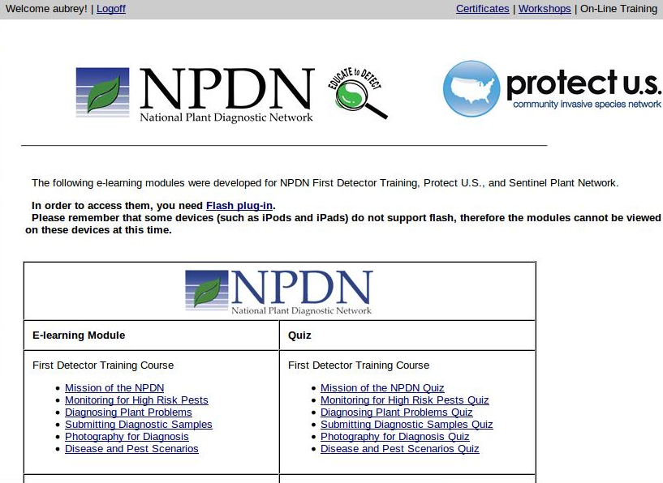
If you have any problems, email me at aubreymoore@guam.net.
