The Coconut Rhinoceros Beetle Problem on Guam: Past, Present and Future

Aubrey Moore

@path/home/aubrey/Desktop/CRB_Past_Present_Future/

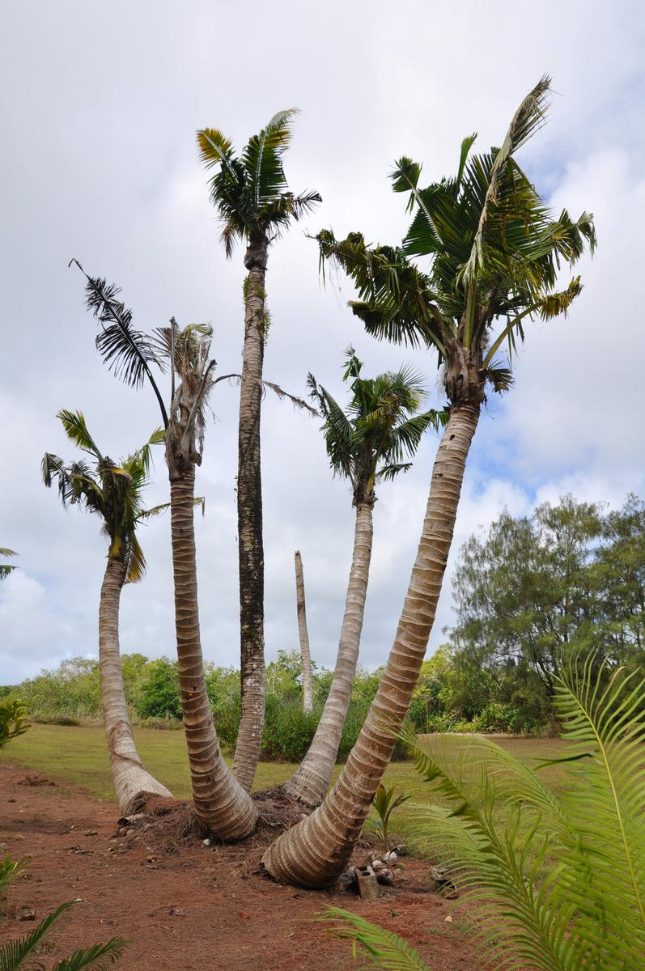

[fig:CRB-damage]Coconut palms at the University of Guam Agricultural Experiment Station in Yigo severely damaged by coconut rhinoceros beetle.

**Guam’s ecosystems are under attack by invasive species.** Many people know about extinction of Guam’s birds by the brown treesnake which invaded the island shortly after WWII. But the contemporary ecological disaster which is currently happening in Guam’s forests is not well known: the trees are dying.

It is estimated that 90% of Guam’s endemic cycads, locally known as *fadang*, have been killed by a coalition of recently-arrived invasive insects which includes a scale insect, a leaf-mining moth, and a defoliating butterfly. Fadang was listed as being the most abundant tree in Guam’s forests in a 2002 forestry survey This plant was added to the National Endangered Species List in 2015 .

The same 2002 forestry survey listed coconut palm as the second most abundant tree on Guam. During recent years, many coconuts and other palms on Guam have been severely damaged and killed by the coconut rhinoceros beetle (CRB). There is no estimate for the proportion of palms killed but it is obvious to residents and visitors that the island’s palms are being killed at an alarming rate.

In this article I present a short history of the CRB problem on Guam and I recommend a strategy to stop the outbreak which is damaging and killing our palms.

# CRB Biology and Invasion History

CRB is a large scarab beetle native to southeast Asia. Like all beetles, CRB has four life stages: egg, grub, pupa, and adult (Figure [fig:CRB-life-cycle]). Only the adult stage causes damage. Grubs feed only on decaying vegetation and do no harm. Adult males and females bore into the crowns of coconut palms and other palms to feed on sap. They do not feed on leaves, but they bore holes through developing leaves on their way to the white tissue at the interior of the crown. When these damaged leaves eventually emerge from the crown, they have v-shaped cuts in them, a distinctive sign of CRB damage (Figure [fig:CRB-damage]). Each adult feeds on sap for only a few days. It then leaves the crown to search for a breeding site. Palms may be killed if a CRB bores through the growing tip (the meristem). Mature palms are rarely killed at low CRB population levels. However, trees are killed when they are simultaneously attacked by many adults during a population outbreak such as the one we are currently experiencing on Guam.

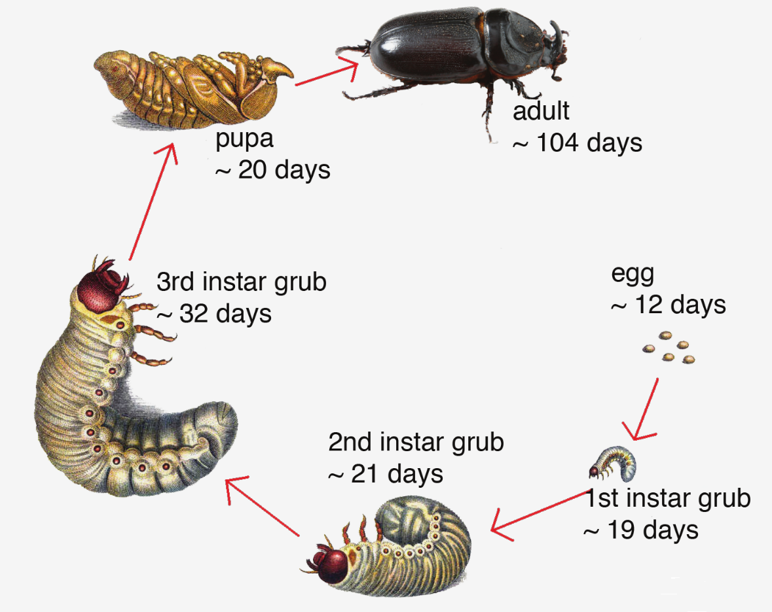

[fig:CRB-life-cycle]Coconut rhinoceros beetle life cycle.

CRB breeding sites can be found in any mass of decaying vegetation. Preferred sites are standing dead coconut stems and fallen coconut logs and fronds. But piles of anything with a high concentration of decaying vegetation can be used as a breeding site including green-waste, dead trees of any species, saw dust, and manure. CRB breeding sites have even been found in commercially bagged soil purchased from a local hardware store . An active breeding site will contain all CRB life stages. Adults locate breeding sites by sniffing out a chemical signal referred to as an aggregation pheromone. This pheromone has been synthesized and is commercially available .

A female rhino beetle lays about 100 eggs during her lifetime. Assuming a 50% sex ratio and 100% survival, there will be a population increase of 5,000% during each generation. Thus population explosions may occur when abundant potential breeding sites are available in the form of rotting vegetation following destruction in the wake of a typhoon, large scale land clearing, or war. Large numbers of CRB adults generated by a population explosion may result in large numbers of palms being killed. The dead standing trunks soon become ideal breeding sites which generate even higher numbers of adults. This positive feedback cycle will end when the rhino beetles run out of food, meaning when most of the palms have been killed and rotted away.

CRB invaded islands in the Pacific and Indian oceans during two waves of movement. The first wave occurred started in 1909 when CRB was accidentally transported to from Sri Lanka to Samoa with shipment of rubber tree seedlings and it ended during the 1970s . All of the CRB range expansion during this period was south of the equator except for the invasion of the Ryuku Islands (Japan) starting in 1921 and invasion of the Palau Islands in about 1942 . In Palau, there was a population explosion of rhino beetles because WWII activities created abundant breeding sites. This resulted in about 50% coconut palm mortality overall, and total loss of coconut palms on some of the smaller islands .

The second wave of CRB invasions started in 2007 with discovery of CRB on Guam, followed by invasion of Oahu (Hawaii), Port Morseby (Papua New Guinea), Guadalcanal, Savo and Malaita (Solomon Islands), and Rota (Commonwealth of the Northern Mariana Islands). Beetles in the second wave of invasions are genetically different from those in the first wave and these are being referred to as the “Guam biotype” or CRB-G for short.

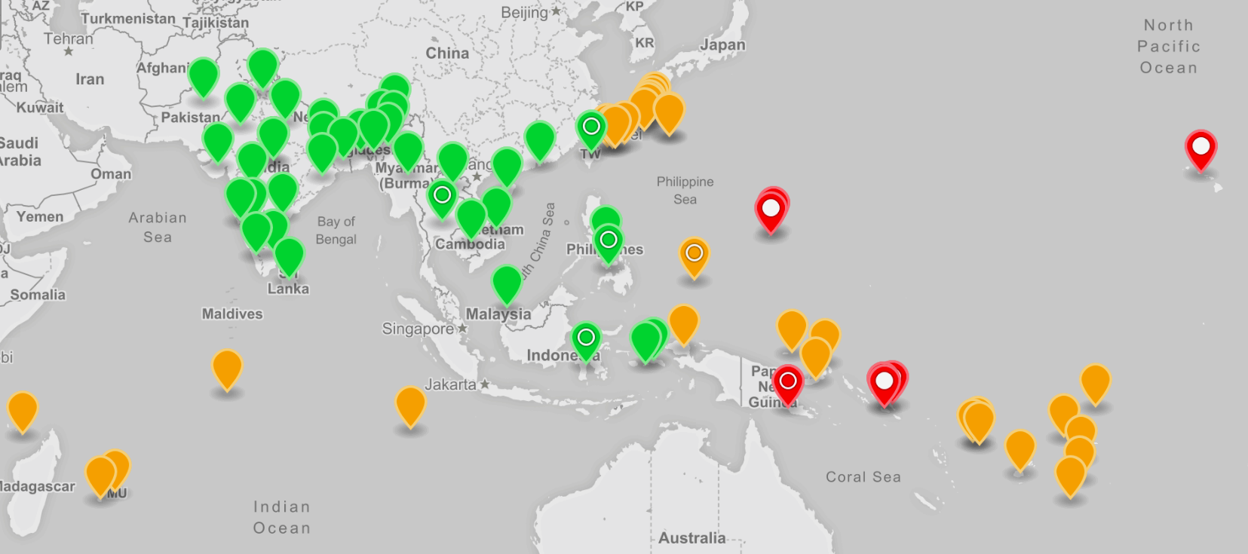

[fig:Distribution]Distribution coconut rhinoceros beetle, *Oryctes rhinoceros*. Green markers: native range; Brown markers: first detected in the 20th century; Red markers: first detected in the 21st century; Open circle: population includes CRB-G biotype; Filled circle: population is exclusively CRB-G biotype. An interactive version of this map is available online at <http://aubreymoore.github.io/crbdist/mymap.html>.

# Guam CRB Eradication Program

CRB was first detected on Guam was found in Lower Tumon on September 11, 2007 (Table [tab:Chronology]). An island-wide survey, completed within two weeks, located CRB grubs and adults and damage symptoms only in Lower Tumon and at the adjacent Faifai Beach, an area totaling less than 1,000 acres . Based on this information it was decided that eradication would be attempted. Here, I am using the word *eradication* in the proper sense, meaning killing every single CRB on the island.

In theory, a CRB population can be eradication from an island by locating and destroying all active breeding sites and ensuring that the arrival pathway is blocked to prevent re-infestation. In practice, CRB eradication is difficult. There have been several CRB eradication attempts, but only one of these was successful. CRB was eradicated from Niuatoputapu Island, also known as Keppel Island, a tiny outer island of Tonga, only 16 square kilometers in area. Eradication was accomplished by a sanitation program which lasted 9 years following first detection of CRB in 1921 .

The Guam CRB Eradication Project was a joint effort involving the United States Department of Agriculture, the Guam Department of Agriculture and the University of Guam. Financial support came from the United States Department of Agriculture, the United States Forest Service and the Legislature of Guam. The project used several tactics aimed at wiping out the CRB population: quarantine, sanitation, trapping, and chemical control. These are explained below.

The opportunity to eradicate CRB from Guam was lost when the infestation spread from the Tumon Bay area to breeding sites on other parts of the island prior to 2010. Most breeding sites are currently inaccessible for application of eradication tactics, being in the deep jungle and/or on military property which includes about one third of the island.

## Quarantine

The Guam Department of Agriculture drew a line around the CRB infestation area and required inspection and/or treatment of any dead vegetation being transport to other parts of the island. The quarantine had to be expanded several times. By 2010, all parts of Guam were infested by CRB.

## Sanitation

Sanitation is the most important tactic in any CRB eradication project. The target is to find and destroy all breeding sites before adults are generated, thus halting reproduction preventing all damage. The eradication program employed 4 detector dogs trained to sniff out rhino beetle grubs.

## Trapping

At the start of the eradication project, we were advised that the adult population could be annihilated using the commercially available aggregation pheromone as a lure. To the contrary, we soon learned that the traps were ineffective for population suppression when new damage appeared in mass trapping areas. However, an island-wide trapping network of about 2,000 traps was useful for monitoring the spread and growth of the CRB population. Island-wide trapping was discontinued when Typhoon Dolphin visited the island in May 2015.

A lot of work was done to improve pheromone traps . Our best pheromone trap design catches about 20 times as many beetles as the original standard trap we started with. However, even these traps catch only about 25% of the adult beetles active in mass trapping areas: not high enough for effective population suppression under current conditions. During our CRB trap improvement project, we discovered that local fishermen were using a small fish gill net called *tekken* to capture CRB adults emerging from compost piles. This has become a useful tool for managing CRB. Tekken captures about 65% of adults attempting to leave infested compost or green-waste piles. What may be more important is that these same piles become attractive to incoming adults which are also trapped.

## Chemical control

Individual palms can be protected from CRB attacks by prophylactic insecticide application. But this is very expensive. A row of 33 severely damaged coconut palms at the University of Guam Agricultural Experiment Station in Yigo were nursed back to apparent perfect health by spraying their crowns with the insecticide cypermethrin on a biweekly schedule. It took 15 months of treatment before all damaged fronds were replaced by healthy ones.

# Guam CRB Biological Control Program

In their native environment insect populations are suppressed by natural enemies which include parasites, predators and pathogens. When alien insects invade islands they escape control by natural enemies, resulting in damaging population explosions. Biological control programs introduce biocontrol agents which specifically target invasive species. There are many examples of successful biological control programs on Guam where invasive species populations are maintained at low levels by purposefully introduced biocontrol agents.

The Guam CRB Biological Control Program was launched following failure of the eradication attempt. There are two widely used biocontrol agents for CRB, a virus called *Oryctes rhinoceros* nudivirus (OrNV) and a fungus called *Metarhizium majus*. Both of these pathogens attack only rhino beetles and pose no risk to other organisms.

## *Oryctes rhinoceros* Nudivirus (OrNV)

Shortly after its discovery in Malaysia in 1963 , OrNV (*Oryctes rhinoceros* nudivirus), was released as a biocontrol agent on Pacific islands which had been invaded by CRB. The release technique, referred to as *auto-dissemination*, is very simple: adult rhino beetles are infected with the virus and then released. The virus quickly spreads throughout the CRB population and persists in the environment indefinitely. Wherever the virus was released, there was a drastic decline of the beetle populations followed by a conspicuous recovery of the badly damaged coconut stands. After OrNV was released in Palau, CRB damage symptoms disappeared almost entirely. We expected the same results on Guam.

OrNV was sourced from AgResearch New Zealand, a NZ government research lab which maintains a collection of OrNV isolates. One isolate was imported and released on Guam under conditions of permits from USDA-APHIS and the Guam Department of Agriculture. Unexpectedly, we observed no response to treatment at field release sites. Subsequent laboratory tests showed that the Guam CRB population is resistant to the OrNV isolates available from AgResearch. This discovery lead to the realization that we are dealing with a genetically distinct CRB which is resistant to biological control by OrNV, which has been named CRB-G . Although the “G” refers to Guam, genetic evidence shows that this biotype evolved thousands of years ago, prior to its arrival on Guam.

As previously mentioned, all CRB invasions of Pacific islands in the 21st century involve CRB-G. The current resurgence of CRB damage in Palau is thought to be caused by a recent invasion of the islands by CRB-G rather than by a different biotype which has been there since WWII.

## *Metarhizium majus*

*Metarhizium majus* is a fungus which acts as a pathogen in rhinoceros beetles. Spores of *M. majus* are produced in a laboratory using corn or rice as a substrate and the resulting material is applied to breeding sites as a bio-insecticide.

*M. majus* was imported from the Philippine Coconut Authority and released on Guam under conditions of permits from USDA-APHIS and the Guam Department of Agriculture. There were no observations of CRB grubs or adults infected with *M. majus* prior to release of the fungus. An extensive post-release survey showed that between 10% and 38% of field collected CRB died from *M. majus* infection within 21 days after collection. *M. majus* has established on Guam and it is often found in untreated breeding sites. However, this biocontrol agent did not suppressed populations enough to prevent the current outbreak.

# Typhoon Dolphin Triggers a CRB Population Explosion

When we thought that the Guam CRB problem could not get worse, it did. Typhoon Dolphin triggered the current CRB outbreak we are now experiencing.

Typhoon Dolphin visited Guam in May 2015. It was not a very strong typhoon by Guam standards, but it was the first one in more than a decade and it created a lot more damage than expected. Abundant piles of decaying vegetation became CRB breeding sites. Some of these new breeding sites were in villages were they could be managed. But most were inaccessible: in jungles and/or on military land. Within a few months, massive numbers of adults were emerging from breeding sites and severely attacking palms which started to die. Prior to Dolphin, we saw some heavily damages palms, but very few dead ones. Once a palm is killed, its dead standing trunk becomes an excellent breeding site which eventually produces even more adults resulting in a self-sustaining outbreak such as the one we are experiencing.

# Where do we go from here?

If we do not control the current rhino beetle outbreak on Guam, it will only end when the beetles run out of food. Which means most of Guam’s palm trees will be killed, as happened in Palau after WWII. If current CRB-G outbreaks in the Pacific cannot be suppressed, it is only a matter of time until this biotype invades other islands through accidental transport. If CRB-G reaches atolls where the coconut palm is *the tree of life* this will be a human tragedy, possibly displacing islanders to larger population centers.

At the 2016 International Congress of Entomology, the USDA sponsored a meeting to plan a regional response to CRB-G . Pacific-based entomologists with extensive experience working with CRB agreed that our best bet for stopping CRB-G outbreaks is to find an effective biocontrol agent for CRB-G. Most likely this will be an isolate of OrNV which is highly pathogenic for CRB-G. Although a regional project has yet to be funded and organized, the search has already begun. The University of Guam has been awarded a grant from USDA-APHIS to collaborate with rhino beetle biocontrol experts at AgResearch New Zealand and another grant from Department of the Interior’s Office of Island Affairs will fund a post-doc entomologist to work on this project.

>p1in>p4.5in Year & Event / Activity  
 Sept 2007 & CRB discovered in Tumon.  
2007 & Governor Camacho issues Executive Order 2007-013: Declaration of Emergency  
2007-2010 & Attempt to eradicate CRB using sanitation, pheromone traps, quarantine, and pesticides.  
2011-present & Attempt to control CRB with biological control agents (*Oryctes rhinoceros* nudivirus and *Metarhizium majus*).  
2014 & Started using tekken net to trap beetles leaving and entering breeding sites.  
May 2015 & Typhoon Dolphin generates abundant CRB breeding sites throughout the island, triggering a self-sustaining island-wide outbreak.  
May 2015 & Island-wide pheromone trapping program for monitoring CRB population trends is discontinued.  
July 2017 & Governor Calvo issues Executive Order 2017-04: Declaration of Emergency