Improving Coconut Rhinoceros Beetle Breeding Site Detection Using Harmonic Radar

Funding proposal to US Forest Service, Pacific Southwest Region

Primary investigator:  Aubrey Moore, PhD  Professor of Entomology  University of Guam  UOG Station  Mangilao, Guam 96923  Phone: (671) 735-2086  aubreymoore@triton.uog.edu | Co-primary investigator:  Matthew Siderhurst, PhD  Professor of Chemistry  Eastern Mennonite University  1200 Park Road  Harrisonburg, VA 22802  Phone: (540) 432-4382  matthew.siderhurst@emu.edu

May 6, 2020

Overview
The coconut rhinoceros beetle, Oryctes rhinoceros L., is a serious pest of coconut and other palms throughout Southeast Asia and on several Pacific Islands including Hawaii, Guam, Rota and the Palau Islands. One of the major hurdles for eradication and control of CRB is the location of cryptic breeding sites. Location and destruction of all CRB breeding sites is essential for eradication, but this has been achieved only once, on the very small (36 km²) Niuatoputapu Island (Catley 1969). While searching for cryptic breeding sites can be conducted by both humans and dogs, these search methods have drawbacks. Supported by a previous US Forest Service grant, we successfully developed a third detection method for cryptic CRB breeding sites using radio-tagged CRB (a so-called "Judas beetle" technique). However, there are both financial and operational issues with radio-tracking: radio tags are expensive and have both limited field- and shelf-life. Harmonic radar (HR) is a cheaper and longer lasting alternative to radio-tracking. HR uses cheaper tags that have a near infinite operational lifetime but have a shorter range and more limited available tracking frequencies. We have recently been successful in using harmonic radar to track the spotted lanternfly, Lycorma delicatula, and are eager to employ this technology to locate cryptic CRB breeding sites. We propose to develop a HR radar tag based CRB tracking system to provide a more cost-effective method for finding cryptic breeding sites, therefore providing a needed tool for CRB eradication and control. Our idea is to tag and release adult CRB. We will then attempt to locate the end points for these tags, rather than to track CRB movement. Our hypothesis is that the tags will accumulate at breeding sites. We expect that tags will be locatable even months after beetle releases.
We request funding support to do a feasibility study of HR on Guam, similar to the CRB radio tracking study we did a few years ago (Moore et al. 2017). If HR successfully locates CRB breeding sites, this technology could become important to development of effective early detection and rapid response (EDRR) for CRB: HR equipment and tags could be quickly deployed to newly invaded islands to help detect active and potential breeding sites.

Background
Oryctes rhinoceros (Linnaeus 1758) (Coleoptera: Scarabaeidae: Dynastinae), commonly known as the coconut rhinoceros beetle (CRB), is endemic to the tropical Asia region (including South East Asia). CRB adults damage both coconut and oil palm, and can sometimes kill palms when they bore into crowns to feed on sap (Bedford 2013). In contrast to adults, CRB grubs cause no economic damage, as they feed on decaying vegetation at breeding sites, which include dead standing coconut palms, fallen coconut logs, rotting coconut stumps, and decaying wood of many tree species (Bedford 1976, 2013). Breeding sites are also found in piles of compost, sawdust, and manure where these materials are available.
CRB was inadvertently introduced into the Pacific in 1909 when infested rubber tree plants were transported to Samoa from Sri Lanka (previously known as Ceylon) (Catley 1969). The pest rapidly multiplied in Samoa and subsequently spread to several nearby Polynesian islands. Separate invasions further distributed CRB through Palau, parts of Papua New Guinea, and other Pacific nations through disruptions and uncontrolled movements during World War II (Gressitt 1953, Catley 1969). The invasive phase of the beetle was brought under control by the discovery and distribution of a viral biocontrol agent, Oryctes rhinoceros nudivirus (OrNV). OrNV is currently present and causes persistent population suppression on many of the CRB infested Pacific Islands (Huger 2005, Bedford 2013).
Detection of CRB on Guam in 2007 (Smith and Moore 2008) heralded a second wave of Pacific island invasions by this pest. Following a failed eradication attempt, it was discovered that the Guam beetles are an OrNV resistant form which is being referred to as the CRB-G biotype (Marshall et al. 2017).
Eradication of coconut rhinoceros beetles from an island is difficult once this pest has become established. On two islands in Fiji, mass trapping using the now superseded synthetic attractant ethyl chrysanthemate coupled with sanitation from 1971 through 1974 failed to eradicate coconut rhinoceros beetles (Bedford 1980). The only proven tactic for eradication is a vigorous sanitation program that discovers and destroys all active and potential breeding sites. The single successful coconut rhinoceros beetle eradication to date was accomplished during the 1920s on the tiny (36 km²) Niuatoputapu Island (also known as Keppel Island), which lies between Samoa and Tonga, using sanitation alone (Catley 1969, Bedford 1976). Given the importance of finding and destroying breeding sites for the success of coconut rhinoceros beetle eradication and control programs and the inherent difficulty of locating breeding sites, which are often cryptic and are found in a wide range of locations (Hinckley 1973, Bedford 1976), there is a pressing need to develop detection methods to reliably find these sites.
To date, three techniques have been used to locate active and potential CRB breeding sites: visual search by humans, search by humans with the assistance of detector dogs, and search by humans radio-tracking CRB carrying miniature transmitters. Unaided human searches can identify both active and potential breeding sites but are inefficient compared to other techniques. Detector dogs trained to smell CRB breeding sites can be more efficient but are more expensive and are limited to ground searches potentially missing arboreal breeding sites (Moore et al. 2015). Radio-tracking has the potential to discover cryptic breeding sites on both the ground and in trees using the so-called Judas technique. Our previous work with CRB radio-tracking (Moore et al. 2017) was performed at two locations on Guam (Fig. 1). We released radio-tagged adults to discover cryptic breeding sites, for potential coconut rhinoceros beetle control. Of 33 radio-tagged beetles that were released, 19 were successfully tracked to landing sites, 11 of which were considered to be active or potential breeding sites, in five different microhabitats. The remaining 14 beetles were lost when they flew beyond the range of receivers. Only one of the radio-tagged beetles was caught in the numerous pheromone traps present at the release sites. Radio-tracking coconut rhinoceros beetles in this way showed promise as a method to identify cryptic breeding sites, which could then be treated, removed, or destroyed.
While radio-tracking allowed the detection of cryptic breeding sites there remain both financial and operational issues with broader implementation of this detection technique: radio tags are expensive ($120-$300/tag) and radio tags have limited field- and shelf-life (several weeks and several months respectively). A cheaper and longer lasting alternative to radio-tracking is harmonic radar, which uses cheaper tags ($3 diode + $1 in wire and adhesive) These tags have a near infinite operational lifetime but have a shorter range and more limited available tracking frequencies.
Vertical-looking radar has been used to track flying insects since the 1970s. Unfortunately, reflections from the ground and vegetation (clutter) prevent use of conventional radar for observing low-flying, crawling or burrowing insects. However, HR can be used for this application (Riley et al. 1996). Use of HR requires target insects to be “tagged” with a device (a ‘chip’) designed to re-radiate a harmonic of the radar signal which can be detected against even strong radar clutter. The re-radiated energy is detected by a circuit in the transceiver tuned to a harmonic of the outgoing radar frequency. The energy to operate the tag is delivered by the illuminating radar, so no on-board battery is required and extreme miniaturization is therefore possible.
Harmonic radar has been applied for tracking insects for several decades using custom built equipment (Mascanzoni and Wallin 1986, Riley et al. 1996, O'Neal et al. 2004, Kissling et al. 2014). In recent years, harmonic radar has been developed commercially for finding avalanche victims, resulting in availability of prebuilt equipment (https://recco.com/) which can be repurposed for tracking insects (O'Neal et al. 2004, Milanesio et al. 2016, Maggiora et al. 2019).
Dr. Siderhurst and his students along with colleagues from USDA APHIS have recently been successful in using harmonic radar to track the spotted lanternfly (SLF), Lycorma delicatula, in eastern Pennsylvania (Fig. 2). SLF is a much smaller insect than CRB and was able to carry diode tags quite easily. Released tagged SLF were tracked to both locations on the ground and in trees near the release site.
We are eager to employ our previous experiences with both CRB tracking and harmonic radar to locate cryptic CRB breeding sites. We propose to develop a harmonic radar tag based CRB tracking system to provide a more cost-effective method for finding cryptic breeding sites, therefore providing a needed tool for CRB eradication and control.

Methodology
TAG FABRICATION: HR diodes will be purchased from RECCO Technology (Lidingö, Sweden). Tag fabrication will be carried out at Eastern Mennonite University (EMU). In brief, several different types of wire and adhesives/contacts will be tested to maximize tag robustness and range. Previously produced SLF HR tags needed to be lighter weight than for CRB so we are cautiously optimistic about improving the performance of the HR tags.
INSECTS: CRB to be used for tracking will be wild-caught from barrel traps containing oryctalure and collected within one week of capture. These beetles will be placed in tubs containing moist peat moss, fed fresh banana slices, and allowed to rest for at least three days.
Only flight-capable CRB will be selected for tagging and release (Moore et al. 2017). Flight-capable beetles will be marked with a unique four-digit identification number engraved on one elytrum using a laser engraver. The ID number, sex, mass, and elytral dimensions of each beetle will be recorded before release. HR tags will be affixed to the pronotum of each beetle using an adhesive.
RELEASE SITES: HR tagged CRB will be released at two locations on Guam: the War in the Pacific National Historical Park in Asan (13.465972° N, 144.710944° E, Figure 1A) and the University of Guam Agricultural Research Station in Yigo (13.532444° N, 144.873333° E, Figure 1B). Asan Beach National Park is roughly triangular with the ocean bordering one side, coastal wetlands on another, and forested hillside on the third. The park itself is a large, open, grassy field and includes coconut palms on the edges, many of which displayed routine CRB damage. The anticipated release site (144.708537° E, 13.473904° N) is at the middle of a large, grassy field. The Yigo site is an inland agricultural experiment station farm bordered by residential areas and uncultivated forest areas that include coconut palms along with many other trees. Again, many of the coconut palms on the station show routine signs of CRB damage. The anticipated release site (144.872750° E, 13.531333° N) is in the middle of an uncultivated field. Thus, both sites feature relatively accessible terrain that provides a variety of potential breeding sites as well as adult food sources.
TRACKING: We will not be tracking beetles in real time. Instead, we will be releasing CRB with attached HR diode tags and after a period of time (initially several days) we will determine where tagged CRB are aggregating. Presumably, CRB will be aggregate at two types of locations, feeding and breeding sites. All HR tags will be on the same frequency, which means that multiple tagged CRB at a location will act to amplify the signal. We will generally follow tracking techniques previously described in Moore et al. (2017).
DATA RECORDING: All release sites and discovery sites (where CRB are found) will be marked with GPS. Where possible, CRB will be recovered to determine the release number engraved on the beetle. Mapping of release the discovery points will be carried out using ArcGIS.

Schedule of Activities (2020)
March-April: Tag fabrication and testing at EMU.
April-early May: Capture, flight test, and mark CRB at UoG.
May: Conduct field releases and tracking on tagged CRB (two week intensive fieldwork period).
June-August: Data analysis.
August-December: Manuscript(s) and final report preparation. Discuss findings with state agencies. Make presentations at scientific meetings. Plan further research with cooperators to implement findings in monitoring and control efforts.

Description of Deliverable Products
We expect to demonstrate the feasibility of detecting cryptic CRB breeding sites using harmonic radar tagged beetles. Results will be disseminated to action agencies and the scientific community through journal articles, conference presentations and personal contacts to ensure further development of the technology for detection and control applications.
We intend to write a detailed protocol for CRB tracking using harmonic radar to describe preparation of beetles, tags, equipment operation, and data recording.
Two harmonic radar transceivers and assembled tags will be kept at the University of Guam for use in subsequent research and/or rapid response projects within Micronesia and the greater Pacific.

Personnel and Partners
Dr. Aubrey Moore: Professor of Entomology at University of Guam. Dr. Moore has over 30 year’s experience in working on invasive species in the Pacific. His current research is focussed on finding solutions to problems caused by coconut rhinoceros beetle, biotype G.
Dr. Matthew Siderhurst: Professor of Chemistry at Eastern Mennonite University. Dr. Siderhurst has over 15 years’ experience working on invasive insects in the Pacific and Australia. His research focuses on insect chemical ecology, natural products structural determination and synthesis. Dr. Siderhurst is involved in several ongoing insect tracking projects using both radiotelemetry and harmonic radar. Tracking projects have included work with Coleoptera, Lepidoptera, Diptera, and Hemiptera.
Drs. Moore and Siderhurst have collaborated on CRB projects for almost 10 years. Their previous radio-tracking work successfully demonstrated the feasibility of using the Judas beetle technique to find cryptic CRB breeding sites (Moore et al., 2017).
If this proposal is funded, others working on CRB on Guam and elsewhere in the Pacific will be invited to participate in the project.

Budget
UoG and EMU will be providing (in-kind) nearly half of the cost for this proposed project, including salaries, partial supplies, equipment and local travel. UoG will provide the lab space and logistical support for the tracking work in Guam. EMU will provide the lab space and equipment for tag fabrication and one of the HR transceivers needed for the research. The requested $20,000 will be used for some supplies, two additional HR transceivers, and travel. Travel costs include flights from VA to Guam (~$2,500 x 3), hotel accommodations (~$100/day x 14 days x 2), and meals (~$50/day x 14 days x 3).

 |  | Requested |  | UoG (matching) |  | EMU  (matching)
Personnel | Scientists, students | - |  | $5,000 |  | $5,000
Supplies | Diodes and wire for tags, field supplies | $2,000 |  | $1,000 |  | $1,000
Equipment | RECCO receivers/transmitters (two transmitters will be purchased and EMU currently has one) | $6,000 |  | - |  | $3,000
Travel | Flights for 3 from VA to Guam, hotel accommodations, and meals (UoG will provide local transport) | $12,000 |  | $1,000 |  | -
Admin. fee | 15% of above direct costs charged by RCUOG as administrative fee | $3,529
 |  | $23,000 |  | $7,000 |  | $9,000

References

Bedford, G. 1980. Biology, ecology, and control of palm rhinoceros beetles. Annual Review of Entomology 25: 309-339.
Bedford, G. O. 1976. Observations on the Biology and Ecology of Oryctes rhinoceros and Scapanes australis (Coleoptera: Scarabaeidae: Dynastinae): Pests of Coconut Palms in Melanesia. Australian Journal of Entomology 15: 241-251.
Bedford, G. O. 2013. Biology and management of palm dynastid beetles: Recent advances. Annals of the Entomological Society of America 58: 353-372.
Catley, A. 1969. The coconut rhinoceros beetle Oryctes rhinoceros (L)[Coleoptera: Scarabaeidae: Dynastinae]. PANS Pest Articles & News Summaries 15: 18-30.
Gressitt, J. L. 1953. The coconut rhinoceros beetle (Oryctes rhinoceros) with particular reference to the Palau Islands.
Hinckley, A. D. 1973. Ecology of the Coconut Rhinoceros Beetle, Oryctes rhinoceros (L.) (Coleoptera: Dynastidae). Biotropica 5: 111-116.
Huger, A. M. 2005. The Oryctes virus: its detection, identification, and implementation in biological control of the coconut palm rhinoceros beetle, Oryctes rhinoceros (Coleoptera: Scarabaeidae). Journal of invertebrate pathology 89: 78-84.
Kissling, D. W., D. E. Pattemore, and M. Hagen. 2014. Challenges and prospects in the telemetry of insects. Biological Reviews 89: 511-530.
Maggiora, R., M. Saccani, D. Milanesio, and M. Porporato. 2019. An innovative harmonic radar to track flying insects: the case of Vespa velutina. Scientific reports 9: 1-10.
Marshall, S. D., A. Moore, M. Vaqalo, A. Noble, and T. A. Jackson. 2017. A new haplotype of the coconut rhinoceros beetle, Oryctes rhinoceros, has escaped biological control by Oryctes rhinoceros nudivirus and is invading Pacific Islands. Journal of invertebrate pathology 149: 127-134.
Mascanzoni, D., and H. Wallin. 1986. The harmonic radar: A new method of tracing insects in the field. Ecological Entomology 11: 387-390.
Milanesio, D., M. Saccani, R. Maggiora, D. Laurino, and M. Porporato. 2016. Design of an harmonic radar for the tracking of the Asian yellow‐legged hornet. Ecology and evolution 6: 2170-2178.
Moore, A., T. Jackson, R. Quitugua, P. Bassler, R. Campbell. 2015. Coconut rhinoceros beetles (Coleoptera: Scarabaeidae) develop in arboreal breeding sites in Guam. Florida Entomologist 98(3): 1012-1014.
Moore, A., D. C. Barahona, K. A. Lehman, D. D. Skabeikis, I. R. Iriarte, E. B. Jang, and M. S. Siderhurst. 2017. Judas beetles: discovering cryptic breeding sites by radio-tracking coconut rhinoceros beetles, Oryctes rhinoceros (Coleoptera: Scarabaeidae). Environmental Entomology 46: 92-99.
O'Neal, M. E., D. Landis, E. Rothwell, L. Kempel, and D. Reinhard. 2004. Tracking insects with harmonic radar: a case study. American Entomologist 50: 212-218.
Riley, J.R., A.D. Smith, Don Reynolds, A. Edwards, Juliet Osborne, Ingrid Williams, Norman Carreck, and Guy Poppy. 1996. Tracking Bees with Harmonic Radar. Nature 379 (January): 29-30.
Smith, S., and A. Moore. 2008. Early detection pest risk assessment: coconut rhinoceros beetle. United States Department of Agriculture.

Figures
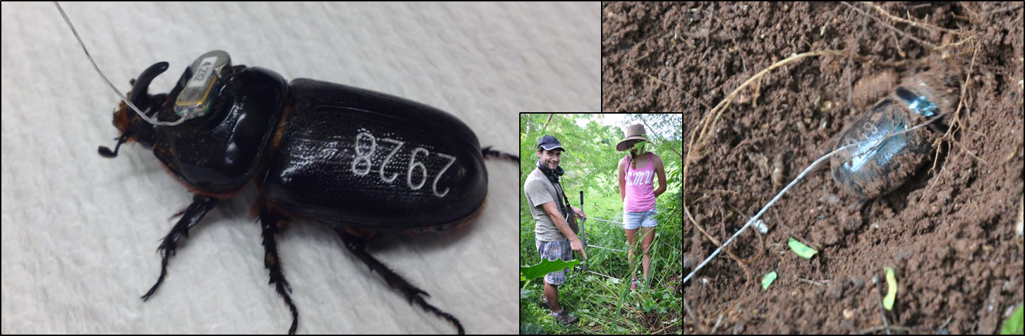
Figure 1. A radio-tagged CRB (left) before release. A successfully located CRB in soil (right). A tracking crew from USDA ARS and Eastern Mennonite University (inset).

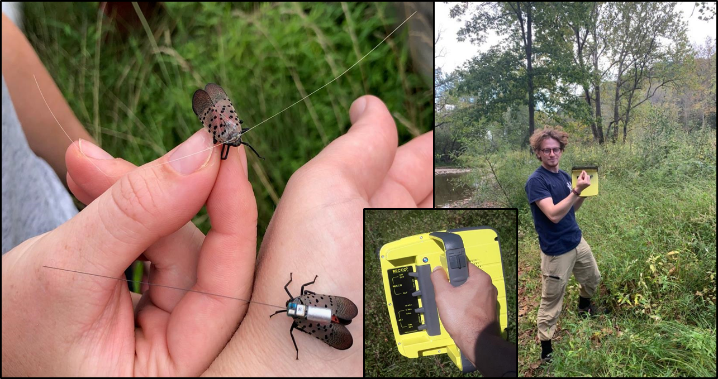
Figure 2. Spotted lanternfly with attached harmonic radar diode tag (top left) and radio-frequency tag (bottom left). USDA APHIS tracker holding RECCO harmonic radar emitter/receiver and a tagged spotted lanternfly (right).

