McIntire-Stennis Proposal

Guam Forest Biodiversity Inventory
Aubrey Moore

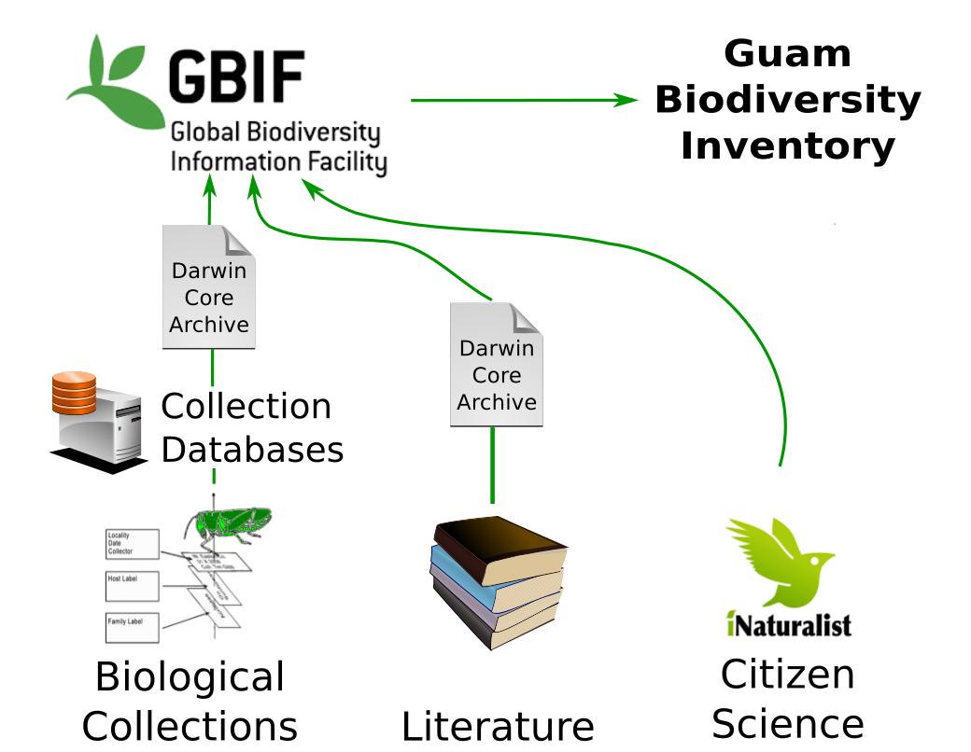
Table of Contents
Section 1: Justification
Section 2: Previous Work and Present Outlook
Section 3: Objectives
Subsection 3.1: Liberate data from biological collections
Subsubsection 3.1.1: Complete digitization of the UOG insect collection
Subsubsection 3.1.2: Complete digitization of the UOG herbarium
Subsection 3.2: Liberate data from the Scientific Literature
Subsection 3.3: Build the Guam Forest Biodiversity Web Site
Subsection 3.4: Outreach / Citizen Science
Subsection 3.5: Collaboration
Section 4: Duration and Timetable
Subsection 4.1: Duration
Subsection 4.2: Timetable
Section 5: Financial Support/Budget
Section 6: Personnel
Section 7: Cooperation/Collaboration

1 Justification
Funding is requested to support building and maintenance of a Guam Forest Biodiversity Inventory. In its simplest form, a biodiversity inventory is simple a checklist of taxa inhabiting a geographic area or habitat of interest. In this case the habitat of interest is Guam’s forests. If funded, this project will be a major component of a larger project aimed at building a Guam Terrestrial Biodiversity Inventory to include all taxa found on the island.
Guam’s forest ecosystems are rapidly being degraded by invasive insect species and habitat destruction. Impacts of bird extinctions caused by brown treesnake predation on Guam’s forests are well known. But these impacts are rivaled by contemporary ecological disasters. A couple of examples:
- In 2002, a USDA Forest Service survey [1] reported that Guam’s endemic cycad, Cycas micronesica, was the most abundant tree (DBH > 5 inches) in Guam’s forests. In 2003 the Asian cycad scale, Aulacaspis yasumatsui, was detected on Guam infesting ornamental cycads. The scale quickly spread to wild cycads and started killing them. Within only 3 years, Cycas micronesica was placed on the IUCN Red List of Threatened Species and in 2016, this plant was placed on the US national endangered species list. It is estimated that 90% of Guam’s cycads have been killed and there is no sign of recovery.
- The same Forest Service survey listed coconut palm, Cocos nucifera, as Guam’s second most abundant tree. Guam’s palms are rapidly being killed by coconut rhinoceros beetle, Oryctes rhinoceros, first detected on the island in 2007. It is likely that 50% or more of the island’s coconut palms will be lost.
Despite rapid destruction of Guam’s forests, as illustrated by these 2 examples, we do not have even a basic checklist which can be used to document changes in biodiversity.
A biodiversity inventory is needed:
- to document changes to Guam’s ecosystems
- to document detection of and impacts caused by invasive species which are arriving at a rapid rate
- to provide free, open access to information on Guam’s flora and fauna (including images and occurrence maps) to the global scientific community, policy makers, and the public
- to act as a digital repository for data from biological surveys and biological collections
- to provide links to scientific literature about taxa which occur on Guam
- to document ecological relationships among taxa such as hosts, predators, parasites, and diseases

The Guam Forest Biodiversity Inventory will use the Global Biodiversity Information Facility (GBIF) as a repository. A custom web site will be built by the PI to serve as a public interface to Guam biodiversity data stored on GBIF. Darwin Core Archives (DwCA) will be used extensively for transferring data to and from GBIF.
The Guam Biodiversity Inventory will facilitate automatic generation and updates to lists such as:
- A list of all invasive species on Guam with year first recorded
- A list of new species described from specimens collected on Guam
- A list of observations for Guam’s endangered species
- A list of Guam’s forest plants with associated herbivores and pathogens
- A list of forest pests and associated biological control agents
- A literature reference list and links to images for all taxa in the database
- Customizable checklists and field guides with images

2 Previous Work and Present Outlook
- This proposal evolves from the PI’s previous McIntire-Stennis project entitled Guam Forest Insect Survey.
- The entire UOG insect collection catalog (34,808 specimen records) has recently been put online at http://scan-bugs.org/portal/collections/misc/collprofiles.php?collid=180 Digital images will be added.
- The PI recently accessioned over 5,000 specimens of insect seed predators from Benita Laird-Hopkins research, part of the Ecology of Bird Loss Project. This records are available in the UOG insect collection online catalog.
- The PI recently put 37,000 digital images of UOG herbarium sheets online at https://osf.io/qdg46/?view_only=c39ff58ac28b4bee94dc231b3f2bef95. Next step is to link these images with the herbarium database.
- The PI designed the Guam Terrestrial Biodiversity Inventory and made a presentation on this at the recent Guam Island Sustainability Conference [2].
- The PI has contracted the Bishop Museum to make PDFs of primary entomological literature for Guam, namely Insects of Guam I and Insects of Guam II. These volumes will be made available for public download from the Bishop Museum web site. These books will be data mined for forest biodiversity information.
- The PI recently established an internship so that students can assist in curating the UOG insect collection.
- The PI is skilled at scientific programming, web design, database design, and database management. This project will use free open source software (FOSS) and free or low cost web hosting. External technical support will not be required.

3 Objectives

3.1 Liberate data from biological collections

3.1.1 Complete digitization of the UOG insect collection
The UOG insect collection catalog has already been made available online using Symbiota. Note that Symbiota automatically uploads data to GBIF.
The next phase of this digitization project will be imaging of all taxa in the collection. Existing images will be uploaded and linked to specimen data. Images will be made for taxa which have not been previously imaged and these will also be uploaded.

3.1.2 Complete digitization of the UOG herbarium
Digital images are available for all herbarium sheets.
The existing herbarium catalog will be converted from a local database to an online database using Symbiota or Specify. Both of these online collection database managers automatically upload to GBIF.

3.2 Liberate data from the Scientific Literature
The PI will organize extraction of Guam biodiversity information from primary scientific publications, starting with Insects of Guam I and II.

3.3 Build the Guam Forest Biodiversity Web Site
The PI will launch a web site to serve as a portal to Guam forest biodiversity data stored in GBIF.
Pages will be developed to dynamically generate lists such as those suggested above (1↑).

3.4 Outreach / Citizen Science
The PI will offer annual workshops on the use of iNaturalist, a social networking app used by citizen scientists and naturalists which enables them to record biodiversity observations with images and georeferencing using smart phones. iNaturalist data which is validated as research grade by the community is automatically uploaded to GBIF. The PI maintains an iNaturalist project entitled Insects of Micronesia.
The PI will work with the UOG Center for Island Sustainability to organize annual bioblitzes. A bioblitz is is an intense period of biological surveying in an attempt to record all the living species within a designated area.

3.5 Collaboration
- Collaboration with taxonomists will be cultivated to help identify a large backlog of unidentified specimens in the UOG insect collection.
- Existing collaboration will be maintained with existing partners list in the Collaboration/Cooperation section of this proposal 7↓.
- The PI will participate in at least one scientific meeting per year covering biological collections and/or biodiversity informatics.
- The PI will encourage donation of voucher specimens to the UOG insect collection from biological surveys such as those being conducted by the Ecology of Bird Loss and the baseline surveys being done by military contractors in support of the military buildup.

4 Duration and Timetable

4.1 Duration
This performance period for this project will be 5 years.

4.2 Timetable
Objective | Y1 | Y2 | Y3 | Y4 | Y5
1. Liberate data from Biological Collections | X | X
2. Liberate data from the Scientific Literature |  | X | X | X | X
3. Build the Guam Forest Biodiversity Web Site | X | X | X
4. Outreach / Citizen Science | X | X | X | X | X
5. Collaboration | X | X | X | X | X

5 Financial Support/Budget
Staff Salary $8,000 per year will be used to fund an existing student internship program. Interns assist in curation of the University of Guam insect collection. Students will also assist in entering data into the Guam Forest Biodiversity Inventory database.
Travel $4,000 per year will facilitate UOG participation in professional meetings and workshops on biological collections and biodiversity informatics such as those hosted by the Integrated Digitized Biocollections Project (iDigBio) and the Entomological Collections Network (ECN). First year funding will allow the PI to attend the ECN meeting associated with the Entomological Society of America meeting in Vancouver during November 2018. Travel money may also be used to support visits to Guam by taxonomists willing to identify specimens in UOG collections.
Materials and Supplies $4,000 per year will fund entomological supplies required to maintain the UOG insect collection. Some of this money will be used for shipping specimens for identification by taxonomists.
\begin_inset External template PDFPages filename McStennis Budget Sheet template.pdf lyxscale 20 extra LaTeX "pages=-"\end_inset

6 Personnel
Guam Forest Biodiversity Inventory Database The Guam Forest Biodiversity Inventory database will be designed and maintained by the PI with no direct cost to this project. Student interns will assist with data entry.
University of Guam Insect Collection The University of Guam Insect Collection is curated by the PI and Dr. Ross Miller with no direct cost to this project. Student interns funded by this project will assist with curation of the collection.
University of Guam Herbarium The University of Guam Herbarium is curated by Dr. Xiao Wei with database support from Dr. Tom Schills with no direct cost to this project.

7 Cooperation/Collaboration
- Guam Plant Extinction Prevention Program (GPEPP)
- Secretariat of the Pacific Regional Environment Program (SPREP)
- International Union for the Conservation of Nature, Invasive Species Specialist Group (IUCN ISSG)
- University of Guam Herbarium
- University of Guam Insect Collection
- Guam Invasive Species Council (GISC)
- Digitized Biocollections Project (IDigBio)
- Entomological Collections Network (ECN)
- Symbiota Collections of Arthropods Network (SCAN/Symbiota)
- iNaturalist
- University of Guam EPSCOR
- University of Guam Center for Island Sustainability

References
[1] J. A. Donnegon: Guam's Forest Resources, 2002, . URL http://www.fs.fed.us/pnw/pubs/pnw_rb243.pdf.
[2] Aubrey Moore: . 2018. URL https://github.com/aubreymoore/Guam-Biodiversity-Inventory-Presentation/raw/master/guam_biodiversity_inventory_presentation.pdf.

