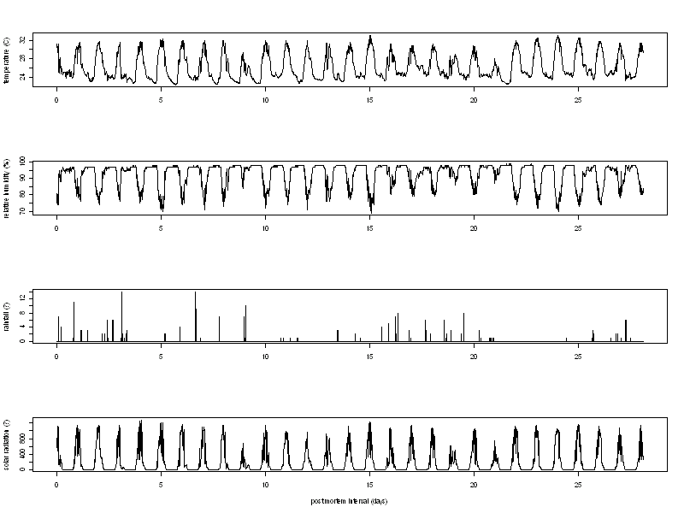Figure 2. Weather data recorded during experiment by an automated weather station within 25 m of each pig.
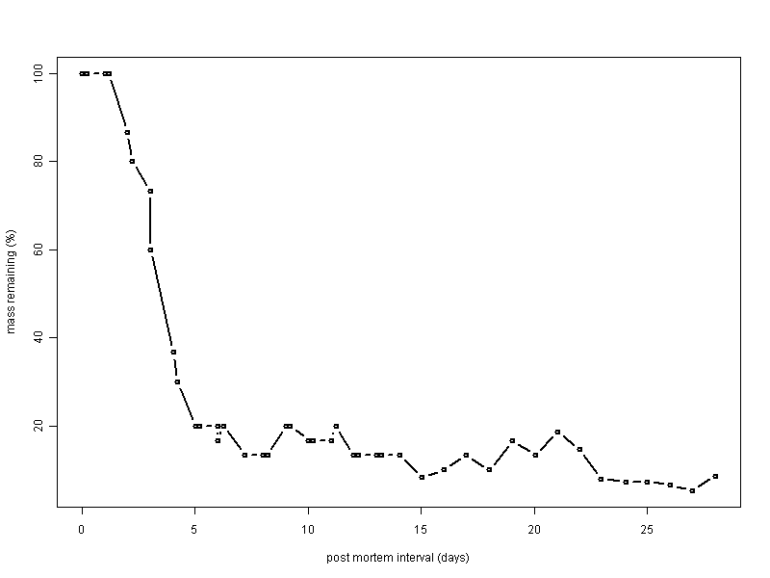Figure 3. Mass remaining for pig 1.
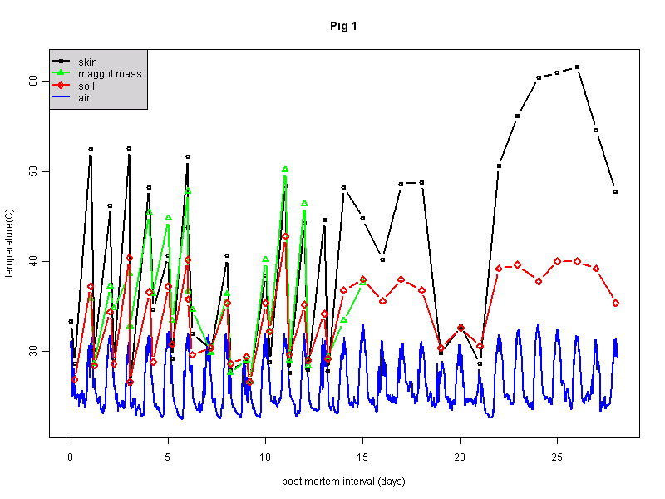Figure 4. Temperature profiles for pig 1. Temperature of skin, maggot massm and soil measured twice per day for first 10 days, daily thereafter using an infrared thermometer. Ambient air temperature measured by an automated weather station at a height of 2 m. Distance between pig and weather station was 25 m.
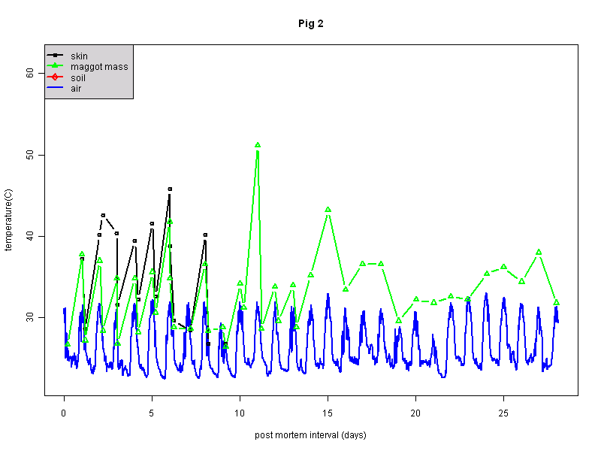Figure 5. Temperature profiles for pig 2.. Temperature of skin, maggot massm and soil measured twice per day for first 10 days, daily thereafter using an infrared thermometer. Ambient air temperature measured by an automated weather station at a height of 2 m. Distance between pig and weather station was 25 m.
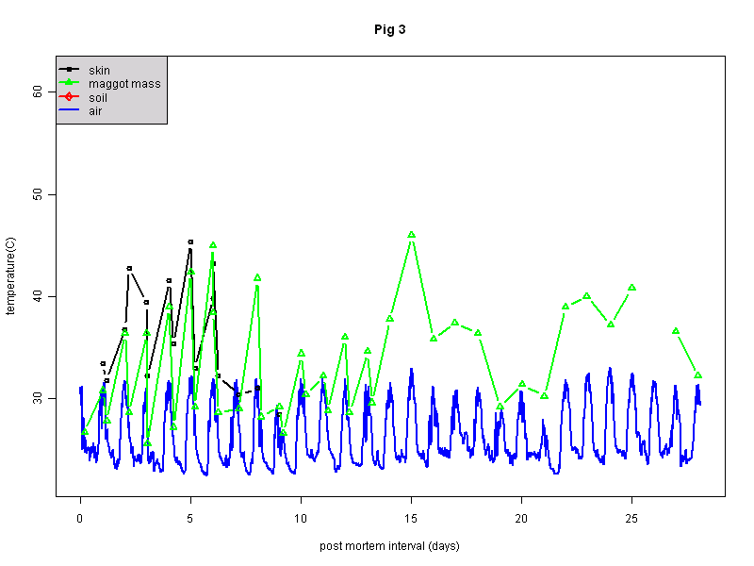Figure 6. Temperature profiles for pig 3. Temperature of skin, maggot massm and soil measured twice per day for first 10 days, daily thereafter using an infrared thermometer. Ambient air temperature measured by an automated weather station at a height of 2 m. Distance between pig and weather station was 25 m.

