of Temperature on Development and Mortality of
Immature Sarcophaga (Liosarcophaga) dux
Thomson (Diptera: Sarcophagidae)

Fahad A. M. Al-Misned
Department of Zoology, College of Science, King Saud University, P.O.Box 2455,
Riyadh 11451, Saudi Arabia

(Received 29/12/1422; accepted for publication 4/4/1423)

Abstract. Total developmental time of Sarcophaga dux Thomson from first -instar larvae to adult emergence was 51.8, 33.0, 25.0, 16.4, 13.6 and 15.1 days when reared at temperatures of 16, 20, 24, 28, 32 and 36 ºC, respectively. There were no significant differences in developmental time between the two sexes (p>0.05). Estimates of the lower developmental threshold temperatures (t_{L}) were 5.9, 12.9 and 11.0 ºC and the thermal constants (K) were 163.2, 143.0 and 289.1 degree-days (DD) for larvae, pupae and total developmental time, respectively. The highest proportion of total mortality for larvae and pupae was recorded at 16 and 36 ºC. The flies reached their maximum weights in pupal and adult stages at 20 and 24 ºC, whereas minimal weights were recorded at 16 and 36 ºC. At all temperatures, the mean adult weight, was smaller in females than in males. The optimal temperature in terms of rapid development, low mortality, and greatest weight ranged between 20 and 28 ºC.

Introduction

The fleshfly, Sarcophaga (Liosarcophaga) dux Thomson (= exuberans Pandelle) has a wide distribution from Japan and the Philippines through China and India to tropical Africa and South Europe [1 - 3].

It is of considerable importance in public hygiene, forensic entomology as well as in reducing different kinds of kitchen and meat industry wastes, of unburried of sea and terretrial invertebrates and vertebrates [4]. The adults of this fly are frequently found around animal carcasses, wounds, man and animal excrements and decaying organic matter of fruits and vegetables [5].

Aspects of biology and behavior of S. dux were briefly described [6-8]. Previously Al-Misned et al. reported the collection of this fly from Saudi Arabia for the
53
first time and described the widespread distribution [3]. However detailed developmental studies under controlled various temperatures are lacking for this fly.

Temperature is the most important environmental factor affecting poikilotherms [9]. The temperature dependent developmental rate curve of an insect is a fundamental feature of its life history. The curve may be modified by humidity, nutrition, etc. but temperature remains as the dominant driving force [10]. The response to temperature can affect the geographical distribution and seasonal abundance of these species [11].

This study was undertaken to determine the rate of development, mortality and size of pupae and adults of S. dux at various constant temperatures, and to estimate the lower developmental threshold and cumulative number of degree-days (DD) necessary to complete each life stage.

Materials and Methods

Larval and pupal stages of S. dux were reared at 16, 20, 24, 28, 32 and 36 ºC at a photoperiod of 15:9 (L:D) h. and 65-70 % rh. All temperatures were accurate to + 1 ºC. Larvae were obtained from an adult fly colony from Riyadh City, which has been in the laboratory for approximately 18 months. S. dux were reared in the laboratory according to techniques described for Parasarcophaga (Liopygia) ruficornis [12].

Within (0-6) h of larviposition groups of fifty first-instar larvae were introduced into rearing jars (11 cm. diameter) containing 70 gm of ground beef. After 4 days media were covered with 3-4 cm. deep sawdust moistened with distilled water. The jars were covered with cotton cloth held by rubber bands to permit ventilation. All jars were exposed to the assigned temperature for 24 hrs prior to use. Two replicate jars were used at each temperature.

Larvae were checked during wandering phase through the sawdust at 12-h intervals until pupation to determine the larval developmental time. Fresh pupae were daily collected for each temperature, isolated, counted,weighed together using Ac-100 balance (Mettler Instrument, Zurich, Switzerland; accuracy, 0.1 mg) and kept in clean jars which were provided with moistened sawdust. Total numbers of pupae for each temperature were counted and larval mortality rates were calculated. Jars were covered with a cloth held by rubber band until adult’s emergence to determine the pupal developmental time. Upon adult emergence, flies were etherized lightly, sexed to males and females, counted and weighed. Total numbers of adults that eclosed from pupae for each temperature were counted and pupal mortality rates were calculated. All emerged adult flies (males or females) from each jar on one day were weighed together.

Statistical methods
Lower thresholds (t_{L}) for development were estimated from the linear regression of the developmental rate (y=1/developmental time) on constant temperatures (x) [13,14]. The thermal constant (K) was calculated from the equation K= y(d - t), where y is the developmental time (days), d is the prevailing temperature (ºC), and t is the theoretical developmental threshold temperature (ºC) [15]. The thermal constant for each temperature was calculated to obtain the overall K (Mean + SD) for each life stage. Values of K represent the number of degree-days (DD) above the threshold needed for development. A x² (Chisquare) nonparametric goodness-of-fit test was used to test trends in larval and pupal mortality. The x² values at each temperature were calculated from the equation X² = 2 (O-E)² / E were O is the percent larval or pupal mortality, E is the combined expected value of mean percent mortality of larvae and pupae [16]. All x² values for a desired range of temperatures were summed for an overall x² test criterion (with df=n -1). Pupal and adult weights were compared among temperature by analysis of variance (ANOVA). Student's t test was used to compare weights of males and females.
Results and Dis‎‎cussion

Developmental time
Mean developmental time of S. dux at six constant temperatures are presented in Table1. Sexes were combined since an initial analysis indicated no significant differences (p>0.05) between males and females. Developmental time generally decreased with increasing temperatures, up to 32º C , whereas it began to increase at 36 º C . This finding is somewhat similar to developmental time of Wohlfahrtia nuba Wiedemann [17] and Parasarcophaga ruficornis (F.) [18] but it is longer than in some other Sarcophagid flies such as Sarcophaga crassipalpis Macquart [19]. and Bercaea cruentata (Meigen) [20]. Regardless of the rearing temperatures used in the present study, the overall mean developmental time (Mean + SD) for larvae, pupae and total development were: males: 9.6 ± 3.52, 16.2 ± 11.19 and 25.9 ± 14.71 days, respectively; females 9.7 ±3.43, 16.1 ± 11.29 and 25.9 ± 14.70 days, respectively. The developmental rate within the range of 16-32 º C was linear (Fig. 1), whereas it was slow at 16 º C and only 27% of larvae developed to the adult stage. In contrast, the development rate was linear within the range of 15-30 º C for S. crassipalpis [19], 21-33 º C for W. nuba [17], 16-34 º C for P. ruficornis [18] and 17-29 º C for B. cruentata [20].

Table 1. Developmental time (days) of S. dux life stages at different temperatures
Temperature  ºC |  | Stages, Mean + SD (range)
Temperature  ºC | n* | Larva | Pupa | Total**
16 | 27 | 15.5 + 2.10 (12 – 19) | 36.3 + 2.72 (34 - 41) | 51.8 + 4.09 (47 - 60)
20 | 79 | 11.7 + 0.78 (10 - 13) | 21.3 + 0.69 (20 - 23) | 33.0 + 0.96 (31 - 36)
24 | 85 | 9.7 + 0.76 (8 – 11) | 15.3 + 0.67 (14 - 17) | 25.0 + 0.93 (23 - 28)
28 | 72 | 7.0 + 0.80 (6 –9) | 9.4 + 0.50 (9 - 10) | 16.4 + 0.87 (15 - 19)
32 | 57 | 6.3 + 0.87 (5 –8) | 7.3 + 0.63 (5 - 08) | 13.6 + 1.08 (11 - 16)
36 | 36 | 7.7 + 0.74 (6 - 9) | 7.4 + 0.80 (5 - 08) | 15.1 + 1.23 (12 - 16)
* Number of larvae reching the adult stage
**Number of days from first instar larvae to emergence of adult.

The percentage duration for larvae and pupae required 29.9 and 70.1, 35.5 and 64.5, 38.8 and 61.2, 42.7 and 57.3, 46.3 and 53.7 and 51.0 and 49.0 % of total developmental time at 16, 20, 24, 28,32 and 36 º C, respectively. The percentage duration of total developmental for larvae increased (r=0.99, p<0.001) and that for pupae decreased (r = -0.99, p<0.001) with increasing temperatures . The decreasing % age for pupal stage, indicate that the physiological processes occurring at this time were especially sensitive to temperature.

Regardless of the rearing temperatures used in the present study, the percentage duration (Mean ± SD) for larvae and pupae required 40.7 ± 7.60 and 49.3 ± 7.60 % of total developmental time, respectively. These proportions agree closely with those of S. crassipalpis [19], W. nuba [17] P. ruficornis [18] and B. cruentata [20].

The linear regression equations describing the relationship between developmental rate (Y) and temperature (X) (16-32 º C, n=5) for larvae, pupae and total developmental time are presented in Fig. 1. The linear regression models were constructed using pooled developmental time for males and females.
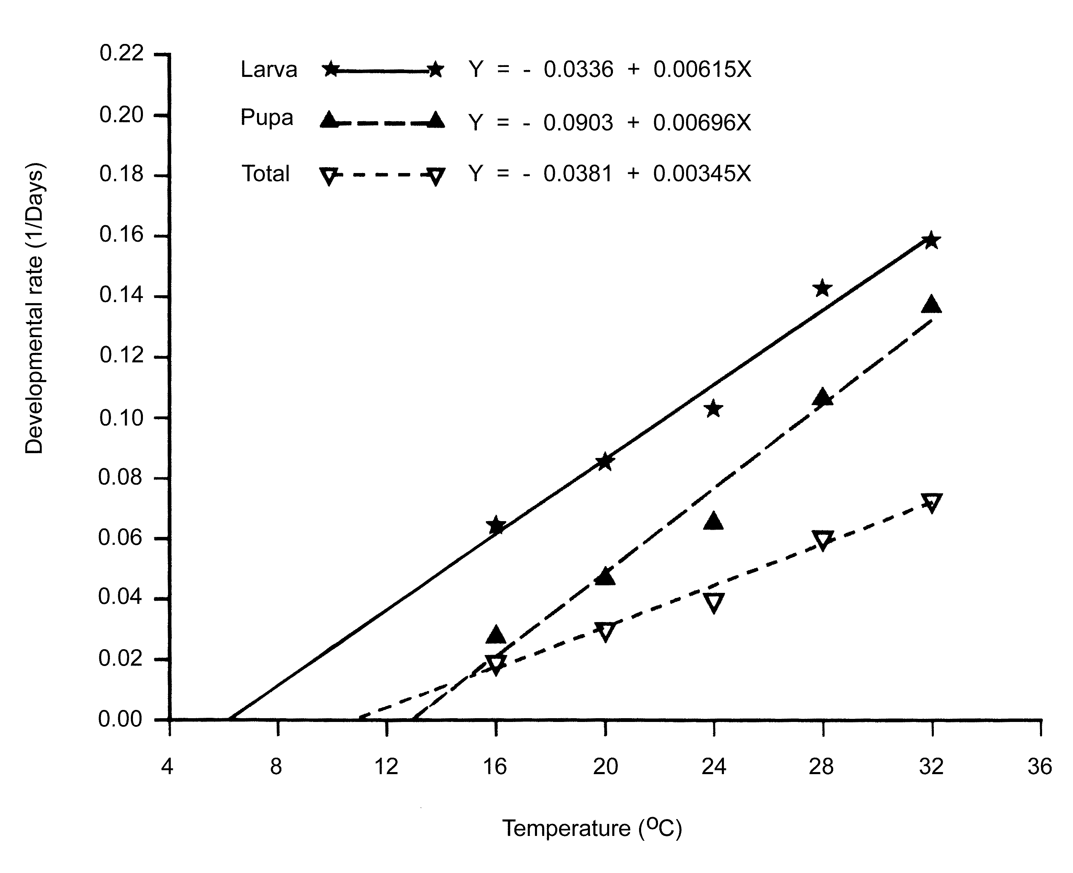
Fig. 1. Developmental rate for immature of S. dux under different temperature.

The lower developmental threshold temperatures (t_{L}) were calculated to be 5.9, 12.9 and 11.0 º C for larvae, pupae and total developmental time, respectively. The degree-days (K) required to complete the stage were 163.2 ± 8.28, 143.0 ± 20.80 and 289.1 ± 24.40 DD for larvae, pupae and total developmental time, respectively. Coefficients of determination (R²) were 98.0, 97.5 and 98.3 % for larvae, pupae and total development, respectively, indicating a good linear fit in all cases (Fig. 1). Degree-days required by S. dux to complete total development were more than the required by other species such as; S. crassipalpis required 284 DD above 10-11.3 º C [19], W. nuba required 268 DD above 13.6 º C [17] and B. cruentata required 229.3 DD above 12.9 º C [20], but less than that of P. ruficornis which required 388 DD above 7.7 º C [18].

Mortality
Mortalities of the immature stages due to temperatures are summarized in Table 2. The highest proportion of total mortality was 73 and 64 % recorded at 16 and 36º C, respectively. The lowest proportion of total mortality was calculated to be 21 and 15 % at 20 and 24 º C, respectively. However, Amoudi et al. found that the lower proportions of total mortality of P. ruficornis were 13 and 10 % at 25 and 28 º C, respectively [18]. Amoudi found that the pupal mortality for W. nuba was low at all temperatures used [17]. Al-Misned and Abou-Fannah, found that the lower proportions of total mortality of B. cruentata were 15 and 13 % at 21 and 25 º C, respectively [20]. There was significant differences (p<0.05) between percent larval and pupal mortality, X² = 7.73 for higher larval than pupal mortality from 20 to 28 º C (X² [p=0.05, df=2] =5.99). It is clear from this finding that larval stage was affected by low temperatures more than the pupal stage, which is more affected by high temperatures (32-36 º C), but the effect was not significant (X² = 1.69, p>0.05) (X² [p=0.05, df=1] =3.84). These results are similar to those reported for P. ruficornis [18] and B. cruentata [20].

Table 2. Mortality of the immature stages of S. dux at different temperatures
Temperature  ºC | % Mortality (n) |  |  | X ²
Temperature  ºC | Larva | Pupa | Total
16 | 27 (100)ª | 63.0 (73)^{b} | 73 (27)^{c} | 14.40
20 | 16 (100) | 6.0 (84) | 21 (79) | 4.55
24 | 11 (100) | 4.5 (89) | 15 (85) | 2.73
28 | 17 (100) | 13.3 (83) | 28 (72) | 0.45
32 | 24 (100) | 27.8 (79) | 43 (57) | 0.95
36 | 36 (100) | 43.7 (64) | 64 (36) | 0.74
ª Initial number of larvae in cohort.
^{b} Number of larvae reached to pupae.
^{c} Number of larvae reaching the adult stage.
^{d} X ² values performed on each set of data indicated differences in mortality between larva and pupa.

A large proportion of the immature stages did not survive at 36 º C, indicating that the upper developmental threshold was between 32 and 36 º C. This result is similar to those reported for P. ruficornis (31-34 º C) [18] and B. cruentata (33 º C ) [20].

Weights
The mean weight of pupae and adults at emergence differed significantly as a function of temperature for pupae (F=210.2; df=5,466 ; p<0.001) and for adults (combined sexes) (F= 71.1; df=5, 350 ; p<0.001) (Table 3). Maximum pupal and adult weights were reached when reared at 20 and 24 º C, while minimum weights were obtained at 16 and 36 º C. In comparison, the maximum pupal and adult weights for W. nuba at 21 º C [17], for P. ruficornis at 25 and 28 º C [18] and for B. cruentata at 21 and 25 º C [20]. At all temperatures used, adult weights were smaller in females than in males, but significant differences between sexes were observed only at 20 ºC (p<0.01) and 28 º C (p<0.05).

Table 3. Fresh weights of pupae and adults of S. dux reared at different temperatures
Temperature  ºC | wt . of Pupae (mg) |  | wt. of Adults (mg)
Temperature  ºC | ♂ + ♀ |  | ♂ |  | ♀ |  | ♂ + ♀
Temperature  ºC | n | Mean +SD | n | Mean +SD | n | Mean +SD | n | Mean +SD
16 | 73 | 78.7+11.83 | 12 | 53.6+10.41 | 15 | 52.3+9.24 | 27 | 52.8+9.60
20 | 84 | 119.3+10.33 | 31 | 79.8+10.48 | 48 | 73.3+9.19** | 79 | 75.9+10.16
24 | 89 | 126.6+10.12 | 37 | 78.1+9.61 | 48 | 74.3+9.17 | 85 | 76.0+9.51
28 | 83 | 101.1+12.03 | 35 | 69.4+13.67 | 37 | 64.2+7.64* | 72 | 66.8+11.22
32 | 79 | 96.3+11.72 | 27 | 58.8+6.86 | 30 | 54.5+10.09 | 57 | 56.5+8.91
36 | 64 | 80.0+16.47 | 12 | 52.1+10.41 | 24 | 49.7+7.27 | 36 | 50.5+8.37
Means between sexes in adults weights are significantly different (*p<0. 05, **p<0.01; t test).

In terms of rapid developmental rate, lower mortality and larger weight, the optimal developmental temperature ranged between 20 and 28 º C for all stages (Tables. 2 and 3). These results are similar to those given for W. nuba (21-33 º C) [17], P. ruficornis (22-28 º C) [18] and B. cruentata (21-29 º C) [20].

The developmental threshold temperatures extracted from our results can help predict when this fly inactivity and when development and growth of populations may be increasing, such data may used in control programs. The response of S. dux to temperature may help to explain its geographic distribution, seasonality and may have its implications in control programs.

Acknowledgement: I express my great appreciation to Mr. Salah Salem Abou-Fannah for technical assistance.

References

[1] |  | Sugiyama, E., Shinonaga, S. and Kano, R. "Sarcophagine Flies from Nepal with the Description of a New Species (Diptera: Sarcophagidae)". Jpn. J. Sanit. Zool., 39 (1988), 355-362.
[2] |  | Lehrer, A. Z. "Sur la validité des espéces Sarcophaga dux Thomson et Sarcophaga exuberans Pandellé, avec la description d une nouvelle espéce africaine du genre Liosarcophaga Enderlein (Diptera Sarcophagidae)". Ibidem, 40 (1995), 85-97.
[3] |  | Al-Misned, F. A. M., Amoudi, M. A. and Abou- Fannah, S. S. M. "First Record of Sarcophaga (Liosarcophaga) dux Thomson, 1868 (Diptera: Sarcophagidae) from Saudi Arabia". Pakistan J. Zool., 33 (2001), 313-315.
 | [4] |  | Povolny, D. "On Three Synonyms of the Palaearctic Flesh-fly Species by A. Z. Lehrer (Diptera, Sarcophagidae)". Acta Univ. Agric. et Silvic. Mendel. Brun. (Brno), 46 (1998), 7-13.
 | [5] |  | Hassanain, M. A., Abdel Ghaffar, F. A., El- Sharably, A. and Abdel Megeed, K. N. "Biological Control of Flesh Flies, Parasarcophaga dux and Chrysomyia albiceps, in Egypt". Egypt J. Zool., 29 (1997), 273-293.
 | [6] |  | Aspoas, B. R. "Comparative Micromorphology of Third Instar Larvae and the Breeding Biology of Some Afrotropical Sarcophaga (Diptera: Sarcophagidae)". Med. Vet. Entomol., 5 (1991), 437- 445.
 | [7] |  | Joshi, S. K. and Joshi, P. V. "Female Accessory Glands of a Flesh Fly, Parasarcophaga dux Thom. (Sarcophagidae, Diptera)". Biovigyanam, 18 (1992), 105-110.
 | [8] |  | Valandikar, S. C. and Hiregoudar, L. S. "Occurrence of Calliphorid, Sarcophagid and Muscid Flies at Bangalore". Curr. Res. Univ. Agric. Sci. Bangalore, 25 (1996), 1-2.
 | [9] |  | Sharpe, P. J. H. and Demichele, D. W. "Reaction Kinetics of Poikilotherm Development". J. Theor. Biol., 64 (1977), 649- 670.
 | [10] |  | Taylor, F. "Ecology and Evolution of Physiological Time in Insects". Am. Nat., 117 (1981), 1-23.
 | [11] |  | Amoudi, M. A., Diab, F. M. and Abou-Fannah, S. S. M. “The Influence of Low Temperature on Development, Adult Longevity and Productivity of Zaprionus indiana Gupta (Diptera: Drosophilidae)”. J. King Saud Univ., Agric. Sci., 5 (1993), 262-274.
 | [12] |  | Amoudi, M. A., Leclercq, M. and Richet, R. "Rearing of a Newly Recorded Dipterous Fly Parasarcophaga (Liopygia) ruficornis (Fabricius) (Diptera: Sarcophagidae) from Saudi Arabia under Laboratory Conditions". Pakistan J. Zool., (1992),181-186.
 | [13] |  | Arnold, C. Y. "The Determination and Significance of the Base Temperature in a Linear Heat Unit System". J. Am. Soc. Hortic. Sci., 74 (1959), 430-445.
 | [14] |  | Campbell, A., Frazer, B. D., Gilbert, N., Gutierrez, A. P. and Mackauer, M. "Temperatures Requirements of Some Aphids and Their Parasites.” J. Appl. Ecol., 11 (1974), 431- 438.
 | [15] |  | Andrewartha, H. G. and Birch, L. C. The Distribution and Abundance of Animals. University of Chicago Press, Chicago, (1954), 782 pp.
 | [16] |  | Hutchison, W. D., Butler, G. D. Jr. and Martin, J. M. "Temperature-dependent Development, Mortality and Longevity of Microplitis rufiventris (Hymenoptera: Braconidae) A Parasitoid of the Beet Armyworm (Lepidoptera: Noctuidae)". Ann. Entomol. Soc. Am., 79 (1986), 262-265.
 | [17] |  | Amoudi, M. A. "Effect of Temperature on the Developmental Stages of Wohlfahrrtia nuba (Diptera: Sarcophagidae)". J. Egypt. Soc. Parasitol., 23 (1993), 697- 705.
 | [18] |  | Amoudi, M. A., Diab, F. M. and Abou- Fannah, S. S. M. "Developmental Rate and Mortality of Immature Parasarcophaga (Liopygia) ruficornis (Diptera: Sarcophagidae) at Constant Laboratory Temperatures". J. Med. Entomol., 31(1994),168-170.
 | [19] |  | Chen, C. p., Denlinger, D. L. and Lee, R. E. Jr. "Responses of Nondiapausing Flesh flies (Diptera: Sarcophagidae) to Low Rearing Temperatures: Developmental Rate, Cold Tolerance, and Glycerol Concentrations". Ann. Entomol. Soc. Am., 80 (1987), 790-796.
 | [20] |  | Al-Misned, F. A. M. and Abou- Fannah, S. S. M. "Development Rate and Mortality of Immature Bercaea cruentata (Meigen) (Diptera: Sarcophagidae) at Constant Laboratory Temperatures". Pakistan J. Zool., 32 (2000), 151-155.

تأثير درجات الحرارة على تطورونسب موت الأطوار غير الكاملة لذبابة
اللحم ساركوفاجا دوكس Sarcophaga dux Thomson
(ثنائية الأجنحة): ساركوفاجيدي Diptera: Sarcophagidae)

فهد عبد المحسن المسند
قسم علم الحيوان، كلية العلوم، ص. ب 2455، جامعة الملك سعود،
الرياض 11451، المملكة العربية السعودية

( قدم للنشر في29/12/ 1422هـ؛ وقبل للنشر في 4/4/ 1423هـ)

ملخص البحث. أجريت هذه الدراسة على ذبابة اللحمSarcophaga dux في المختبر لمعرفة تأثير بعض درجات الحرارة على تطور ونسب موت الأطوار غير الكاملة . وكانت فترة النمو الكلية من الطوراليرقي الأول إلى بزوغ الطور الكامل 51.8، 33، 25،16.4، 13.6، 15.1يوم عند درجات الحرارة 16، 20، 24، 28، 23 و36م على التوالى. كما اثبتت الدراسة أنه لا توجد فروق معنوية بين متوسطات فترات التطور لكل من الذكور والإناث. وكانت درجات الحرارة الدنيا التي يتوقف عندها النمو هي 5.9، 12.9، 11م. لليرقات والعذارى وفترة التطور الكلية (من الطور اليرقي الأول الى الطور الكامل) على التوالي. واستخدمت البيانات لإيجاد نموذج يربط الوحدات الحرارية اللازمة لإكمال النمو (DD) للتنبؤ بكثافة هذه الذبابة في الحقل وقد قدرت بـ 163.2، 143، 289.1 (DD) لليرقات والعذارى والفترة الكلية على التوالي. كما أظهرت الدراسة أن اعلى نسبة موت سجلت عند درجات الحرارة 16 و36°م وأن اكبر وزن للعذارى والذباب الكامل كان عند درجات الحرارة 20 و 24°م. وأقل وزن عند 16 و36°م . وكانت أوزان إناث الذباب الكامل أقل من أوزانها في الذكور عند كل درجات الحرارة التي أختبرت. كما استخلص من البحث أن درجة الحرارة المثلى لتربية هذه الذبابة تقع بين درجتى حرارة 20 و 28°م.

