We use the following scheme for transmission:
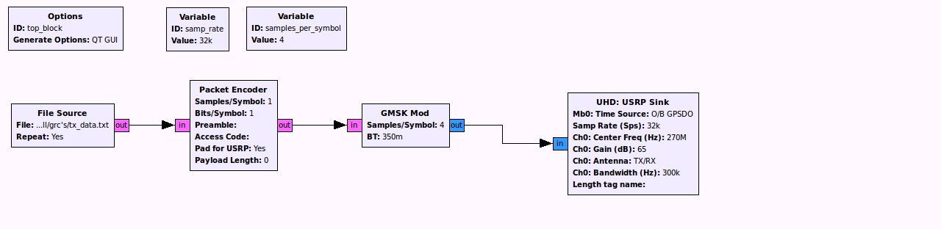
This raise some doubts about how much power where we transmitting to the antenna, since the required gains to “see” something were too high.

We connected the signal to an spectrum analyzer, to discover the exact amount of power transmitted.

All results are obtained when transmitting at 270Mhz, although we tried 144Mhz and 400Mhz with similar results.

We use the channel A of the spectrum analyzer, since it's entry was at 50 Ohms (We first tried channel R, and there's a 3dB difference, since it's entry is 1MOhm). We also removed all attenuation, and set the reference level to 0 dBm.

Ch0 Gain set to GNU Radio's USRP Sink | Power measured in the spectrum analyser
65 dB | -39.4 dBm
75 dB | -29.5 dBm
85 dB | -25 dBm
95 dB | -25 dBm ?
105 dB | -25 dBm ??
130 dB | -25 dBm ???????

Transmitting at 75 dB Gain (so, -29.5 dBm), we have obtained different measures, at different points.
Since the fact of observing the signal (and myself standing in the middle of the transmission affects), I tried moving to different positions and keeping the measure when, if I've move just a little, the measure doesn't change. The ideal would be that the radio itself was able to save that value without anyone having to look at it... WIP.

Tx Power | Position | Rx Power
85 dB | Pos 1 | -26 dBm
85 dB | Pos 2 | -32 dBm
85 dB | Pos 3 | -33 dBm

