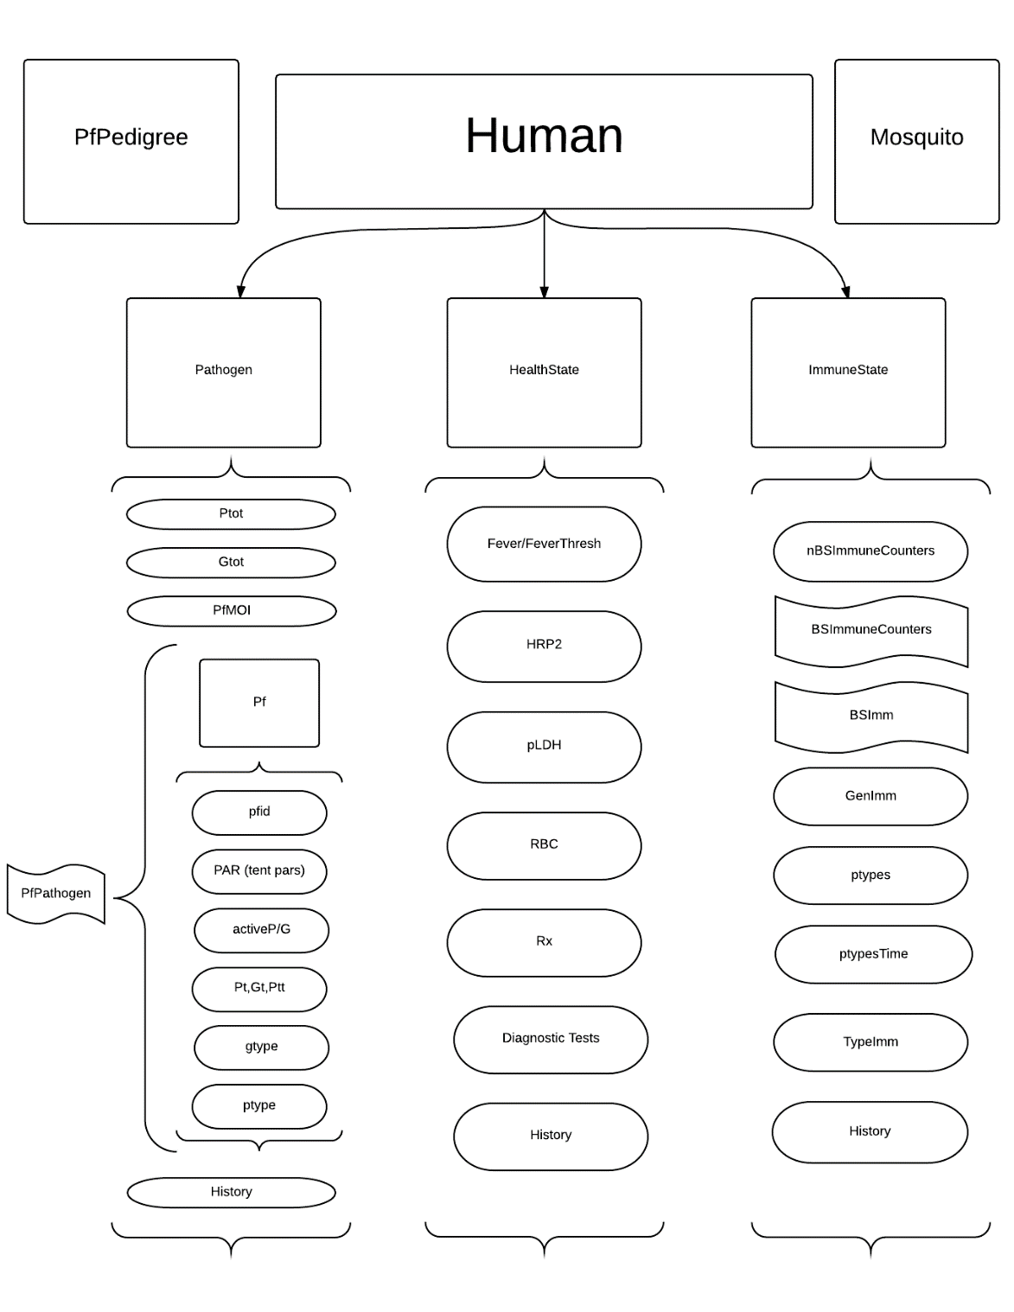

**CLASSES**

Notation: camelcase with capitalization on the first letter denotes the class, and camelcase with a lower case first letter denotes an instantiation of the class (i.e. ImmuneState is the class, immuneState is the particular immune state within a human object)

**PfPedigree**

The PfPedigree contains a list of attributes of every clonal lineage of Pf parasite, specifically the pfid, genotype, phenotype, a list of Human ids (ixh) of every Human infected with this specific clonal variant, the times of the beginning and end of each Human infection, as well as a list of Mosquito ids (ixm) and times of infection (they are assumed to be infected for the duration of their lives)

The pedigree is referenced at the creation of a new Pf object – the ids of the micro- and macrogametocytes are used to look up the parent genotypes, which are then recombined following our genetic algorithm to create the genotype of the new clonal variant.

Fields:

gtype – list of real-valued vectors within the unit n-cube ordered by pfid; vector is of

length nAntigenLoci

ptype – list of integer-valued vectors with component values for component i contained

in (1,nptype[i])

ixh – list of human ids infected by a particular parasite clonal lineage with given pfid

ixm – list of mosquito ids infected by a particular parasite clonal lineage with given pfid

mac – list of ids of macrogametocyte lineage for a given pfid

mic – list of ids of microgametocyte lineage for a given pfid

nAntigenLoci – integer, number of antigens we’re considering in the genotype vector

nptypes – integer-valued vector, number of distinct phenotypes for each of the antigens

of interest

PedLength – integer, current number of distinct clonal lineages on the part of the

landscape the pfPedigree is instantiated in

sib – sibling type (may not be used)

th – list of times a particular human was infected by a clonal lineage with given pfid

thEnd – list of times a particular human cleared a clonal lineage with given pfid

tm – list of times a particular mosquito was infected by a clonal lineage with given pfid

tmEnd – list of times a particular mosquito died/cleared a clonal lineage with a given

pfid

Methods:

initialize( ) – called automatically at instantiation of object, sets default values for

nAntigenLoci and nptypes

get_*field*( ) - accessors for each of the above fields, no input necessary. Output is the

value of the field listed in the method

**Human**

The Human class acts as an environmental container for the immuneState, healthState, and Pathogen objects. To instantiate a human object, one needs to input the unique human id (ixH), the human’s age, the sex (M for male, F for female), and the location id. Creating a human object also queues the creation of a set of internal fields that are instantiations of ImmuneState, HealthState, and Pathogen (see diagram). Any updates can be queued in the Human, and the cross-talk between the different internal objects are done through function calls in the Human with inputs using values accessed within the Human.

Fields:

ixh – unique human id

age – age of human

sex – sex of human (‘M’ for male, ‘F’ for female)

locH – current location id of human

immuneState – immuneState object, see ImmuneState class description

healthState - healthState object, see HealthState class description

pathogen - pathogen object, see Pathogen class description

history – list of past values for various fields

Methods:

initialize( ixh, age, sex, locH )

infectHuman( t, pfid )

clearPathogen( t, pfid )

infectMosquito( t, pfid, ixm )

moveHuman( newlocH )

updateHuman( t )

get_*field*( )

set_*field*( newFieldValue )

**ImmuneState**

An immuneState object contains lists of immune counters for general immunity, as well as an array of times when a particular phenotype was last seen within the human.

Fields:

nBSImmunecounters

BSImm

wx

wn

dxp

dtp

GenImm

ptypesTime

typeImm

nptypes

history

Methods:

initialize( )

get_*field*( )

set_*field*( newFieldValue )

update_immuneState( t, Ptot )

update_history( )

sigmoidX( X, X50, Xs, atMax )

dynamicXdt ( X, P, PAR )

daysSinceUnder( X, P, PAR )

daysSinceOver( X, P, PAR )

antibodyRegister( t, pfid )

dynamicCounter( P, PAR )

gImPAR( wx, wn, P50, Ps, atMax, b, sigma )

ptype2Mat( ptype, nptypes)

shift( v, places, dir )

update_typeImmunity( t, ptype )

crossImm( ptype, nptypes )

**HealthState**

Fields:

Fever

feverThresh

HRP2

RBC

pLDH

Rx

history

Methods:

initialize( )

get_*field*( )

set_*field*( newFieldValue )

update_healthState( Ptot, RBCHist )

update_Fever( Ptot )

update_HRP2( Ptot )

update_pLDH( Ptot )

update_RBC( Ptot, RBCHist )

update_history( )

RDT( )

HSRDT( )

PCR( )

LAMP( )

LightMic( )

sigmoidX( X, X50, Xs, atMax )

Treat( Rx )

**Pathogen**

Fields:

PfPathogen

Ptot

Gtot

PfMOI

history

Methods:

initialize( )

get_*field*( )

set_*field*( newFieldVal )

add_Pf( t, pfid) ## currently include more inputs, but can look up from pfped

remove_Pf( t, pfid )

update_pathogen( t )

update_Ptot( t )

update_Gtot( )

update_history( )

log10sum( x )

log10vals( x )

**Pf**

Fields:

pfid

PAR

gdk

activeP

activeG

Pt

Ptt

Gt

mic

mac

gtype

ptype

mu

Methods:

initialize( mic, mac, pfid, seed=F )

get_*field*( )

set_*field*(newFieldVal)

getGtype( mic, mac, mu, seed=F )

getPtype( gtype, nptypes )

mutate( gtype, mu )

update_Pf( t )

update_Pt( t )

update_Ptt( t )

update_Gt( t )

GamCyGen( t, P, PAR )

Pf.MaxPD( N, mn, vr )

Pf.PeakD( min )

Pf.MZ0( )

Pf.Duration( peakD, N, mn )

tentPAR( t, pfid )

gr_tent( t, PAR )

dPdt_tent( t, P, PAR, PD=0, IM = 0 )

shift( v, places, dir=”right”)

log10sum( x )

log10vals( x )

immuneMod_tent( BSImm )

sigmoid01( x, xh, b, max )