Software Architecture

Architecture Pattern: MVC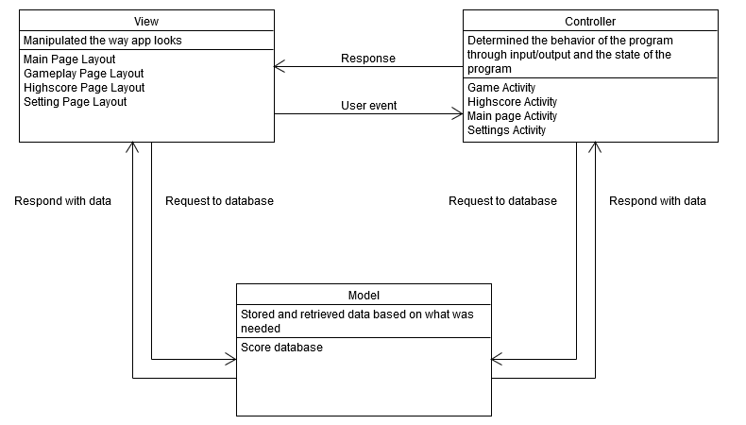

Design Patterns

Singleton

Singleton makes sure that there is only one state of the game.

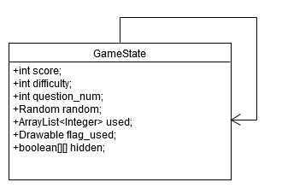

Façade

Façades are used to make communicating with database simpler through high level handler

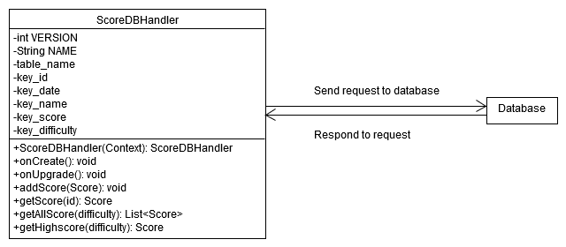

Observer

The logic is separated between the views and model/controller classes, like the box model shows. All the layout files are made in XML file that is read by the Android and the remaining codes are in Java and SQLite

