Software Requirements Specification

for

Flag Quest

**Version 1.0 approved**

**Prepared by Cody Otterbine**

**Akira Uchiyamada**

**Ruben Perez**

**Eddie Garcia**

**Asah Oghenerukevwe**

**Kazi Abdul Muktadir**

**The Left Overs**

**March 04, 2018**

Table of Contents

Table of Contents

1. Introduction 4

1.1 Purpose 4

1.2 Scope of Product 4

1.3 Overview 4

2. Overall Description 4

2.1 Product Perspective 5

2.1.1 Related Apps 5

2.2 Product Functions 6

2.2.1 Ease of Use 6

2.2.2 Gameplay 6

2.2.3 Other features 6

2.3 User Classes and Characteristics 6

2.3.1 Casual Gamers 6

2.4 Operating Environment 7

2.5 Assumptions 7

3. Specific Requirement 7

3.1 External Interface Requirements 7

3.1.1 User Interfaces 7

3.1.2 Hardware Interfaces 8

3.1.3 Software Interfaces 8

3.1.4 Communications Interfaces 8

3.2 Performance Requirements 8

3.3 Design Constraints 8

3.4 Quality Requirements 8

3.5 Privacy and Security Requirement 8

4. Use Case 10

5. Appendix 11

5.1 Acronyms, Abbreviations, Definitions 11

5.2 References 11

Revision History

|  |  |  |  |
| --- | --- | --- | --- |
| **Name** | **Date** | **Reason For Changes** | **Version** |
| Akira Uchiyamada | 5/9/2018 | Added use case section and more security req. | 1.1 |
|  |  |  |  |

# Introduction

## Purpose

The purpose of this Software Requirement Specification (SRS) document is to analyze and describe the Flag Quest project in a high-level language. By doing so, the non-engineers can better understand the process behind the project and the team can generate a more well-defined specification that can be used to base the design and development of the further in the project.

## Scope of Product

Flag Quest is a puzzle/trivia game app that focuses on flag related questions. Although trivia quizzes are something that are done often, Flag Quest will provide various type of questions relating to flag and country associated to it such as filling in the blank questions, which is atypical for many trivia quiz game apps, as well as statistics and social media linking that can motivate and capture players. The goal of this app is to enter the trivia quizzing app’s market and capture the audience through unique features.

## Overview

There will be three sections after this introduction, which are Overall Description, Specific Requirements, and Use Case. In Overall Description section, there will be detailed description of what Flag Quest is, which includes details such as comparison with other related programs, expected type of users, the required environment to run the application, and others. Next, in Specific Requirements section, there will be detailed explanations of requirements for the implementation of the application, such as functional requirements, software/hardware requirements, and some constraints we may encounter. Finally, in Use Case section, there will be high level details on exactly what feature will be added and how the user will perform such actions. There will also be misuse case, which are things attackers may do to attack the game. With these three sections, it will be possible to grasp the general idea behind the Flag Quest app.

# Overall Description

This section will thoroughly examine the high-level aspects of this application such as the role of this application to the potential user, its impact in the market, and detailed explanation on how to use the application.

## Product Perspective

Flag Quest is a game that involves guessing the flag within a given time and with varying difficulty. Because Flag Quest will not be the first game of its kind to be in the market, we will first begin by analyzing the existing program and then creating something that can stand out.

### Related Apps

There are three applications we researched that performs similar functionality as the Flag Quest, which are Trivia Crack, National Flags Quiz, and FlagMaster.

#### Trivia Crack

Trivia Crack is a puzzle/trivia game that requires players to answer quizzes based on trivia. Trivia Crack challenges the players by imposing time limit for every question and penalizing them when the players failed to answer the question before the time is out. Trivia Crack also offers hints to the question by slightly penalizing the player before revealing it, which encourages the player to attempt the question before viewing the hint to minimize the penalty. Flag Quest aims to be different from Trivia Crack through focusing on the flags instead of general trivia, and the mechanics of the hints will also be revised, as it will be clear in the later sections.

#### National Flags Quiz

National Flags Quiz is also a puzzle/trivia game that focuses on the flags like Flag Quest. There are two modes for National Flag Quiz. One mode gives the player the name of the country, and the player is required to select the correct flag from the four flags given. Another mode tests the reverse of the first mode, which is providing the user the flag, which player then selects the correct country from the choices. There are difficulty setting of Easy, Medium, Hard, and player can also choose to enable time limit to challenge themselves further. To differentiate from this game, Flag Quest aims to make various types of questions, which includes, but not limited to: hidden flags that gradually reveals themselves over time, fill in the blank, and hangman style answers.

#### FlagMaster

FlagMaster is another puzzle/trivia game that quizzes on flags. The major difference between FlagMaster and National Flags Quiz is the difficulty setting. The FlagMaster has 10 difficulties labeled from 1 to 10, and the difficulties must be purchased using in game currency to unlock higher difficulties. The quizzes are also identical to National Flags Quiz, which further indicates that Flag Quest offering different types of quizzes help Flag Quest stand out from similar applications. Flag Quest also aims to differentiate from FlagMaster by tracking high scores of players to motivate players to improve.

## Product Functions

This section will list high-level functionalities Flag Quest are required to have to stand out in the market, based on the three similar apps examined. In order to make the best app in the market, it would be useful to take some aspects of the similar apps that are effective and combine them, as well as add our own feature to the game to be original.

### Ease of Use

The app must be easy to use and intuitive to use. As such, this game will only have the main game section, high score page, and settings page to keep the game simplistic.

### Gameplay

There will be several distinctive features in gameplay to help Flag Quest be unique from its competitions. First, there will be time limit to questions. The time limit will challenge the players to answer the questions as quickly as possible. The score will also be tied to the amount of time players spent on each question, which can become an incentive for players to play over and over to improve their score. Next, there will be variety in questions asked. The biggest problem we encountered with the three apps is that the games eventually became mundane because every questions were simple multiple choice without any twist. By rotating various types of questions, it will help keep the players from being too tired. Lastly, the game will also have an in-game points that players can earn through playing the game. With the points, players can buy some hints to the questions in order to effectively answer them.

### Other features

Other than the main game feature, there will be several minor but important features to Flag Quest to help players enjoy the experience. High score screen, for example, will have a graph to show the player’s improvement over time to help encourage them to play more. Additionally, Flag Quest will connect to some social media such as Twitter to help the players share their score with their friends. This will not only help the users enjoy the game by sharing with their friends, it also publicize the game by encouraging their group of friends to play the game.

## User Classes and Characteristics

There are various type of users Flag Quest can appeal to. This section will analyze the type of users it will most likely attract and how the app can retain their interest.

### Casual Gamers

The casual gamers tend to play games that are simple and easy to get into, which is perfect audience for Flag Quest. The game shouldn’t last for prolonged period each sessions, so the casual gamers can simply bring up the game on their smartphone and spend some time on the game during various waiting time they encounter throughout the day. Casual gamers tend to also have access to social media, which helps them utilize the feature fully.

## Operating Environment

As of now, Flag Quest will be available only on Android system. The SDK tool used to develop will be version 26.0.2, which is a version released on April 2017. Because Flag Quest does not require any specific functionality, most Android version should be able to run the application. Other than a device with Android operating system, Flag Quest does not depend on anything else, making it easy to install and use.

## Assumptions

There are several assumptions that has been made in order to make this app. First, we assumed that the list of countries featured in Olympics is the most complete list of countries available. List of countries recognized by United Nation is also an alternative to the Olympics, however, the number of countries is less in the list provided by United Nation. The SDK version 26.0.2 is also assumed to support enough Android versions for our purpose.

# Specific Requirement

In this section, there will be list of requirements the app must fulfill, as well as several design constraints that may be applied, in order to become a full app. The types of requirement include the external requirements, functional requirements, and quality requirements.

## External Interface Requirements

External interface requirements refer to things that are outside the programming realm that must be considered, such as the user interface, hardware, software, and communication. By establishing external interface requirement, the development process will be smoother because it leads to preparation beforehand.

### User Interfaces

**Main Page**

3.1.1.1 The system shall only have Play, Settings, and Highscore screen for simplicity

**Play screen**

3.1.1.2 The system shall have a visible timer that will inform the user of the remaining time

3.1.1.3 The system shall show the current score the player built over the game

3.1.1.4 The system shall show every type of questions clearly

3.1.1.5 The system shall have a submit button for every question to avoid penalizing the accidental clicks

3.1.1.6 The system shall display the result screen

**Highscore page**

3.1.1.7 The system shall create a line graph to display the progress

3.1.1.8 The system shall show the list of top 20 best score for each difficulty

3.1.1.9 The system shall show the name, points date, and difficulty for every score entry

**Settings page**

3.1.1.10 The system shall allow users to set the volume of the music or mute it altogether9

3.1.1.11 The system shall allow the user to connect to social media, which will be used to share scores

### Hardware Interfaces

3.1.2.1 The system shall run on fully updated Android devices

3.1.2.2 The system shall run on devices that are connected to internet

### Software Interfaces

3.1.2.1 The system shall store and read user’s scoreboard

3.1.3.2 The system shall read the questions and answers from a database

### Communications Interfaces

3.1.4.1 The system shall use internet protocols to connect to the internet

## Performance Requirements

3.2.1 The system shall retrieve user’s scoreboard in under 1 second 98% of the time

3.2.2 The system shall retrieve user’s information from their social media account in under 3 seconds 98% of the time under average internet condition

## Design Constraints

3.3.1 The system shall run on Android devices, which has limited number of tools to use

3.3.2 The system shall be natural on any monitor aspect ratio to consider varying aspect ratio on Android devices

3.3.3 The system shall be complete in under three months

## Quality Requirements

3.4.1 The system shall be fully graphically designed

3.4.2 The system shall have fair difficulty for each difficulty setting

3.4.3 The system shall be responsive, so 98% of the action are performed in under a second

## Privacy and Security Requirement

**Privacy**

3.5.1 The system shall only store the user’s username, social media account and date of the score set for user’s personal information

3.5.2 The system shall not purposefully give out the personal information stored to 3rd party

3.5.3 The system shall only use the user’s username and date of the score set to keep track of the user’s score

3.5.4 The system shall only use the user’s social media account to upload the score and only if the user request to do so

**Security**

3.5.1 The system shall encrypt user’s social media information to protect their account

3.5.2 The system shall prevent the editing of scores to uphold the integrity of the scoreboard

3.5.3 The system shall not upload any information unless the user chooses to upload the score to their twitter account, in which only the score is sent

# Use Case

In this section, we will discuss the use cases of the flag quest.

## Use Case Diagram

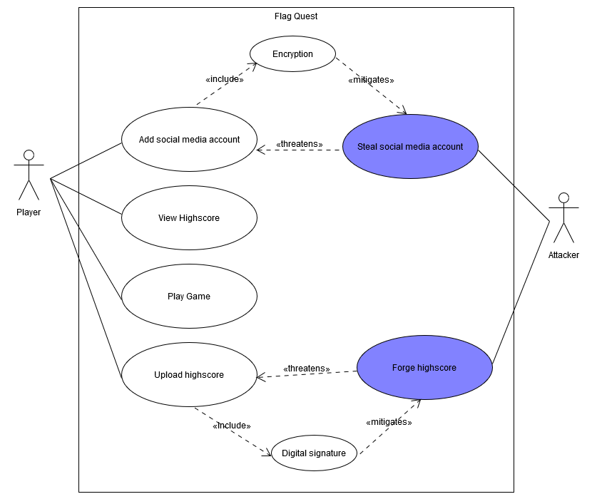

Use case diagram shows the major features for the application. In the most high-level view, the player can add social media account, view highscore, play game, and upload highscore. Attacker, or any theoretical malicious user that aims to ruin the application, can steal social media account from the user or forge highscores and upload it as if it is real.

## Use Case Details

|  |  |
| --- | --- |
| **ID** | 1 |
| **Name** | Play Game |
| **Description** | Player plays the game |
| **Actors** | Player, system |
| **Precondition** | The application has been opened |
| **Steps**  **(Basic)** | |  |  | | --- | --- | | Actor: Player | Actor: System | | 1. User selects play game | 1. System shows difficulties | | 1. User selects a difficulty | 1. System displays appropriate questions | | 1. User answers questions properly | 1. System displays next question for 10 times. Return to step 5 until all 10 has been answered | |  | 1. System records the score in database | |
| **Steps (alternate)** | |  |  | | --- | --- | | Actor: Player | Actor: System | | 5a1. User inputted the wrong answer | 5a2. System displays “wrong answer” and subtract score and prompt for another answer | | 5b1. User ran out of time | 5b2. System subtract scores and display next question or end the game based on the amount of questions done. | |
| **Postcondition** | The user played the game and system recorded the score |

|  |  |
| --- | --- |
| **ID** | 2 |
| **Name** | View highscore |
| **Description** | The app displays all the scores player have made |
| **Actors** | Player, system |
| **Precondition** | The application has been opened |
| **Steps**  **(Basic)** | |  |  | | --- | --- | | Actor: Player | Actor: System | | 1. User selects highscore | 1. System shows easy scoreboard | | 1. User selects a difficulty | 1. System shows the scoreboard for the difficulty | |
| **Steps (alternate)** |  |
| **Postcondition** | The app shows the scoreboard for the desired difficulty |

|  |  |
| --- | --- |
| **ID** | 3 |
| **Name** | Add social media account |
| **Description** | Adds a social media account for the user |
| **Actors** | Player, system |
| **Precondition** | The application has been opened |
| **Steps**  **(Basic)** | |  |  | | --- | --- | | Actor: Player | Actor: System | | 1. User selects settings | 1. System shows setting | | 1. User selects “add social media account” | 1. System shows the setting for adding social media accounts | | 1. User selects the social media account they want to add |  | | 1. User inputs the information required to log in to the social media account | 1. System stores the access token generated through authentication | |
| **Steps (alternate)** | |  |  | | --- | --- | | Actor: Player | Actor: System | | 6a1. User inputs the wrong information for login | 6a2. System displays “wrong login information” and prompt for the information again | |
| **Postcondition** | The app stored the user’s social media account for sharing |

|  |  |
| --- | --- |
| **ID** | 4 |
| **Name** | Upload highscore |
| **Description** | The system posts the desired score to their social media account |
| **Actors** | Player, system |
| **Precondition** | The application has been opened |
| **Steps**  **(Basic)** | |  |  | | --- | --- | | Actor: Player | Actor: System | | 1. User selects highscore | 1. System shows easy scoreboard | | 1. User selects a difficulty | 1. System shows the scoreboard for the difficulty | | 1. User selects the social media account they want to post with on the score they want to post | 1. System posts the score to the user’s social media account | |
| **Steps (alternate)** | |  |  | | --- | --- | | Actor: Player | Actor: System | | 5a1. User selects the social media account that they did not set up | 5a2. System displays “No account has been set for that platform” | |
| **Postcondition** | The score has been posted on the user’s social media account |

## Misuse Case Details

|  |  |
| --- | --- |
| **ID** | 5 |
| **Name** | Steal social media account |
| **Description** | Player plays the game |
| **Actors** | Player, system |
| **Precondition** | The application has been opened |
| **Steps**  **(Basic)** | Actor: Attacker   1. Attacker listens for any packets sent by the user 2. Attacker retrieves the access code for the user |
| **Steps (alternate)** |  |
| **Capture Point** | 1. The access code will be encrypted, and only decrypted from the server’s side |

|  |  |
| --- | --- |
| **ID** | 6 |
| **Name** | Forge highscore |
| **Description** | Player plays the game |
| **Actors** | Player, system |
| **Precondition** | The application has been opened |
| **Steps**  **(Basic)** | Actor: Attacker   1. Attacker cheats the score and saves invalid score 2. Attacker uploads it in social media |
| **Steps (alternate)** |  |
| **Capture Point** | 1. Every score will hold digital signature to show its validity 2. The scores shared will hold some kind of watermark to indicate the validity of the score |

# Appendix

## Acronyms, Abbreviations, Definitions

*SRS: Software Requirement Specifiction* – Refers to this document, which is intended to inform the readers unfamiliar with software engineering process by using high-level language to describe the project in detail.

*SDK*: *Software Development Kit* – A kit that contains tools developers can use to create software. In this project’s case, Android SDK is used to write an Android app.

*API:*

*HTTP: Hypertext Transfer Protocol ­*– A protocol that controls what kind of data is exchanged between the client and server

*TCP: Transmission Control Protocol* – A protocol that determines how the data is transmitted through the internet, so the data is received in a reliable manner

## References

*List of countries*: https://www.olympic.org/pyeongchang-2018/results/en/general/nocs-list.htm